To: MWATA President
From: Alexei Habermehl
Date: October 15, 2025
Subject line: MWATA Fare Evasion Regression Analysis

Approximately 508,000 people ride DC Metrorail a day on average, effectively existing as the veins of D.C.. However, MWATA has recently faced existential budget deficits, with fare evaders being identified as a major loss of potential revenue. By using MWATA’s 2021-2024 dataset, we are using regression modeling to analyze if fare evasion can be substantially described by the weekday, if it’s a holiday, and more. Our summarized findings are as follows:
- Ridership volume has a significant positive relationship with fare evasion
- Holding other variables constant, weekdays have the highest rates of fare evasion
- The model explains ~20% of the variance
We subset the data to only show Metrorail rides, filtered out “free metro” days to reduce outliers, and cleaned all zero, and negative datapoints under both the fair evasion and entries categories. The DV is Non-tapped entities (ie. Individuals who were “sensored” skipping the fare by either jumping over the turnstile, or running behind someone), and the four IV’s are Metro entries (interval), exit amount (interval), Weekday/Saturday/Sunday (Saturday was the reference, made into dummy variables), and holidays (with no being the reference). Average paid entries and exit amounts are the averages on a day of all metro stops combined. Data tables are as follows:
Table 2: Quantitative Summary
 | Freq | Min | Max | Med. | Mean | SD | Skewness
Fare Evasion  Avg. Paid Entries  Avg. Exit Amount | 57693  57693  57693 | 1  1  0 | 5020  32477  39926 | 179  2501  2470 | 303.32  3364.76  3328.23 | 5.77  2992.92  2961.73 | 2.29  1.95  2.00

Fare evasion amount is highly positively skewed, implying most datapoints cluster toward the lower end. Avg. paid entries and average exits should theoretically be near perfectly even, but slightly differ, with paid entries being higher. This may imply more people are willing to scan up front, but may attempt to escape paying when leaving.
Table 1: Categorical Summary
 | Freq. | Percent
Day Type
Saturday(Ref) | 8257 | 14.31%
Sunday | 8362 | 14.49%
Weekday  Holiday | 41074 | 71.19%
No(Ref) | 56232 | 97.47%
Yes | 1461 | 2.53%
Total | 57693 | 100%
Most riders ride on the weekday, however, almost all week days seem to have similar ridership amounts. Holidays has a noticeably small “yes” variable, not only because most days are holidays, but because holidays with
Regression Analysis
Assumptions: Residual datapoint frequency form a general bell curve around zero, implying minimal skew. However, #entries and #exits didn’t pass the multicollinearity test, with both having values ~9. , To correct the multicollinearity issue, we’d be able to simply remove one of the columns and focus on just one category.
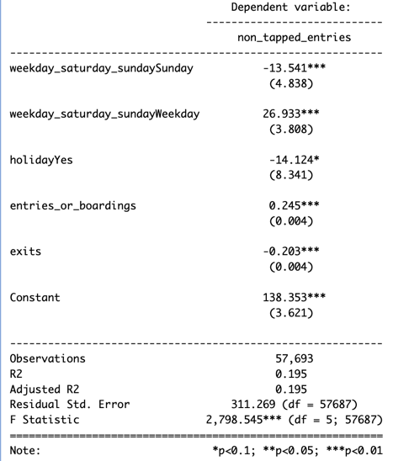
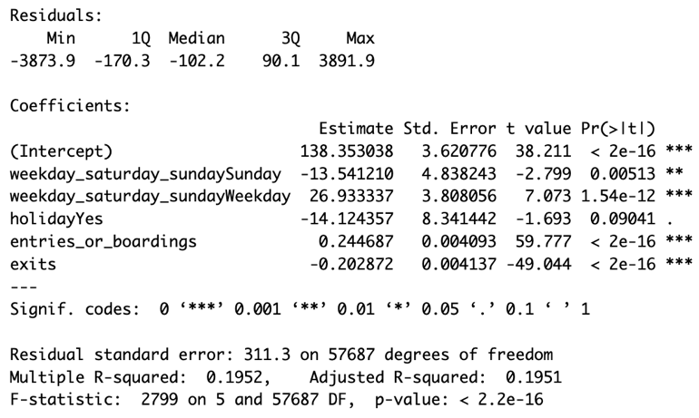
Regression Equation: 138.35 – 0.203(exits)+0.245(entries)-14.12(Holiday=yes), +26.933(weekday?) -13.541(Sunday)
Our model first indicates high significance, with a p value next to zero, and a F statistic of over 2.5k, and power ~1 at alpha =0.5. Our model explains ~19.5% of the variance (Adj. R^2 = 0.195), meaning our model is a quite satisfactory, meaning our factors definitely have an impact on the DV. The Cohen’s F implies the effect size is very large. In terms of the variables themselves, entries and exits had the greatest impact on the IV, both having the two largest t values and miniscule p values. In terms of categorical variables, weekdays seemed to have the highest rates of fare-evaders, albeit to a much less significant level than the numerical independent variables. In summary, we can overall conclude that metro stops with high traffic on the weekdays tend to face the greatest amount of fare evaders, to a pretty significant extent.
We can conclude that metro stops with the heaviest foot traffic tend to face the highest fare evaders, further bolstered when it’s a weekday, and not a holiday. Because of this, we suggest MWATA focus most of their anti-fare evading technology and staff during these time periods to minimize fare evading to the highest extent. In terms of the data, we would suggest to further improve fare-evading technology. Tens of thousands of data points were lost due to faulty fare evading machines polluting the “zero fare evasion” output.

Additional supporting graphs:

