МОЛДАВСКИЙ ГОСУДАРСТВЕННЫЙ УНИВЕРСИТЕТ
ФАКУЛЬТЕТ „МАТЕМАТИКА И ИНФОРМАТИКА”
ДЕПАРТАМЕНТ “ИНФОРМАТИКА”

Отчет по индивидуальной работе №2
По предмету «Framework-uri pentru Dezvoltarea Aplicațiilor Web»

Автор: ______________ Морозан Алексей
Группа: IA1902

Кишинёв 2021
1.Начальная настройка проекта
1.1 Подключение всех необходимых пакетов

User@HOME-PC MINGW64 /d/programs/XAMPP/htdocs
$ composer create-project symfony/skeleton crudProj
User@HOME-PC MINGW64 /d/programs/XAMPP/htdocs
$ cd crudProj
User@HOME-PC MINGW64 /d/programs/XAMPP/htdocs/crudProj
$ composer require "twig/twig:^3.0"
User@HOME-PC MINGW64 /d/programs/XAMPP/htdocs/crudProj
$ composer require annotations
User@HOME-PC MINGW64 /d/programs/XAMPP/htdocs/crudProj
$ composer require symfony/orm-pack
User@HOME-PC MINGW64 /d/programs/XAMPP/htdocs/crudProj
$ composer require --dev symfony/maker-bundle
User@HOME-PC MINGW64 /d/programs/XAMPP/htdocs/crudProj
$ php bin/console make:controller LibraryController
User@HOME-PC MINGW64 /d/programs/XAMPP/htdocs/crudProj
$ composer require form validator
User@HOME-PC MINGW64 /d/programs/XAMPP/htdocs/crudProj
$ composer require --dev symfony/profiler-pack
User@HOME-PC MINGW64 /d/programs/XAMPP/htdocs/crudProj
$ composer require doctrine maker

1.2 Создание сущностей (Книга и Автор)

User@HOME-PC MINGW64 /d/programs/XAMPP/htdocs/crudProj
$ php bin/console make:entity

Class name of the entity to create or update (e.g. GrumpyKangaroo):
> Book
B?[Ko?[Ko?[Kk?[K

?[34mcreated?[39m: src/Entity/Book.php
?[34mcreated?[39m: src/Repository/BookRepository.php

Entity generated! Now let's add some fields!
You can always add more fields later manually or by re-running this command.

?[32mNew property name (press ?[39m?[32m<return>?[39m?[32m to stop adding field
s)?[39m:
> name

?[32mField type (enter ?[39m?[33m??[39m?[32m to see all types)?[39m [?[33mstrin
g?[39m]:
> string
s?[K?7?[30;47mimple_array?[39;49m?8t?[K?7?[30;47mring?[39;49m?8r?[K?7?[30;47ming
?[39;49m?8i?[K?7?[30;47mng?[39;49m?8n?[K?7?[30;47mg?[39;49m?8g?[K?7?8

?[32mField length?[39m [?[33m255?[39m]:
> 255

?[32mCan this field be null in the database (nullable) (yes/no)?[39m [?[33mno?[
39m]:
> no

?[33mupdated?[39m: src/Entity/Book.php

?[32mAdd another property? Enter the property name (or press ?[39m?[32m<return>
?[39m?[32m to stop adding fields)?[39m:
> genre

?[32mField type (enter ?[39m?[33m??[39m?[32m to see all types)?[39m [?[33mstrin
g?[39m]:
> string
s?[K?7?[30;47mimple_array?[39;49m?8t?[K?7?[30;47mring?[39;49m?8r?[K?7?[30;47ming
?[39;49m?8i?[K?7?[30;47mng?[39;49m?8n?[K?7?[30;47mg?[39;49m?8g?[K?7?8

?[32mField length?[39m [?[33m255?[39m]:
> 255

?[32mCan this field be null in the database (nullable) (yes/no)?[39m [?[33mno?[
39m]:
> no

?[33mupdated?[39m: src/Entity/Book.php

?[32mAdd another property? Enter the property name (or press ?[39m?[32m<return>
?[39m?[32m to stop adding fields)?[39m:
>
?[37;42m ?[39;49m
?[37;42m Success! ?[39;49m
?[37;42m ?[39;49m
Next: When you're ready, create a migration with ?[32mphp bin/console make:migr
ation?[39m

The name of Entity or fully qualified model class name that the new form will b
e bound to (empty for none):
> Book

Сущность автор:

User@HOME-PC MINGW64 /d/programs/XAMPP/htdocs/crudProj
$ php bin/console make:entity

Class name of the entity to create or update (e.g. BraveKangaroo):
> Author
A?[Ku?[Kt?[Kh?[Ko?[Kr?[K

?[34mcreated?[39m: src/Entity/Author.php
?[34mcreated?[39m: src/Repository/AuthorRepository.php

Entity generated! Now let's add some fields!
You can always add more fields later manually or by re-running this command.

?[32mNew property name (press ?[39m?[32m<return>?[39m?[32m to stop adding field
s)?[39m:
> name

?[32mField type (enter ?[39m?[33m??[39m?[32m to see all types)?[39m [?[33mstrin
g?[39m]:
> string
s?[K?7?[30;47mimple_array?[39;49m?8t?[K?7?[30;47mring?[39;49m?8r?[K?7?[30;47ming
?[39;49m?8i?[K?7?[30;47mng?[39;49m?8n?[K?7?[30;47mg?[39;49m?8g?[K?7?8

?[32mField length?[39m [?[33m255?[39m]:
> 255

?[32mCan this field be null in the database (nullable) (yes/no)?[39m [?[33mno?[
39m]:
> no

?[33mupdated?[39m: src/Entity/Author.php

?[32mAdd another property? Enter the property name (or press ?[39m?[32m<return>
?[39m?[32m to stop adding fields)?[39m:
> surname

?[32mField type (enter ?[39m?[33m??[39m?[32m to see all types)?[39m [?[33mstrin
g?[39m]:
> string
s?[K?7?[30;47mimple_array?[39;49m?8t?[K?7?[30;47mring?[39;49m?8r?[K?7?[30;47ming
?[39;49m?8i?[K?7?[30;47mng?[39;49m?8n?[K?7?[30;47mg?[39;49m?8g?[K?7?8

?[32mField length?[39m [?[33m255?[39m]:
> 255

?[32mCan this field be null in the database (nullable) (yes/no)?[39m [?[33mno?[
39m]:
> no

?[33mupdated?[39m: src/Entity/Author.php

?[32mAdd another property? Enter the property name (or press ?[39m?[32m<return>
?[39m?[32m to stop adding fields)?[39m:
> date_of_birth

?[32mField type (enter ?[39m?[33m??[39m?[32m to see all types)?[39m [?[33mstrin
g?[39m]:
> string
s?[K?7?[30;47mimple_array?[39;49m?8t?[K?7?[30;47mring?[39;49m?8r?[K?7?[30;47ming
?[39;49m?8i?[K?7?[30;47mng?[39;49m?8n?[K?7?[30;47mg?[39;49m?8g?[K?7?8

?[32mField length?[39m [?[33m255?[39m]:
> 255

?[32mCan this field be null in the database (nullable) (yes/no)?[39m [?[33mno?[
39m]:
> no

?[33mupdated?[39m: src/Entity/Author.php

?[32mAdd another property? Enter the property name (or press ?[39m?[32m<return>
?[39m?[32m to stop adding fields)?[39m:
> date_of_death

?[32mField type (enter ?[39m?[33m??[39m?[32m to see all types)?[39m [?[33mstrin
g?[39m]:
> string
s?[K?7?[30;47mimple_array?[39;49m?8t?[K?7?[30;47mring?[39;49m?8r?[K?7?[30;47ming
?[39;49m?8i?[K?7?[30;47mng?[39;49m?8n?[K?7?[30;47mg?[39;49m?8g?[K?7?8

?[32mField length?[39m [?[33m255?[39m]:
> 255

?[32mCan this field be null in the database (nullable) (yes/no)?[39m [?[33mno?[
39m]:
> yes

?[33mupdated?[39m: src/Entity/Author.php

?[32mAdd another property? Enter the property name (or press ?[39m?[32m<return>
?[39m?[32m to stop adding fields)?[39m:
>

?[37;42m ?[39;49m
?[37;42m Success! ?[39;49m
?[37;42m ?[39;49m

Next: When you're ready, create a migration with ?[32mphp bin/console make:migr
ation?[39m

2021-12-03T15:55:12+00:00 [info] User Deprecated: The "Symfony\Bridge\Doctrine\L
ogger\DbalLogger" class implements "Doctrine\DBAL\Logging\SQLLogger" that is dep
recated Use {@link \Doctrine\DBAL\Logging\Middleware} or implement {@link \Doctr
ine\DBAL\Driver\Middleware} instead.

1.3 Создание формы для книги и автора

User@HOME-PC MINGW64 /d/programs/XAMPP/htdocs/crudProj
$ php bin/console make:form

The name of the form class (e.g. OrangeGnomeType):
> CrudType

User@HOME-PC MINGW64 /d/programs/XAMPP/htdocs/crudProj
$ php bin/console make:form

The name of the form class (e.g. OrangeGnomeType):
> Author

1.4 Настройка внутренних компонентов симфони

Так как объект не может быть конвертирован в строку пришлось в настройках симфони в методе createChoiceLabel преобразовать не сам объект а лишь его имя

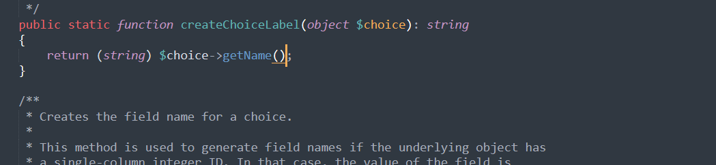

2. Форматирование созданных классов форм

Для того чтобы можно было реализовать форму update для автора и книги мне пришлось немного подкорректировать класс форм и добавить вывод id в форме (CrudFormType- класс формы для книги)
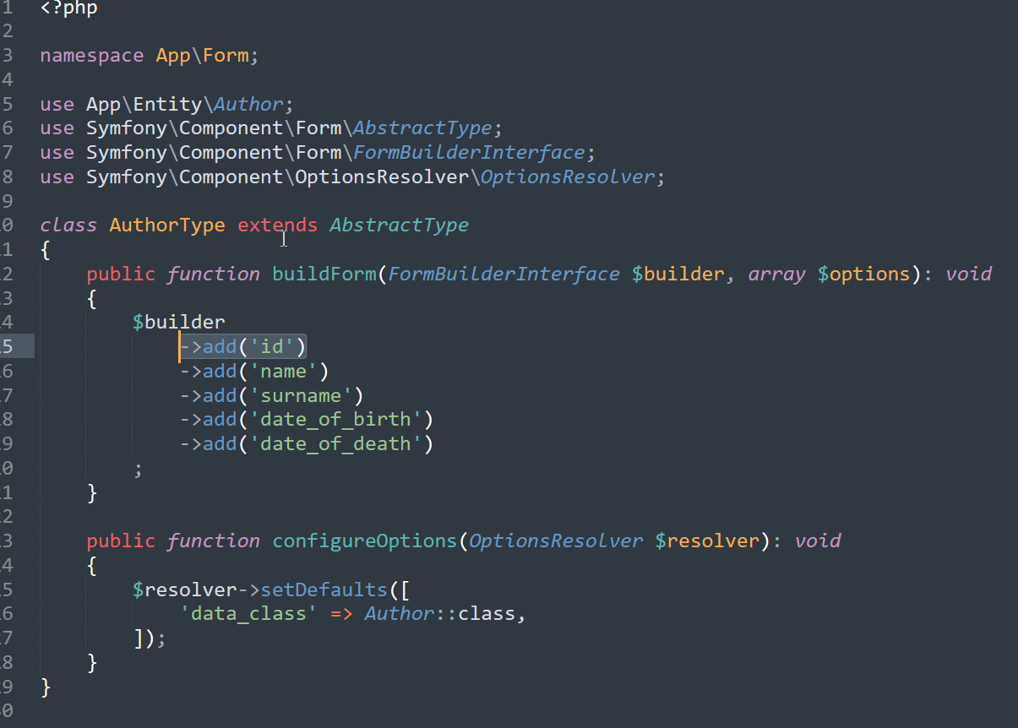
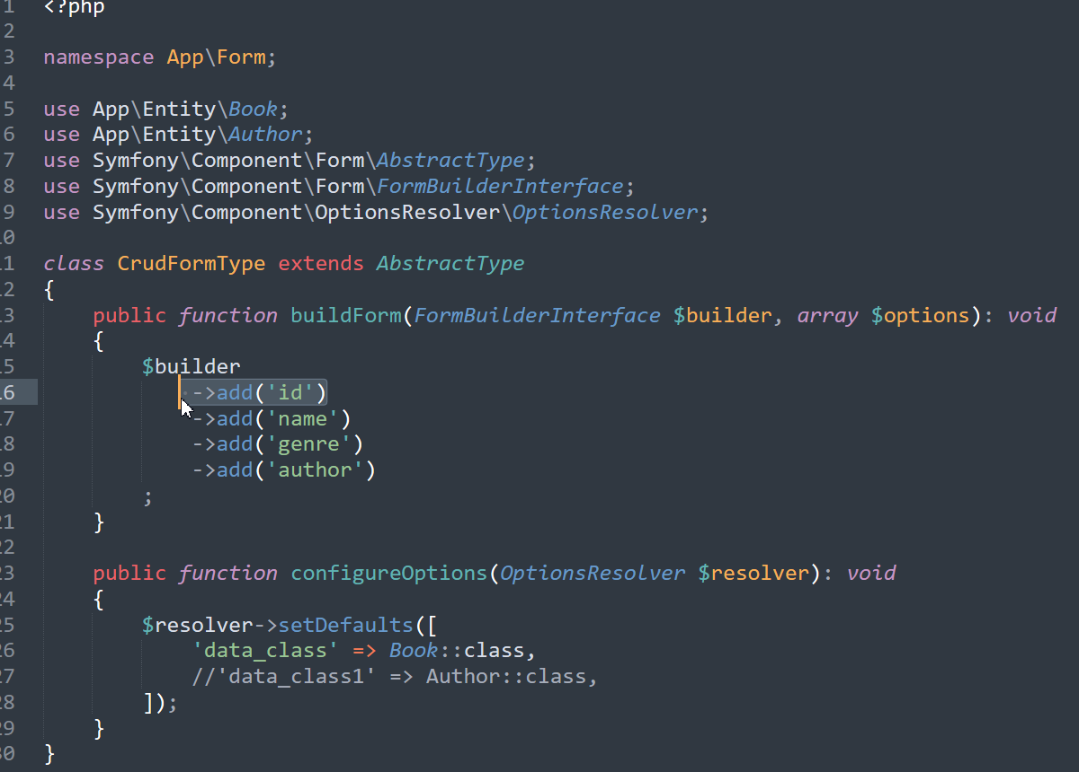
3.Создание файлов twig для операций создание, обновление
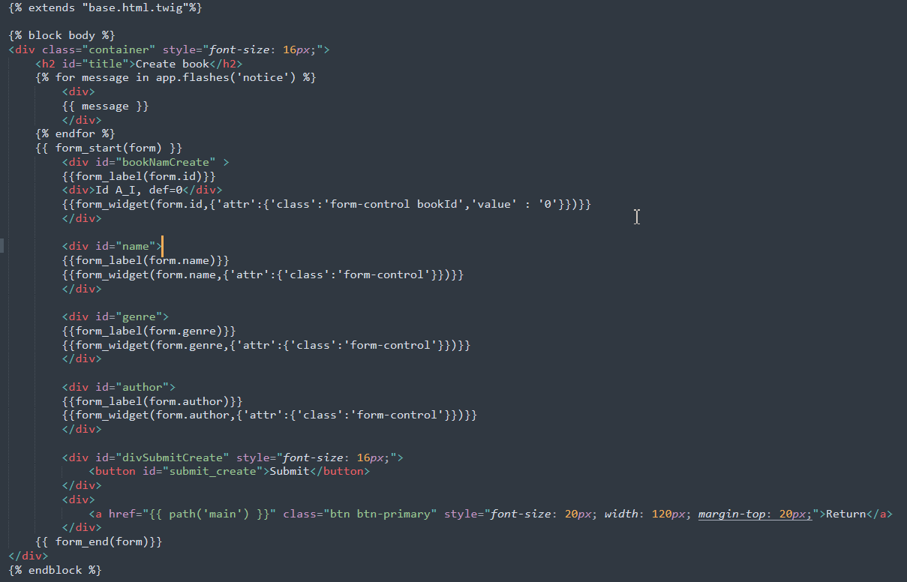
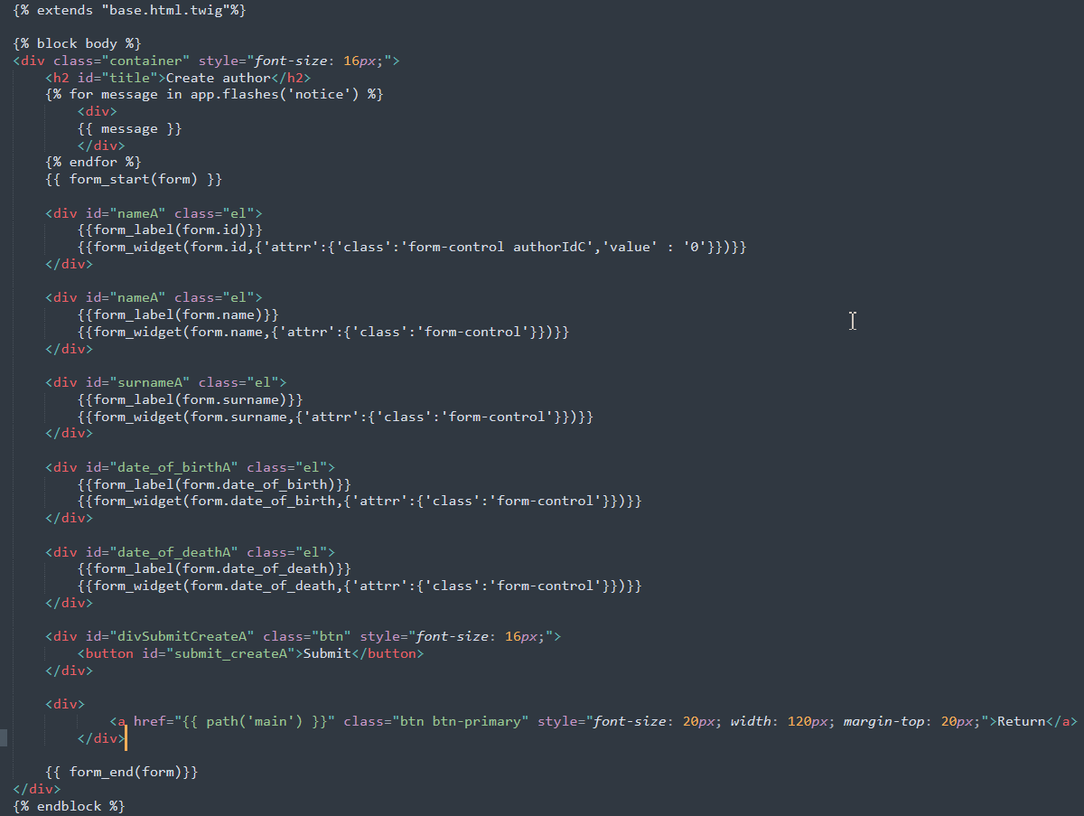

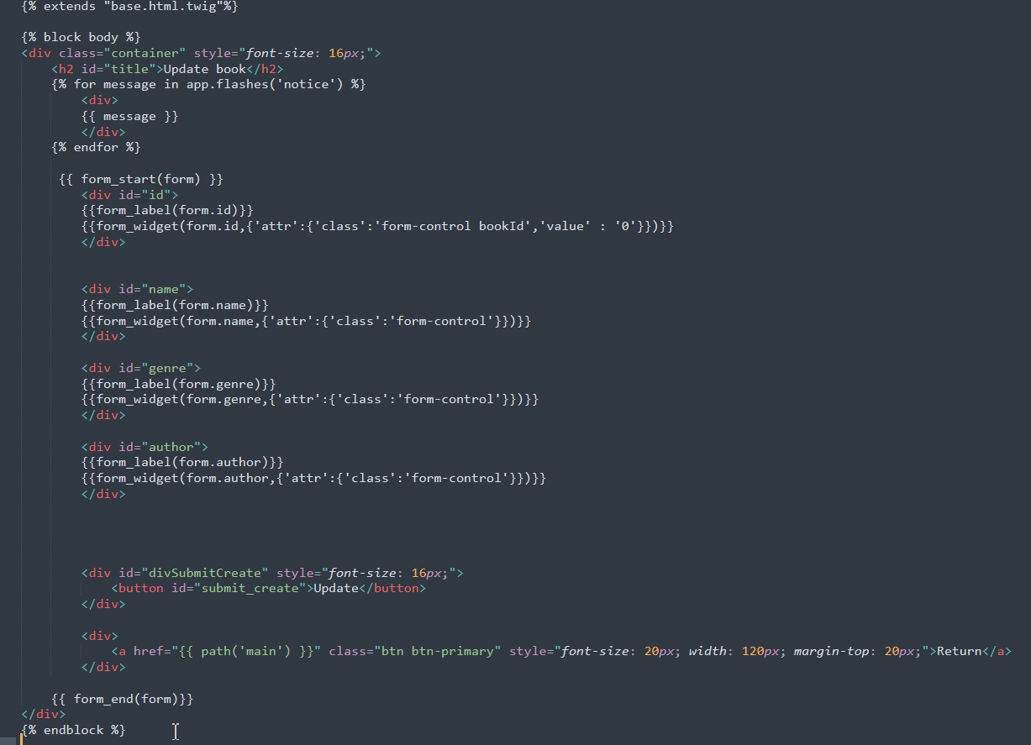
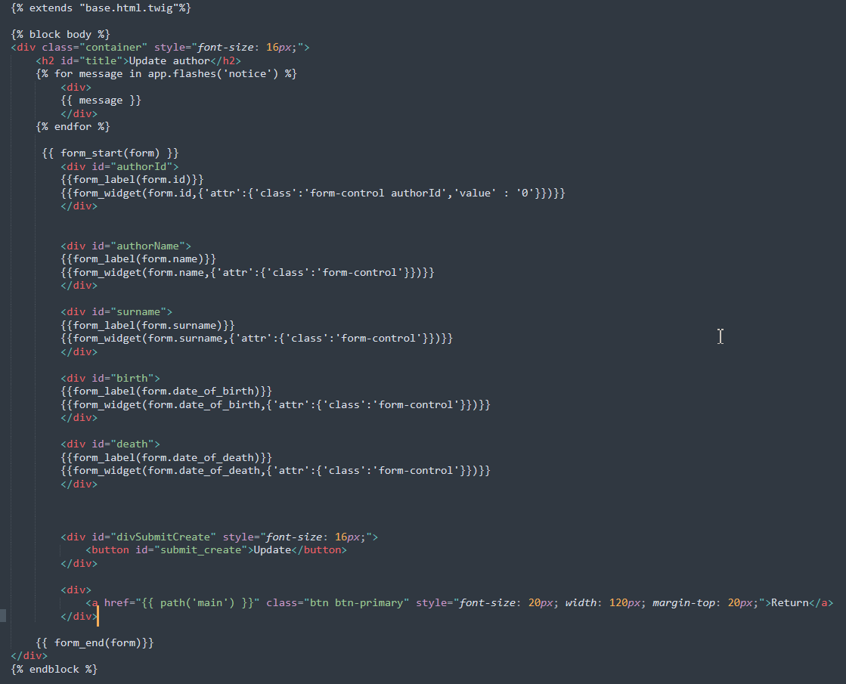

4. Создание контроллера
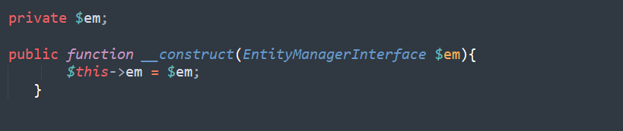
Переменная entitymanagerinterface

Функция для вставки в базу данных книги
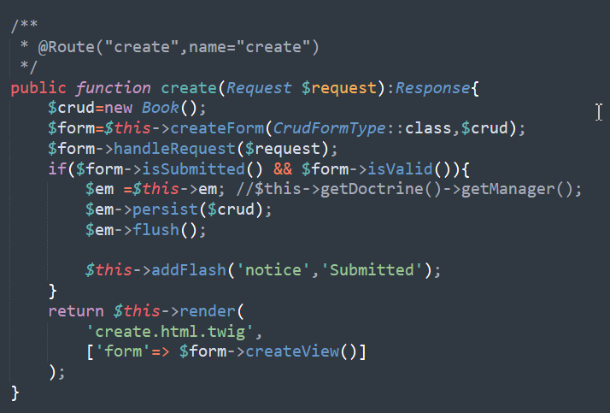

Функция для вставки в базу данных автора
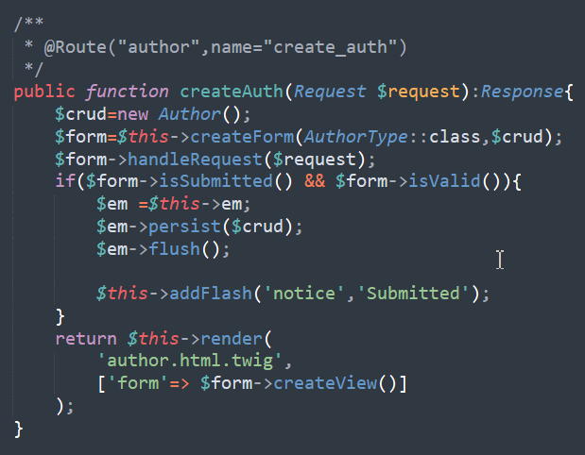

Функция для обновления данных о книге
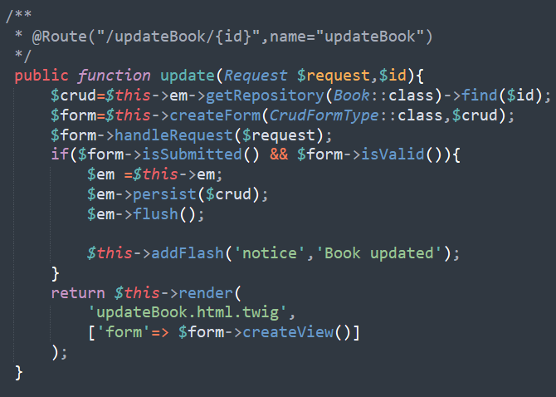
Функция для обновления автора
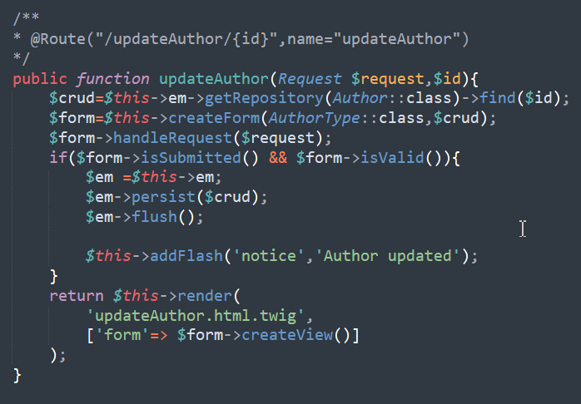

Функция индекс для главной страницы
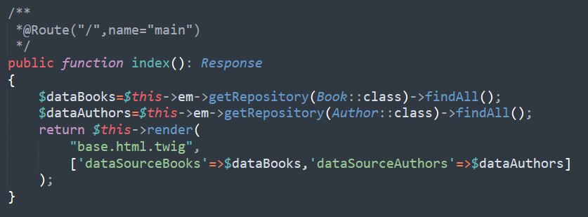
Функция удаления книги
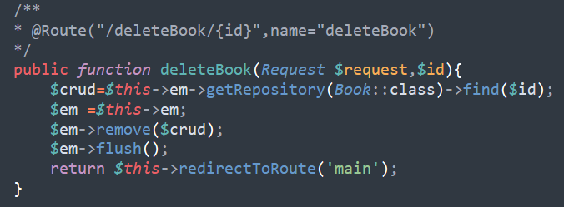

Функция удаления автора
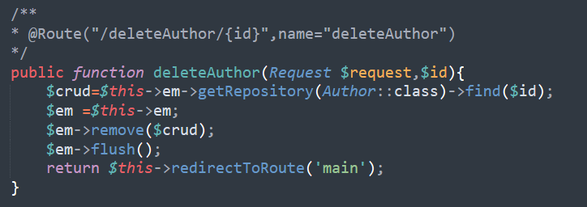

Результат:

Главная страница:
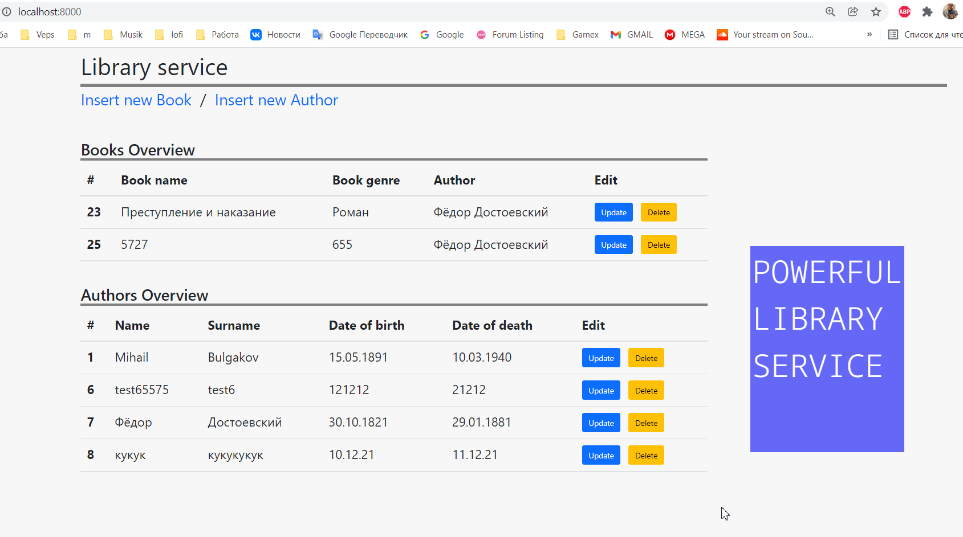

Меню создания книги
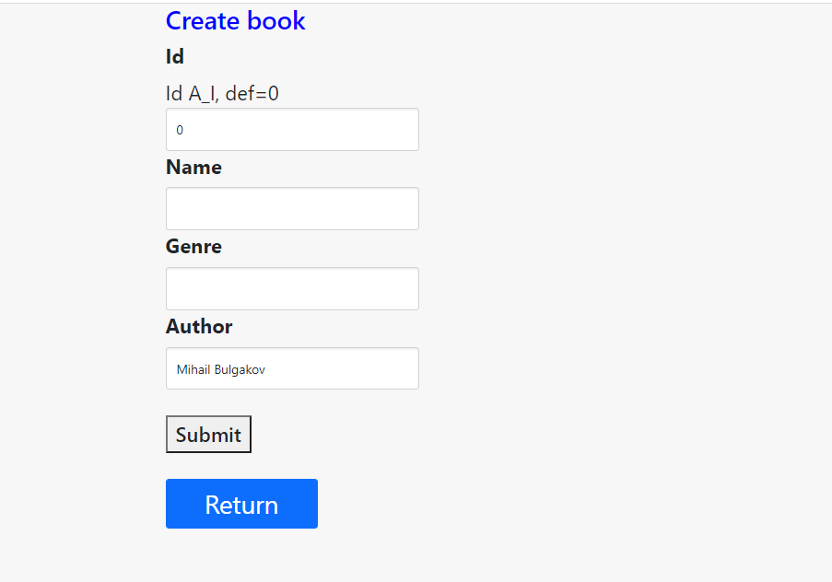
Меню создания автора
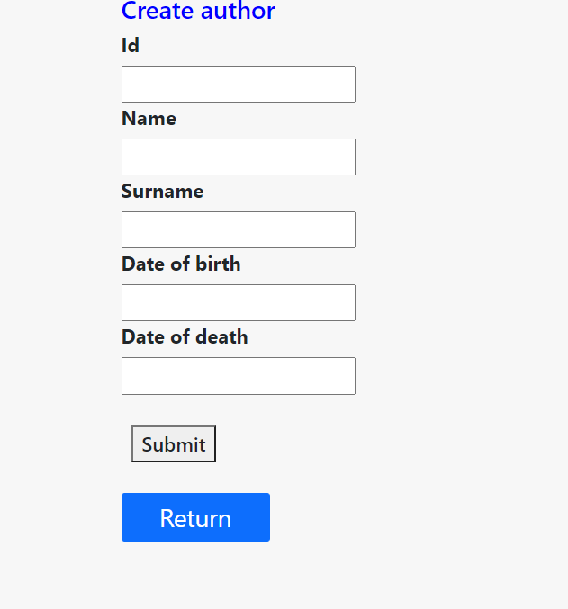
Меню обновления сущностей
