**Analysis of the results of the restructuring of the Diplomation Database.**

**Introduction**

Some images describe the structure that the database will take after refactoring the Diplomation project. Giving it a better consistency and eliminating unnecessary tables.

**Promotion relationship with Jury:**

The following image shows a part, of how the relationship of the Promotion table with Jury is currently structured.

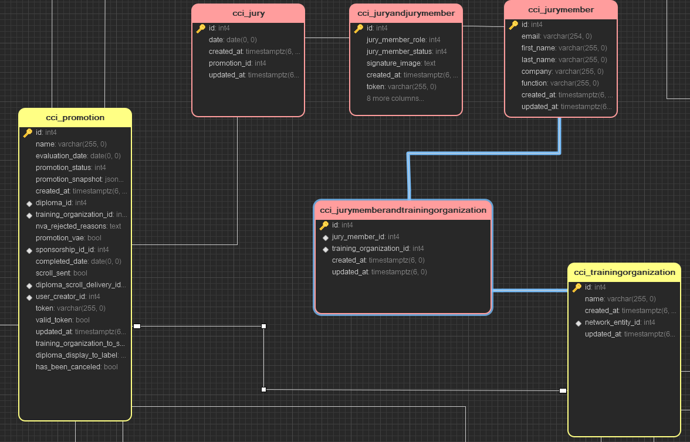

Solutions:

At some point I thought of the following image as a possible solution. But, later I realized that it did not make sense that the Jury table had that data.

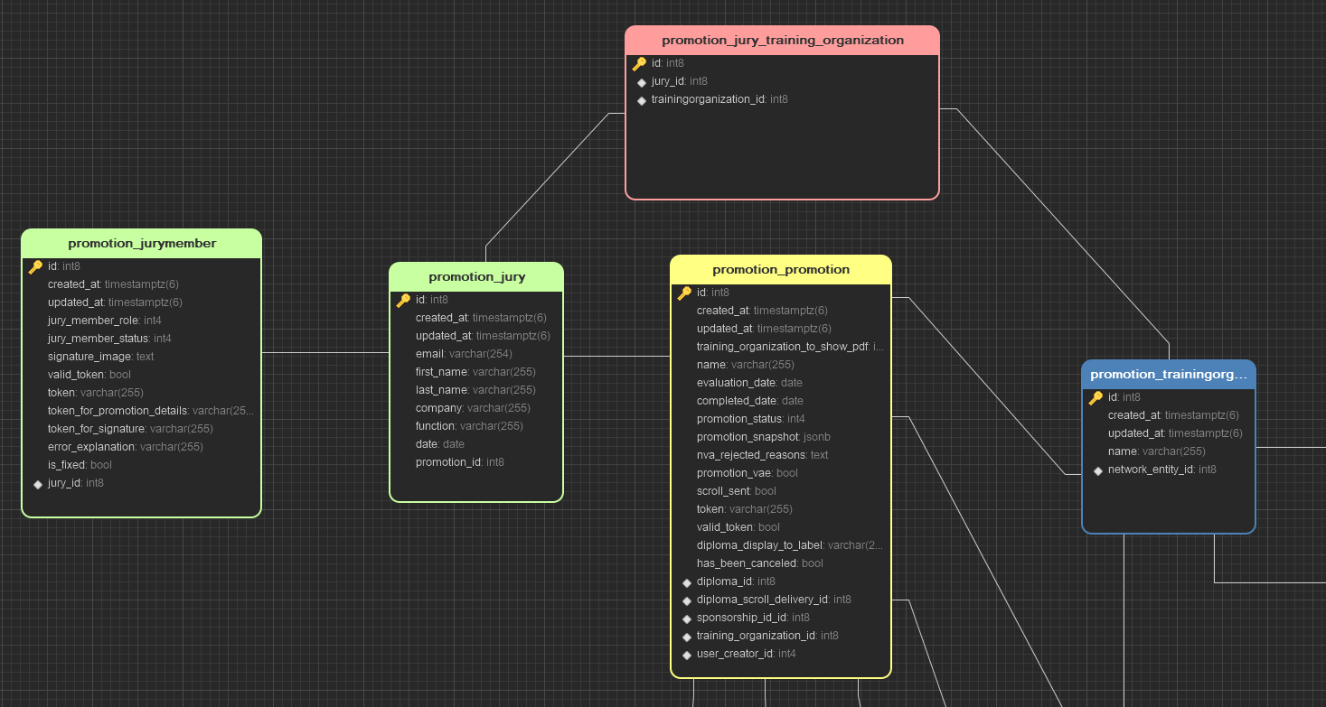

As a second idea and the most successful is to put all the data in JuryMember and that Jury remains with the attributes it currently has. The explanation is that the jury members should have as properties or attributes, their personal data, signature, the role they are going to play in the jury, etc.

Something like this would be the structure or relationship:

