TWITTER’S DOGS

By Alexander Ofuonyeadi.

In this blog post, we take a look at twitter’s dogs by reviewing data obtained from the WeRateDogs twitter page ([@dog_rates](https://twitter.com/dog_rates)). Investigations were made to know the dog with the tweets and likes.

WeRateDogs is a Twitter account that rates people's dogs with a humorous comment about the dog. These ratings almost always have a denominator of 10. The numerators, though? Almost always greater than 10. 11/10, 12/10, 13/10, etc. Why? Because "they're good dogs Brent." WeRateDogs has over 4 million followers and has received international media coverage.

Data used in this project was provided by Udacity and as it was a requirement for my data analyst nanodegree program. The archive contains basic tweet data (tweet ID, timestamp, text, etc.) for all 5000+ of their tweets as they stood on August 1, 2017. The data was cleaned to remove redundant data.

Question 1: What dog breed is the most loved?

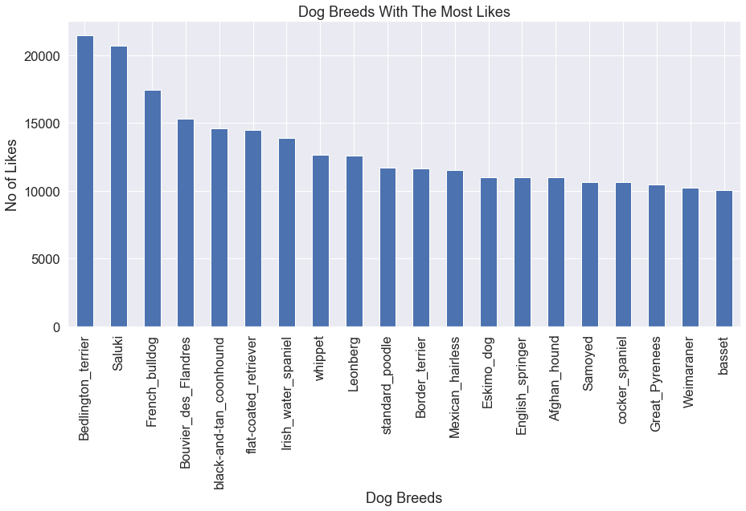

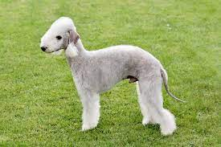 Bedlington terrier is the most liked dog breed based on the mean count of likes.

2. What dog breeds have the highest mean score?

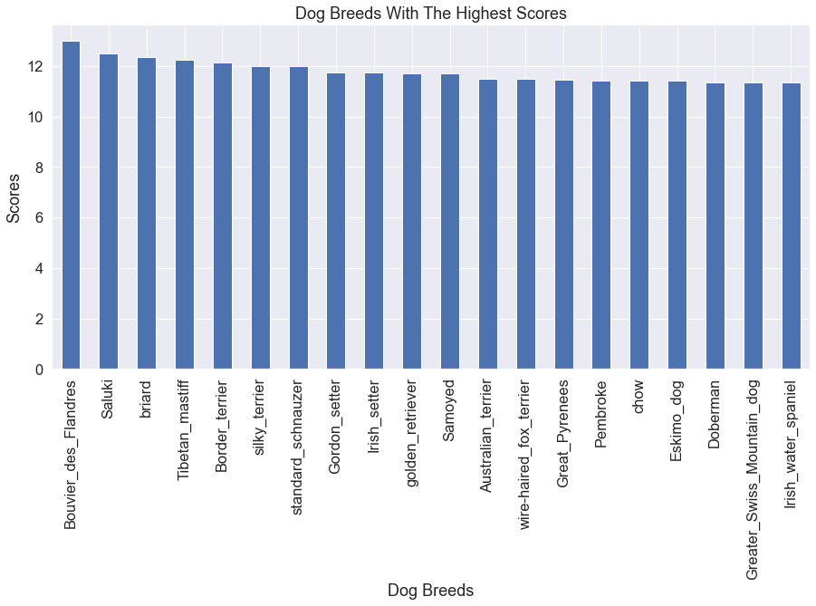

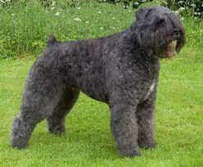 The Bouvier des Flandres also has the highest mean score of 13.

3. What source produces the most tweets?

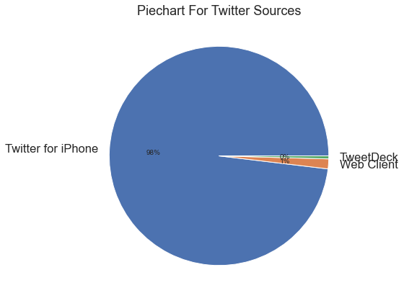

We see that most of the tweets come from iphones (98%).

4. What dogs are generally the most loved?

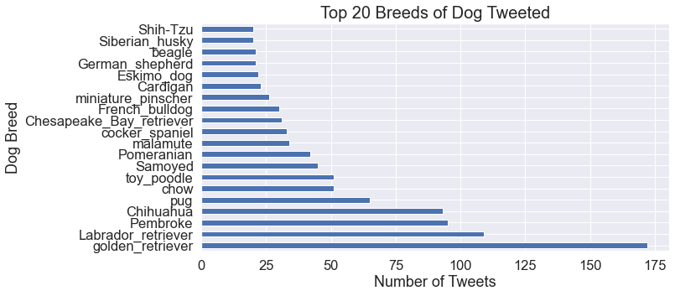

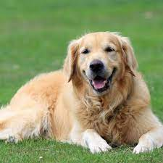 The golden retriever is generally the most loved and represented dog.

### In conclusion, Bedlington terrier is the most liked dog breed based on the mean count of likes, the clumber also has the highest mean score. The Standard poodle is the dog breed that is most retweeted with most of the tweets coming from iphones. The Komondor is easily recognized by AI, with the Irish Wolfhound being the least recognized. The most common dog names are Oliver, Penny, Coper, Tucker and Charlie. We observe positive relationships between the number of tweets and likes. We also observe a positive relationship between dog score and likes. Puppers are generally the most liked at the dog age stage.