|  |  |
| --- | --- |
| D:\PAL\Logo_4_21_15\Logo_4_21_15\Primary Logo\png_files\EPAM_LOGO_Full_Color_RGB.png | CDP Automated Testing Mentoring Program  2018-Q2 |

Module 4: unit testing frameworks for javascript

## home task

As a basis for this home task, use this git repository: <https://github.com/stranger2626/js-unit-testing>

1. Based on example in index.js and index.spec.js create the Calculator class with defined methods:

* add - this method should summarize all parameters, that you send to method and return result
* multiply -  this method should multiply all parameters, that you send to method and return result

1. Create unit tests that check how your implemented methods work;
2. Create coverage reporter and make a screenshot, that later you will attach to your home tasks;
3. Enable lint task, and check the lint errors – also, make a screenshot of the console and attach it.

**Task can be reviewed and run using repository:**

**https://github.com/Alexey-Kachemirov/js\_atm4.git**

1. **Based on index.js file I create class ‘calculator’ with the following methods:**

* sum – this method summarizes all parameters, that you send to method and return result
* mult – this method multiplies all parameters, that you send to method and return result
* 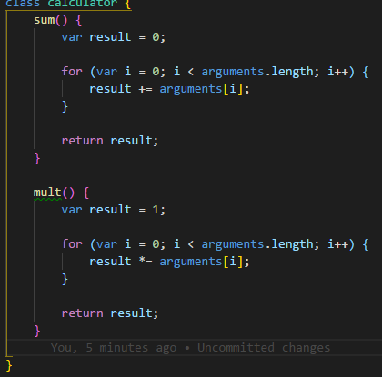

1. **Based on index.spec.js file I created unit tests that check my methods for class ‘calculator’.**

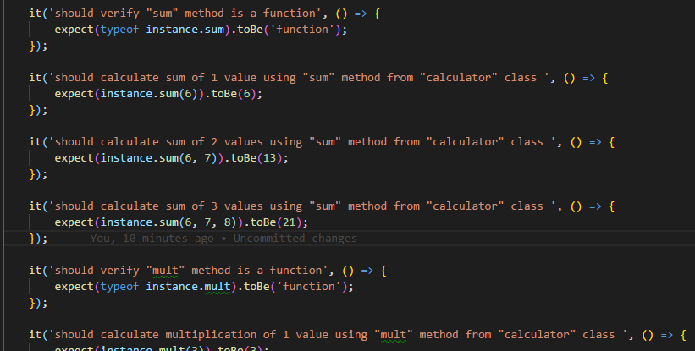

1. **I run coverage reporter using command with in-build script from package.json file:**

* ***npm run test-coverage***

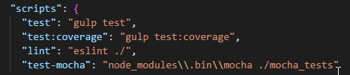

My added tests passed correctly. It is visible on the screen below:

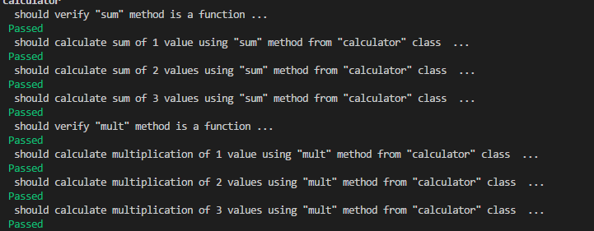

Also reports are recorded in ***\js-unit-testing\report\coverage\***folder of the project. Results are represented in several views. I will just demonstrate results for my tests after running the following command:

* ***npm run test***

**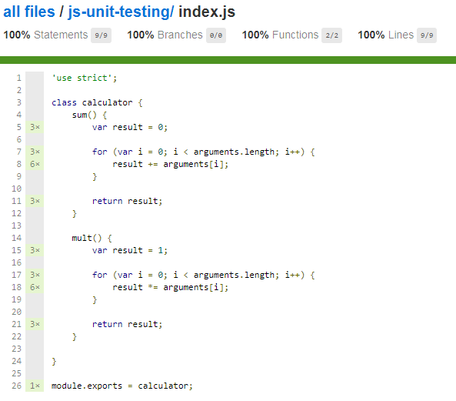**

1. **I enabled lint task using command:**

* ***npm run lint***

To demonstrate how eslint work I made several errors in files and run lint task. I got the following errors:

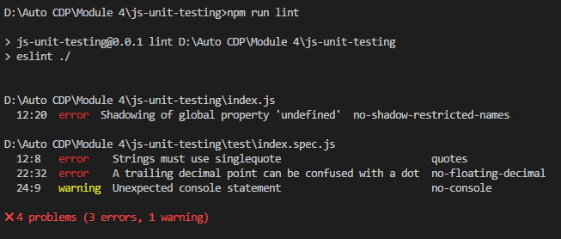

Next screens demonstrate error in **.js** file and corresponding line with restriction in **.eslintrc** file.

**Error 1 – no-shadow-restricted-names**

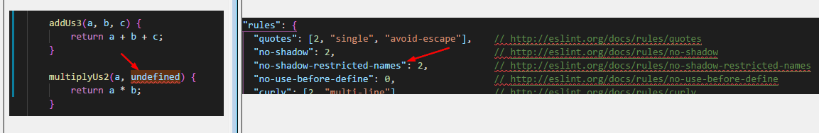

**Error 2 - quotes**

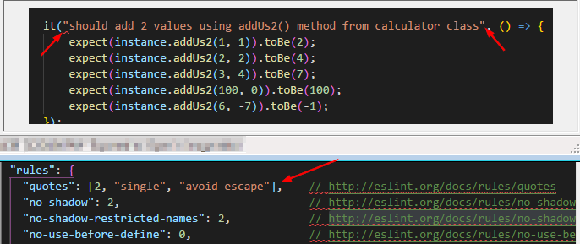

**Error 3 – no-floating-decimal**

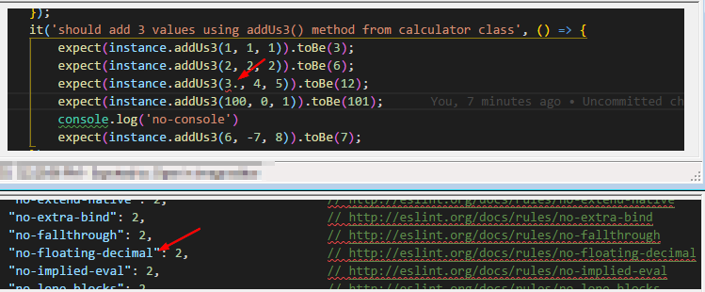

**Warning 4 – no console**

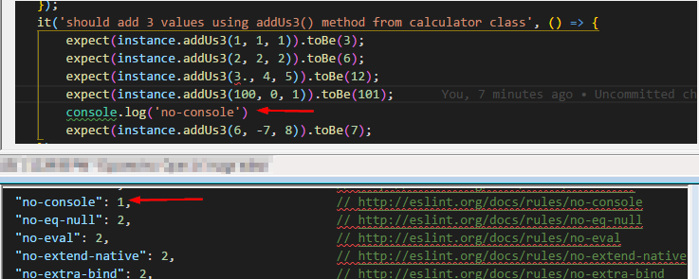

The last problem is marked as warning as eslint has parameters set to ‘1’ that corresponds to warning not error:

