How to create Python-plugins for SynWrite

Intro

SynWrite supports Python-based API, but it's not analog of Sublime Text API. API defines class Editor to access editor-control-related functions. Module sw defines Editor and several objects of Editor class: ed (active editor), and 3 others (for inactive editors).

You can find entire functions list at SW Wiki.

First, plugin needs to import sw:
from sw import *

Example: to get current caret position, call:
x, y = ed.get_caret_xy()

Example: to get line at this caret position, call:
s = ed.get_text_line(y)

Example 1 – Dialog “Go to line number”

Let's make simple dialog which allows to enter new line number for caret. Not useful, but example can be extended to more complex one – e.g. dialog “Go to paragraph number” or “Go to function name”.
In SynWrite, call menu command “Tools – New plugin”, and enter new Python module name my_goto. You'll see created editor tab with Python code, with class Command and method run. Extend code to the following:

from sw import *
offset = 2 # offset N lines from top editor edge

class Command:
def run(self):
n = ed.get_caret_xy()[1] + 1
s = dlg_input('Go to line number:', str(n), '', '')
if s is not None:
if not s.isdigit():
msg_status('Not a number: ' + s)
else:
n = int(s) - 1
ed.set_top(n - offset)
ed.set_caret_xy(0, n)
msg_status('Gone to line ' + s)

All is simple:
- we read caret position (ed.get_caret_xy)
- we show dialog to enter new number (dlg_input)
- we place caret to new position (ed.set_caret_xy) with indent from top editor edge (ed.set_top does the scrolling)
- we show some message in status-bar (msg_status)

To call new plugin, just call ready menu item “Tools - Plugins - SynMyGoto”.
You can also rename this menu item, and set its hotkey. (To do this, call menu command “Options - Advanced - Edit file SynPlugins.ini”.)

Example 2 — Plugin with two commands

Example of plugin with 2 menu items, and with memory. First menu item will copy selection text into plugin memory, and second one will paste text from memory.

Also create the plugin stub (command “Tools - New plugin”, enter module name my_copy), and then create two new methods instead of run: run_copy + run_paste (note that method names can be any – you can adjust file SynPlugins.ini for them later). Enter code:

from sw import *

class Command:
data = ''
def run_copy(self):
nstart, nlen = ed.get_sel()
if nlen > 0:
self.data = ed.get_text_sel()
msg_status('String copied to buffer')
else:
msg_status('No selection made')

def run_paste(self):
if self.data:
ed.insert(self.data)
msg_status('String pasted from buffer')
else:
msg_status('No data in buffer')

Let's adjust ini file for this code: call menu command “Options - Advanced - Edit file SynPlugins.ini”, find section [Commands] and write in it:

[Commands]
MyCopy\Copy to buffer=py:syn_my_copy;run_copy;;Alt+C;
MyCopy\Paste from buffer=py:syn_my_copy;run_paste;;Alt+V;

Here we've specified:
- method names run_nnnnn;
- hotkeys Alt+C, Alt+V;
- menu items names inside common submenu “MyCopy”;
- between “;;” is empty string — it's place for lexers list (example: “C,Pascal” means that menu item will be enabled for lexers C and Pascal).

We left strings "syn_my_copy", which mean subfolder name inside folder “Py”.

Restart SW, you should see new submenu “Tools - Plugins - MyCopy”, plugin should work.

Plugins debugging

To test Python API, call Py-console — hotkey is Ctrl+tilde – and first enter (in the bottom field):
from sw import *

Then enter any API commands, e.g.:
print(ed.get_caret_xy())

If Py-plugin comes into exception, you'll hear error beep, and Py error will be printed into console. For ex, if you mistype function name “ed.set_topline”, you'll see in console:

Traceback (most recent call last):
...
File "...\__init__.py", line 15, in run
ed.set_topline(n - offset)
NameError: global name 'ed.set_topline' is not defined

Plugins with dialogs

In theory, it's possible to create your own dialogs in plugins. You should use standard Py library Tkinter for this.
But you must warn users, that they must install this add-on into SynWrite first.
I.e., they must open add-on archive in SynWrite and confirm its installation.

Auto-completion

If you write plugins inside SynWrite ifself, you can use auto-completion plugin: SynJedi. After you install it, specify search path for plugin – path to subfolder Py of SynWrite folder.

An example (completion list):

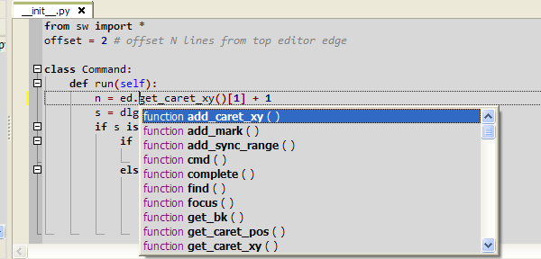

Conclusion

That's all.

