How to create Python-plugins for SynWrite

Intro

SynWrite supports Python-based API. API defines class Editor to access editor-control-related functions. Module “sw” defines Editor and several objects of Editor class: ed (active editor), and 3 others (for inactive editors).

You can find entire functions list at SW Wiki.

First, plugin needs to import sw:
from sw import *

Example: to get current caret position, call:
x, y = ed.get_caret_xy()

Example: to get line at this caret position, call:
s = ed.get_text_line(y)

Example 1 – Dialog “Go to line number”

Let's make simple dialog which allows to enter new line number for caret. Not useful, but example can be extended to more complex one – e.g. dialog “Go to paragraph number” or “Go to function name”.
In SynWrite, call menu command “Plugins – Make Plugin”, and enter new Python module name my_goto.

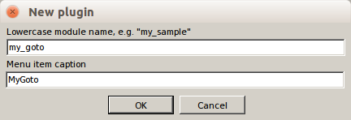
You'll see created editor tab with Python code, with class Command and method run. Extend code to the following:

from sw import *
offset = 3 #offset from top editor edge

class Command:
def run(self):
x, y = ed.get_caret_xy()
s = dlg_input('Go to line number:', str(y+1), '', '')
if s is None:
return
if not s.isdigit():
msg_status('Not a number: '+s)
return
n = int(s)-1
if not ((n>=0) and (n<ed.get_line_count())):
msg_status('Incorrect line number: '+s)
return

ed.set_top(n - offset)
ed.set_caret_xy(0, n)
msg_status('Gone to line ' + s)

All is simple:
- we read caret position (ed.get_caret_xy)
- we show dialog to enter new number (dlg_input)
- we place caret to new position (ed.set_caret_xy) with indent from top editor edge (ed.set_top does the scrolling)
- we show some message in status-bar (msg_status)

To call new plugin, use menu item “Plugins — MyGoto” (after restart of SW).
You can also rename this menu item, and set its hotkey. (To do this, call menu command “Options - Advanced - Edit file SynPlugins.ini”.)

Example 2 — Plugin with two commands

Example of plugin with 2 menu items, and with memory. First menu item will copy selection text into plugin memory, and second one will paste text from memory.

Create new plugin (command “Plugins — Make Plugin”, enter module name my_copy), and then create two new methods instead of run: run_copy + run_paste (note that method names can be any – you can adjust file SynPlugins.ini for them later). Enter code:

from sw import *

class Command:
data = ''
def run_copy(self):
nstart, nlen = ed.get_sel()
if nlen > 0:
self.data = ed.get_text_sel()
msg_status('String copied to buffer')
else:
msg_status('No selection made')

def run_paste(self):
if self.data:
ed.insert(self.data)
msg_status('String pasted from buffer')
else:
msg_status('No data in buffer')

Let's adjust ini file for this code: call menu command “Options - Advanced - Edit file SynPlugins.ini”, find section [Commands] and write in it:

[Commands]
MyCopy\Copy to buffer=py:syn_my_copy;run_copy;;Alt+C;
MyCopy\Paste from buffer=py:syn_my_copy;run_paste;;Alt+V;

Here we've specified:
- method names run_nnnnn;
- hotkeys Alt+C, Alt+V;
- menu items names inside common submenu “MyCopy”;
- between “;;” is empty string — it's place for lexers list (example: “C,Pascal” means that menu item will be enabled for lexers C and Pascal).

We left strings "syn_my_copy", which mean subfolder name inside folder “Py”.

Restart SW, you should see new submenu “Plugins - MyCopy”, plugin should work.

Plugins debugging

To test Python API, call Py-console — hotkey is Ctrl+tilde – and first enter (in the bottom field):
from sw import *

Then enter any API commands, e.g.:
print(ed.get_caret_xy())

If Py-plugin comes into exception, you'll hear error beep, and Py error will be printed into console. For ex, if you mistype function name “ed.set_topline”, you'll see in console:

Traceback (most recent call last):
...
File "...\__init__.py", line 15, in run
ed.set_topline(n - offset)
NameError: global name 'ed.set_topline' is not defined

Plugins with dialogs

It is possible to show dialogs, use functions dlg_nnnnn from module sw. The superb function dlg_custom is needed, if you need your own customized dialog with complex set of items. E.g. the Update dialog in AddonManager is made using dlg_custom.

Auto-completion

If you write plugins inside SynWrite ifself, you can use auto-completion plugin "Python Intel”. An example (completion list):

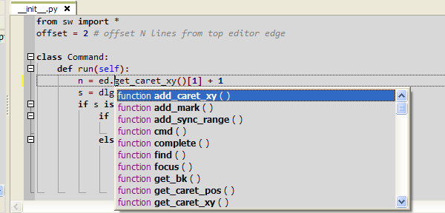

How to make distro

To make distro from your plugin, in zip format, make these files:
- install.inf (see examples in ready plugins: it must specify menu items, folder inside “Py”, etc)
- __init__.py (main file with python code) + additional .py files, if needed
- folder “readme” with files:
- readme.txt: write here all useful info, how to use plugin, how to configure it, copyright
- history.txt: write here log of changes, last change on top
- license files, if needed
Zip all into “plugin.Author_Name.Plugin_Long_Name.zip”. Install.inf/__init__.py must be in root of zip. Then open this zip file in SW, like text file. SW must show prompt to install. After installing, SW must show report and plugin menu item must appear in Plugins menu.

