# Implement the application

*using ASP.NET Web.APi + AngularJs + SQLite*

First page: **list of all users**

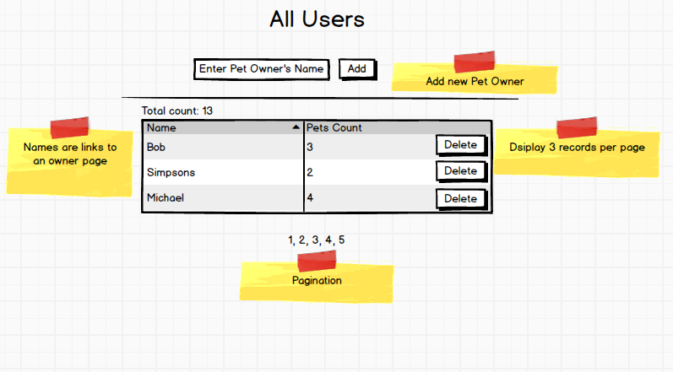

Second page: **single user page** with the list of pets

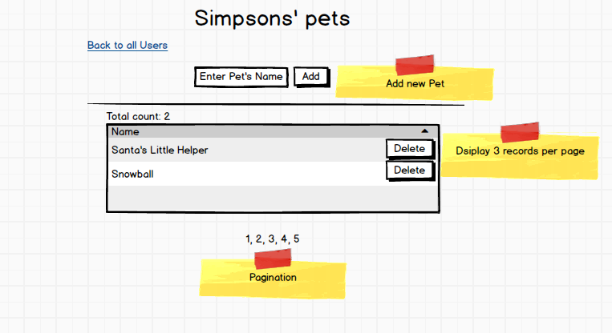

***Important****: Make sure project will run succefully on another developer PC*

Please **upload completed test task** to:

<https://www.dropbox.com/request/ZPvC9jQnPlkboIKdEZrD>*

*- We will be notified once you complete upload, and please make sure First&Last Name are correct