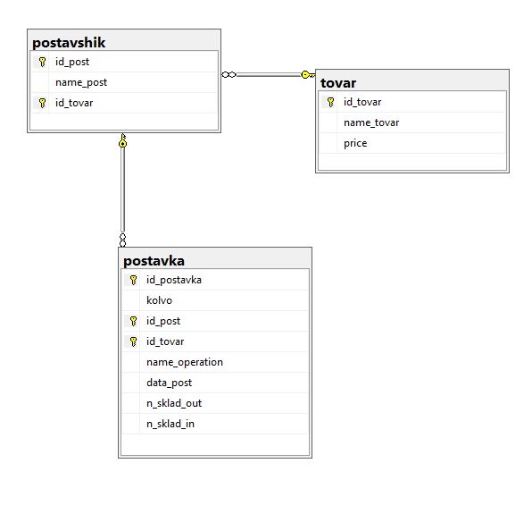

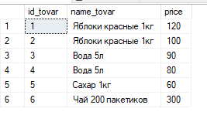

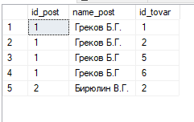

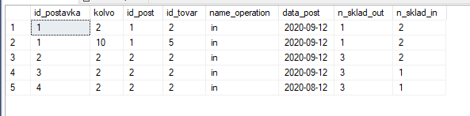

--select name_tovar from tovar

--where price <= all(select price from tovar)

--select id_postavka,data_post,n_sklad_in from postavka

--where id_postavka in (

--select id_postavka from postavka

--group by id_postavka

--having sum(kolvo) >=all(select sum(kolvo) from postavka group by id_postavka)

--)

--select n_sklad_in from postavka

--group by n_sklad_in

--having sum(kolvo) >= all(select sum(kolvo) from postavka group by n_sklad_in)

--select sum(kolvo), data_post from postavka

--group by data_post

--having sum(kolvo) <= all(select sum(kolvo) from postavka group by data_post)

--select id_post,max(price) max_price from postavshik,tovar

--where postavshik.id_tovar = tovar.id_tovar

--group by id_post

--having max(price) >= all(

--select max(price) from postavshik,tovar

--where postavshik.id_tovar = tovar.id_tovar

--group by id_post)

--select data_post,n_sklad_in from postavka

--group by data_post,n_sklad_in

--having sum(kolvo) >= all(select sum(kolvo) from postavka group by data_post,n_sklad_in)

--select data_post,sum(kolvo*price) profit from postavka, postavshik,tovar

--where postavshik.id_tovar = tovar.id_tovar and postavshik.id_tovar = postavka.id_tovar

--and postavshik.id_post= postavka.id_post

--group by data_post

--having sum(kolvo*price) >= all(

--select sum(kolvo*price) from postavka, postavshik,tovar

--where postavshik.id_tovar = tovar.id_tovar and postavshik.id_tovar = postavka.id_tovar

--and postavshik.id_post= postavka.id_post

--group by data_post

--)

--select n_sklad_in,sum(kolvo) from postavka

--group by n_sklad_in

--having sum(kolvo) <= all(

--select sum(kolvo) from postavka

--group by n_sklad_in

--)

--select id_post,count(id_tovar) from postavshik

--group by id_post

--having count(id_tovar) <= all(

--select count(id_tovar) from postavshik

--group by id_post

--)

--select id_tovar,count(n_sklad_in) from postavka

--group by id_tovar

--having count(n_sklad_in) =(

--select count(n_sklad_in) from postavka

--group by id_tovar

--having count(n_sklad_in) >= all(

--select count(n_sklad_in) from postavka

--group by id_tovar)

--)

--insert into tovar(name_tovar,price) values

--('Яблоки красные 1кг', 120),

--('Яблоки красные 1кг', 100),

--('Вода 5л', 90),

--('Вода 5л', 80),

--('Сахар 1кг', 60),

--('Чай 200 пакетиков', 300)

--insert into postavshik values

--(1,'Греков Б.Г.',1),

--(1,'Греков Б.Г.',2),

--(2,'Бирюлин В.Г.',2),

--(1,'Греков Б.Г',5),

--(1,'Греков Б.Г',6)

--insert into postavka values

--(1,10,1,5,'in','20200912',1,2),

--(1,2,1,2,'in','20200912',1,2),

--(2,2,2,2,'in','20200912',3,2)

--(3,2,2,2,'in','20200912',3,1),

--(4,2,2,2,'in','20200812',3,1)