Sample Manual
Scope 3
Measurements 3

Scope
This manual describes how to install the sample unit and check that it works.

Measurements
The leakage current must be below 5 μA and the insulation above 10 MΩ.

Limits
Test | Min | Max
Voltage, V | 11.5 | 12.5
Current, mA | - | 350

Picture
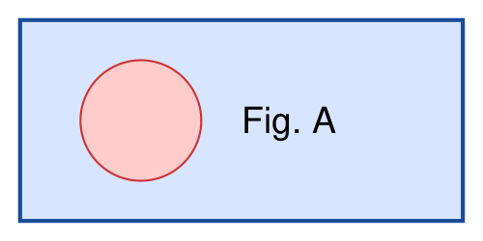
Figure 1 - Bracket position
- Check the bracket.
- Tighten the screws.

