Hybrid Recommendation Engine - Documentation

Note
For execution instructions, dataset setup, and detailed usage examples, please refer to the README.md file.

Overview
This document provides a high-level explanation of the models implemented in the Hybrid Recommendation Engine. For detailed setup instructions, execution steps, and usage examples, please refer to the README.md file included in the project.

Models Description

2.1. Collaborative Filtering
Collaborative Filtering is a user-based recommendation approach that leverages user interaction patterns. It identifies similar users using cosine similarity and predicts preferences based on neighbors' ratings. This model works well when sufficient user interaction data is available.

2.2. Content-Based Filtering
Content-Based Filtering recommends items based on their attributes (e.g., genres). It builds a user profile using items the user has previously liked and finds similar items using similarity measures. This approach is particularly useful for handling cold-start scenarios for new users.

Hybrid Model
The Hybrid Model combines Collaborative Filtering and Content-Based Filtering to leverage the strengths of both approaches. It computes a weighted score from both models using a parameter alpha (α), which controls the contribution of each component. This improves recommendation robustness and helps mitigate sparsity and cold-start issues.

System Design
  - High Level system /Architecture diagram
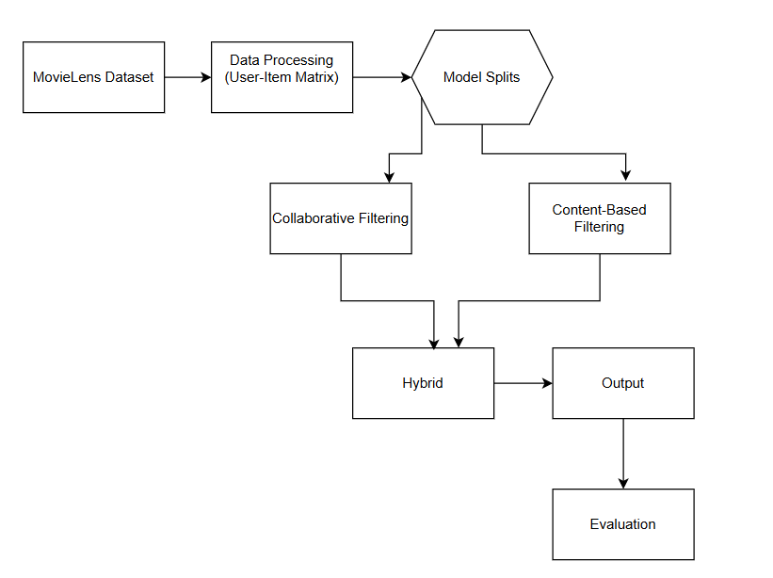

This diagram presents the high-level architecture of the Hybrid Recommendation System.
The process starts with the MovieLens dataset, which is transformed into a user-item matrix during data processing. The system then splits into two modeling approaches: Collaborative Filtering and Content-Based Filtering.
Both models generate recommendation signals that are combined in the Hybrid module. The hybrid model produces final recommendations, which are then evaluated using standard performance metrics.

  - Data Flow Diagram
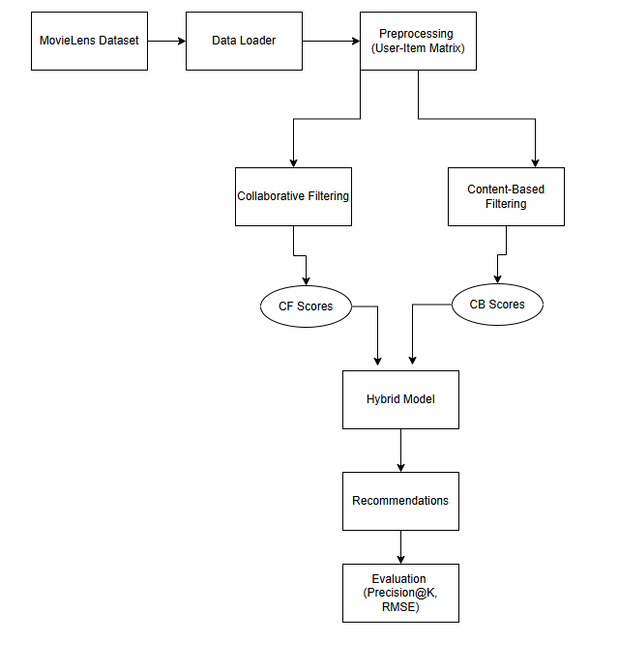
This diagram shows the data flow of the Hybrid Recommendation System, from input data to final evaluation.
The process begins with the MovieLens dataset, which is loaded and transformed into a user-item matrix during preprocessing. This matrix is used as input for two parallel models: Collaborative Filtering (CF) and Content-Based Filtering (CB).

Collaborative Filtering generates CF Scores by analyzing similarities between users and predicting item preferences based on neighbor behavior. Content-Based Filtering produces CB Scores by comparing item features (e.g., genres) with a user’s profile.

These scores are combined in the Hybrid Model using a weighted approach to produce final recommendation scores. The system then outputs Top-N recommendations, which are evaluated using Precision@K and RMSE.

