**בקר הארדואינו – Arduino UNO WIFI Rev.2**

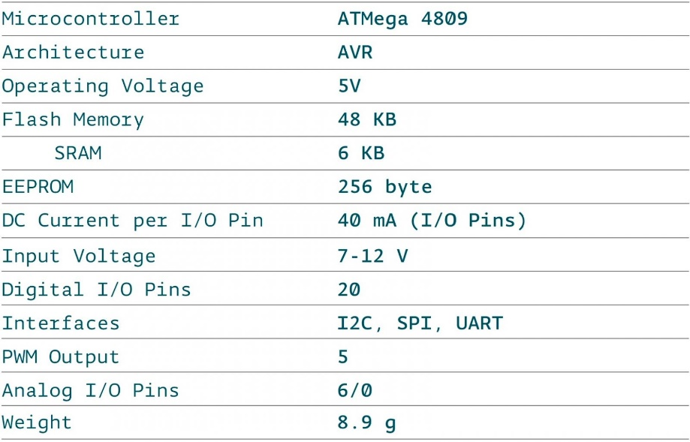

**רגש טמפרטורה עמיד למים DS18B20 -**

Size of Stainless steel sheath : **6 x 30**mm  
Power supply range : 3.0V to 5.5V  
Operating temperature range : -55°C to +125°C (-67°F to +257°F)  
Storage temperature range : -55°C to +125°C (-67°F to +257°F)  
Accuracy over the range of -10°C to +85°C : ±0.5°C.

**רגש גובה מים (ללא מגע)<– XKC-Y25-V**

Input voltage: (InVCC) DC 5 ~ 24 V

Current consumption: 5mA

Output voltage(High level): InVCC

Output voltage (Low level): 0V

Output current: 1 ~ 50mA

Response time: 500mS

Working temperature: 0 ~ 100 degree

Induction thickness (Sensitivity) Range: 0 ~ 20mm

Communication: RS485

Humidity: 5% to 100%

Material: ABS

Waterproof: IP67