## C:\Users\winuser\Desktop\20170227_220906.jpgSinushkin Alexey

Date of Birth: 09/18/1985

Kyakhta (Russian Federation)

+7 924 7515684

sinushkin\_alexey@mail.ru

## Professional Skills

* 6+ in Net Framework C#, ASP.NET, Windows forms, Visual Basic
* OOP, UML, MVC
* Programming languages: C#, VB, Java (Android, JavaME, JavaSE), C, ASM (Atmel, ARM), VBA Excel
* HTML5, JavaScript, Prototype, CSS, LESS, Angular JS
* XML XSLT XSD
* Entity Framework, Linq, Castle project (NHibernate)
* Oracle 9i, MS SQL, PostgreSQL, MySQL, T-SQL, PL/SQL
* SVN, GIT, TFS, Jira
* Autodesk Autocad, Autodesk Inventor, Altium Designer, Adobe Photoshop

## WorkExperience

**2017-present** time at hushhush

Responsibilities: Development, C#, Web, JavaScript, Java SE

**2009 –2017** at [www.snowbars.ru](http://www.snowbars.ru).

Responsibilities: Communicating with clients and consulting.

**2007 – 2009** at www.cft.ru.

Responsibilities: supporting and development web projects (3 items in a same time) which were created before

**2005 – 2007** at [www.LLAFF.com](http://www.LLAFF.com).

Responsibilities: website creation and support on the second role, work with databases.

2002–2007 IT Programming Courses. I started to learn php, html, JavaScript. Administrating of Windows 2003 Server. DNS configuration. Database support.

## Education

2002–2007IRKUTSK NATIONAL RESEARCH TECHNICAL UNIVERSITY

## Foreign Languages Skills

English – Intermediate.

## My experience samples

(Press on image – it is hyperlink)

## Battery charger (3years of a stable work)

ARM Cortex-M0 C Code. Using RTOS “CoOS”.

Description: Microcontroller controls non-inverting input of TL494 to up voltage from 11.5 to 14.2 Volts.

It shows charging voltage, current and DAC value on display 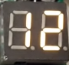.

Also were made PCB routing, gerber file generation and order to manufacture

[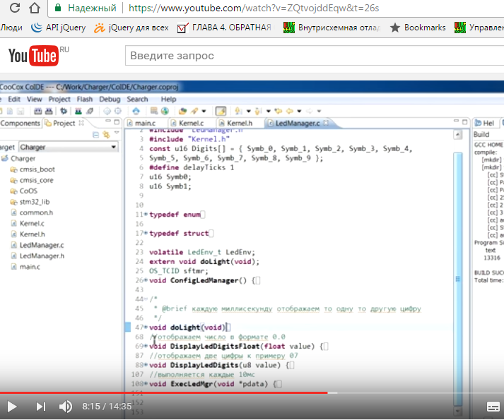](https://www.youtube.com/watch?v=ZQtvojddEqw&t=26s)

## FreeGPStracker (with open protocol, for motorcycle alarm system)

C#, ASP.NET, JavaScript/Prototype, PostgreSQL

It is old project on ASP.NET. You can track your phone or other device using android 3.0+ application

First page reworked using Bootstrap 4.3 at <http://www.track-it.ru/index.html>

Old version (table markup) still present http://www.track-it.ru/index-free.aspx

[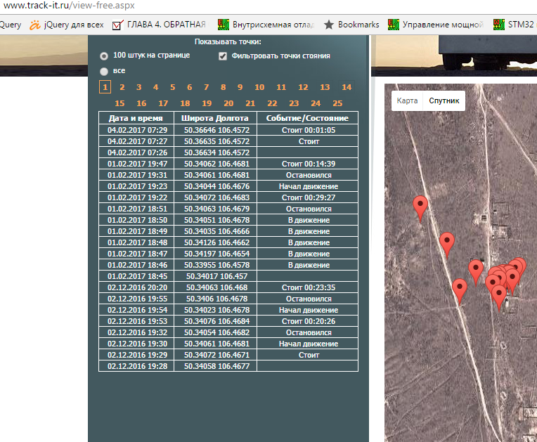](http://www.track-it.ru)

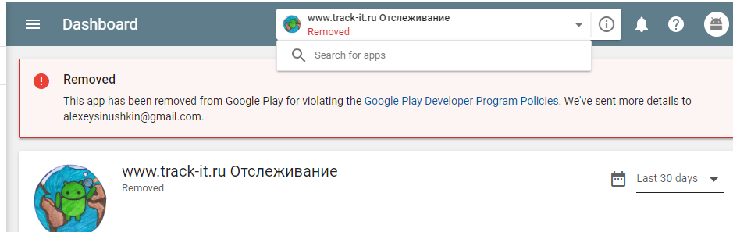

Ok It was removed by Google a month ago (March 2019). I didn’t know why yet.

## Microcontroller firmware update (over Play Market)

STM32 Cortex-M3, C code, Assembler code. (Bootloader)

Solving general problem: self-updating of firmware for small devices. In this project there is link between Android phone and microcontroller. *Phone* – *Bluetooth SPP – Microcontroller.*

Phone – is user user control

Microcontroller – low hardware level

In this video I describe how to configure linker, change vectors (interruption) map. Also I provide for free own exchange protocol

This project is a small part of other (see below) project **Configuration coal boiler over Android application**

[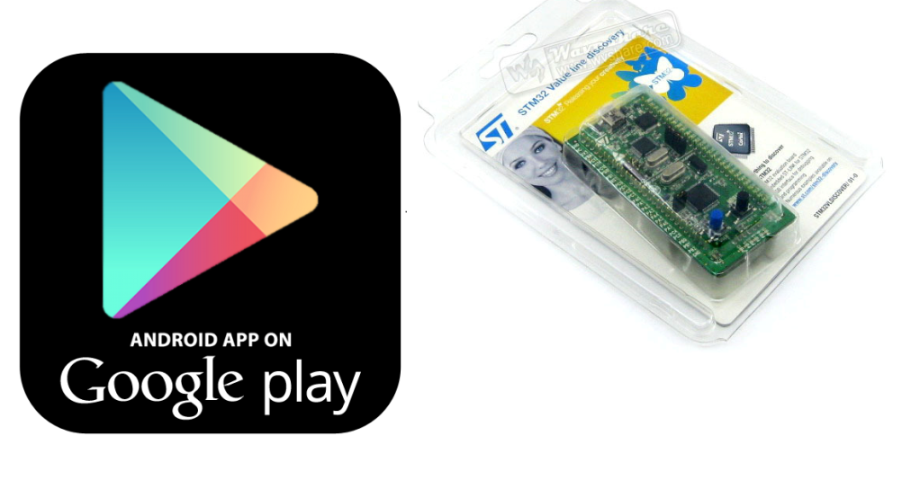](https://youtu.be/O-37mAwccyE)

## Hardware project. Configuration coal boiler over Android application

Build reliable network protocol for communicating over Bluetooth with hardware

We configure hardware and disconnect. After disconnecting hardware can work as we want.

For example we can calibrate weight sensor and other parameters. You can click on image and view video on Youtube.

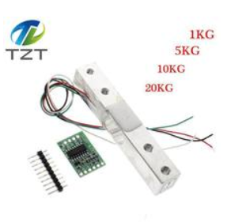

[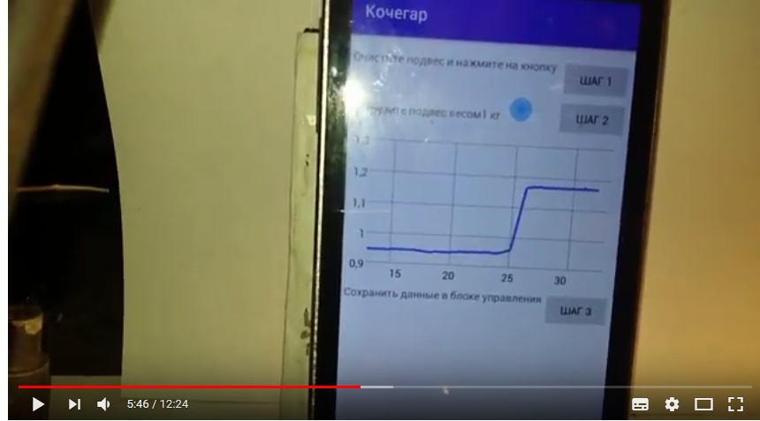](https://www.youtube.com/watch?v=is7TGNw-U5w)

## Rework Java SE (Swing) project for Haas Automation

.

I did not request right to place here some screenshot or video.