There is the chrome extension built with JavaScript. (You can check it from the video)

You have to integrate the sentiment analysis python model into the extension.

* Determine the most popular keywords/phrases for these products' *negative* reviews (we're omitting positive reviews for now)
  + **IMPORTANT**: we need to determine the sentiment of the review in order to see if it actually a positive or negative review. We can't just go off the star rating of the review. This will need to be done with a machine-learning library like [nltk](https://realpython.com/python-nltk-sentiment-analysis/)
* Display the keyword results to the plug-in user while they're looking at the products on Amazon.com (the keywords should appear as an embedded window)

Here are some visual mockups to help illustrate:

* 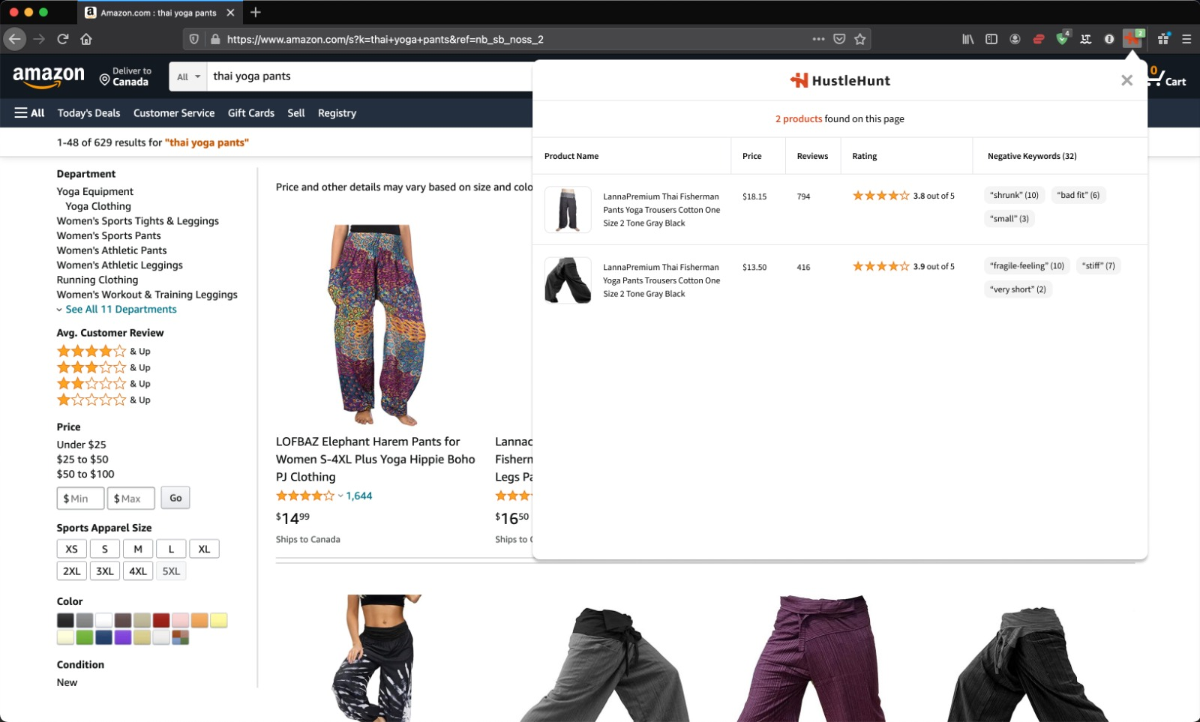
* The above image shows what the user sees when they navigate to Amazon.com and click on the web extension. If there are any products on the product feed page matching the criteria of being between 3.0 and 4.2 stars and having 5+ reviews, they will appear in the web extension's main menu here.
* 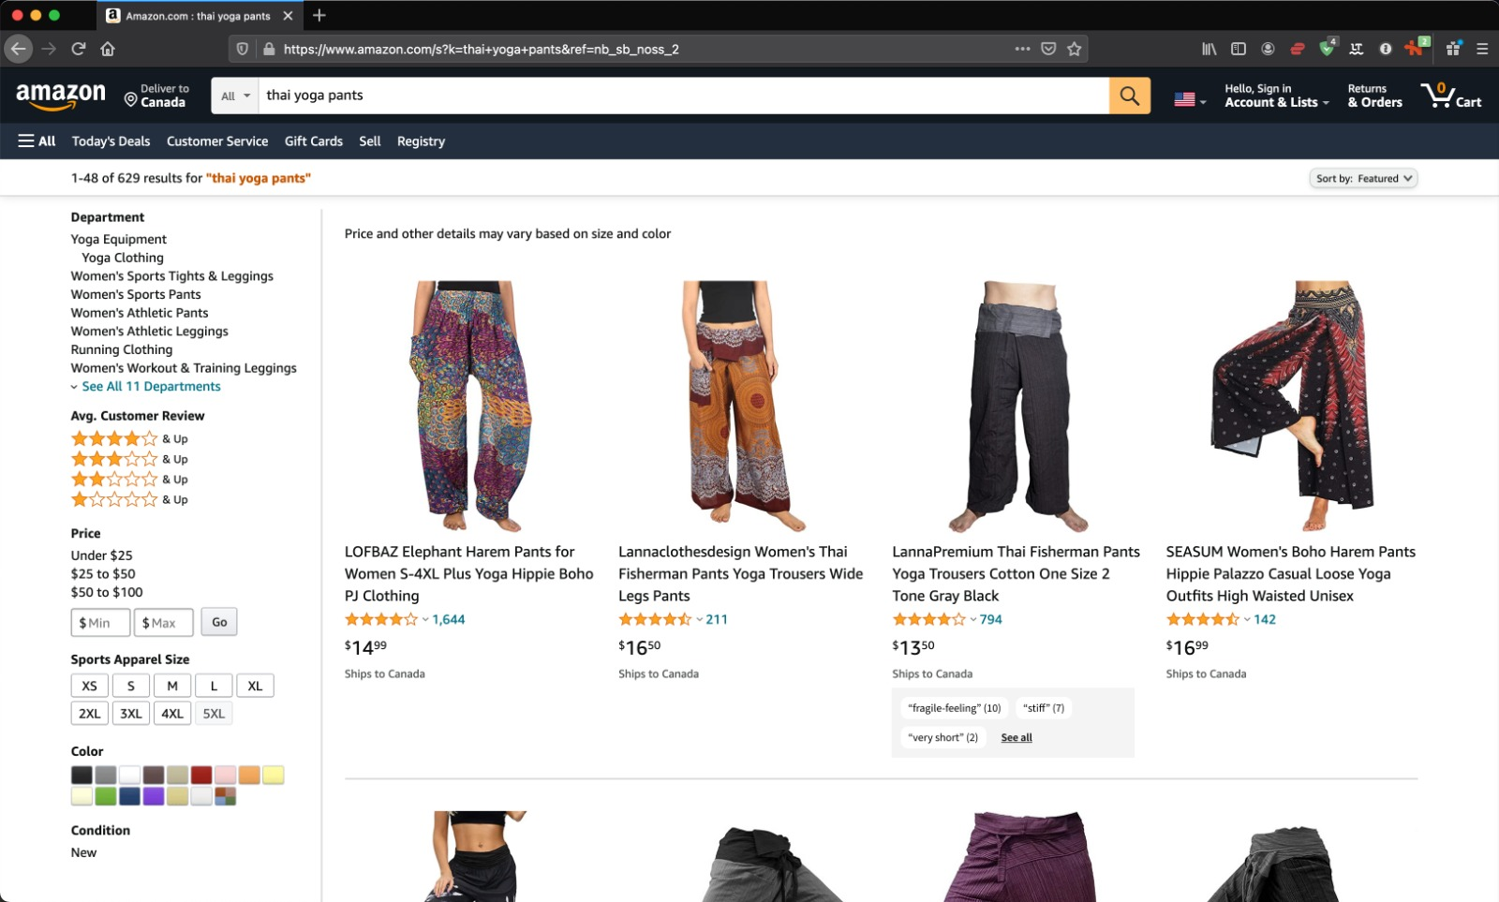

The above image shows what the web extension will display on the Amazon.com product feed pages for those products matching the criteria. The negative keywords should be shown in a small embedded window beneath the matching products. The number of keywords will be limited to 3-5 because of the smaller real estate on this page.

And then for the web extension view on the product detail pages, the only difference will be that the number of keywords will be expanded to 5-10 since there is more space on these pages.

Basically, if the matching product's reviews doesn't yield any keywords with a count greater than one, then we should go by the recency of the negative review to determine the keywords shown on the product feed and product detail pages.

So for example, if the product's negative reviews only give you the words "abc"(1), "abcd"(1), "abcde"(1), "abcdef"(1), "abcdefg"(1), "abcdefgh" (1)... All with just a count of 1, then only return 3-5 keywords for the product feed and 5-10 keywords for the product detail page based on the recency (most recent) of the review that the keyword is in and not the popularity (count) of the keyword. Does that make sense?

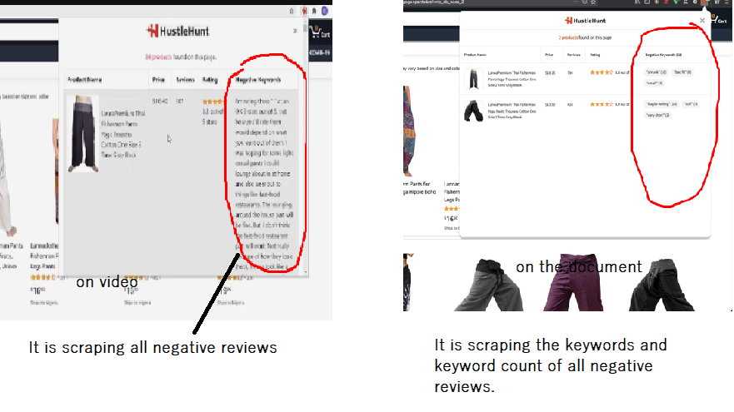

I need it till 1th April.

Hello, it is Alexey.

My freelancer account was closed a few hours ago. But I am not sure why it is closed so I am asking to the support team.

So now, we can work on skype. Please contact me on skype.

live:.cid.14e4b80d135eca1e

It is my skype address