Университет ИТМО МФ КТиУ, Ф ПИиКТ

**Лабораторная работа №4**

**Дисциплина «Вычислительная математика»**

**Аппроксимация функции методом наименьших квадратов**

**Выполнил** Галлямов Камиль Рустемович

**Преподаватель:**

Машина Екатерина Алексеевна

г. Санкт-Петербург 2024 г.

# Вычислительная реализация задачи

Линейная аппроксимация:

y = $\frac{4x}{x^{4}+3}$

n = 11

x in [0;2]

h = 0.2

|  |  |  |  |  |  |  |  |  |  |  |  |
| --- | --- | --- | --- | --- | --- | --- | --- | --- | --- | --- | --- |
| i | 1 | 2 | 3 | 4 | 5 | 6 | 7 | 8 | 9 | 10 | 11 |
| xi | -2 | -1.8 | -1.6 | -1.4 | -1.2 | -1 | -0.8 | -0.6 | -0.4 | -0.2 | 0 |
| yi | -0.42 | -0.53 | -0.67 | -0.82 | -0.95 | -1.0 | -0.94 | -0.77 | -0.53 | -0.27 | 0.0 |

φ(x) = a + b * x

Вычисляем суммы: sx = -11, sxx = 15.4, sy = -6.9, sxy = 7.63

$$\left\{\begin{aligned}n*a+sx*b=sy \\ sx*a+sxx*b=sxy\end{aligned}\right. \left\{\begin{aligned}11*a-11*b=-6.9 \\ -11*a+15.4*b=7.63\end{aligned}\right. \left\{\begin{aligned}11*a-11*b=-6.9 \\ 4.4*b=0.73\end{aligned}\right.$$

$$\left\{\begin{aligned}b=0.73/ 4.4 =0.17 \\ 11a=-6.9+11*0.17=-5.03 \end{aligned}\right.\left\{\begin{aligned}b =0.17 \\ a=-0.46 \end{aligned}\right.$$

φ(x) = -0.46 + 0.17 * x

|  |  |  |  |  |  |  |  |  |  |  |  |
| --- | --- | --- | --- | --- | --- | --- | --- | --- | --- | --- | --- |
| i | 1 | 2 | 3 | 4 | 5 | 6 | 7 | 8 | 9 | 10 | 11 |
| xi | -2 | -1.8 | -1.6 | -1.4 | -1.2 | -1 | -0.8 | -0.6 | -0.4 | -0.2 | 0 |
| yi | -0.42 | -0.53 | -0.67 | -0.82 | -0.95 | -1.0 | -0.94 | -0.77 | -0.53 | -0.27 | 0.0 |
| φ (xi) | -0.8 | -0.77 | -0.73 | -0.7 | -0.66 | -0.63 | -0.6 | -0.56 | -0.53 | -0.49 | -0.46 |
| (φ (xi)- yi)^2 | 0.144 | 0.056 | 0.004 | 0.015 | 0.082 | 0.137 | 0.118 | 0.043 | 0 | 0.05 | 0.212 |

σ = $\sqrt{\frac{\sum{{(φ (xi)- yi)}^{2}}}{n}}$ = **0.278**

Квадратичная аппроксимация:

y = $\frac{4x}{x^{4}+3}$

n = 11

x in [0;2]

h = 0.2

|  |  |  |  |  |  |  |  |  |  |  |  |
| --- | --- | --- | --- | --- | --- | --- | --- | --- | --- | --- | --- |
| i | 1 | 2 | 3 | 4 | 5 | 6 | 7 | 8 | 9 | 10 | 11 |
| xi | -2 | -1.8 | -1.6 | -1.4 | -1.2 | -1 | -0.8 | -0.6 | -0.4 | -0.2 | 0 |
| yi | -0.42 | -0.53 | -0.67 | -0.82 | -0.95 | -1.0 | -0.94 | -0.77 | -0.53 | -0.27 | 0.0 |

φ(x) = a + b * x + c * x^2

Вычисляем суммы: sx = -11, sxx = 15.4, sxxx = -24.2, sxxxx = 40.53,

sy = -6.9, sxy = 7.63, sxxy = -10.06

$$\left\{\begin{aligned}n*a+sx*b+sxx*c=sy \\ sx*a+sxx*b+sxxx*c=sxy \\ sxx*a+sxxx*b+sxxxx*c=sxxy\end{aligned}\right. \left\{\begin{aligned}11*a-11*b+15.4*c=-6.9 \\ -11*a+15.4*b-24.2*c=7.63 \\ 15.4*a-24.2*b+40.53*c=-10.06\end{aligned}\right.$$

$$\left\{\begin{aligned}11*a=-6.9+11*b-15.4*c \\ 4.4*b-8.8*c=0.73 \\ 15.4*a-24.2*b+40.53*c=-10.06\end{aligned}\right.\left\{\begin{aligned}a=-0.63+b-1.4*c \\ 4.4*b-8.8*c=0.73 \\ 15.4*a-24.2*b+40.53*c=-10.06\end{aligned}\right.$$

$$\left\{\begin{aligned}a=-0.63+b-1.4*c \\ 4.4*b-8.8*c=0.73 \\ -9.7+15.4*b-21.56*c-24.2*b+40.53*c=-10.06\end{aligned}\right.$$

$$\left\{\begin{aligned}a=-0.63+b-1.4*c \\ 4.4*b-8.8*c=0.73 \\ -8.8*b+18.97*c=-0.36\end{aligned}\right.\left\{\begin{aligned}a=-0.63+b-1.4*c \\ 4.4*b=0.73+8.8*c \\ -1.46-17.6*c+18.97*c=-0.36\end{aligned}\right.$$

$$\left\{\begin{aligned}a=-0.63+b-1.4*c \\ 4.4*b=0.73+8.8*c \\ 1.37*c=1.1\end{aligned}\right.\left\{\begin{aligned}a=-0.63+b-1.4*c \\ 4.4*b=7.77 \\ c=0.8\end{aligned}\right. \left\{\begin{aligned}a=-0.63+1.77-1.4*0.8 \\ b=1.77 \\ c=0.8\end{aligned}\right.$$

$$\left\{\begin{aligned}a=0.02 \\ b=1.77 \\ c=0.8\end{aligned}\right.$$

φ(x) = 0.02 + 1.77 * x + 0.8 * x ^ 2

|  |  |  |  |  |  |  |  |  |  |  |  |
| --- | --- | --- | --- | --- | --- | --- | --- | --- | --- | --- | --- |
| i | 1 | 2 | 3 | 4 | 5 | 6 | 7 | 8 | 9 | 10 | 11 |
| xi | -2 | -1.8 | -1.6 | -1.4 | -1.2 | -1 | -0.8 | -0.6 | -0.4 | -0.2 | 0 |
| yi | -0.42 | -0.53 | -0.67 | -0.82 | -0.95 | -1.0 | -0.94 | -0.77 | -0.53 | -0.27 | 0.0 |
| φ (xi) | -0.32 | -0.57 | -0.76 | -0.89 | -0.95 | -0.95 | -0.88 | -0.75 | -0.56 | -0.3 | 0.02 |
| (φ (xi)- yi)^2 | 0.01 | 0.002 | 0.009 | 0.005 | 0.0 | 0.003 | 0.003 | 0.0 | 0.001 | 0.001 | 0.0 |

σ = $\sqrt{\frac{\sum{{(φ (xi)- yi)}^{2}}}{n}}$ = **0.056**

У квадратичной аппроксимации среднеквадратичное отклонение меньше, поэтому это приближение наилучшее.

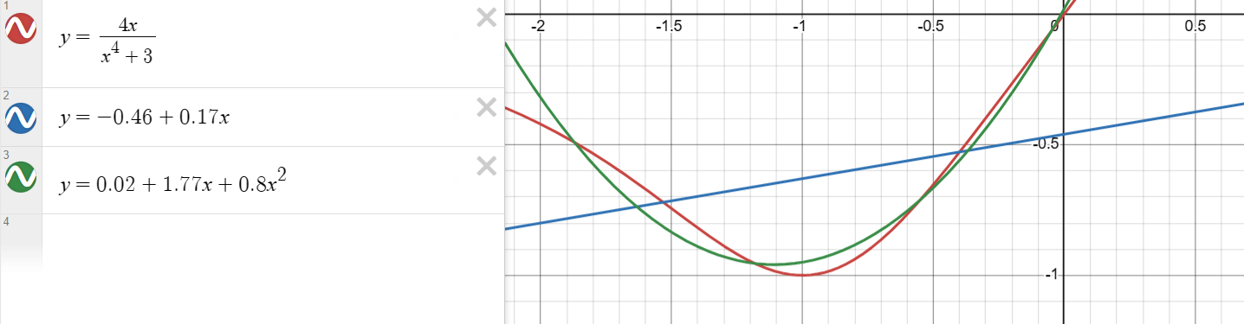

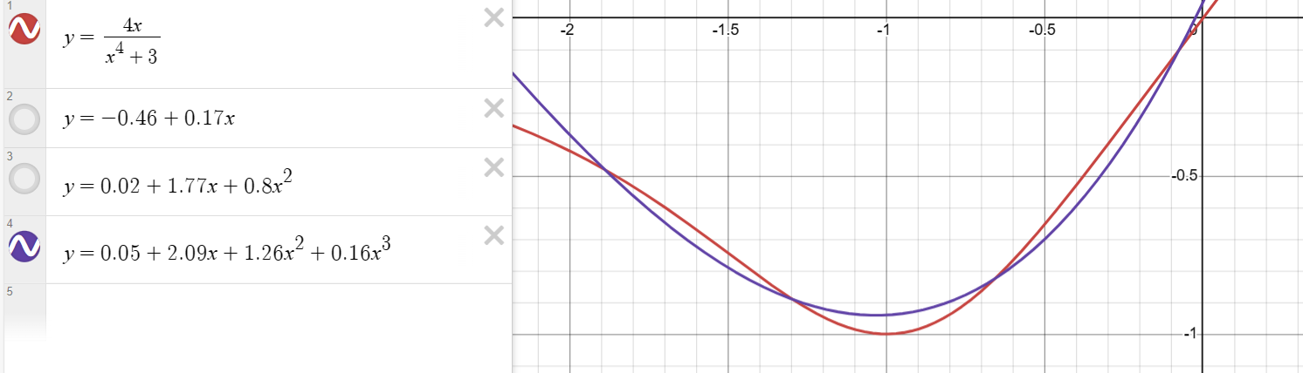

Для кубической аппроксимации: σ = $\sqrt{\frac{\sum{{(φ (xi)- yi)}^{2}}}{n}}$ = **0.045**

# Программная реализация задачи

**import** **inspect**

**from** **math** **import** sqrt, exp, log

**import** **matplotlib.pyplot** **as** **plt**

**def** **calc_det2**(A):

**return** A[**0**][**0**] * A[**1**][**1**] - A[**0**][**1**] * A[**1**][**0**]

**def** **solve2**(A, B):

n = **2**

det = calc_det2(A)

det1 = calc_det2([[B[r], A[r][**1**]] **for** r **in** range(n)])

det2 = calc_det2([[A[r][**0**], B[r]] **for** r **in** range(n)])

x1 = det1 / det

x2 = det2 / det

**return** x1, x2

**def** **calc_det3**(A):

pos = A[**0**][**0**] * A[**1**][**1**] * A[**2**][**2**] + \

A[**0**][**1**] * A[**1**][**2**] * A[**2**][**0**] + \

A[**0**][**2**] * A[**1**][**0**] * A[**2**][**1**]

neg = A[**0**][**2**] * A[**1**][**1**] * A[**2**][**0**] + \

A[**0**][**1**] * A[**1**][**0**] * A[**2**][**2**] + \

A[**0**][**0**] * A[**1**][**2**] * A[**2**][**1**]

**return** pos - neg

**def** **solve3**(A, B):

n = **3**

det = calc_det3(A)

det1 = calc_det3([[B[r], A[r][**1**], A[r][**2**]] **for** r **in** range(n)])

det2 = calc_det3([[A[r][**0**], B[r], A[r][**2**]] **for** r **in** range(n)])

det3 = calc_det3([[A[r][**0**], A[r][**1**], B[r]] **for** r **in** range(n)])

x1 = det1 / det

x2 = det2 / det

x3 = det3 / det

**return** x1, x2, x3

**def** **calc_det4**(A):

n = **4**

sign = **1**

r = **0**

res = **0**

**for** c **in** range(n):

A_ = [[A[r_][c_] **for** c_ **in** range(n) **if** c_ != c]

**for** r_ **in** range(n) **if** r_ != r]

res += sign * A[r][c] * calc_det3(A_)

sign *= -**1**

**return** res

**def** **solve4**(A, B):

n = **4**

det = calc_det4(A)

det1 = calc_det4([[B[r], A[r][**1**], A[r][**2**], A[r][**3**]] **for** r **in** range(n)])

det2 = calc_det4([[A[r][**0**], B[r], A[r][**2**], A[r][**3**]] **for** r **in** range(n)])

det3 = calc_det4([[A[r][**0**], A[r][**1**], B[r], A[r][**3**]] **for** r **in** range(n)])

det4 = calc_det4([[A[r][**0**], A[r][**1**], A[r][**2**], B[r]] **for** r **in** range(n)])

x1 = det1 / det

x2 = det2 / det

x3 = det3 / det

x4 = det4 / det

**return** x1, x2, x3, x4

**def** **linear_approximation**(xs, ys, n):

sx = sum(xs)

sxx = sum(x ** **2** **for** x **in** xs)

sy = sum(ys)

sxy = sum(x * y **for** x, y **in** zip(xs, ys))

a, b = solve2(

[

[n, sx],

[sx, sxx]

],

[sy, sxy])

**return** **lambda** x: a + b * x, a, b

**def** **quadratic_approximation**(xs, ys, n):

sx = sum(xs)

sxx = sum(x ** **2** **for** x **in** xs)

sxxx = sum(x ** **3** **for** x **in** xs)

sxxxx = sum(x ** **4** **for** x **in** xs)

sy = sum(ys)

sxy = sum(x * y **for** x, y **in** zip(xs, ys))

sxxy = sum(x * x * y **for** x, y **in** zip(xs, ys))

a, b, c = solve3(

[

[n, sx, sxx],

[sx, sxx, sxxx],

[sxx, sxxx, sxxxx]

],

[sy, sxy, sxxy]

)

**return** **lambda** x: a + b * x + c * x ** **2**, a, b, c

**def** **cubic_approximation**(xs, ys, n):

sx = sum(xs)

sxx = sum(x ** **2** **for** x **in** xs)

sxxx = sum(x ** **3** **for** x **in** xs)

sxxxx = sum(x ** **4** **for** x **in** xs)

sxxxxx = sum(x ** **5** **for** x **in** xs)

sxxxxxx = sum(x ** **6** **for** x **in** xs)

sy = sum(ys)

sxy = sum(x * y **for** x, y **in** zip(xs, ys))

sxxy = sum(x * x * y **for** x, y **in** zip(xs, ys))

sxxxy = sum(x * x * x * y **for** x, y **in** zip(xs, ys))

a, b, c, d = solve4(

[

[n, sx, sxx, sxxx],

[sx, sxx, sxxx, sxxxx],

[sxx, sxxx, sxxxx, sxxxxx],

[sxxx, sxxxx, sxxxxx, sxxxxxx]

],

[sy, sxy, sxxy, sxxxy]

)

**return** **lambda** x: a + b * x + c * x ** **2** + d * x ** **3**, \

a, b, c, d

**def** **exponential_approximation**(xs, ys, n):

ys_ = list(map(log, ys))

_, a_, b_ = linear_approximation(xs, ys_, n)

a = exp(a_)

b = b_

**return** **lambda** x: a * exp(b * x), a, b

**def** **logarithmic_approximation**(xs, ys, n):

xs_ = list(map(log, xs))

_, a_, b_ = linear_approximation(xs_, ys, n)

a = a_

b = b_

**return** **lambda** x: a + b * log(x), a, b

**def** **power_approximation**(xs, ys, n):

xs_ = list(map(log, xs))

ys_ = list(map(log, ys))

_, a_, b_ = linear_approximation(xs_, ys_, n)

a = exp(a_)

b = b_

**return** **lambda** x: a * x ** b, a, b

**def** **calc_measure_of_deviation**(xs, ys, fi, n):

epss = [fi(x) - y **for** x, y **in** zip(xs, ys)]

**return** sum((eps ** **2** **for** eps **in** epss))

**def** **calc_standard_deviation**(xs, ys, fi, n):

**return** sqrt(sum(((fi(x) - y) ** **2** **for** x, y **in** zip(xs, ys))) / n)

**def** **calc_pearson_correlation_coefficient**(xs, ys, n):

av_x = sum(xs) / n

av_y = sum(ys) / n

**return** sum((x - av_x) * (y - av_y) **for** x, y **in** zip(xs, ys)) / \

sqrt(sum((x - av_x) ** **2** **for** x **in** xs) *

sum((y - av_y) ** **2** **for** y **in** ys))

**def** **calc_coefficient_of_determination**(xs, ys, fi, n):

av_fi = sum(fi(x) **for** x **in** xs) / n

**return** **1** - sum((y - fi(x)) ** **2** **for** x, y **in** zip(xs, ys)) / sum((y - av_fi) ** **2** **for** y **in** ys)

**def** **get_str_content_of_func**(func):

str_func = inspect.getsourcelines(func)[**0**][**0**]

**return** str_func.split('lambda x: ')[-**1**].split(',')[**0**].strip()

**def** **draw_plot**(a, b, func, dx=**0.1**):

xs, ys = [], []

a -= dx

b += dx

x = a

**while** x <= b:

xs.append(x)

ys.append(func(x))

x += dx

plt.plot(xs, ys, 'g')

**def** **main**(xs, ys, n):

**if** all(map(**lambda** x: x > **0**, xs)) **and** all(map(**lambda** x: x > **0**, ys)):

approximation_funcs = [

linear_approximation,

power_approximation,

exponential_approximation,

logarithmic_approximation,

quadratic_approximation,

cubic_approximation

]

**else**:

approximation_funcs = [

linear_approximation,

quadratic_approximation,

cubic_approximation

]

best_sigma = float('inf')

best_apprxmt_f = None

**for** apprxmt_f **in** approximation_funcs:

**print**(apprxmt_f.__name__, ": ")

fi, *coeffs = apprxmt_f(xs, ys, n)

s = calc_measure_of_deviation(xs, ys, fi, n)

sigma = calc_standard_deviation(xs, ys, fi, n)

**if** sigma < best_sigma:

best_sigma = sigma

best_apprxmt_f = apprxmt_f

r2 = calc_coefficient_of_determination(xs, ys, fi, n)

**print**('fi(x) =', get_str_content_of_func(fi))

tmp = '(a, b, c)' **if** len(coeffs) == **3** **else** '(a, b)'

**print**(f'coeffs {tmp}:', list(map(**lambda** cf: round(cf, **4**), coeffs)))

**print**(f'S = {s:.5f}, σ = {sigma:.5f}, R2 = {r2:.5f}')

**if** apprxmt_f **is** linear_approximation:

**print**('r =', calc_pearson_correlation_coefficient(xs, ys, n))

plt.title(apprxmt_f.__name__)

draw_plot(xs[**0**], xs[-**1**], fi)

**for** i **in** range(n):

plt.scatter(xs[i], ys[i], c='r')

plt.xlabel("X")

plt.ylabel("Y")

plt.show()

**print**('-' * **50**)

**print**(f'best_func: {best_apprxmt_f.__name__}')

**if** __name__ == '__main__':

case = **2**

**if** case == **1**:

xs = [**1.2**, **2.9**, **4.1**, **5.5**, **6.7**, **7.8**, **9.2**, **10.3**]

ys = [**7.4**, **9.5**, **11.1**, **12.9**, **14.6**, **17.3**, **18.2**, **20.7**]

**elif** case == **2**:

xs = [**1.1**, **2.3**, **3.7**, **4.5**, **5.4**, **6.8**, **7.5**]

ys = [**3.5**, **4.1**, **5.2**, **6.9**, **8.3**, **14.8**, **21.2**]

**elif** case == **3**:

xs = [**1.1**, **2.3**, **3.7**, **4.5**, **5.4**, **6.8**, **7.5**]

ys = [**2.73**, **5.12**, **7.74**, **8.91**, **10.59**, **12.75**, **13.43**]

**else**:

h = **0.2**

x0 = -**2**

n = **11**

xs = [round(x0 + i * h, **2**) **for** i **in** range(n)]

f = **lambda** x: **4** * x / (x ** **4** + **3**)

ys = [round(f(x), **2**) **for** x **in** xs]

n = len(xs)

main(xs, ys, n)

# Тестовые данные

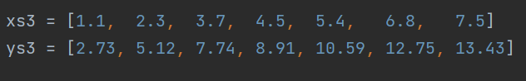

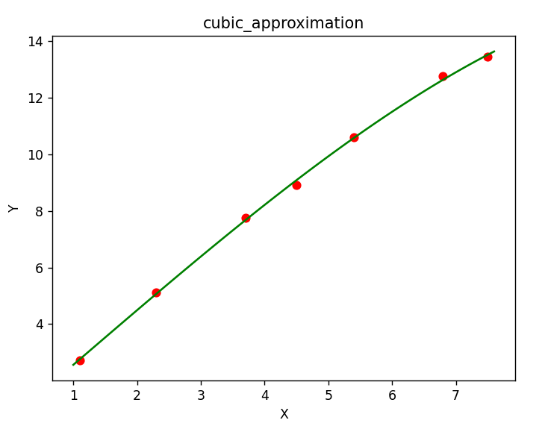

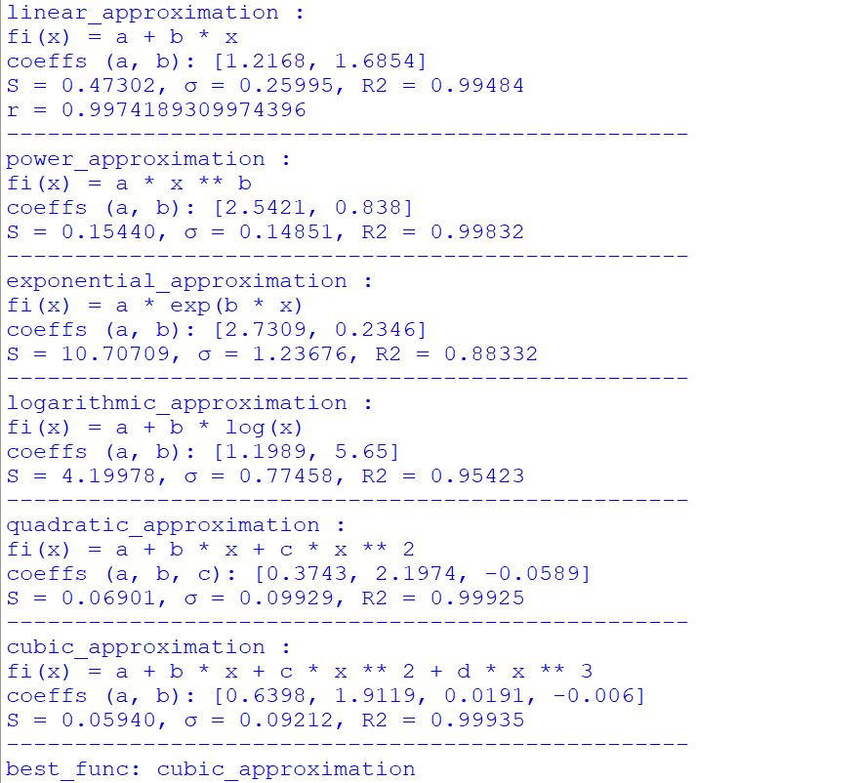

# Вывод

В ходе лабораторной работы я познакомился с аппроксимацией функции методом наименьших квадратов.

Метод наименьших квадратов – хороший метод, определяются параметры, при которых значения аппроксимирующей функции приблизительно совпадали бы со значениями исходной функции. В качестве аппроксимирующих функций обычно берут многочлены. Чем выше степень многочлена, тем точнее. Можно использовать экспоненциальные, логарифмические, степенные функции (сводя их преобразованиями к линейному аппроксимированию). Аппроксимирующая функций проходит в ближайшей близости от точек из заданного массива данных.