[select](http://localhost/phpmyadmin/url.php?url=https://dev.mysql.com/doc/refman/5.5/en/select.html" \t "mysql_doc) \* from tbl\_customers

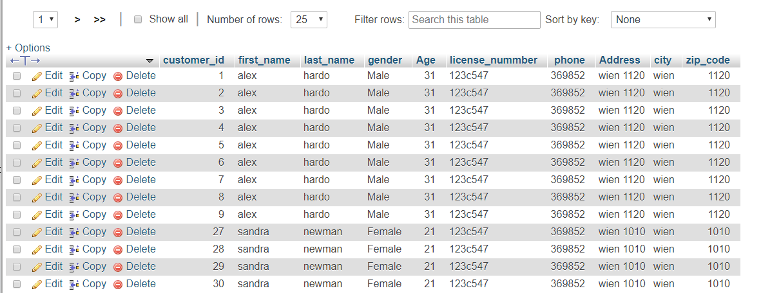

[select](http://localhost/phpmyadmin/url.php?url=https://dev.mysql.com/doc/refman/5.5/en/select.html) \* from tbl\_cars

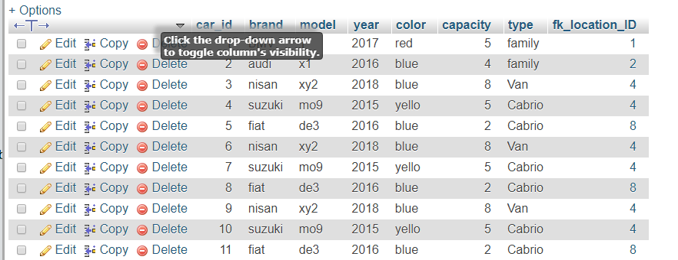

[SELECT](http://localhost/phpmyadmin/url.php?url=https://dev.mysql.com/doc/refman/5.5/en/select.html) \* FROM `tbl\_cars` where [year](http://localhost/phpmyadmin/url.php?url=https://dev.mysql.com/doc/refman/5.5/en/date-and-time-types.html)=2015

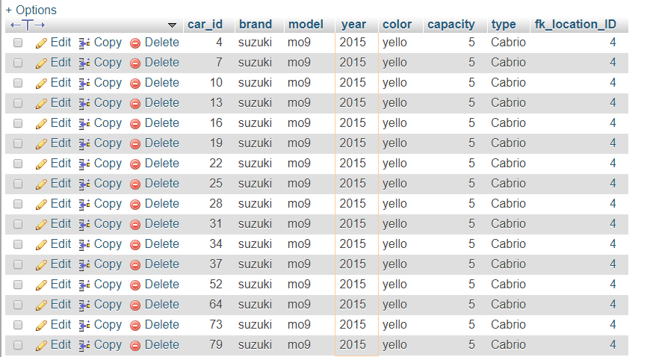

[SELECT](http://localhost/phpmyadmin/url.php?url=https://dev.mysql.com/doc/refman/5.5/en/select.html) \* FROM `tbl\_cars` where capacity=5

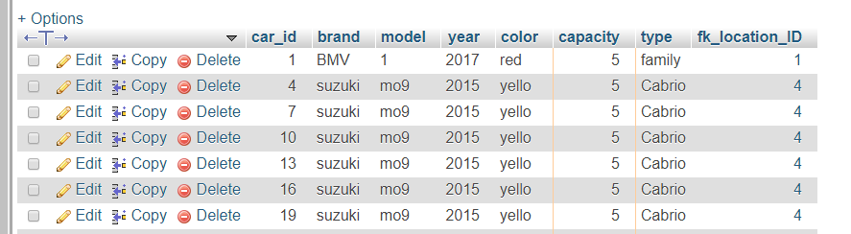

[SELECT](http://localhost/phpmyadmin/url.php?url=https://dev.mysql.com/doc/refman/5.5/en/select.html) \* FROM `tbl\_suppliers`

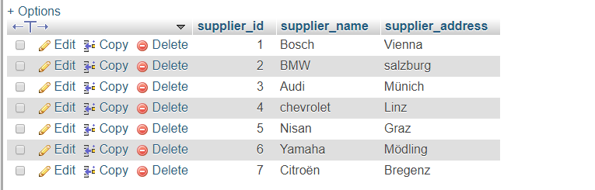

[SELECT](http://localhost/phpmyadmin/url.php?url=https://dev.mysql.com/doc/refman/5.5/en/select.html) \* FROM `tbl\_location`

