Alexis Miranda

COMP 157

11/14/16

Project 2

Shift Table:

Input size: 0..m-1

Basic operation: Setting array values

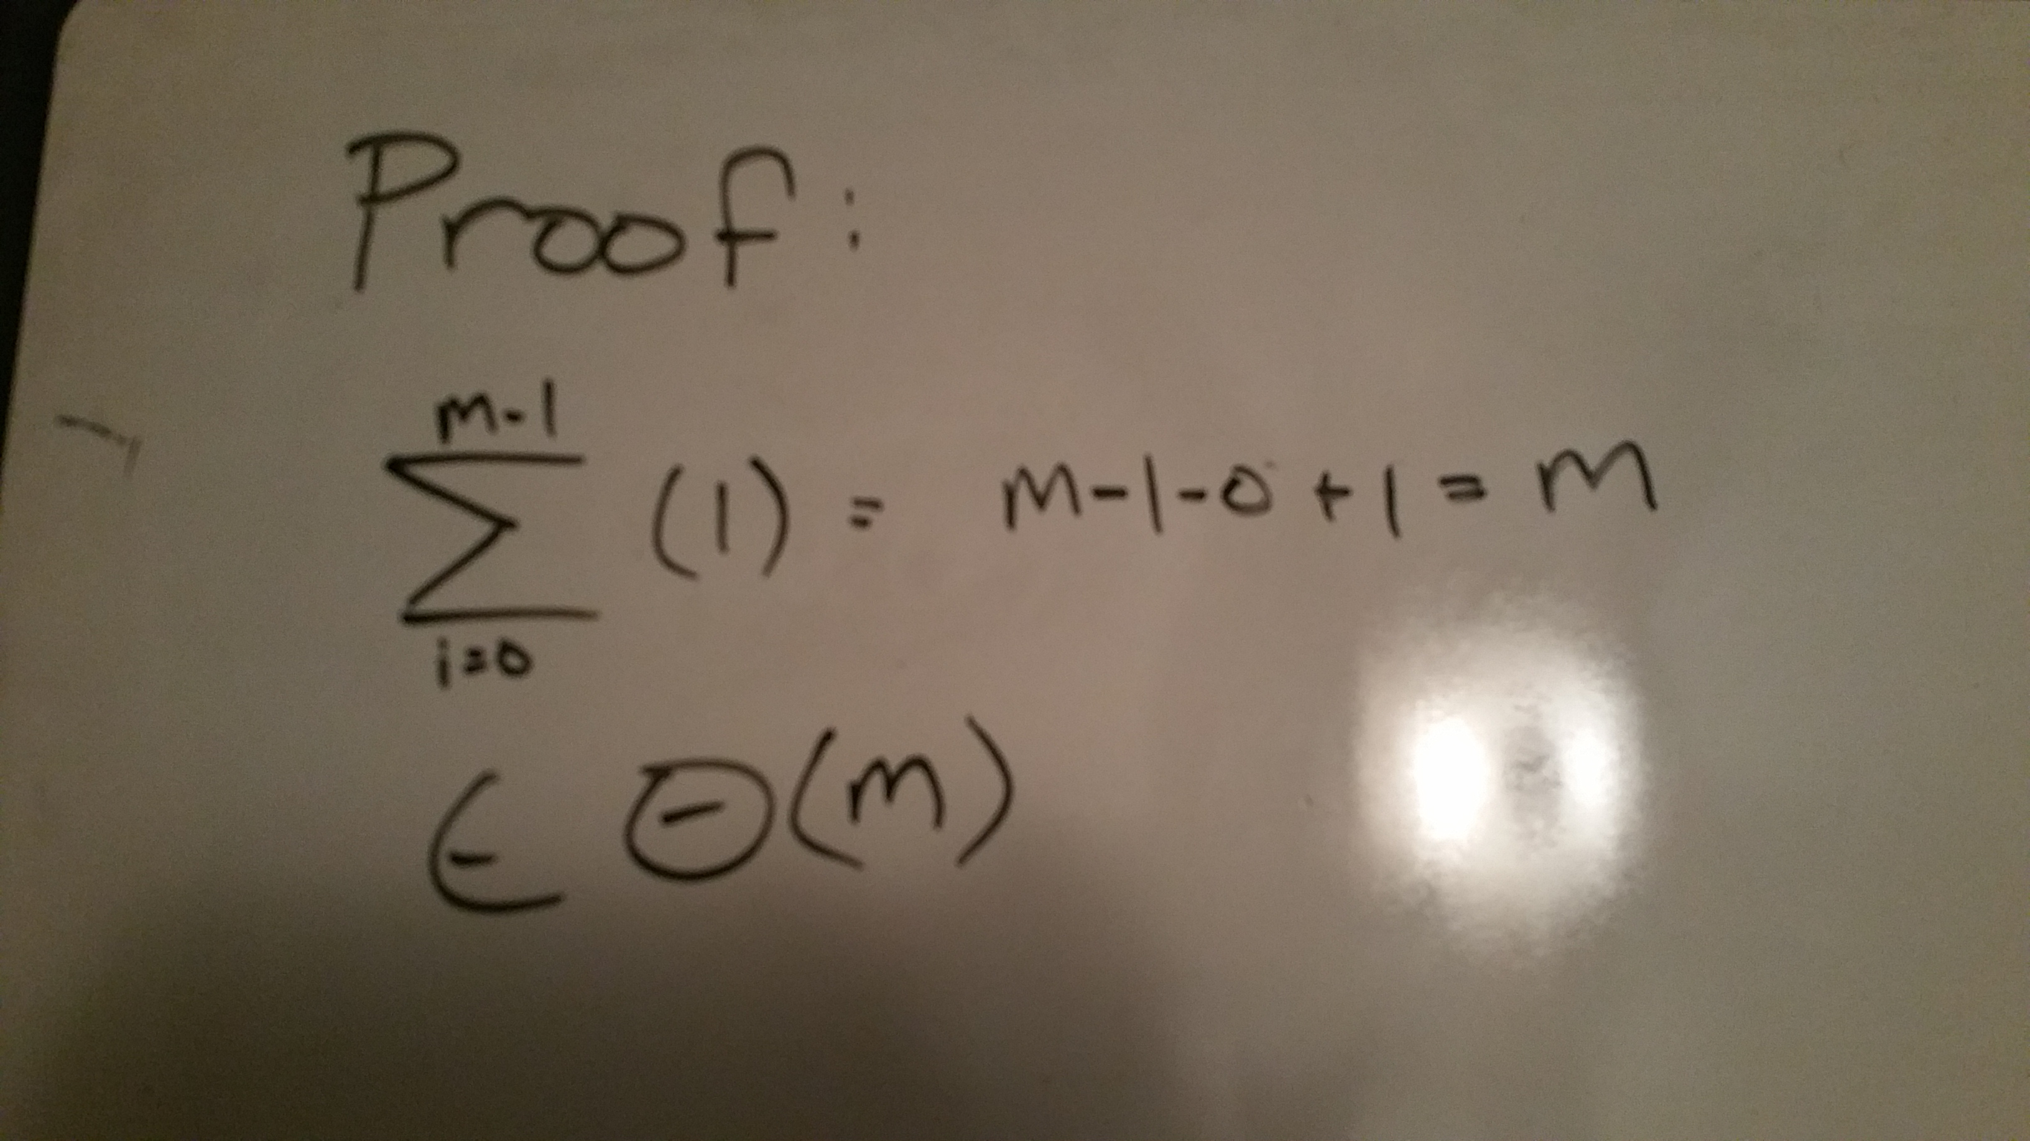

All Horspool deviations:

Input size: 0..m-1, 0..n-1

Basic operation: comparison

