Methodology 3000words
3.1 Study Area
3.2 Data
3.2.1 Data Sources
3.2.2 Exploratory Data Analysis
3.3 Methodology Workflow
3.3.1 Phase 1 Existing Provision and Utilisation
3.3.2 Phase 2 Demand Estimation and Spatial Mismatch
3.3.3 Phase 3 P-Median Location-Allocation Model
3.3.4 Phase 4 Scenario Analysis and Evaluation
3.4 Ethical Considerations

Methodology 3570words
This chapter described the methodological framework of assessing the spatial efficiency and distributional equity of public EV charging locations. The analysis was carried out using Python, and reproducible data cleaning and analysis code can be accessed through Github.【link】

3.1. Study Area
This study focuses on Greater London. London is a high-density city, and limited access to private parking increases residents’ reliance on the public charging network (He et al., 2022). The need for additional public charging infrastructure is also recognised in London’s policy objectives (Transport for London, 2025). Moreover, household vehicle ownership, income deprivation and existing public charging provision vary considerably across the city. Greater London therefore provides a suitable case for examining the relationship between spatial efficiency and distributional equity in charging infrastructure planning.

The study uses 2021 Lower Layer Super Output Areas (LSOAs) as the basic spatial unit. LSOAs are standard geographical units used for UK census statistics. Each LSOA has a usually resident population of between 1,000 and 3,000 people (ONS, 2021). Both official census statistics and income-deprivation data are available at this level. In the model, all Greater London LSOAs serve as both demand nodes and candidate allocation nodes. Each LSOA represents an area of potential public-charging demand and a possible area for receiving additional provision. Distances are measured between LSOA centroids. This reduces the computational burden of using a complete road network and maintains a consistent spatial resolution throughout the analysis.
【add Greater London LSOA boundary map】

3.2 Data
3.2.1 Data Sources
Table X. Overview of core data resources
The table below lists the core data resources used in this study.
Dataset | Description | Observation Unit | Source | Year / Period
Census 2021 TS045: Car or van availability | Number of households with 0, 1, 2, and 3 or more cars or vans | LSOA | Office for National Statistics (ONS) | 2021
IoD2025 Income Domain | Income deprivation score, rank and decile for each LSOA | LSOA | Ministry of Housing, Communities and Local Government (MHCLG) | 2025
EVSE location registry | Registry of public charging infrastructure | Connector, EVSE and charging location | Zapmap | September 2025
Charging activity records | Charging-session records containing EVSE identifiers, session times and durations | Individual charging session | Zapmap | September 2025
ONS 2021 LSOA boundaries | Polygon boundaries and geographical identifiers | LSOA | ONS Geography | 2021

Census 2021 TS045 data were used to construct the household vehicle-stock base for potential public-charging demand. The IoD2025 Income Domain provides a continuous income-deprivation score for each LSOA. This score was used to construct the equity component of the demand weight.

Data on existing charging infrastructure were obtained from the EVSE location registry. The registry contains information at several levels, including charging locations, EVSEs and connectors. Charging location was selected as the main planning unit for measuring existing provision. Each of September 2025 charging activity records represents an individual charging session and includes an EVSE identifier and information on charging time. Together, the two datasets were used to construct measures of existing provision and observed utilisation.

In addition to the core datasets, this study also use the summary statistics from the Department for Transport (DfT) EV Driver Tracker Year 1 as parameter source to set the charging frequency and the percentage of public charging.

3.2.2 Exploratory Data Analysis
Before modelling, exploratory spatial analysis was conducted on four variables: the household vehicle-stock proxy, income deprivation, existing on-street charging provision and observed utilisation. This analysis was used to assess data completeness and identify broad spatial patterns. Figure X shows the spatial distribution of these variables.

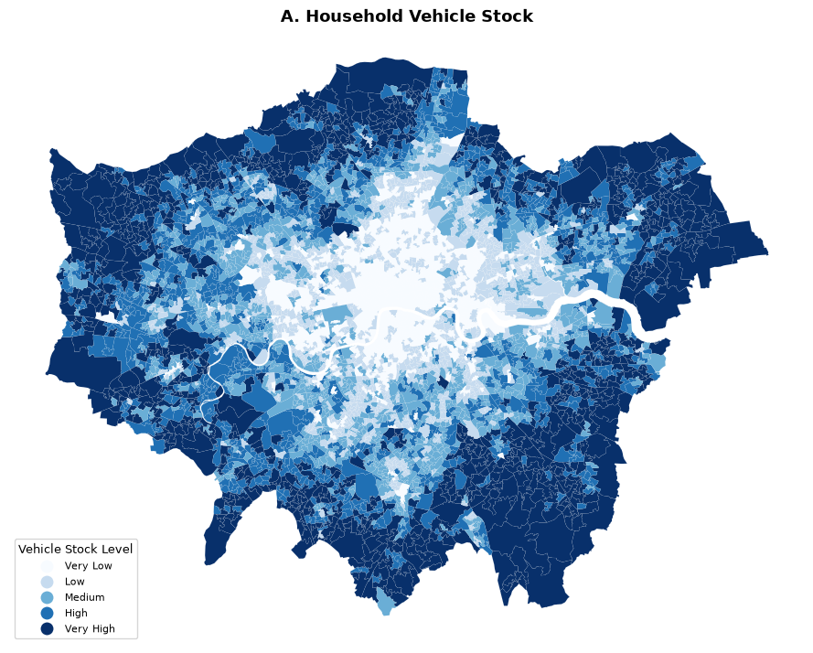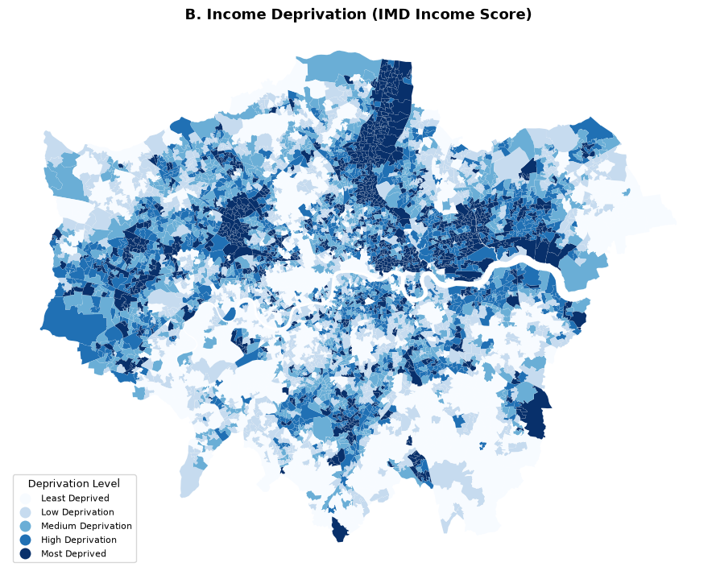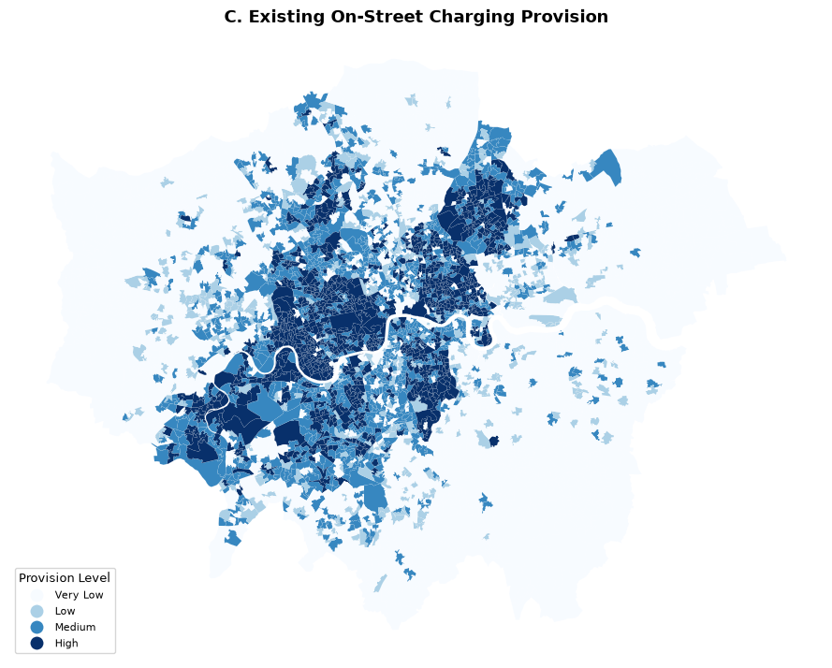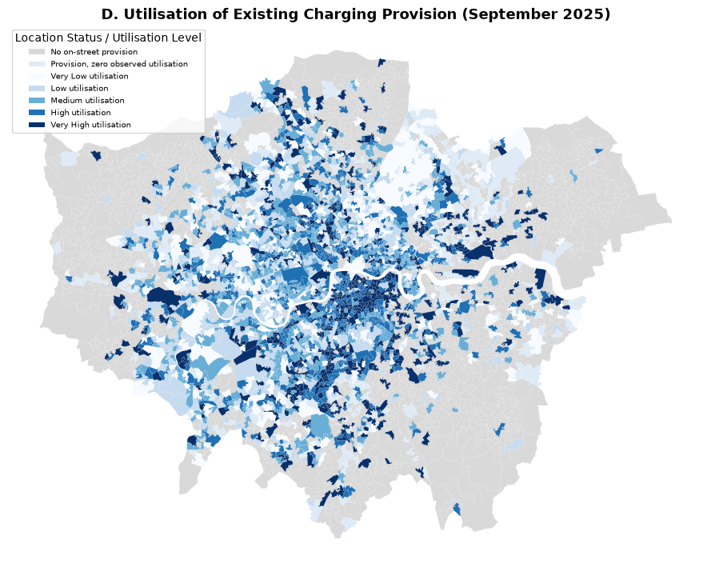
Figure X shows that household vehicle stock is generally higher in outer London and lower in central London. Income deprivation follows a different spatial pattern, with higher levels mainly found in east and north-east London and in some parts of inner London. Existing on-street charging provision, by contrast, is more concentrated in inner London, while many outer-London LSOAs have no registered provision. Observed utilisation also varies considerably across existing charging locations. This suggests that the amount of infrastructure and the intensity of utilisation do not follow the same spatial pattern.

3.3. Methodology Workflow
The study proceeded through four linked phases. Each phase produced inputs used in the subsequent modelling or evaluation. Phase 1 measured existing provision and observed utilisation. Phase 2 combined vehicle stock, charging behaviour, utilisation pressure and income deprivation to construct LSOA-level demand weights. Phase 3 used these weights in a P median location–allocation model. Phase 4 compared spatial efficiency and distributional equity across different deprivation-weighting and investment scenarios.
【workflow】

3.3.1 Phase 1 Existing Provision and Utilisation
To measure the amount and actual use of existing on-street charging provision in Greater London, this phase constructed two indicators: existing provision and realised utilisation. They describe the spatial distribution of current infrastructure and reflect the actual occupancy of existing facilities during the September 2025 observation period sepelrately. They were used to construct the utilisation adjustment in Phase 2 and to identify spatial mismatches between estimated demand and existing provision.

Let :
$$e_{i}=\text{number of registered on-street charging locations in LSOA }i$$

Zapmap distinguishes between charging locations, devices, EV chargers or EVSEs, and connectors (Zapmap, 2026). Charging location is a geographical site containing one or more charging devices, while an EVSE is a charging unit that can independently control a charging session and serve one vehicle. This study uses charging location as the common unit for defining both existing and additional provision to ensure their comparability. As charging locations may contain different numbers of EVSEs, the number of locations mainly reflects the spatial coverage of public charging infrastructure. If an LSOA has no registered charging locations, this does not mean that it has no potential charging demand. In addition to not representing service ability, the number of charging locations cannot reflect how intensively the existing infrastructure is used.

The September 2025 charging-session records were therefore used to calculate EVSE-level realised utilisation. The observation window ran from 00:00 on 1st September 2025 to 00:00 on 1st October 2025. This covered 30 days (43,200 minutes). The utilisation of each EVSE $j$ was defined as:

$$ur_{j}=\frac{total occupied minutes recorded for EVSE j}{43,200 min}$$

Before calculation, overlapping or directly adjacent time intervals for the same EVSE were merged to avoid double-counting occupied time. The resulting $ur_{j}$ represents the proportion of the September observation period during which EVSE $j$ was occupied. EVSEs included in the location registry but with no charging sessions observed in September were retained and assigned $ur_{j}$=0. Removing these EVSEs would leave only devices with recorded charging activity and would therefore overestimate observed utilisation.

As the final spatial analysis was conducted at the LSOA level, EVSE-level utilisation was further aggregated. First, the utilisation values of all EVSEs at the same charging location were averaged to obtain location-level utilisation. The location-level values for all on-street charging locations within the same LSOA were then averaged to obtain the mean observed utilisation for LSOA $i$, denoted by $u_{i}$. Zero-session EVSEs were retained throughout this process. This two-stage aggregation prevented charging locations with more EVSEs from receiving greater weight.

LSOA-level utilisation is then converted into utilisation-pressure adjustment：
$$U_{i}=\left\{\begin{matrix}1+u_{i}, & e_{i}>0, \\ 1, & e_{i}=0.\end{matrix}\right.$$
For LSOA without existing on-street provision，the value of $U_{i}$ is set to 1 as neutral adjustment. This approach avoids incorrectly interpreting “no EVSE available for observation” as “zero utilisation”.

3.3.2 Phase 2 Demand Estimation and Spatial Mismatch
Spatial optimisation requires the relative distribution of charging demand across Greater London to be identified. This study constructed a relative equity-adjusted public-charging demand weight for each LSOA. Its main purpose was to establish relative demand weights across LSOAs and provide the demand input for the subsequent location–allocation model. The demand measure was constructed in four stages: household vehicle stock, public-charging behaviour parameters, existing provision utilisation and income-deprivation weighting.

The overall structure is:
$$D_{i}\left(α\right)=\left(H_{i}C_{i}\right)×P_{d}×P_{pub}×U_{i}×\left(1+α⋅IMD_{i}\right)$$
where $D_{i}\left(α\right)$ is the equity-adjusted public-charging demand weight for LSOA $i$.

As data of EV ownership at the LSOA level were unavailable, this study used household vehicle stock to represent the spatial base that may generate future public-charging demand. Census 2021 TS045 provides the number of households in each LSOA with no cars or vans, one, two, or three or more. The “three or more” category was treated as three vehicles, providing a conservative estimate for this group. The average number of vehicles per household, $C_{i}$, was calculated from these categories and multiplied by the total number of households $H_{i}$, in each LSOA. Household vehicle ownership was selected because vehicle availability is usually measured at the household level (JONG, G. D. et al., 2004). Using total population instead would not distinguish between households with and without vehicles, thereby systematically diluting the estimated demand.

Not every vehicle needs to be charged every day. This study therefore introduced two charging-behaviour parameters to convert vehicle stock into daily public-charging demand. The Department for Transport (DfT) EV Driver Tracker Year 1 reported that Battery Electric Vehicle (BEV) drivers charged an average of 4.3 times over a two-week period, including 2.6 home-charging events and 1.8 public-charging events. Based on these, $P_{d}$ and $P_{pub}$ were calculated as follows:
$$P_{d}=\frac{4.3 times}{14days}≈0.31 P_{pub}=\frac{1.8 times}{1.8 times+2.6 times}=\frac{1.8 times}{4.4 times}≈0.41$$
$P_{d}$: probability that a vehicle requires charging on a given day.
$P_{pub}$: proportion of charging events occurring at public facilities.

The report gives an average total of 4.3 charging events over two weeks, but the times for home charging and public charging sum to 4.4. This small difference results from the independent rounding of figures presented in different tables in the original report. As the calculation of $P_{pub}$ relies on the breakdown by charging location, this study used the combined total of 4.4 as the common basis for calculating both $P_{d}$ and $P_{pub}$, ensuring consistency between the two parameters. This approach follows the general logic used by He et al. (2022), who converted EV demand into daily public-charging demand using charging frequency and the public-charging share. However, their underlying demand was derived from an EV purchase survey. As $P_{d}$ and$P_{pub}$ take the same values across all LSOAs, they mainly adjust the overall scale of demand and do not change the relative spatial distribution derived from household vehicle stock.

In order to reflect pressure already observed within the existing charging network, $U_{i}$calculated in Section 3.3.1 is added into the formula. A higher $U_{i}$ indicates that the existing infrastructure was occupied more frequently during the observation period. The recognised demand for that area was therefore increased accordingly. This approach distinguishes between “EVSE that exist but were not used” and “no EVSE available for observation”.

The preceding components describe potential demand and observed pressure, but do not yet incorporate the equity objective of this study. The final step included the IoD2025 Income Domain Score in the demand weight. Let $IMD_{i}$ denote the income-deprivation score of LSOA $i$, and let $α$ denote the strength of deprivation weighting. Four scenarios were considered: $α$ =0, 0.1, 0.3and 0.5. When $α$ =0 , no additional weight is given to income deprivation in the demand estimation, providing an unweighted baseline. As $α$ increases, income-deprived LSOAs receive higher relative weights in the demand estimation. This adjustment changes the planning priority assigned to these areas in the subsequent spatial optimisation. Therefore, $α$ provides a controlled scenario parameter for examining how stronger deprivation weighting affects the final allocation of charging provision. After these steps, each Greater London LSOA received an equity-adjusted demand weight${ D}_{i}\left(α\right)$under each $α$ scenario.
Finally， household vehicle-stock demand is compared spatially with the existing provision from Phase 1, and categorised into four types:
$${\text{Category}}_{i}=\left\{\begin{matrix}\text{Demand-implied desert}, & e_{i}=0, H_{i}C_{i}≥\tilde{H_{i}C_{i}} \\ \text{Low-demand, no provision}, & e_{i}=0, H_{i}C_{i}<\tilde{H_{i}C_{i}} \\ \text{Saturated / potentially underprovided}, & e_{i}>0, u_{i}≥{\tilde{u_{i}}}^{ \left(e>0\right)} \\ \text{Apparently adequate}, & e_{i}>0, u_{i}<c\end{matrix}\right.$$$\tilde{H_{i}C_{i}}$ is the London-wide median calculated across all LSOAs, while ${\tilde{u_{i}}}^{ \left(e>0\right)}$ is the provision-specific median only across LSOAs with existing provision. The classification was based on household vehicle stock rather than equity-adjusted demand, ensuring that the diagnosis remained independent of the subsequent α scenarios. These categories were then compared by income deprivation to examine whether different socioeconomic areas showed different forms of demand–provision mismatch. This analysis provided the background of existing provision situation for the Phase 3 location–allocation model.

3.3.3 Phase 3 P-Median Location-Allocation Model
After measuring existing charging provision and estimating equity-adjusted demand, Phase 3 integrated these two types of information into a p-median location–allocation model. The aim was to determine the spatial allocation of additional public charging provision across Greater London LSOAs, given a fixed total amount of additional provision. The model was formulated as a Mixed-Integer Linear Programme (MILP), with allocation decisions made at the LSOA level. By minimising demand-weighted distance, the model aimed to serve recognised demand using charging provision located as nearby as possible. The equity-adjusted demand constructed in Phase 2 incorporated income deprivation into the objective. When $α$ >0, income-deprived LSOAs received higher demand weights. Assigning their demand to more distant provision therefore resulted in a higher objective cost. Equity was thus incorporated into the optimisation through demand weighting.

This model uses the following sets and parameters:
$I$: set of LSOA demand nodes, representing where charging demand is generated.
$J$: set of candidate allocation nodes, representing where additional charging locations can be placed. $I=J$: all 4,994 Greater London LSOAs serve as both demand and allocation nodes, so additional provision may in principle be allocated to any LSOA.
$D_{i}^{α}$: equity-adjusted recognised demand weight for LSOA $i$, calculated in Phase 2 under equity scenario $α$.
$d_{ij}$: Euclidean distance between the centroids of LSOAs $i$ and $j$, calculated in EPSG:27700 and used as a proxy for the distance required to reach charging provision.
$e_{j}$: number of existing on-street charging locations in LSOA $j$, calculated in Phase 1
K: scaling parameter that converts charging-location provision into supported recognised demand. Its baseline value was calibrated as $K_{0}=\frac{\sum_{i}{D_{i}^{\left(0\right)}}}{\sum_{j}{e_{j}}+p_{ref}}≈13.17 p_{ref}=5,000$
$λ$: penalty weight for unserved-demand slack, set to λ=1.05×max($d_{ij}$) $≈7,899$m
$p$: total number of additional charging locations available for allocation in each model scenario.
$U_{j}$: maximum amount of additional charging provision that can be allocated to LSOA $j$. This parameter acts as a safeguard against excessive spatial concentration and was subject to sensitivity testing.

To control the computational size of the Greater London-wide model, only the (k) nearest candidate allocation nodes were retained for each demand node. Here, (k) is a computational sparsification parameter rather than a service radius based on planning policy. Its value was examined through sensitivity testing and was set to (k=40).

The model includes decision variables as follows：
$x_{j}$: number of additional charging locations allocated to LSOA $j$; must be a non-negative integer because provision is delivered in discrete units.
$y_{ij}$: assignment variable linking the demand of LSOA $i$ to capacity located in LSOA $j$; $y_{ij}∈\left[0,1\right]$ allows this to represent the proportion of LSOA $i$'s demand served by allocation node $j$.
$s_{j}$: unserved-demand slack associated with allocation node $j$, representing the recognised demand assigned to that node that cannot be supported by its existing and additional provision.

The model’s objective function and constraints are as follows
Objective Function
$$\min{\sum_{i∈I}{\sum_{j∈J}{D_{i}}}\left(α\right)}⋅d_{ij}⋅y_{ij}+λ\sum_{j}{s_{j}}$$

Subject to
C1
$$\sum_{i}{D_{i}^{α}}y_{ij}≤K\left(e_{j}+x_{j}\right)+s_{j} ∀j, s_{j}≥0$$
C2
$$\sum_{j}{y_{ij}}=1 ∀i$$
C3
$$\sum_{j}{x_{j}}=p$$
C4
$$x_{j}∈Z≥0, 0≤x_{j}≤U_{j}, y_{ij}∈\left[0,1\right]$$

The former part of the objective function minimises the distance cost between the recognised demand and its corresponding charging provision. For the same distance, an LSOA with a higher $D_{i}^{α}$ will have a greater impact on the objective function. The latter part penalise unserved-demand slack via $λ$。Without this penalty, the model could reduce spatial allocation costs by leaving demand unserved rather than assigning it to available capacity. To avoid this, $λ$ was set slightly above the maximum $d_{ij}$ in the permitted assignment network. λ=1.05×max($d_{ij}$) $≈7,899$m
herefore, whenever investment capacity is available, the model prioritises assigning demand to that capacity rather than using slack.

Constraint C1 links assigned demand to the available provision at each allocation node. The estimated demand that LSOA $j$ can support is determined by its existing provision $e_{j}$ and additional provision $x_{j}$. The scaling parameter $K$converts this provision into the same model scale as $D_{i}^{α}$. When the available provision cannot support all demand assigned to the node, the difference is represented by $s_{j}$. As $K$ is a model-scale calibration rather than an estimate of actual charging throughput, its effect was examined through sensitivity testing. Its baseline value was calibrated as $K_{0}=\frac{\sum_{i}{D_{i}^{\left(0\right)}}}{\sum_{j}{e_{j}}+p_{ref}}≈13.17 p_{ref}=5,000$

Constraint C2 requires the recognised demand of each demand LSOA to be fully included in the assignment. As $y_{ij}$ is continuous, the aggregate demand of one LSOA can be shared across multiple permitted allocation nodes. This is consistent with the aggregated nature of LSOA-level demand, as users within the same LSOA do not necessarily use the same charging location. Continuous assignment also avoids the high computational burden of imposing binary restrictions on the full set of $y_{ij}$ variables.

Constraint C3 fixes the total amount of additional charging provision allocated across Greater London at $p$. Therefore, different model runs compare how provision should be spatially allocated at a given investment level.

Constraint C4 requires $x_{j}$ to be a non-negative integer and limits it to $U_{j}$. The integer requirement reflects that additional provision is allocated in discrete units, while $U_{j}$prevents additional provision from becoming excessively concentrated in a single LSOA. Sensitivity testing of this upper bound was used to determine whether it had a substantial effect on the final allocation.

The model was implemented in Python using PuLP and solved with the CBC solver. The solver status was recorded for each scenario. Phase 4 varied the deprivation weighting and investment level while keeping the model structure unchanged, and compared the resulting spatial allocations and efficiency–equity outcomes.

3.3.4 Phase 4 Scenario Analysis and Evaluation
Phase 4 compared different spatial allocation scenarios by varying deprivation weighting and investment level. The core analysis used four deprivation-weighting levels: $α∈\left\{0, 0.1, 0.3, 0.5\right\}$. $α$ =0 represents the baseline scenario without income-deprivation weighting. As $α$increases，LSOAs with higher levels of income deprivation receive greater planning weights in the demand measure. The study also considered three levels of additional provision:$p∈\left\{2000, 5000, 8000\right\}$ . These levels setting refers to the estimated future shortfall in public charging infrastructure across Greater London. TfL and GLA (2025) estimated that London would face a shortfall of approximately 17,500 to 25,500 public charge points by 2030. Using the lower estimate of approximately 17,500 as a reference, this study selected three integer investment levels: 2000, 5000, and 8000. These represent approximately 11%, 29%, and 46% of the estimated shortfall, respectively, covering a range from a pilot-scale investment to almost half of the shortfall. Among these, $p$ =5000 was also used as the reference investment level for sensitivity testing. Combining the four $α$ scenarios with the three $p$ scenarios produced 12 core model configurations. All other model parameters were held constant across these configurations to allow the effects of deprivation weighting and investment level on the final allocation to be compared.

The spatial performance of different scenarios was evaluated using a gravity-based accessibility measure. This approach was first proposed by Hansen (1959), measuring accessibility through continuous distance decay. Existing EV charging location studies commonly use a fixed service radius (e.g. Liu, 2012; He et al., 2022). However, such measures are sensitive to the choice of threshold and cannot reflect relative differences in accessibility among LSOAs within the service area. As this study examines continuous changes in accessibility across areas with different levels of deprivation, a commonly used inverse-distance decay form was adopted:
$$A_{i}\left(α,p \right)=\sum_{j}{\frac{e_{j}+x_{j}\left(α,p \right)}{d_{ij}+c}}$$
For LSOA $i$, accessibility $A_{i}$ represents the existing and additional charging provision accessible under each scenario, with its contribution decreasing as spatial distance increases. Provision located closer to LSOA $i$ therefore makes a greater contribution to its accessibility. $c$ is a small positive constant in the denominator that prevents division by zero when $j=i$, where ($d_{ii}=0$). It was set to 100 metres.
$$\overline{A}\left(α,p \right)=\frac{\sum_{i}{D_{i}^{\left(0\right)}}A_{i}\left(α,p \right)}{\sum_{i}{D_{i}^{\left(0\right)}}}$$
The overall spatial performance of Greater London was evaluated using mean accessibility. For each investment level $p$, the different $α$ =0 scenarios were compared with the baseline allocation at $α$ =0 under the same value of $p$.

$$ΔA_{i}\left(α,p \right)=A_{i}\left(α,p \right)-A_{i}\left(0,p \right)$$
Distributional equity was evaluated through changes in accessibility across different income-deprivation groups. First, the change in accessibility for each LSOA was calculated relative to the $α$ =0 scenario at the same investment level $p$. These changes were then aggregated by London-specific income-deprivation decile, and the mean changes across deprivation groups were compared. The analysis focused on the difference between the most and least deprived areas to examine whether stronger deprivation weighting resulted in improved accessibility for disadvantaged areas.

Finally, the unserved-demand slack share was reported separately as a model diagnostic. Slack represents the recognised demand that could not be supported by modelled capacity at a given provision level. By combining overall accessibility, deprivation-based accessibility change and slack diagnostics, the spatial efficiency and distributional outcomes of different scenarios could be evaluated together.

3.4 Ethical Considerations
This study aims to provide interpretable analytical results for the spatial planning of public EV charging infrastructure in Greater London, with a focus on balancing spatial efficiency and deprivation-based equity. The Census, IoD and LSOA boundary data are publicly available. The EVSE registry and charging-session records were obtained under a data-sharing agreement and were used only for this research. The charging activity data contain no personally identifiable information, and the final analysis was aggregated to the charging-location or LSOA level. Therefore, this study did not involve individual-level profiling or attempt to identify the charging behaviour of specific users. All data were processed and stored in accordance with their conditions of access and use. This study was conducted in accordance with UCL’s research ethics requirements and received ethical approval (Project ID: 4063).

