Equity-Oriented Spatial Optimization of Electric Vehicle Charging Infrastructure: A Scenario-Based Approach for Greater London

Abstract
Declaration of Authorship
Acknowledgements
List of Figures
List of Tables

1. Introduction 1000words
1.1. Background
- Transport Decarbonisation and the Transition to Electric Mobility (HoC Library 2025).
- Electric mobility cannot expand without accessible and dependable charging infrastructure.
- 写多少人依赖public charging
- The total number of chargers is not enough to describe whether residents are adequately served. Their spatial distribution also matters. charging points其实比电动车发展地快，但是人们还是有抱怨，要分析谁真需要。public charging on a call
- Market-led deployment may follow visible demand, current EV ownership and purchasing power, potentially reproducing existing spatial inequalities.
- Existing demand is itself shaped by who already owns an EV, so a purely efficiency-driven approach can systematically under-serve deprived areas that have real, latent need but little currently visible demand.
- Planning therefore needs a framework that connects changing demand, existing provision, spatial allocation and equity.

1.2. Research Question and Objectives
Research Question:
How to balance spatial efficiency and deprivation-based equity within a spatial optimisation framework, using the allocation of additional public EV charging provision across Greater London LSOAs as a case study?

Research Objectives
O1. Demand estimation and equity weighting
Estimate baseline EV charging demand for each LSOA in Greater London and apply alternative income-deprivation weights to construct equity-prioritised demand scenarios.

O2. Existing provision and spatial mismatch
Measure existing on-street charging provision and utilisation, and identify spatial mismatches between estimated demand and effective charging provision.

O3. Optimised allocation
Determine the optimal number of additional public EV charging locations allocated to each LSOA under each income-deprivation-weighting scenario.

O4. Efficiency–equity evaluation
Evaluate how stronger income-deprivation weighting changes spatial efficiency and distributional equity, using a consistent set of performance metrics.

1.3. Structure
Chapter 2 reviews three separate bodies of literature (location-allocation optimisation, demand modelling, and equity analysis) and identifies the gap between them that this dissertation addresses.。
Chapter 3 sets out the methodology used to answer O1-O4. Chapter 4 presents the results. Chapter 5 discusses what they mean. Chapter 6 concludes.

2. Literature Review 3500words
2.1. Stream 1: Location-Allocation Optimisation
- location-allocation models determine where facilities should be located and how spatial demand should be assigned to them.
- Main facility-location models and their planning objectives
- Applications to EV charging infrastructure, focusing on differences in demand nodes, candidate locations, distance measures, service thresholds, capacity assumptions and the treatment of existing infrastructure.
- Efficiency-oriented limitations: some areas may receive less attention
- Optimisation results depend heavily on the demand surface entered into the model, creating the need to examine how EV charging demand is estimated.

2.2. Stream 2: Demand Modelling for EV Charging
- Definitions of observed, latent and future demand
- Spatial demand proxies (e.g.population, households, vehicle ownership, current EV ownership, travel activity, land use and observed charging sessions.)
- Examine how behavioural parameters, such as charging frequency, public-charging share and access to home charging, are combined with spatial demand bases.
- Discuss the potential value and limitations of observed charger utilisation: it may indicate charging pressure, but it is also influenced by existing supply, commuter activity, charger characteristics and data coverage.
- Conclude that demand modelling is not a neutral technical step because the selected demand proxy affects which areas receive priority in the subsequent optimisation.

2.3. Stream 3: Equity Analysis of Charging Infrastructure
- Distinguish equality from equity: equal infrastructure provision does not necessarily produce equitable outcomes where communities differ in need, disadvantage or reliance on public charging.
- Review evidence on whether charging availability and accessibility vary according to income, deprivation, housing conditions, population density and existing EV adoption.
- Compare common equity measures, including charger density, distance-based accessibility, population coverage, unmet demand, differences between deprivation groups and inequality indices.
- Review how equity can be incorporated into infrastructure planning through post-hoc assessment, equity-weighted demand, minimum-service constraints, multi-objective optimisation or scenario analysis.
- Conclude that much of the equity literature diagnoses existing inequalities, while fewer studies translate equity evidence into an operational strategy for allocating future charging capacity.

2.4. The Research Gap
- Contributions of the three streams
- There remains limited evidence on how income-related disadvantage can be incorporated into spatial EV charging demand and location-allocation modelling while accounting for existing provision and evaluating both efficiency and distributional outcomes.
- This dissertation addresses the gap through a scenario-based spatial decision-support framework that connects demand estimation, additional capacity allocation and the evaluation of efficiency and income-equity outcomes across Greater London LSOAs.

3. Methodology 3000words
3.1. Study Area
● The study area is Greater London, divided into 4,994 Lower Layer Super Output Areas (LSOAs) — small, standardised statistical units used in UK census geography, each covering roughly 1,500 residents.
● LSOAs are used as both the demand side (where people live and need to charge) and the supply side (where new charging locations can be allocated) of the model, so the analysis operates at a consistent spatial resolution throughout.

3.2. Data
3.2.1 Data Sources
This study combines household vehicle-ownership data, income-deprivation data, registered EV charging infrastructure, observed charging activity and spatial boundary data. These datasets differ in their original observational units and will be harmonised to the 2021 LSOA geography for subsequent analysis. Table X summarises the core data resources.

Table X. Overview of core data resources
Dataset | Description | Observation Unit | Source | Year / Period
Census 2021 TS045: Car or van availability | Number of households with 0, 1, 2, and 3 or more cars or vans | LSOA | Office for National Statistics (ONS) | 2021
IoD2025 Income Domain | Income deprivation score, rank and decile for each LSOA | LSOA | Ministry of Housing, Communities and Local Government (MHCLG) | 2025
EVSE location registry | Registry of public charging infrastructure | Connector, EVSE and charging location | Zapmap | September 2025
Charging activity records | Charging-session records containing EVSE identifiers, session times and durations | Individual charging session | Zapmap | September 2025
ONS 2021 LSOA boundaries | Polygon boundaries and geographical identifiers | LSOA | ONS Geography | 2021

Parameter source
Published aggregate statistics from the DfT EV Tracker Year 1 report are used to derive the charging-related parameters $P_{d}$ and $P_{pub}$. As the underlying survey microdata are not directly analysed in this study, the report is treated as a secondary parameter source rather than a core analytical dataset.

The data sources support the research objectives as follows:
- Census 2021 TS045 provides household car and van availability data used to establish the baseline vehicle-stock demand across LSOAs. (Objective 1)
- DfT EV Tracker Year 1 provides published charging-frequency and location-type statistics used to derive the demand parameters $P_{d}$ and $P_{pub}$. (Objective 1)
- IoD2025 Income Domain provides the continuous income-deprivation score used to incorporate equity into the demand framework. (Objective 1)
- EVSE location registry provides the locations, characteristics and spatial distribution of existing public charging infrastructure. (Objective 2 and Objective 3)
- Charging-activity records provide observed charging-session information used to assess the usage of existing provision. (Objective 2 and Objective 3)
- ONS 2021 LSOA boundaries provide the common spatial reference for integrating all datasets and defining the spatial units used in the allocation and evaluation stages. (Objectives 1–4)

3.2.2 Data Cleaning and Integration
Data cleaning will include:
- standardising LSOA, location, EVSE and connector identifiers and validating the internal charging-infrastructure hierarchy;
- resolving inconsistent and superseded location identifiers using the EVSE-side location foreign key as the canonical assignment;
- removing exact duplicate and invalid charging-session records, merging overlapping intervals and restricting activity to the September 2025 observation window;
- retaining registered EVSEs with no observed sessions as zero-utilisation observations;
- retaining very short sessions after sensitivity analysis showed negligible effects on LSOA-level utilisation;
- spatially assigning on-street charging locations to 2021 LSOAs and aggregating the cleaned data to one observation per LSOA.

3.2.3 Exploratory Data Analysis
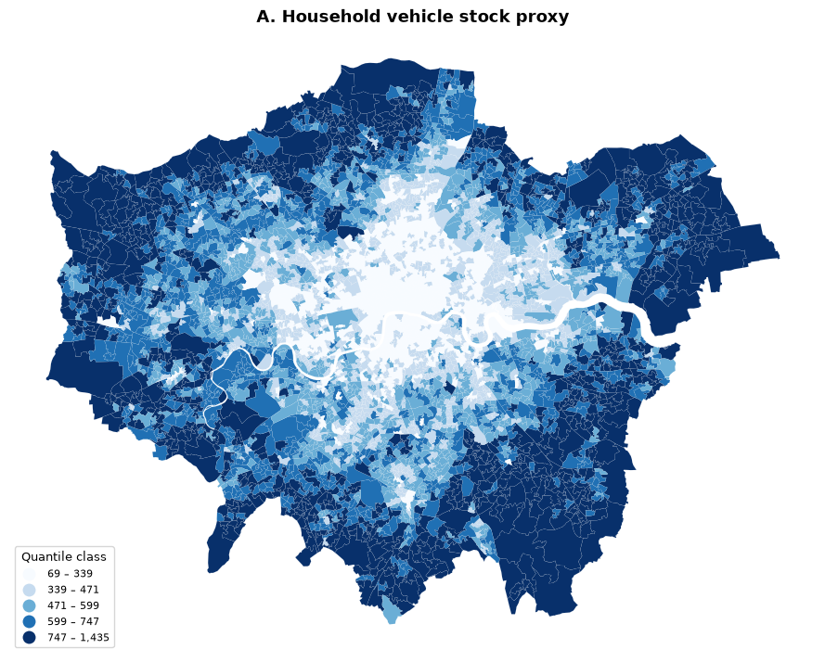
A – Household vehicle stock proxy: Higher vehicle-stock demand is generally concentrated in outer London, while central London shows lower household car ownership.
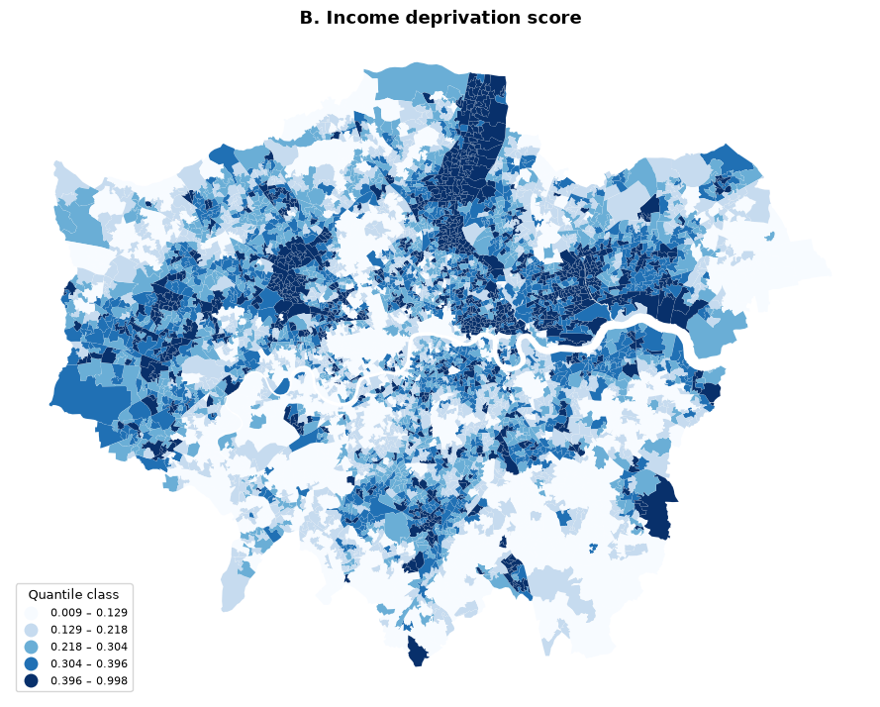
B – Income deprivation score: Income deprivation follows a different spatial pattern from vehicle ownership, with higher deprivation concentrated in parts of east, north-east and inner London.
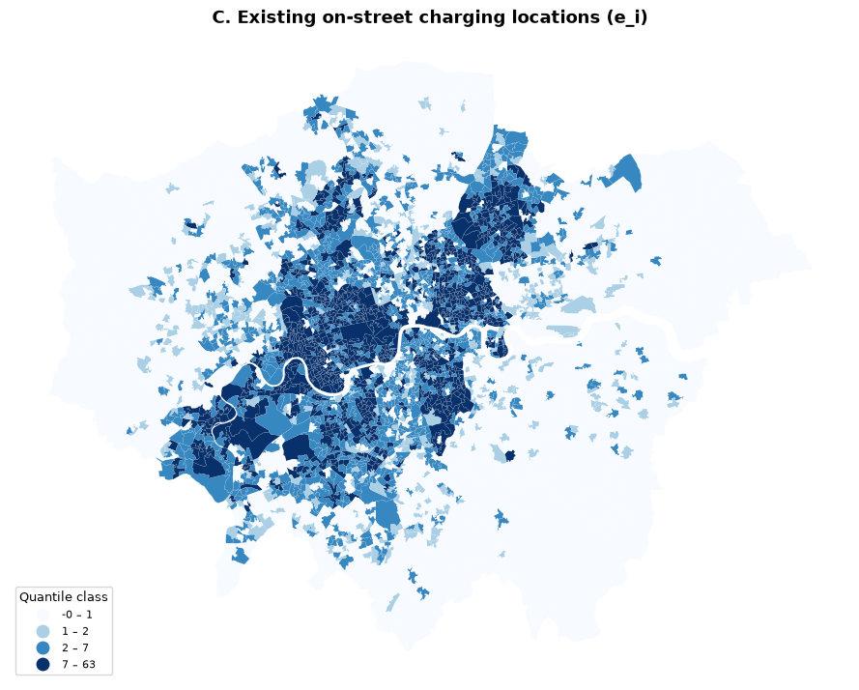
C – Existing on-street charging locations ($e_{i}$): Existing on-street charging provision is concentrated mainly in inner London, while many outer-London LSOAs contain few or no registered locations.
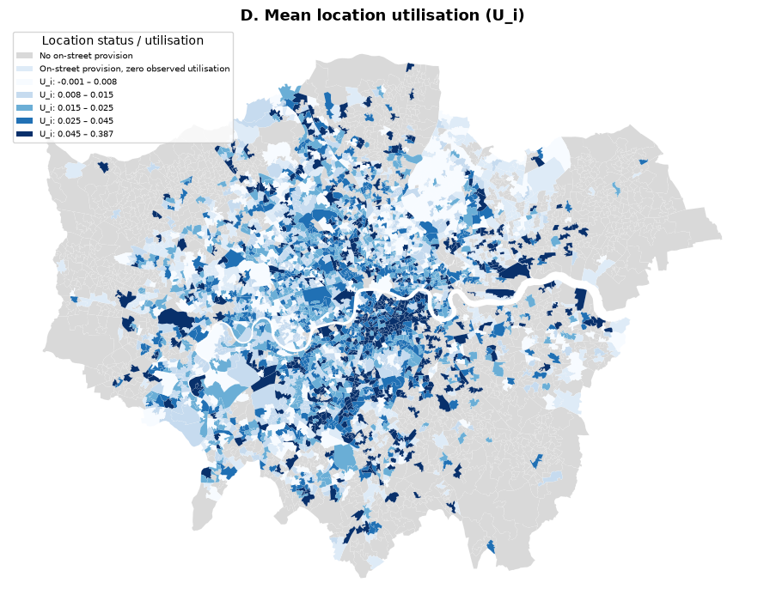
D – Mean location utilisation ($U_{i}$): Observed utilisation varies independently of provision quantity, distinguishing LSOAs with no provision, unused provision and relatively higher usage pressure.

3.3. Methodology Workflow
【to be added】

3.3.1. Phase 1: Demand Estimation
Purpose
- Construct an LSOA-level measure of relative potential demand for public EV charging, used as the demand weight in the allocation model.
- Use the resulting demand weights as inputs to the subsequent allocation model.
- The measure supports spatial prioritisation rather than providing an exact forecast of charging sessions or required charging locations.

Overall structure
$$D_{i}\left(α\right)=\left(H_{i}C_{i}\right)×P_{d}×P_{pub}×U_{i}×\left(1+α⋅IMD_{i}\right)$$
where $D_{i}\left(α\right)$ is the equity-adjusted public-charging demand weight for LSOA $i$.

Step 1: Household vehicle-stock base
- $H_{i}$: number of households in LSOA $i$.
- $C_{i}$: average number of cars or vans per household, estimated from Census 2021 TS045.
- The “three or more” category is conservatively treated as three vehicles.
- $H_{i}C_{i}$ estimates the number of household vehicles potentially requiring charging.
- Rationale: vehicle-owning households provide a more direct basis for charging demand than total population.
Step 2: Public-charging demand parameters
- $P_{d}=\frac{4.3}{14}≈0.31$ $P_{d}$: probability that a vehicle requires charging on a given day.
- $P_{pub}=\frac{1.8}{4.4}≈0.41$ $P_{pub}$: proportion of charging events occurring at public facilities.
- Both parameters are derived from published statistics in the DfT EV Tracker Year 1 report.
- Rationale: not every vehicle charges daily, and only part of total charging demand is served by public infrastructure
Step 3: Utilisation-pressure adjustment
- $U_{i}$ represents the mean observed utilisation of existing on-street charging locations in LSOA $i$.
- It is used to increase recognised demand where existing infrastructure experiences greater observed usage pressure.
- LSOAs without an existing charging location receive the neutral adjustment specified in the demand formula.
- Cross-reference: the construction of $U_{i}$ from charging-session data is explained in Phase 2.
- Rationale: vehicle ownership alone may not capture local pressure already visible in the use of existing infrastructure.
Step 4: Income-deprivation weighting
- $IMD_{i}$: IoD2025 Income Domain Score for LSOA $i$.
- $α$: scenario parameter controlling the strength of income-deprivation weighting.
- $α=0$ represents the unweighted baseline, while larger values assign greater planning priority to more income-deprived LSOAs.
- Rationale: relying only on currently visible vehicle demand may reproduce existing inequalities.
- Higher $α$ increases recognised planning demand.
- Interpretation: the weighting does not imply that deprived areas contain more vehicles, but that their potential need receives greater priority in planning.
Output
- One equity-adjusted demand weight for each LSOA under every α scenario.
- Scenario summaries showing how total recognised demand and its spatial distribution change as deprivation weighting becomes stronger.
- These weights enter the Phase 3 p-median model.

3.3.2 Phase 2: Existing Provision and Utilisation
Purpose
- Measure the quantity and observed use of existing on-street charging infrastructure.
- Construct the utilisation variable required by the Phase 1 demand formula.
- Identify spatial mismatches between estimated demand and current effective provision.

Step 1: Existing provision
$$e_{i}=\text{number of registered on-street charging locations in LSOA }i$$
- Provision is counted at the charging-location level rather than by device, EVSE or connector.
- Rationale: existing and additional provision must use the same planning unit.
- $e_{i}=0$ indicates no registered on-street location, not an absence of charging demand.
Step 2: Realised utilisation per EVSE (u$r_{j}$)
- The observation window covers September 2025, comprising 3$0 days × 24h × 60min$ = 43,200 minutes.
- For each EVSE $j$, all recorded sessions are restricted to the observation window.
- Realised utilisation is calculated as:
$$ur_{j}=\frac{total occupied minutes recorded for EVSE j}{43,200 min}$$
- EVSEs registered in the infrastructure dataset but with no observed September sessions are retained with:
$${ur}_{j}=0$$
- Interpretation: ${ur}_{j}$ represents the proportion of the September observation period during which EVSE $j$ was occupied.
Step 3: Aggregation from EVSE to LSOA $\left(u_{i}\right)$
- EVSE-level utilisation values are first averaged across all EVSEs within each charging location.
- The resulting location-level means are then averaged across all on-street charging locations within LSOA $i$ to obtain $u_{i}$.
- Zero-session EVSEs remain included in the location-level average.
- Rationale: averaging first within each location prevents locations containing more EVSEs from receiving disproportionate weight.
- Interpretation: $u_{i}$ represents the mean observed utilisation of an existing on-street charging location in LSOA $i$.
Step 4: Utilisation-pressure adjustment $\left(U_{i}\right)$
$$U_{i}=\left\{\begin{matrix}1+u_{i}, & e_{i}>0, \\ 1, & e_{i}=0.\end{matrix}\right.$$
- $U_{i}$ converts observed utilisation into the adjustment factor used in the Phase 1 demand formula.
- Higher $u_{i}$ produces a larger demand adjustment.
- LSOAs without existing provision receive a neutral adjustment rather than being interpreted as having zero utilisation pressure.
Step 5: Effective provision $\left(S_{i}^{eff}\right)$
$$S_{i}^{eff}=e_{i}u_{i}$$
- $S_{i}^{eff}$ combines the number of existing charging locations with their mean observed utilisation.
- Because utilisation is averaged at location level before aggregation, locations containing more EVSEs do not receive disproportionate weight.
- Interpretation: $S_{i}^{eff}$ is a utilisation-weighted indicator of existing provision, not a direct measure of electrical capacity.
Step 6: Demand–provision mismatch
- Compare estimated demand with $e_{i}$, $u_{i}$ and $S_{i}^{eff}$.
- Distinguish between:
  - LSOAs with estimated demand but no existing provision;
  - LSOAs with existing provision and relatively high utilisation;
  - LSOAs with existing but lightly used provision.
- Examine whether these patterns vary with income deprivation.
- Purpose: identify different forms of spatial mismatch before the p-median model determines how additional provision should be allocated.

3.3.3 Phase 3: P-Median Location-Allocation Model
Purpose
- Determine how many additional public charging locations should be allocated to each Greater London LSOA under each income-deprivation-weighting scenario.
- Convert the equity-adjusted demand weights $D_{i}^{α}$ from Phase 1 and the existing provision $e_{j}$ from Phase 2 into a spatial allocation of additional infrastructure.
- Minimise the demand-weighted distance between LSOAs generating charging demand and LSOAs receiving charging provision.
Why p-median?
- The p-median model is designed to locate a fixed amount of infrastructure so that the total demand-weighted distance between demand and provision is minimised.
- This is appropriate because the study evaluates spatial accessibility continuously through distance, rather than classifying demand as either covered or uncovered using a single threshold.
- Unlike a maximum covering location problem, which maximises the amount of demand within a predefined service radius, p-median identifies the allocation that produces the lowest overall travel burden across all demand nodes.
- Previous EV charging research has shown that p-median can improve distance efficiency but may give less priority to low-demand areas. In this study, this limitation is addressed transparently through the equity-adjusted demand weight $D_{i}^{α}$.
- When $α>0$, more income-deprived LSOAs receive larger demand weights. The model therefore incurs a greater penalty when their demand is assigned to distant charging capacity.

Model type and solution approach
- Formulate the p-median extension as a Mixed-Integer Linear Program（MILP）.
- Distinguish fixed model inputs from solver-determined decision variables.
- Explain that $x_{j}$ is integer, whereas $y_{ij}$ and $s_{j}$ are continuous.
- Clarify that all objective and constraint expressions remain linear, with $K$ fixed for each model run.
- Implement the model in PuLP and solve it using CBC.
- Report solver status and optimality gap; claim global optimality only where CBC formally verifies an optimal solution.

Objective Function
$$\min{\sum_{i∈I}{\sum_{j∈J}{D_{i}}}\left(α\right)}⋅d_{ij}⋅y_{ij}+λ\sum_{j}{s_{j}}$$
In C1–C4 below, every summation over $j$ (and, by extension, over $i$ in C1) ranges only over LSOA $i$'s permitted candidate set — not the full set $J$. This candidate set is constructed by a k-nearest-neighbour pruning step ($k=40$) performed before the model is built; the full construction, rationale and sensitivity testing are given in Phase 4 (§Nearest-neighbour assignment pruning). The formulas below are written in their general form for readability — wherever $j$appears, it should be read as $j∈\text{cand}\left(i\right)$
k is a computational sparsification parameter, not a policy-derived distance rule. It is chosen large enough that genuine capacity is very likely reachable for most demand nodes, while keeping the MILP tractable. Its adequacy is checked, not derived — via the $k∈\left\{30 , 40 , 50\right\}$ sensitivity test — rather than justified by a formula.
Constraints C1–C4
C1
$$\sum_{i}{D_{i}^{α}}y_{ij}≤K\left(e_{j}+x_{j}\right)+s_{j} ∀j, s_{j}≥0$$
C2
$$\sum_{j}{y_{ij}}=1 ∀i$$
C3
$$\sum_{j}{x_{j}}=p$$
C4
$$x_{j}∈Z≥0, 0≤x_{j}≤U_{j}, y_{ij}∈\left[0,1\right]$$

Model sets, parameters and decision variables
- $I$: set of LSOA demand nodes, representing where charging demand is generated.
- $J$: set of candidate allocation nodes, representing where additional charging locations can be placed. $I=J$: all 4,994 Greater London LSOAs serve as both demand and allocation nodes, so additional provision may in principle be allocated to any LSOA.
- $D_{i}^{α}$: equity-adjusted recognised demand weight for LSOA $i$, calculated in Phase 1 under equity scenario $α$.
- $d_{ij}$: Euclidean distance between the centroids of LSOAs $i$ and $j$, calculated in EPSG:27700 and used as a proxy for the distance required to reach charging provision.
- $y_{ij}$: assignment variable linking the demand of LSOA $i$ to capacity located in LSOA $j$; $y_{ij}∈\left[0,1\right]$ allows this to represent the proportion of LSOA $i$'s demand served by allocation node $j$.
- $y_{ij}$ represents the proportion of recognised demand at LSOA $i$ assigned to charging locations at LSOA $j$.
- Demand from one LSOA may therefore be divided across multiple allocation nodes.
- This reflects the aggregated nature of LSOA-level demand, since residents within the same LSOA may use different nearby charging locations.
- Continuous assignment also reduces the computational burden that would result from imposing binary restrictions on the full set of $y_{ij}$ variables.
- $e_{j}$: number of existing on-street charging locations in LSOA $j$, calculated in Phase 2.
- $x_{j}$: number of additional charging locations allocated to LSOA $j$; must be a non-negative integer because provision is delivered in discrete units.
- $s_{j}$: unserved-demand slack associated with allocation node $j$ — the amount of demand assigned to $j$ that its existing and additional provision cannot support once $K$ has been applied. Without a cost attached to $s_{j}$, the model could satisfy C1 for free by leaving demand unserved rather than genuinely reassigning it; the penalty term$λ\sum_{j}{s_{j}}$ in the objective function exists specifically to remove that free option (see $λ$, item 10).
- $K$: scaling parameter converting the number of charging locations into the amount of demand they can support. How it is calculated: $K_{0}=\frac{\sum_{i}{D_{i}^{\left(0\right)}}}{\sum_{j}{e_{j}}+p_{ref}}$, with $p_{ref}=5,000$. Using the actual data ($\sum_{i}{D_{i}^{\left(0\right)}}$, $\sum_{j}{e_{j}}=21,364$), this evaluates to $K_{0}≈13.17$. This is a model-balancing calibration — it is the value at which existing provision plus a reference investment of 5,000 units would just balance total baseline demand — not an empirical estimate of real-world charger throughput, and is declared as such (Limitation L2). Sensitivity to this assumption was tested at the reference scenario ($α=0.3$, $p=5,000$) across $K∈\left\{{0.5K}_{0}\right.,K_{0},2\left.K_{0}\right\}$; results are reported in §4.3/Discussion rather than as a separate methodology subsection. 敏感性测试
- $λ$: penalty weight applied to unserved demand in the objective function. How it is calculated, in plain terms: $λ$ is set to $1.05×$ the longest distance that actually appears in the model's permitted assignment network (i.e. the largest $d_{ij}$among all $i$–$j$ pairs the sparsified model is allowed to use — see $k$, Phase 4). In this data, that longest permitted distance is approximately 7,523 m, giving $λ≈7,899$. The idea is simple: leaving one unit of demand unserved must always cost more than sending it to the single farthest place the model is allowed to send it — so $λ$ only needs to exceed that worst-case real distance, not be an arbitrarily large number. This guarantees the model will always prefer a genuine reassignment over unserved slack whenever any reachable capacity exists, while keeping the two terms in the objective function on comparable numerical scales.
- $p$: fixed total number of additional locations available for allocation, tested at $2,000, 5,000, 8,000$ (justification and TfL-anchored reasoning in Phase 4).
- $U_{j}$: maximum number of additional charging locations permitted in LSOA , set to 150. Sensitivity testing at produced identical allocation results, with in all cases, confirming that the constraint is non-binding. It is retained as a formal safeguard against unrealistic spatial concentration.

3.3.4 Phase 4: Scenario Analysis and Evaluation
A. Scenario Analysis
Purpose
- Convert the model parameters $α$ and $p$ into a transparent and reproducible experimental design. ($K$, $U_{j}$ and $k$ are defined and their sensitivity reported in the variable list in §3.4.3; no maximum service-radius scenario is tested.)
- Distinguish between the two parameters varied in the core scenario comparison ($α$, $p$) and the parameters held constant across all scenarios.
- Ensure that differences between model outputs can be attributed to the intended changes in equity weighting or investment level, not to incidental changes in other settings.

Core scenario grid
The core analysis varies two policy-relevant parameters:
$$α∈\left\{0 , , 0.1 , 0.3 0.5\right\} \\ p∈\left\{2,000 , , 5,000 8,000\right\}$$
- $α$ controls the strength of income-deprivation weighting in the recognised demand $D_{i}^{\left(α\right)}$.
- $α=0$ represents the unweighted baseline, while progressively larger values give greater priority to more income-deprived LSOAs.
- $p$ represents the total number of additional charging locations available for allocation and defines low-, medium- and high-investment scenarios.
- Combining four values of $α$ with three values of $p$ produces 12 core model configurations.
- The configuration $α=0.3, p=5,000$ is used as the reference scenario for supplementary sensitivity tests.
TfL/GLA (2025) estimate a 2030 public-chargepoint gap of approximately 17,500–25,500 units against London's current stock (§1). $p$ is tested at three levels representing low, medium and high investment scenarios, chosen as round numbers spanning roughly 10–45% of the lower-bound gap (~17,500 units): $p=2,000$ (≈11%, a modest pilot), $p=5,000$ (≈29%, also used as the reference scenario for sensitivity testing), and $p=8,000$ (≈46%, approaching half the target gap).

Pre-evaluation model checks
Before $A_{i}\left(α , p\right)$ is calculated, each model run will be checked to confirm it represents a meaningful, feasible allocation rather than a degenerate solution.
The checks include:
- confirming the solver status (Optimal / Feasible within time limit / Infeasible) and reported optimality gap for every $\left(α , p\right)$ configuration;
- confirming $\sum_{j}{x_{j}}=p$ (the fixed investment-budget constraint is satisfied);
- confirming the capacity constraint (C1) is not violated for any $j$, once $s_{j}$ has been accounted for;
- calculating total slack $\sum_{j}{s_{j}}$ as a share of total scenario demand, and checking that the solution is not dominated by $y_{ii}≈1$ across most demand nodes with the shortfall absorbed into slack — the specific pattern the $λ$ penalty is designed to prevent;
- confirming that changes in $α$ or $p$ produce changes in $x_{j}$, rather than a flat, unresponsive allocation.
$A_{i}\left(α , p\right)$ is interpreted only where these checks confirm the underlying allocation is a genuine, feasible, non-degenerate solution.

B. Evaluation
Purpose
- Evaluate how the spatial distribution of charging accessibility changes as the income-deprivation weight $α$ increases, using a single accessibility measure applied consistently across all scenarios.
- Examine this change from two angles: the overall shift in accessibility across Greater London, and how that shift is distributed across income-deprivation deciles.
Accessibility measure
$$A_{i}\left(α,p \right)=\sum_{j}{\frac{e_{j}+x_{j}\left(α,p \right)}{d_{ij}+c}}$$
Variables
- $A_{i}\left(α\right)$: accessibility score for LSOA $i$under equity scenario $α$ — the total charging provision reachable from $i$, discounted by distance. Higher values indicate greater accessibility.
- $e_{j}$: number of existing on-street charging locations in LSOA $j$, calculated in Phase 2 (unchanged across scenarios).
- $x_{j}\left(α\right)$: number of additional charging locations allocated to LSOA $j$under scenario $α$, taken from the Phase 3 p-median solution.
- $e_{j}+x_{j}\left(α\right)$: total charging provision available at LSOA $j$ once new capacity from scenario $α$ is added — the supply term contributing to $i$'s accessibility.
- $d_{ij}$: Euclidean distance between the centroids of LSOAs $i$ and $j$, as defined in Phase 3.
- $c$: a small positive constant added to the denominator to keep $A_{i}$ finite when $j=i$ (where $d_{ii}=0$); set to 100 m. It has no distance-decay role of its own and is not a parameter requiring separate justification.
- $\frac{1}{d_{ij}+c}$: the distance-decay weight. Provision nearby contributes strongly to $A_{i}$; provision far away contributes little. Decay is continuous — there is no threshold at which provision abruptly stops counting.
Overall accessibility change
$$\overline{A}\left(α,p \right)=\frac{\sum_{i}{D_{i}^{\left(0\right)}}A_{i}\left(α,p \right)}{\sum_{i}{D_{i}^{\left(0\right)}}}$$
- The $D_{i}^{\left(0\right)}$-weighted mean accessibility score across Greater London under scenario $α$, using the same fixed baseline-demand weighting basis as the rest of Phase 4.
- Compared against $\overline{A}\left(0\right)$ to assess whether stronger equity weighting raises or lowers accessibility overall.
Distributional change
$$ΔA_{i}\left(α,p \right)=A_{i}\left(α,p \right)-A_{i}\left(0,p \right)$$
- The change in LSOA $i$'s accessibility relative to the unweighted baseline.
- Reported by London-specific deprivation decile: the mean $ΔA_{i}\left(α\right)$for the most deprived decile is compared against the mean $ΔA_{i}\left(α\right)$for the least deprived decile, to assess whether accessibility gains are concentrated in more deprived LSOAs.
Model feasibility diagnostic
- The total slack $\sum_{j}{s_{j}}$ from Phase 3, expressed as a share of total scenario demand, is reported alongside $\overline{A}\left(α\right)$and $ΔA_{i}\left(α\right)$. It answers a distinct question — how much recognised demand the capacity constraints could not accommodate — that the accessibility scores do not capture on their own.

Output
Phase 4 produces:
- a summary table of overall accessibility $\overline{A}\left(α , p\right)$ across the 12 core $α×p$ configurations, including its percentage change relative to $α=0$ at the same $p$;
- maps showing the LSOA-level allocation of $x_{j}\left(α , p\right)$ under each core scenario;
- maps showing LSOA-level accessibility change $ΔA_{i}\left(α , p\right)$ relative to the unweighted scenario at the same $p$;
- deprivation-decile profiles of $ΔA_{i}\left(α , p\right)$;
- model-feasibility diagnostics (solver status, slack share $\sum_{j}{s_{j}}$) and sensitivity results for $K$, $k$ and $c$.
Whether accessibility gains are concentrated in more deprived deciles as $α$ increases will be assessed directly from the decile profiles of $ΔA_{i}\left(α , p\right)$.

3.4. Ethical Considerations
- ethical approval
- no personally identifiable information is present in, or used from, any data source.

4. Results 500-1000words
4.1. Demand Estimation Results
Figure 4.1a. Equity-adjusted demand across all four scenarios (shared colour scale)
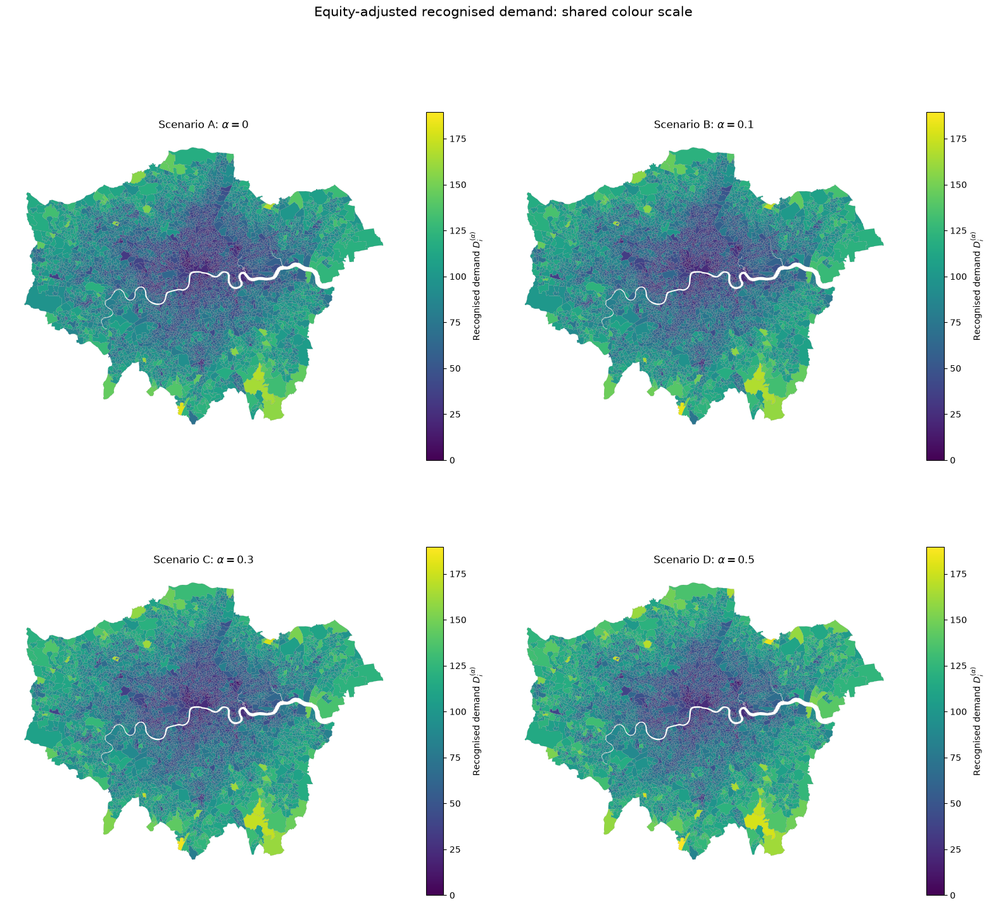
$D_{i}\left(α\right)$ across all four equity scenarios, plotted on a shared colour scale for direct comparison.
The four panels look broadly similar: demand is dominated by household vehicle stock ($H_{i}C_{i}$), which varies far more across LSOAs than the equity multiplier does. Outer boroughs (notably the south-east and north-east) show consistently higher demand, reflecting higher car ownership rather than income deprivation.
This confirms the demand "skeleton" is not overwhelmed by the equity term — the multiplicative structure keeps household vehicle stock as the dominant driver, with the equity weighting acting as a secondary adjustment.
Figure 4.1b. Where equity weighting adds recognised demand ($D_{i}\left(α\right)-D_{i}\left(0\right)$, Scenarios B/C/D vs A)
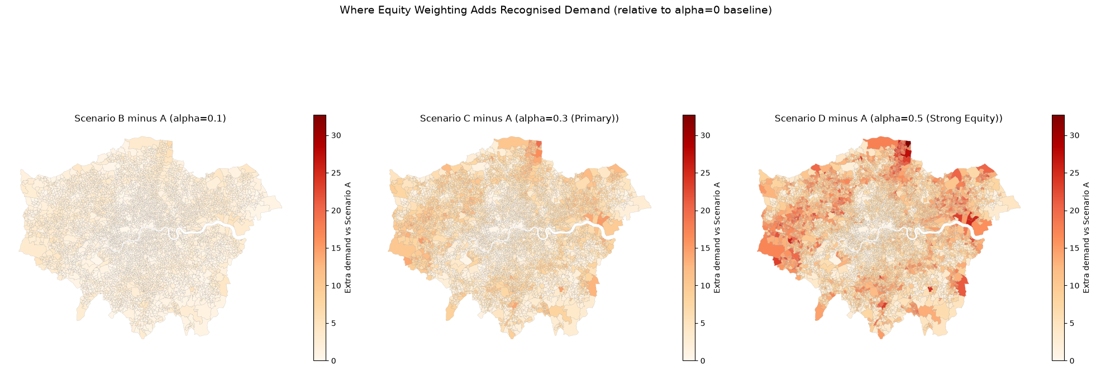
Isolates the demand added purely by the equity term, on its own colour scale (the added amounts are small relative to $D_{i}$ itself).
The added demand grows in both magnitude and spatial extent as $α$ increases — barely visible at $α=0.1$, clearly concentrated in specific LSOAs by $α=0.3$, and covering a substantially larger area with several near-maximum values by $α=0.5$.
The spatial pattern of added demand tracks income deprivation (cf. EDA Panel B), confirming the equity mechanism is directing additional recognised demand toward the intended areas.

4.2 Existing Provision & Spatial Mismatch
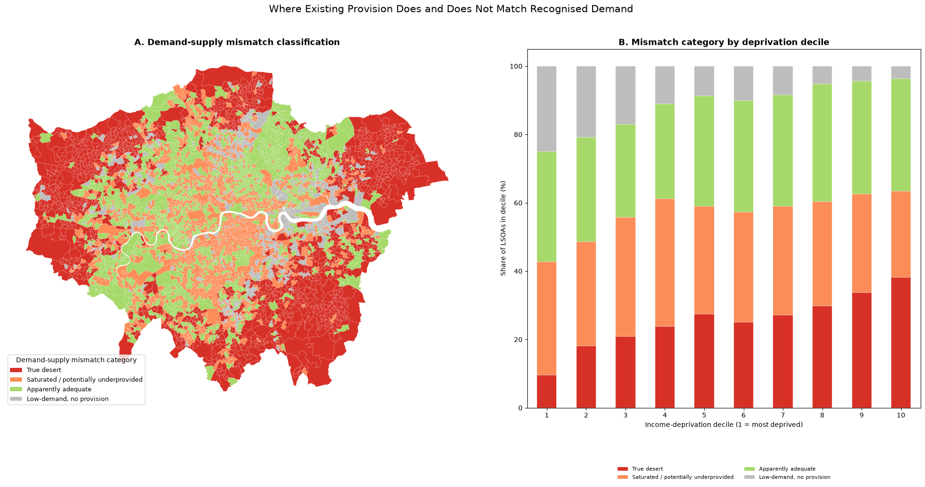
Finding 1 — counter-intuitive: True desert rises with affluence, not deprivation
- Decile 1 (most deprived): 9.6% → Decile 10 (least deprived): 38.2%, roughly monotonic.
- Likely explanation: $B_{i}$ (car-ownership demand) itself higher in affluent outer boroughs → more LSOAs cross the desert threshold even where off-street parking reduces reliance on on-street charging.
- Reads as a limitation of on-street-only supply measure ($e_{i}$), not evidence deprived areas are well served.

Finding 2 — consistent with equity motivation: saturation skews toward deprived deciles
- Saturated/underprovided: Decile 1 = 33.2% vs Decile 10 = 25.2%.
- Where provision exists in deprived areas, it's used more intensively — consistent with greater observed utilisation pressure
Finding 3 — most directly motivates O1's equity term
- Low-demand, no provision: Decile 1 = 25.0% vs Decile 10 = 3.6% — steep gradient.
- Car-ownership-only demand ($B_{i}$) systematically under-flags deprived LSOAs as low priority.
- Direct empirical bridge to $\left(1+α⋅IMD_{i}\right)$ in §3.4.1 — this is the blind spot the equity weighting corrects.

4.3. Allocation & Evaluation

5. Discussion 2000words
5.1. Implications
5.2. Next steps
5.3. Limitations
L12 A maximum service-radius scenario (e.g. 800 m, following Kchaou-Boujelben 2021) was considered but not tested within the project timeline. This is a natural direction for future sensitivity analysis.
6. Conclusion 500words
7. References
8. Appendix
Research log
整理repository

