Tema 1

**Ex1:**

Sa se afiseze orasul si codul locatiei in care lucreaza in prezent salariatii angajati pe un job al carui titlu se termina in "clerk" sau care se gaseste intr-o tara a carei denumire are pe a 4-a sau a 5-a pozitie litera "a".

SELECT DISTINCT l.location_id, l.city

FROM employees e, jobs j, locations l, countries c, departments d

WHERE ((e.job_id = j.job_id) AND (c.country_id = l.country_id)

AND (d.department_id = e.department_id) AND (d.location_id = l.location_id)

AND (lower(j.job_title) LIKE '%clerk'))

UNION

SELECT DISTINCT l.location_id, l.city

FROM locations l, countries c

WHERE c.country_name LIKE '____a%' OR c.country_name LIKE '___a%';

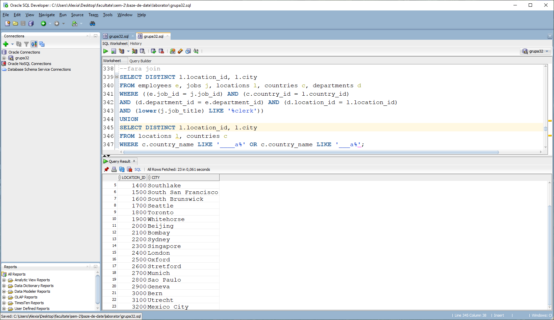

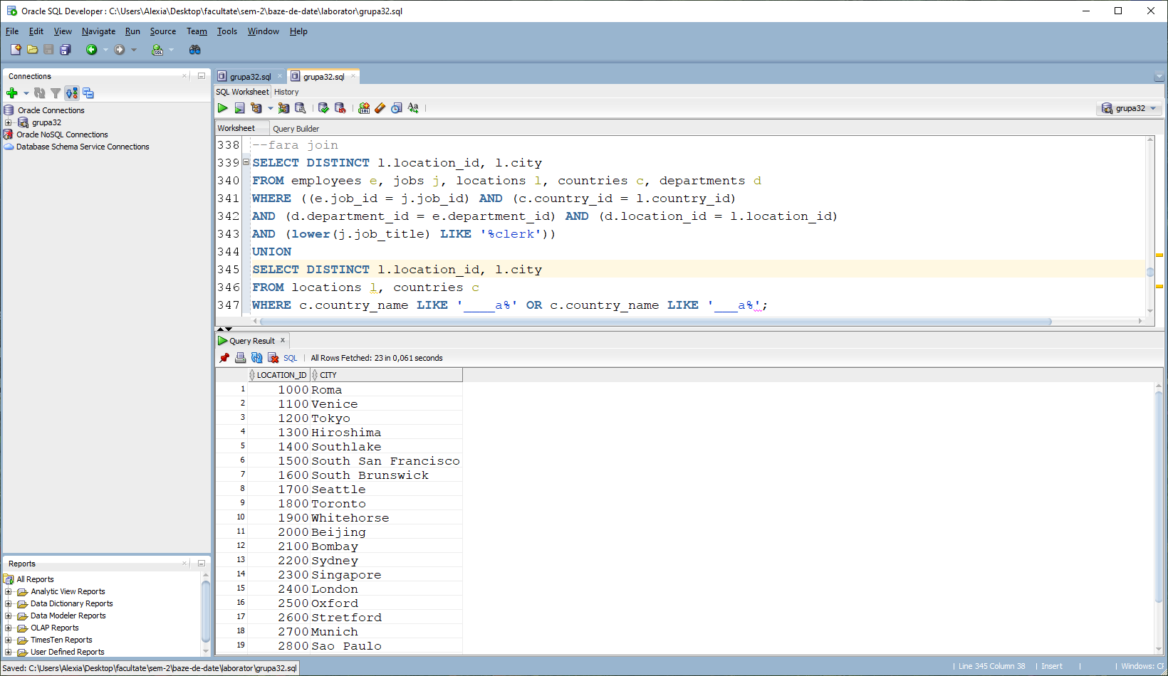

**Ex 2a):**

Sa se afiseze numele complet, job-ul (titlul) actual si departamentul (numele) actual

pentru angajatii care in prezent lucreaza intr-un departament si pe un job

pe care au lucrat in trecut si alti salariati angajati dupa 29-Octombrie-1993.

Se va tine cont atat de job, cat si de departament. Ordonati rezultatele descrescator in functie de codul departamentului si  apoi dupa titlul jobului.

SELECT DISTINCT e1.first_name, e1.last_name , j.job_title, d.department_name,e1.department_id

FROM employees e1

LEFT JOIN departments d ON e1.department_id = d.department_id

LEFT JOIN jobs j ON e1.job_id = j.job_id

WHERE

e1.department_id IN

(SELECT DISTINCT h.department_id FROM employees e

JOIN job_history h ON e.employee_id = h.employee_id

WHERE e.hire_date > '29-10-1993' )

AND

e1.job_id IN

(SELECT DISTINCT h.job_id FROM employees e

JOIN job_history h ON e.employee_id = h.employee_id

WHERE e.hire_date > '29-10-1993')

ORDER BY e1.department_id DESC, j.job_title DESC;

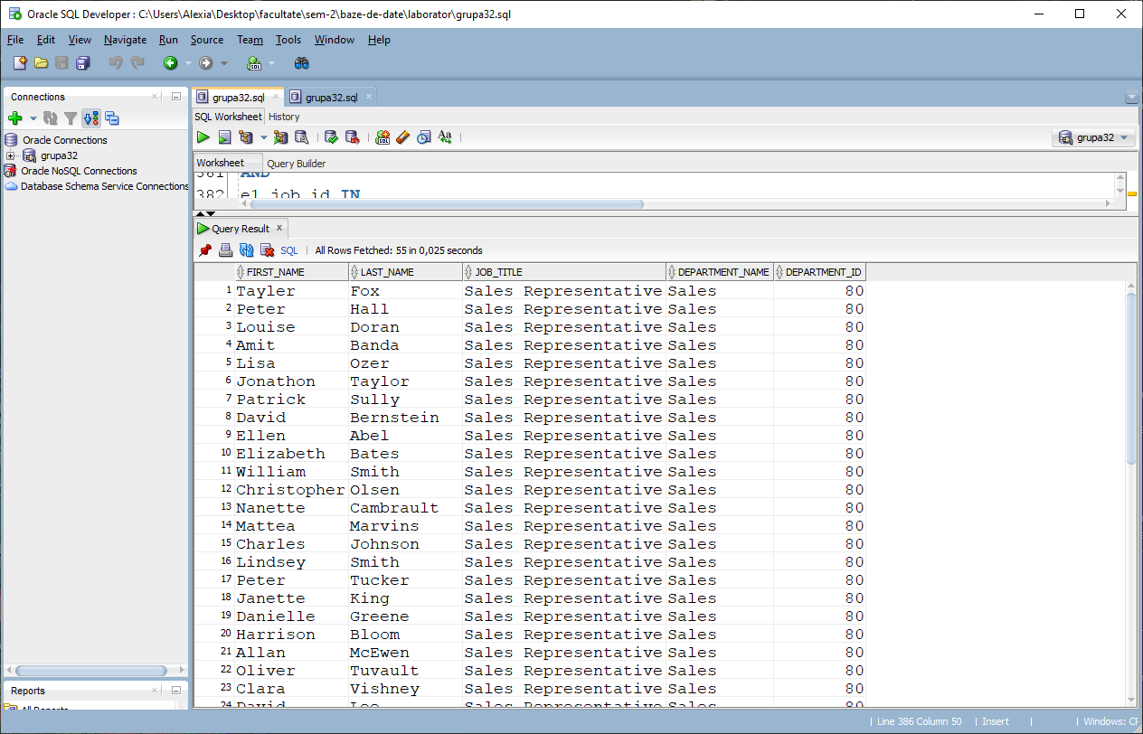

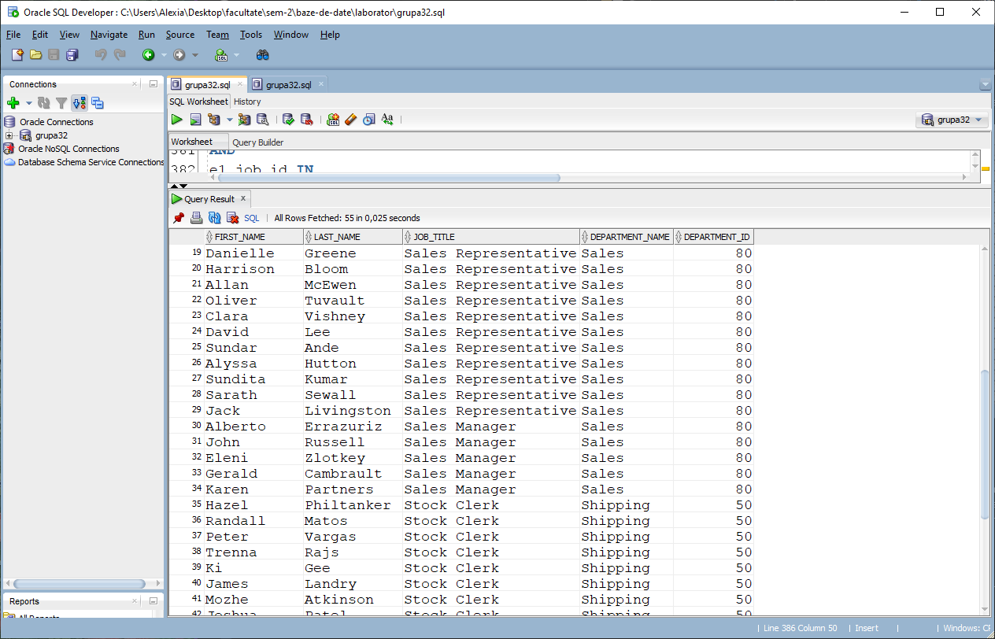

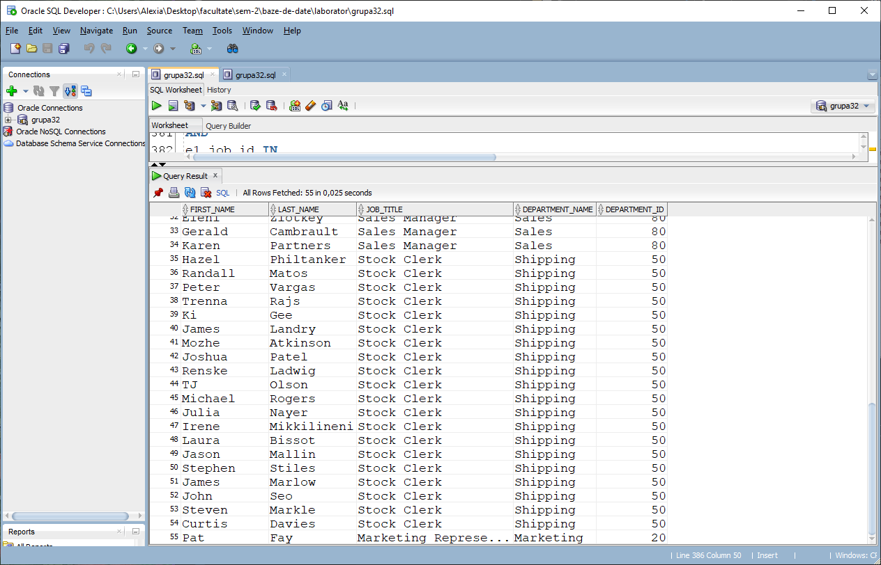

**Ex 2b):**

Modificati cererea anterioara astfel incat sa se tina cont doar de lista job-urilor pe care au lucrat in trecut angajatii indiferent de departamentul in care au lucrat. Discutati diferentele aparute in cod, cat si despre rezultatele obtinute.

SELECT DISTINCT e1.first_name, e1.last_name , j.job_title, d.department_name,e1.department_id

FROM employees e1

LEFT JOIN departments d ON e1.department_id = d.department_id

LEFT JOIN jobs j ON e1.job_id = j.job_id

WHERE

e1.job_id IN

(SELECT DISTINCT h.job_id FROM employees e

JOIN job_history h ON e.employee_id = h.employee_id

WHERE e.hire_date > '29-10-1993')

ORDER BY e1.department_id DESC, j.job_title DESC;

Fata de codul de la 2a), acesta elimina filtrarea dupa departamente, cautandu-se doar job-urile pe care le-au avut angajatii intrecut. Astfel, imi afiseaza un rezultat in plus, anume pe Kimberly Grant care nu tine de vreun departament. In cod propriu-zis, a fost eliminat SELECT-ul ce continea conditiile legate de departament.

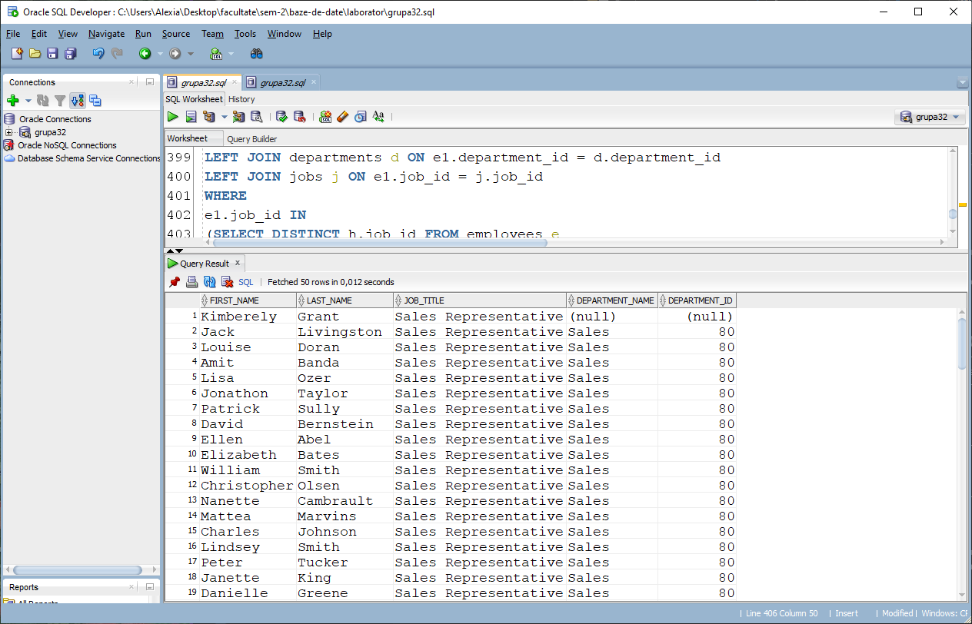

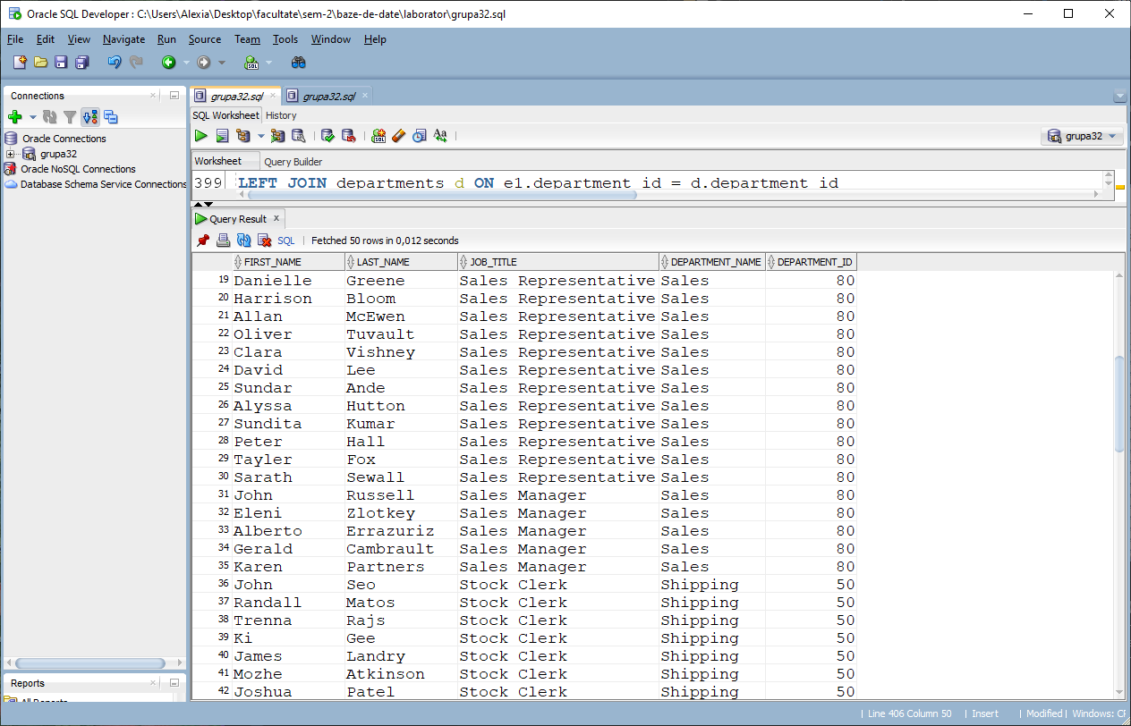

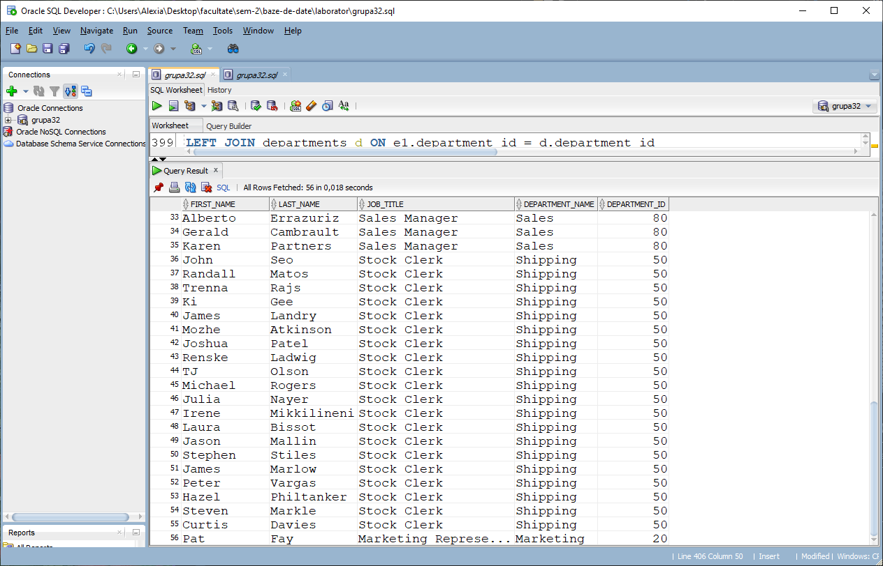

**Ex2c):**

Sa se afiseze numele complet, job-ul (titlul) actual si departamentul (numele) actual

pentru angajatii care in prezent lucreaza intr-un departament sau pe un job

pe care au lucrat in trecut si alti salariati angajati dupa 29-Octombrie-1993. Discutati diferentele aparute in cod, cat si despre rezultatele obtinute.

SELECT DISTINCT e1.first_name, e1.last_name , j.job_title, d.department_name,e1.department_id

FROM employees e1

LEFT JOIN departments d ON e1.department_id = d.department_id

LEFT JOIN jobs j ON e1.job_id = j.job_id

WHERE

e1.department_id IN

(SELECT DISTINCT h.department_id FROM employees e

JOIN job_history h ON e.employee_id = h.employee_id

WHERE e.hire_date > '29-10-1993' )

OR

e1.job_id IN

(SELECT DISTINCT h.job_id FROM employees e

JOIN job_history h ON e.employee_id = h.employee_id

WHERE e.hire_date > '29-10-1993')

ORDER BY e1.department_id DESC, j.job_title DESC;

La acest subpunct, rezultatele include angajatii care au lucrat in acelasi departament sau pe acelasi job in trecut. In cod, singura diferenta fata de subpct a) este cuvantul “AND” care a fost inclocuit cu “OR” pentru a indeplini cerinta.

