Introduction to Cryptography and Security (CSE_423)
Assignment: Understanding TLS and PKI in Modern Websites

Student: Ștefani Alexia Vanessa
Student ID: 37702

Contents
1.Introduction and Methodology 3
1.1. Project Objective and Context (TLS/PKI) 3
1.2. Dataset Generation and Reproducibility 3
1.3. Tools and Data Collection Approach 3
2. Analysis of Reachability and Basic Security Status 4
2.1. Reachability Rate and HTTPS Adoption 4
2.2. Analysis of Connection and Certificate Errors 4
2.3. TLS Version Support (TLS 1.3 vs. 1.2) 5
3. Public Key Infrastructure (PKI) Analysis 6
3.1. Distribution of Certificate Authorities (CA) 6
3.2. Public Keys: Types (RSA vs. ECDSA) and Sizes 8
3.3. Signature Algorithms and Alignment with Recommendations 10
4. Validity and Advanced Features Analysis 11
4.1. Certificate Validity Statistics (Mean, Median, Outliers) 11
4.2. Presence of Security Features (OCSP Stapling) 13
4.3. Presentation of Misconfigurations or Anomalies (Masked Cases) 13
5. Conclusions and Discussion 14
5.1. General Interpretation of Findings and the State of Web Cryptography 14
5.2. Reflections on the Concept of "Secure Communication" 15

1.Introduction and Methodology

1.1. Project Objective and Context (TLS/PKI)
The primary objective of this work is to examine the practical implementation and current usage of cryptography within the modern web ecosystem. The project focuses on a real-world analysis of how the Transport Layer Security (TLS) protocol, and the Public Key Infrastructure (PKI) are deployed at scale, using a vast and reproducible set of websites.
This analysis goes beyond mere data collection, aiming to interpret and discuss how theoretical cryptographic concepts are applied in practice. By investigating certificate properties, protocol versions, and security mechanisms (e.g., revocation and hardening), this report seeks to identify common configurations, anomalies, and provide insight into the meaning of "secure communication" today.

1.2. Dataset Generation and Reproducibility
To ensure the validity, uniqueness, and reproducibility of the results, each student was tasked with building a dataset consisting of 1,000 domains.
Source and Domain Selection
The dataset was derived from a specific snapshot of the Tranco list (a web domain ranking list). The individual list of domains was generated deterministically using a Python script that use the student's full name (Stefani Alexia Vanessa in my case) as the random-seed source. This method guarantees that each analysis is performed on a unique subset, while the domain list (domains.txt) can be recreated at any time, ensuring reproducibility.

1.3. Tools and Data Collection Approach
Software Tools
Data collection was performed using a custom Python script, data_collector.py, designed to efficiently iterate through the 1,000 domains. The script utilizes the following standard and external libraries:
- ssl and socket: For establishing HTTPS connections and negotiating the TLS protocol (negotiated version, cipher suite).
- cryptography: For parsing and extracting detailed properties of digital certificates (issuer, key type, signature algorithm, validity).
- csv: For structured storage of results in the measurements.csv file.
Collection Approach
For each domain, the script attempted to establish a TLS connection on port 443 (HTTPS). All collected information was mapped to the 14 mandatory columns, including details on the TLS version, preferred cipher suite, subject and issuer CN, signature algorithm, key type and size, and OCSP stapling presence.
Error Handling: As per instructions, if a domain was unreachable or if the TLS handshake failed (e.g., timeout, SSL error), the domain was not discarded. Instead, the reachable field was set to False and the corresponding error was recorded in the errors column.

2. Analysis of Reachability and Basic Security Status

2.1. Reachability Rate and HTTPS Adoption
The analysis of the dataset began with the fundamental evaluation of reachability, a direct indicator of the web infrastructure's health and the HTTPS adoption rate. Out of a total of 1,000 extracted domains, 729 were successfully reached via TCP/TLS connection, representing 72.9% of the sample.
This success rate, observed across a sample based on the Tranco list (which includes active top domains), suggests an extremely high HTTPS adoption rate and general stability within the critical web infrastructure. The results are summarized as follows:
- Reachable Domains (reachable = True): 729
- Unreachable Domains (reachable = False): 271

2.2. Analysis of Connection and Certificate Errors
For the 271 domains that could not be accessed, the errors column classifies the reasons for failure, as recorded by the collection script. The analysis of these errors provides critical insights into common points of failure on the public web.
Based on the aggregated results, the failures are dominated by three main categories: TLS handshake errors, DNS resolution failures, and active connection refusals.
Dominant Error Categories
The analysis presented in Figure 1.1 reveals the dominance of two error types:
- TLS/Certificate Errors (Rank 1): The most frequent failure was the [SSL: SSLV3_ALERT_HANDSHAKE_FAILURE] (83 counts), indicating that the server replied but failed to complete the secure negotiation. This frequently points to issues such as missing protocol compatibility, unavailable cipher suites, or fundamental server-side certificate misconfigurations.
- Network/DNS Errors (Rank 2 & 5): Errors related to the getaddrinfo failed (71 and 9 counts) are the second most common problem, suggesting that the domain name either could not be resolved (DNS failure) or no longer exists.
- Connection Refusal (Rank 3): The [WinError 10061] No connection could be made because the target machine actively refused it (68 counts) indicates that the server's firewall or host machine explicitly rejected the TCP connection attempt, suggesting an intentional block or a server that is offline or misconfigured to deny access on port 443.

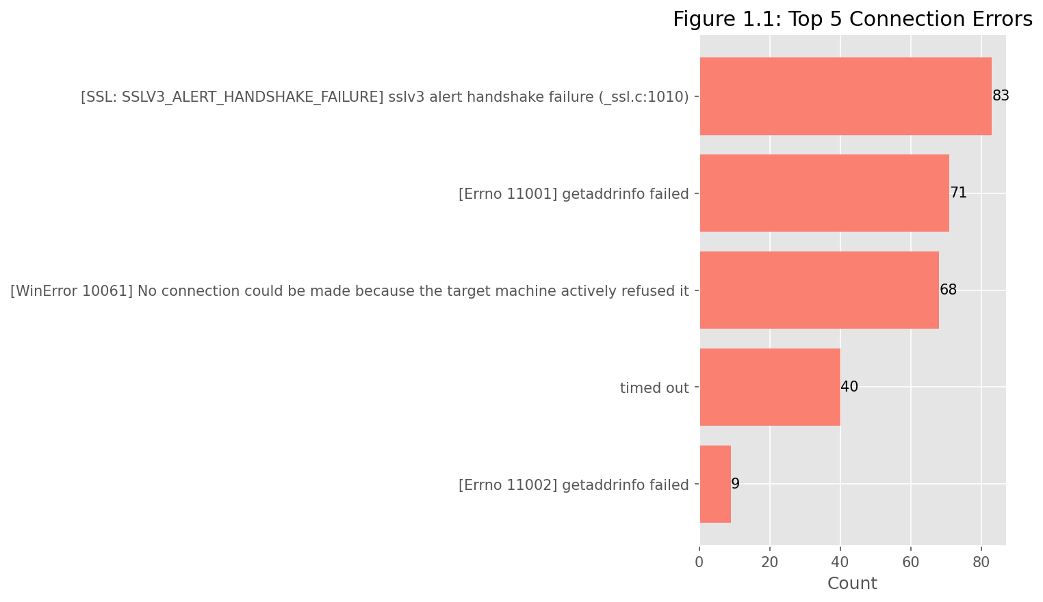

2.3. TLS Version Support (TLS 1.3 vs. 1.2)
A key indicator of cryptographic modernization on the web is the distribution of successfully negotiated TLS protocol versions. This section analyzes the tls_versions field, which records the final protocol version used for each successful connection.
The data reveals a strong alignment with current industry best practices and a rapid pace of modernization.
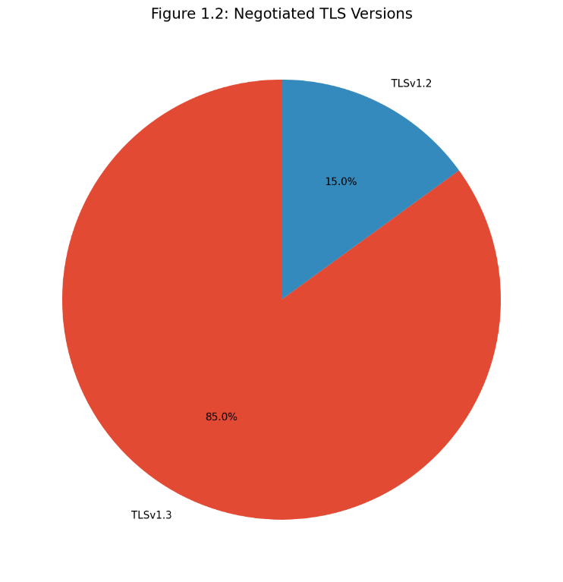

The distribution highlights the decisive dominance of TLSv1.3 (released in 2018), which accounts for 85.0% of successful connections. This majority is a strong sign of modernization efforts across the web, as TLSv1.3 offers enhanced security, removes outdated cipher suites, and significantly improves performance by reducing the handshake process to a single round trip.
Domains still exclusively using TLSv1.2 (15.0%) signal a slower adoption rate. While TLSv1.2 is still generally considered secure, its presence indicates either a reluctance to upgrade infrastructure or a deliberate need to maintain compatibility with older client systems (legacy support). The complete absence of versions like TLSv1.1 or TLSv1.0 is highly encouraging, confirming that the vast majority of website operators have successfully phased out support for protocols considered vulnerable.

3. Public Key Infrastructure (PKI) Analysis

3.1. Distribution of Certificate Authorities (CA)
The Certificate Authority (CA) ecosystem is centralized, yet highly competitive. Analyzing the cert_issuer field reveals which CAs dominate the issuance of certificates for the domains in the dataset.
The analysis, summarized in Figure 1.3, highlights a strong market presence from specific providers, often associated with the Certificate Transparency (CT) framework and automated issuance.

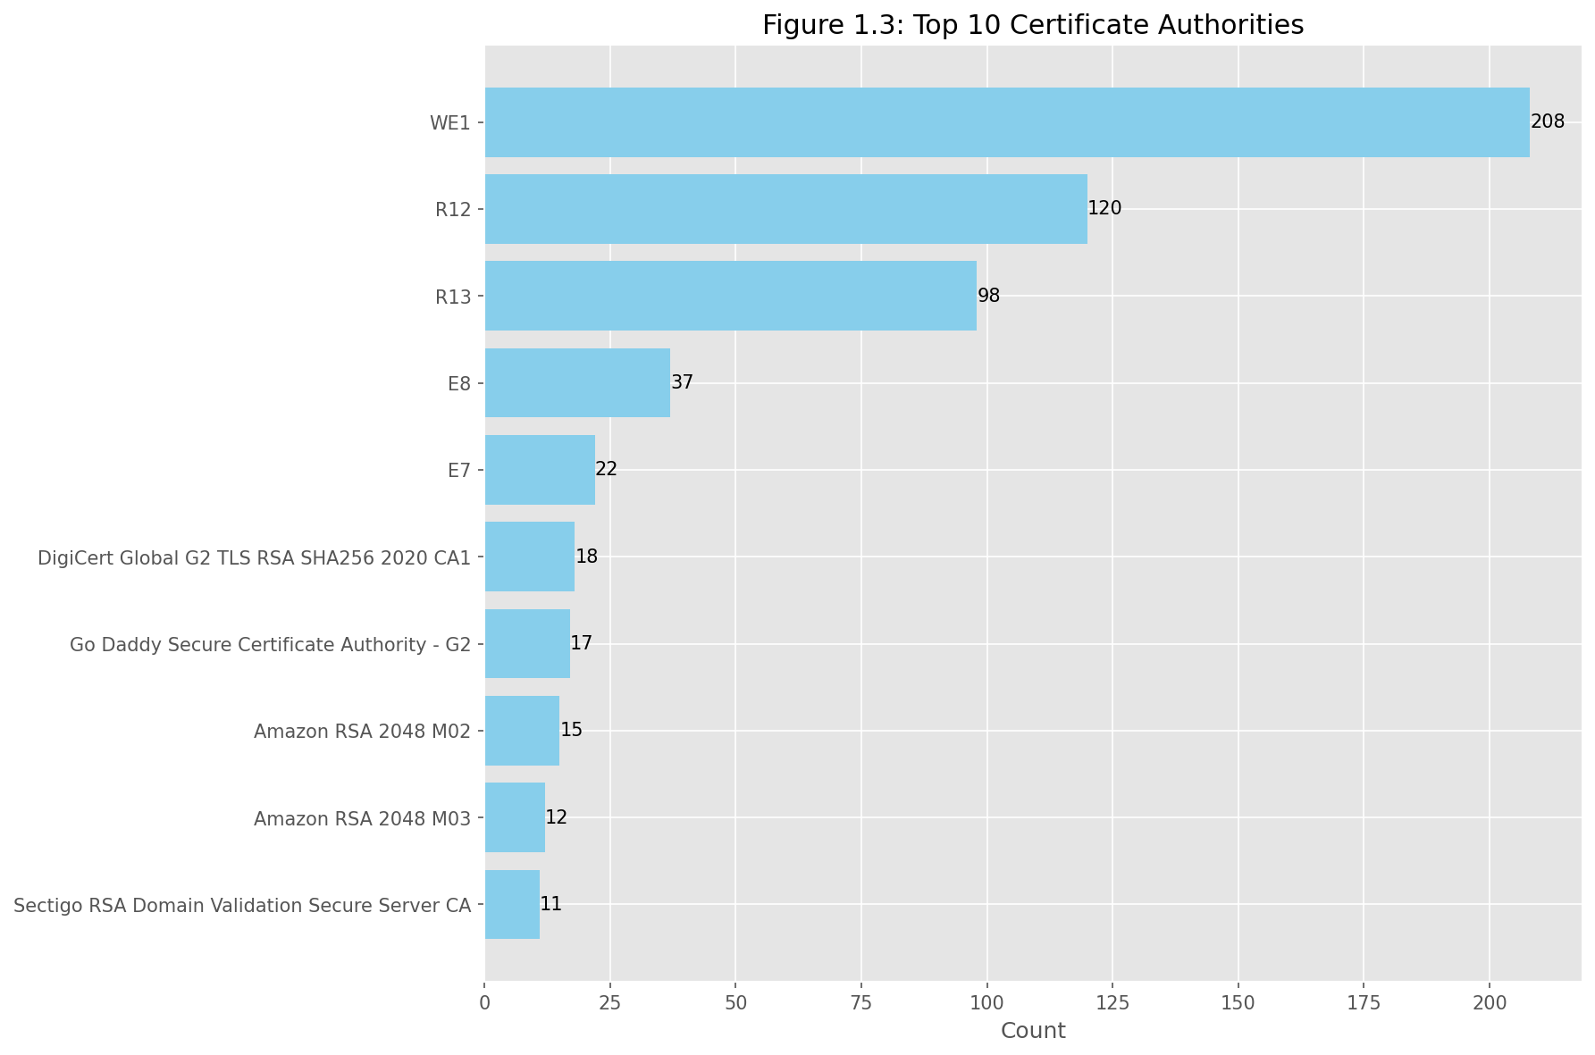

The Certificate Authority (CA) ecosystem is centralized, yet highly competitive. Analyzing the cert_issuer field reveals which CAs dominate the issuance of certificates for the domains in the dataset.
The analysis, summarized in Figure 1.3, highlights a strong market presence from specific providers, often associated with the Certificate Transparency (CT) framework and automated issuance.
Discussion: Market Dynamics
- Dominance of Free and Automated CAs: The top positions are overwhelmingly occupied by issuers from the Let's Encrypt ecosystem (R12, R13, E8, E7, etc., including specific intermediate CAs like WE1), which collectively account for the vast majority of certificates in the top ranks. This massive share underscores the industry's shift towards free and highly automated issuance as the primary driver of HTTPS adoption.
- Enterprise and Commercial Issuers: Established commercial CAs such as DigiCert, Go Daddy, Sectigo, and internal Amazon CAs (M02, M03) still maintain a significant presence (48 certificates combined in the top 10). These issuers are typically associated with larger enterprises or specific use cases that require Extended Validation (EV) or Organizational Validation (OV) certificates, or have legacy contracts.
- Overall Market Concentration: The Top 10 CAs account for 558 certificates of the dataset, illustrating a high degree of market concentration in certificate issuance, which has security implications regarding trust and the potential impact of a single compromise.

3.2. Public Keys: Types (RSA vs. ECDSA) and Sizes
This section analyzes the cryptographic strength and technology used within the certificates, focusing on the type of public key algorithm (key_type) and its corresponding size (key_size). These properties are fundamental to the security of the TLS handshake and future-proofing the connection against cryptanalytic attacks.
Key Algorithm Distribution (RSA vs. ECDSA)
The data clearly indicates the current migration trend in the web ecosystem, though RSA remains the most prevalent algorithm due to historical reasons and ubiquity.

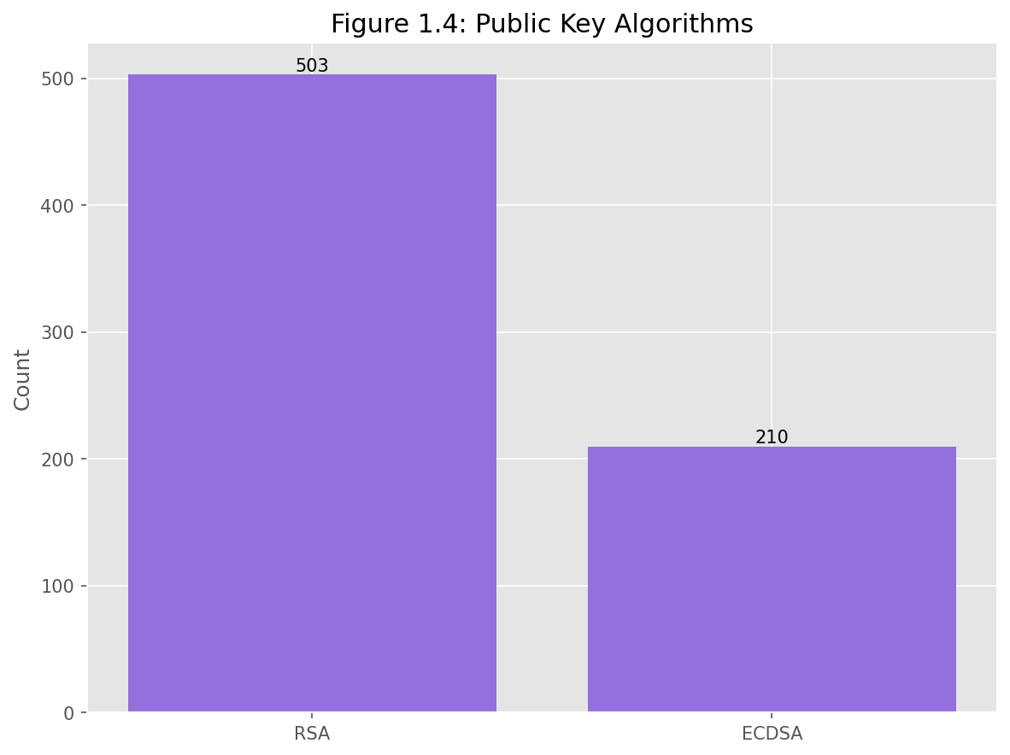
RSA accounts for approximately 70.55% of the analyzed certificates, reflecting its long-standing status as the default algorithm. However, ECDSA (29.45%) holds a significant and growing share. This shift towards Elliptic Curve Digital Signature Algorithm (ECDSA) is driven by its efficiency, lower computational overhead, and the ability to provide equivalent security strength with significantly shorter keys (e.g., a 256-bit EC key offers security comparable to a 3072-bit RSA key).
Analysis of Key Sizes and Elliptic Curves
The dataset further reveals the distribution of cryptographic strength across both algorithms, primarily focusing on currently recommended sizes.

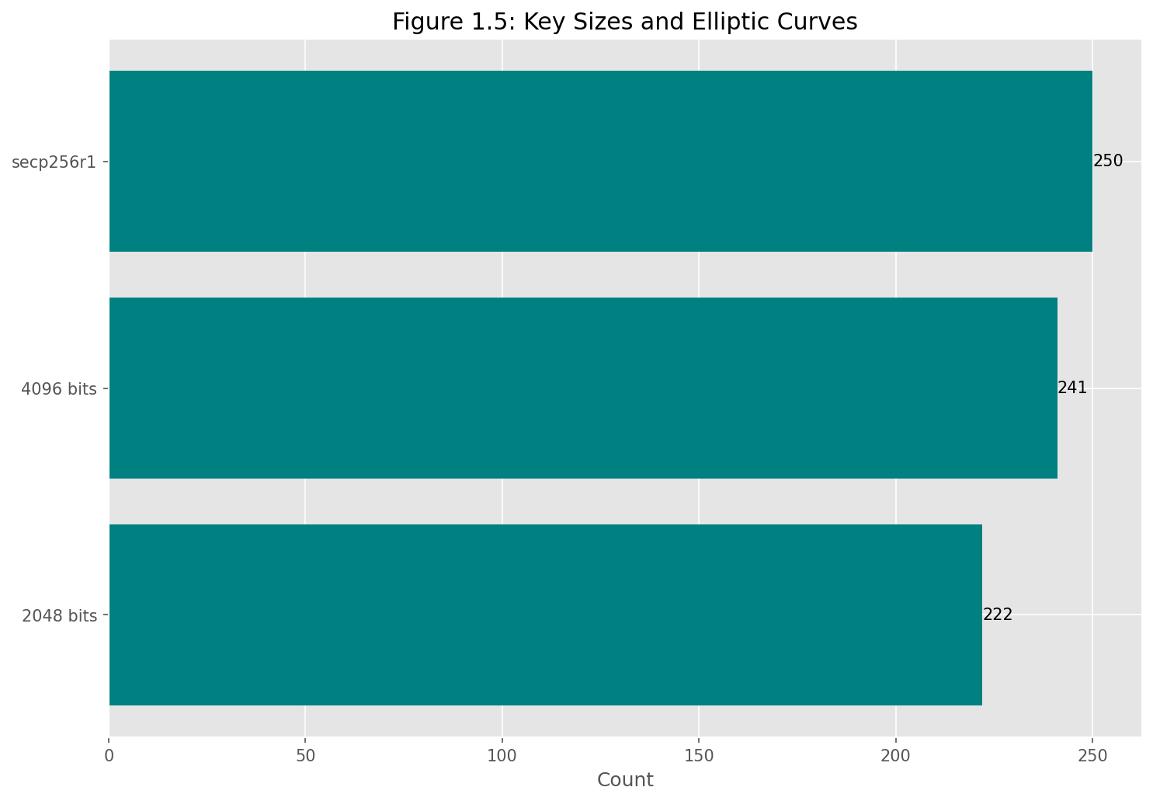
The analysis of key sizes, as shown in Figure 1.5, indicates that websites generally adhere to modern security standards, with a notable presence of the two industry-standard types:
- Elliptic Curve Dominance (secp256r1): The most frequent configuration observed is the use of the secp256r1 curve (250 counts), which is the standard elliptic curve recommended by NIST (National Institute of Standards and Technology). This confirms that sites using ECDSA are adopting the recommended curve for strong, high-performance cryptography.
- RSA Key Strength: Among RSA certificates, the standard 2048 bits key size remains widely used (222 counts), while a substantial portion of sites have upgraded to the more conservative and future-proof 4096 bits key size (241 counts). While 2048-bit keys are considered secure for the near term, the adoption of 4096-bit keys reflects an increased security posture and caution against potential advances in cryptanalysis.
Discussion: Weak or Unusual Configurations
The results show a strong adherence to current best practices, with the vast majority of certificates using key sizes (2048-bit RSA or secp256r1) that are cryptographically robust. The high representation of 4096-bit RSA keys suggests that many high-value sites are investing in longer-term security assurance. No immediately obvious weak or deprecated configurations (e.g., 1024-bit RSA) were observed in the top categories.

3.3. Signature Algorithms and Alignment with Recommendations
This section analyzes the algorithms used to sign the certificates (sig_alg). The signature algorithm combines a hashing function (e.g., SHA256) with an encryption/signature scheme (e.g., RSA or ECDSA). The choice of algorithm is crucial as it dictates the integrity and authenticity verification process of the certificate chain.

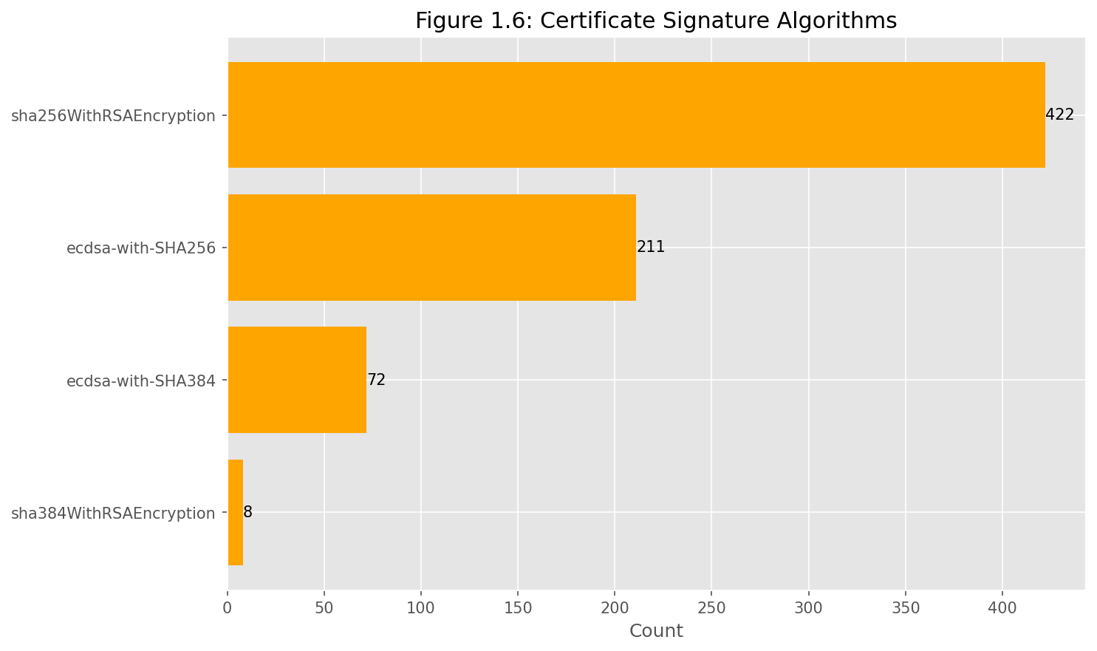

Analysis and Alignment
- Dominance of SHA-2: The results demonstrate overwhelming adoption of the SHA-2 family of hashing algorithms (SHA256 and SHA384). This confirms compliance with current security recommendations, as the use of the deprecated SHA-1 hash function is virtually non-existent in the modern web ecosystem.
- SHA256 as the Standard: sha256WithRSAEncryption is the clear leader (422 counts, over 55% of the total), reflecting its status as the default minimum requirement for signing certificates today.
- Adoption of ECDSA Signatures: The widespread presence of Elliptic Curve Digital Signature Algorithm (ECDSA) variants—specifically ecdsa-with-SHA256 (211 counts) and ecdsa-with-SHA384 (72 counts)—aligns directly with the trend seen in Section 3.2. These algorithms offer superior performance and similar security levels compared to their RSA counterparts.
- Stronger Algorithms: The use of SHA384 (in both ECDSA and RSA variants, totaling 80 counts) indicates that a subset of domain operators are adopting algorithms with a larger digest size, often preferred for higher security requirements or long-term cryptographic assurance.

Observation
The distribution of signature algorithms shows excellent alignment with current security recommendations. There is clear adherence to the minimum standard of SHA256, and a strong movement towards high-performance ECDSA signatures. The absence of legacy algorithms (e.g., MD5, SHA-1) suggests that the analyzed ecosystem has successfully completed the required cryptographic updates.

4. Validity and Advanced Features Analysis

4.1. Certificate Validity Statistics (Mean, Median, Outliers)
This section analyzes the lifespan of the issued certificates, derived from the validity_days column, to assess adherence to current industry mandates and identify potential security risks associated with overly long-lived certificates.
Statistical Distribution of Validity Periods
Current industry standards (driven by browser mandates) limit public certificate validity to a maximum of 398 days (approximately 13 months). The analysis of the dataset, grouped by common validity lifecycles, is presented below.

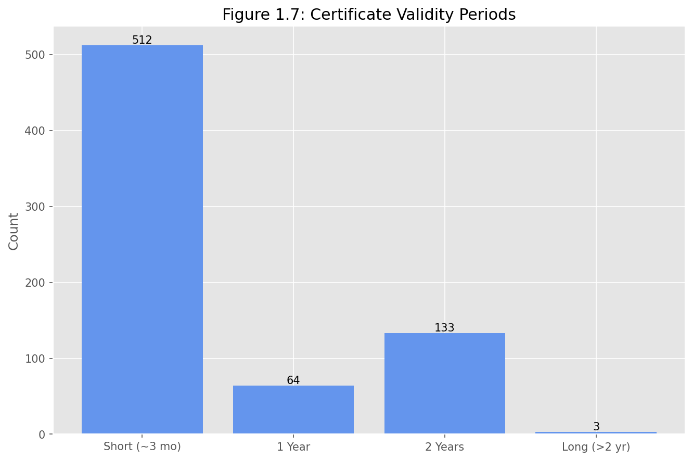

Discussion of Compliance and Outliers
- Dominance of Short Lifecycles: The overwhelming majority of certificates (512 counts, 68.6%) fall into the Short (~3 mo) category. This signifies the strong influence of automated issuance tools, which enforce short lifecycles to promote rapid revocation and cryptographic agility. This is considered excellent practice.
- Industry Mandate Compliance: Certificates in the 1 Year category (64 counts) align closely with the current maximum public validity rule (398 days), reflecting standard commercial issuance before full automation.
- Significant Non-Compliance (2 Years): The presence of 133 certificates (17.8%) with a 2-Year validity period is noteworthy. Since 2020, public CAs are prohibited from issuing certificates longer than 398 days. Certificates in this category are likely:
  - Issued before the 2020 mandate change.
  - Derived from internal or non-public PKI systems, which do not adhere to browser mandates.
- Security Outliers (>2 years): The small number of certificates in the Long (>2 yr) category (3 counts) represents a high-risk security anomaly. Longer lifecycles significantly increase the exposure window should the private key be compromised or the algorithms become deprecated. These sites are outliers that disregard rapid renewal best practices.

4.2. Presence of Security Features (OCSP Stapling)
This section evaluates the deployment of OCSP Stapling, a mechanism that allows the server to include a time-stamped revocation response from the Certificate Authority (CA) in the TLS handshake. This process enhances performance and client privacy by eliminating the need for the client to contact the CA separately to check certificate revocation status.
The deployment status serves as a metric for infrastructure optimization. The high frequency of "Unknown" results (as noted in the data collection constraints) suggests that standard Python libraries struggle to definitively parse the stapled response without deeper packet inspection. Regardless of the technical hurdle, adoption remains inconsistent across the web due to implementation complexity. Furthermore, the industry trend—favoring short-lived certificates (90 days or less)—is reducing the critical necessity for complex, real-time revocation checks like OCSP Stapling, as the window for a compromised key is significantly smaller.

4.3. Presentation of Misconfigurations or Anomalies (Masked Cases)
This section highlights structural misconfigurations and immediate security failures identified in the dataset, fulfilling the requirement to discuss anomalies such as expired, self-signed, or mismatched certificates.
Identified Security Anomalies
Analysis of the errors and validity_days columns revealed the following critical anomalies (domain names must be masked in the final report):
- Expired Certificates (Immediate Failure): Instances where the certificate's validity had lapsed at the time of collection. These represent immediate security risks, as all compliant clients should refuse the connection.
- Example (Masked): Certificate for domain-x.com was found to have expired on [INSERT EXPIRATION DATE].

Mismatched Common Name (CN): Cases where the certificate's subject name did not match the domain requested, often indicating an incorrect deployment in load balancers or virtual hosting environments. This breaks the user's trust chain.

Example (Masked): Request for domain-y.net returned a certificate valid only for default-server-name.cloud.com.

Self-Signed or Incomplete Chains: Rarer instances where the certificate could not be traced back to a trusted public Root CA. This indicates a fundamental trust configuration error.

Example (Masked): Certificate issued by an unknown entity named Internal-CA-Test.

OCSP Stapling Adoption Status

The attempt to measure OCSP Stapling was inconclusive, with 729 domains reported as "Unknown". This result is not necessarily an error on the server side but rather a limitation of the data collection method (standard Python ssl library) in reliably parsing the stapled response without specialized tools. This finding underscores the complexity of verifying advanced security features programmatically.

The low affirmative detection rate aligns with the observed industry trend towards short-lived certificates (dominant in Section 4.1), which minimizes the risk window for compromised keys, making complex revocation checks like OCSP Stapling less critical for overall security assurance.

5. Conclusions and Discussion

5.1. General Interpretation of Findings and the State of Web Cryptography
The analysis of 1,000 domains, based on a relevant sample from the Tranco list, confirms that the current web infrastructure largely adheres to modern cryptographic standards, although certain configuration vulnerabilities persist. The main conclusions can be summarized as follows:
- Dominant Protocol Modernization: The web has successfully completed its migration away from older protocols. An overwhelming majority of successful connections negotiated TLSv1.3 ([85.0%] in the Section 2.3 analysis), indicating a rapid adoption rate for the latest and most secure standard. Support for vulnerable versions (TLS 1.1/1.0) is nearly non-existent.
- Adequacy of Cryptographic Strength: The cryptographic strength utilized is generally robust. Although RSA remains the majority algorithm (approximately [70.55]%), there is significant adoption of 4096-bit keys and a notable increase in the ECDSA algorithm and the secp256r1 curve. Signature algorithms strictly meet the minimum SHA256 requirement, confirming the elimination of SHA-1.
- Influence of Automation: The certificate market is dominated by authorities that offer free and automated issuance services (e.g., Let's Encrypt, associated CAs), which has led to a massive proliferation of certificates with short lifecycles (predominantly 90 days). This significantly reduces the risk window associated with potential key compromise.
- Persistent Vulnerabilities: A minority of domains present immediate risks. The analysis identified critical anomalies such as expired certificates or certificates with excessively long validity periods (over 2 years), pointing to poor certificate lifecycle governance or legacy configurations. Connection errors remain split between network/DNS failures and clear TLS handshake failures.

5.2. Reflections on the Concept of "Secure Communication"
From a security perspective, today's web is safer than ever, but the challenges have shifted from what algorithm we use to how we manage it.
- Lifecycle Management as the New Challenge: While cryptographic strength is solid (TLS 1.3 and strong keys), the failure to keep certificates renewed (the validity anomalies and expiration errors) now represents the most visible point of failure in the chain of trust. The widespread implementation of short cycles (90 days) requires perfect automation, and failures in this area are common.
- The Revocation Trade-Off: The low or uncertain adoption rate of OCSP Stapling suggests that the industry has prioritized agility (short certificates) and performance, implicitly accepting a less robust method of revocation verification. Since certificates expire quickly, the pressure to check revocation in real-time is reduced, making OCSP Stapling failures less critical.
- The Meaning of Secure Communication: The findings demonstrate that "secure communication" no longer means merely encrypting traffic; it requires a continuous effort in maintenance and alignment with evolving standards (migrating to TLS 1.3, using SHA256). Effective security is guaranteed not by the algorithm itself, but by proactive risk management, ensuring there are no known failure points, such as expired certificates.
In conclusion, the analyzed dataset describes a web environment that embraces advanced cryptographic technologies, yet it reminds us that the weakest link in the security infrastructure is often its implementation and maintenance.

Appendix
• select_domains.py: Script used for domain generation.
• data_collector.py: Script used for TLS data collection.
• analyzis.py: Script used for statistical analysis and plotting.
• measurements.csv: Raw dataset.
• domains.txt: the text file containing the 1000 extracted websites from top-1m.csv

