Aleks Atanasov

COS 221

Fall Semester 2022

Vladimir Georgiev

10.12.2022

Project User Guide

User Guide

Idea:

We have a datafile called “Data.txt”. Inside it, information about all the rented vehicles could be found. Of course, multiple vehicles could be also added or removed, but user should be careful considering the different types of vehicles and their attributes. That is why in the data we have a line of strings, without spaces just commas separating different attributes fields. One line that represent one vehicle at a time.

Every single vehicle starts with its type:(Car, Electric, Van, Luxury, Scooter, Bike, Kart, RX7, RX250 and Double) and after that the respective remaining attributes it has.

If the user does not want to add or remove data, he can simply run the program. When adding a vehicle, user should be careful which vehicle what attributes possess. And that in some cases duration is measured in days, minutes, hours or laps.

**Car** and **Electric** have: name, model, colour, year of production, horsepower, mileage, transmission, fuel type, daily rent price, duration of rent, maximum tank amount, tank amount after rent, yes or no whether user paid protection Plus, cost of protection Plus

**Van** has: number of seats, van type, number of doors, name, model, colour, year of production, horsepower, mileage, transmission, fuel type, daily rent price, duration of rent, maximum tank amount, tank amount after rent, yes or no whether user paid protection Plus, cost of protection Plus

**Luxury** has: whether or not the car has sports mode, whether or not car is cabrio, name, model, colour, year of production, horsepower, mileage, transmission, fuel type, daily rent price, duration of rent, maximum tank amount, tank amount after rent, yes or no whether user paid protection Plus, cost of protection Plus

**Scooter** has: name, starting fee, duration in minutes, price per minute, top speed and weight

**Bike** has: name, number of wheels, price per hour, duration in hours, number of gears, colour and wheels size

**Kart** and **RX7** have: name, number of laps, price per lap, number, horsepower, and max speed

**RX250** has: starting fee, whether or not the kart has paddle shifters, name, number of laps, price per lap, number, horsepower, and max speed

**Double** has: capacity, weight limit, name, number of laps, price per lap, number, horsepower, and max speed

Execution of the program:

After the program is ran all the vehicles are displayed. They are sorted in an ascending order by their total price. Additionally, more detailed information about the pricing is displayed under the total price so the user can also see the rent and refill tank price - which combined give the total price.

For example: we can take the first line of our data file:

Car,Peugeot_Allure,5008,green,2019,256,automatic,diesel,25,2,60,50,true,75

We see type Car, name is Peugeot Allure, model is 5008, colour is green, year of production is 2019, horsepower is 256, the transmission is automatic, the car runs on diesel, its rent price is 25, duration is 2 days, the full tank of the car is 60, the tank amount left after the usage was 50, it had protection plus and the protection plus costed 75.

Its rent price was $125, while the refill price was $31.4, making it combined $156.4 total price.

After the listed vehicles user has the option to type and search for a specific vehicle.

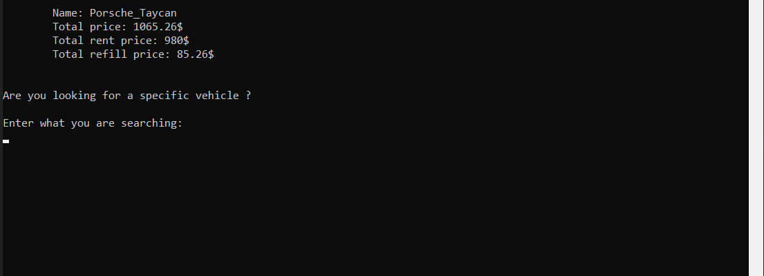

User can search a vehicle by typing its name/part of its name. After that all matches are displayed – after that we reach the end of the program!

