**Task:** To implement simple “Hello , Java “ program in Java(v19).

**Program:**

import java.io.*;

import java.lang.*;

public class hello{

public static void main(String args[]){

System.out.println("Hello Java");

}

}

**Output:**

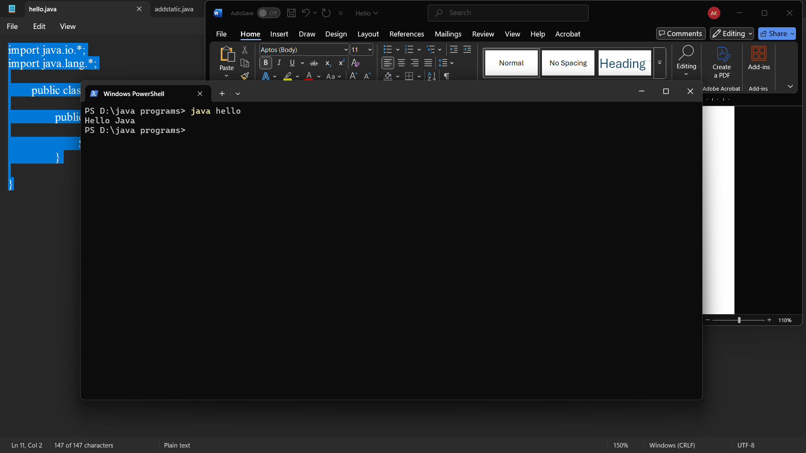

**Task:** To implement arithmetic operations of two integers In java

**Program:**

import java.io.*;

import java.lang.*;

class plus{

void OP(){

int a=20, b= 10, c;

System.out.println("Addition: "+ a +"+" +b+ " =" + (a+b));

System.out.println("Substraction: "+a+"-"+b+" =" + (a-b));

System.out.println("Multiplication: "+a+"*"+b+" =" + (a*b));

System.out.println("Division: "+a+"/"+b+" =" + (a/b));

System.out.println("Modulus: "+a+"%"+b+" =" + (a%b));

}

}

public class addstatic{

public static void main(String args[]){

plus p=new plus();

p.OP();

}

}

**Output:**

