Arduino

Arduino is a programming language similar to C, making it easy to configure Arduino or similar electronic boards. To do this, we're going to use the Arduino manufacturer's software.

The board we have is similar to the arduino uno.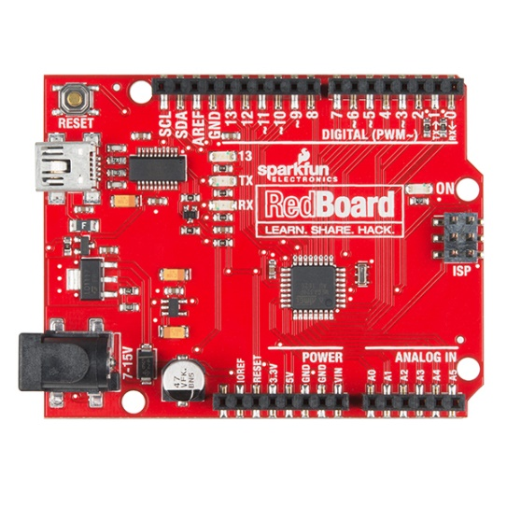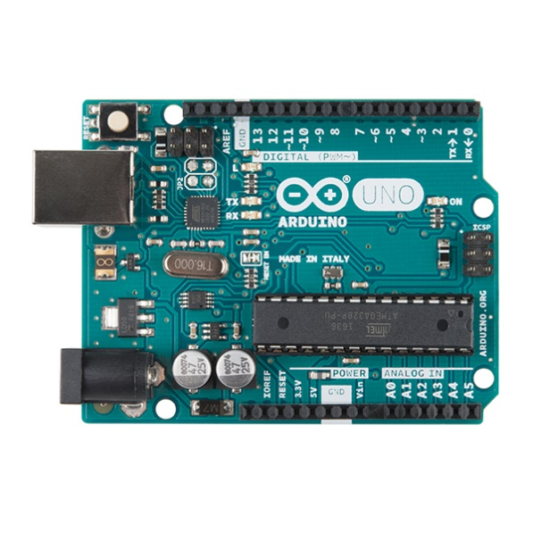

Arduino UNO

Sparkfun RedBoard

Their functions are totally similar.

To use the board, you first need to download the Arduino software, available free of charge from this link.

<https://www.arduino.cc/en/software>

Once this has been done, simply open the code in the "project_sensor\avec_expl\arduino_finale\S17_ecranlcd" folder, where the code is explained. To implement the code on the board, you first need to connect the Arduino board to your computer and check that the correct port is associated with it. To do this, go to Outils 🡪 Port 🡪 Select the associated port:

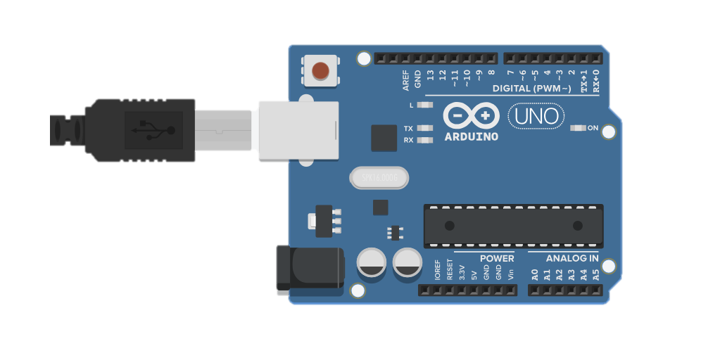

The next step is to embed the code in the card. Simply press this button, and the code will self-compile and embed itself in the card :

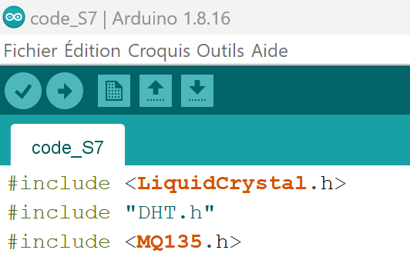

HARDWARE :

For the hardware part of our system, all connections must be respected as shown in the images below:

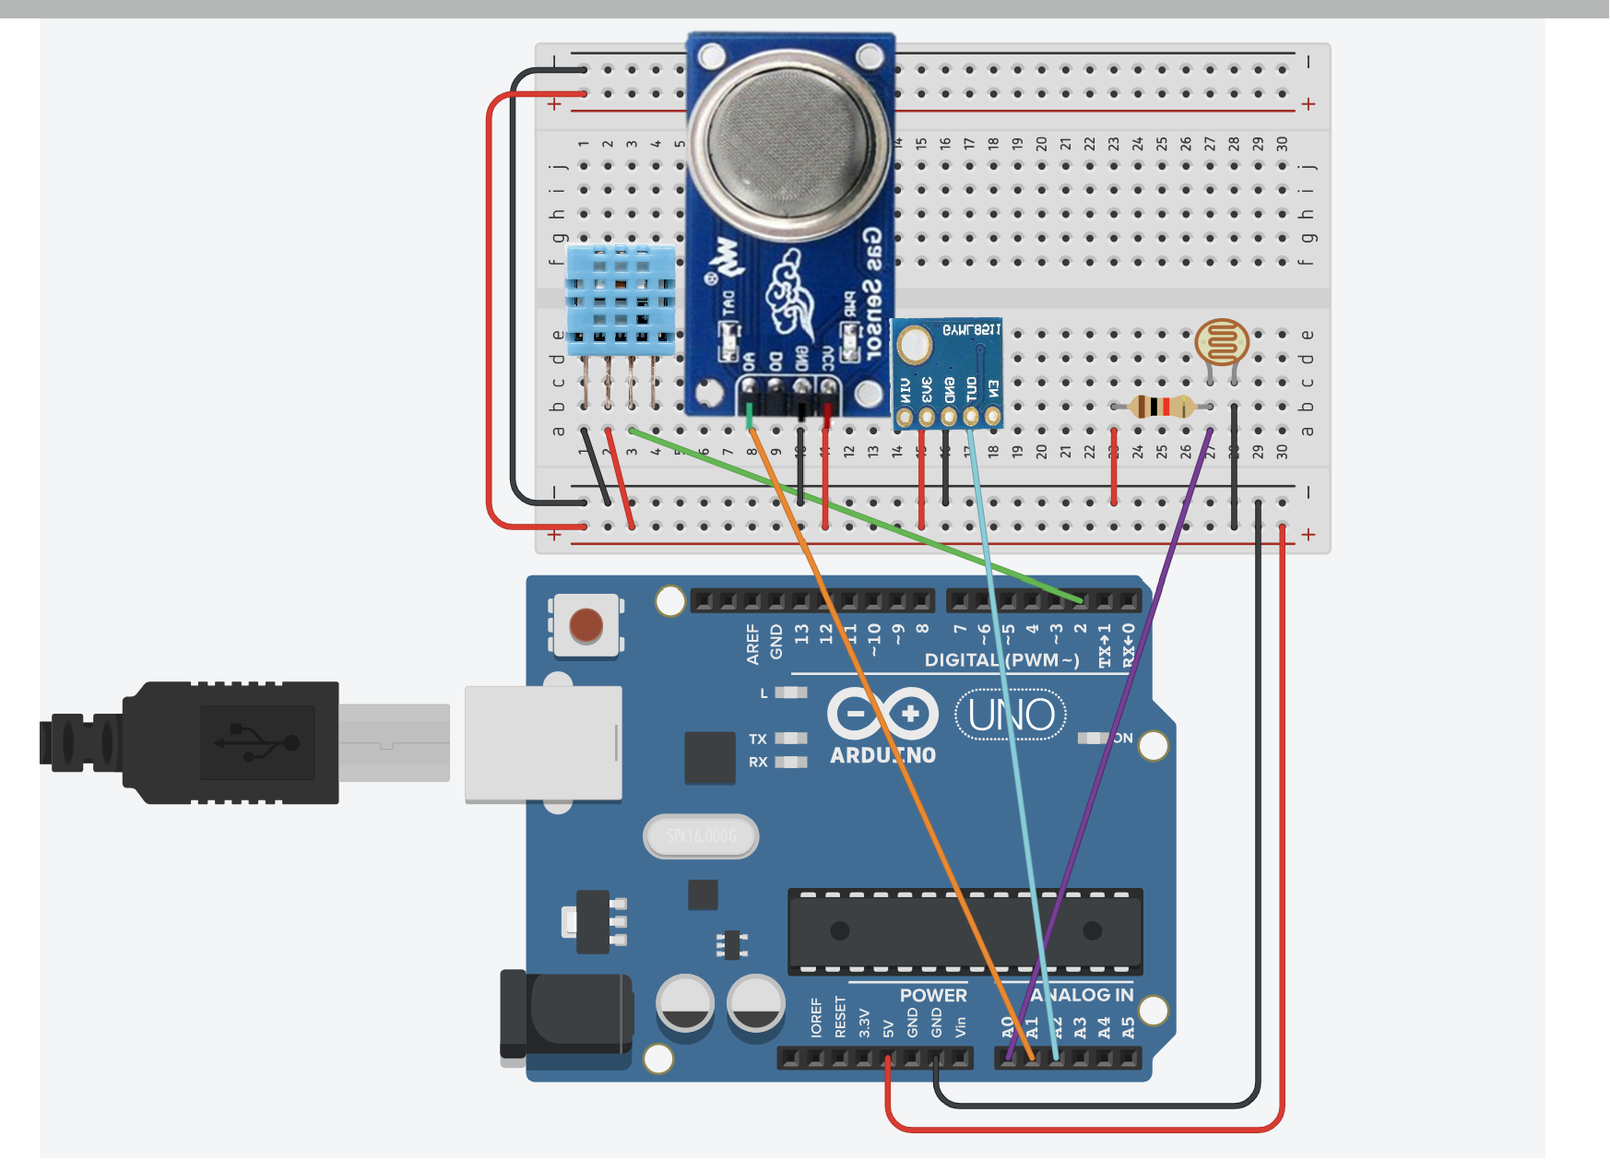

XAMPP

Xampp is a software package that combines a virtual machine running on Apache2 and a MySql database, making it easy to launch our database without the need for complex configuration.

The first step is to install the XAMPP software.

https://www.apachefriends.org/fr/download.html

Once installation is complete, simply open the software, which looks like this: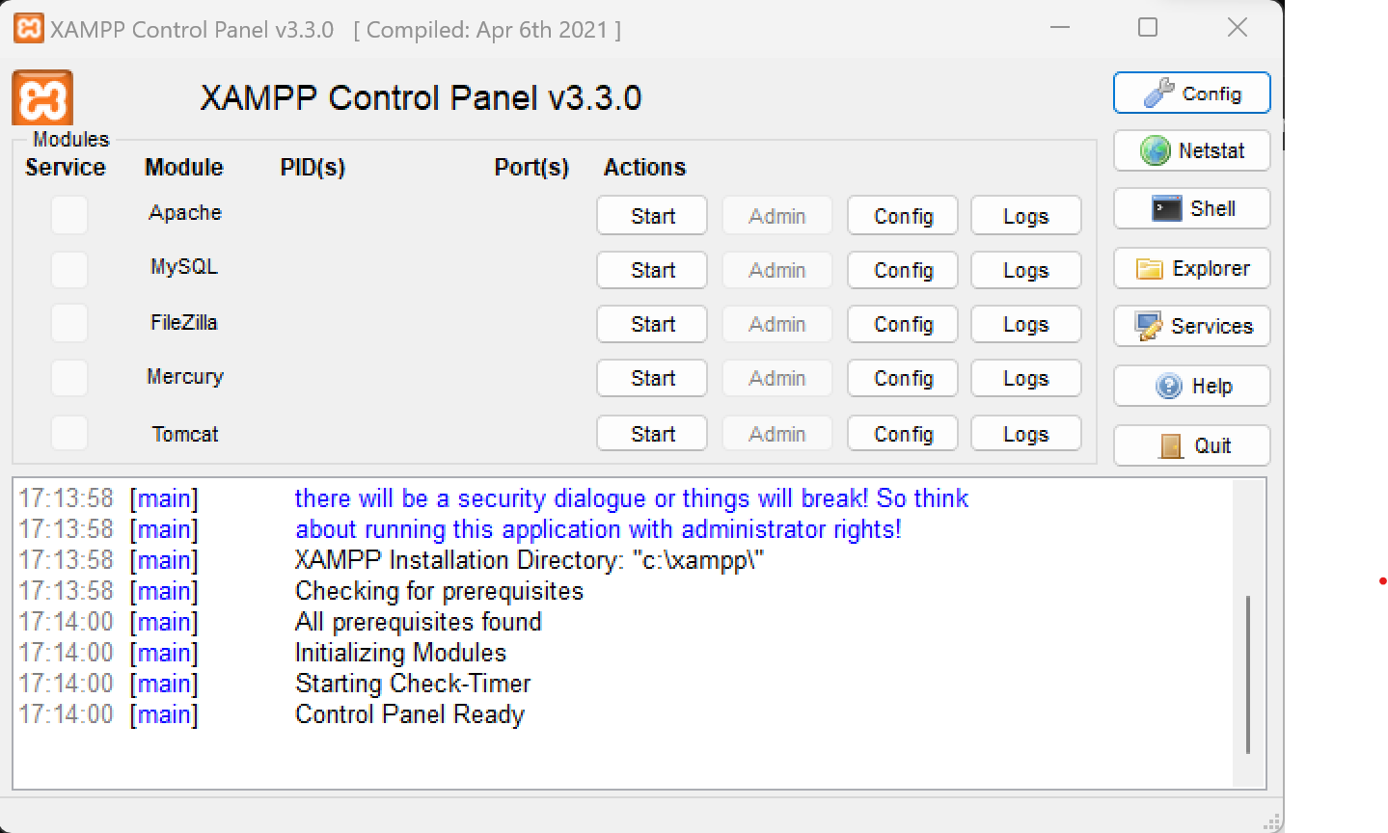

First, you need to start the virtual machine running Apache and the database running Mysql. Then click on the two 'start' buttons circled above.

Once this is done, to access the database, simply click on the 'Admin' button as shown below.

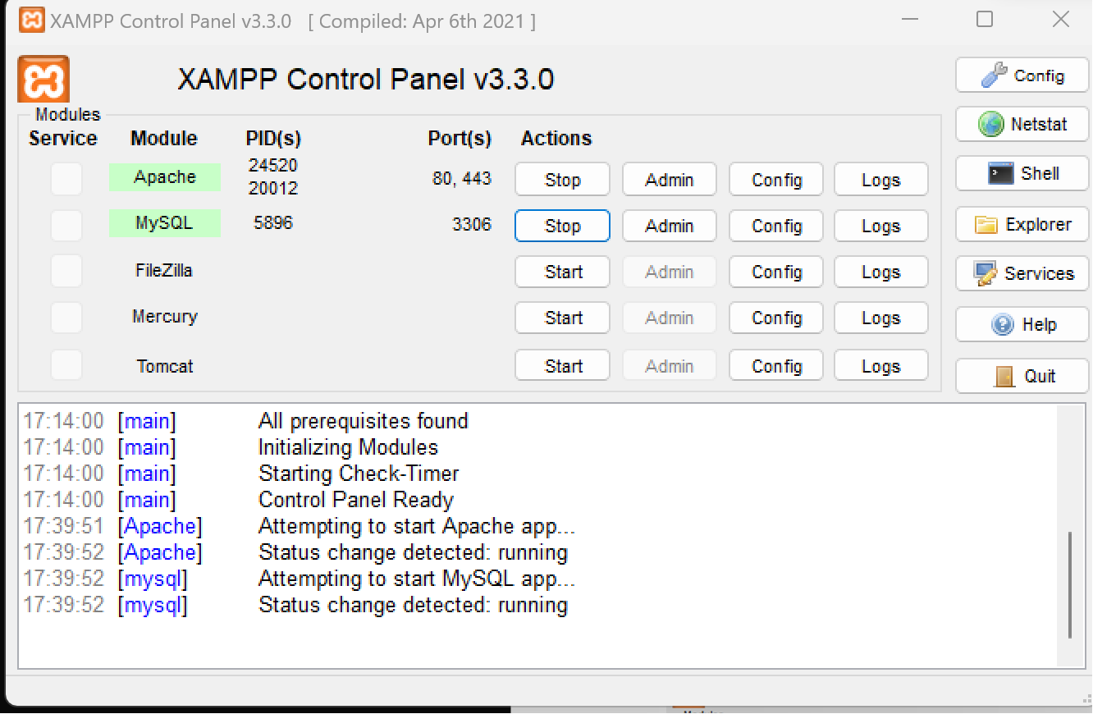

If nothing happens, open any web browser and run http://localhost/phpmyadmin/.

Once you're in myAdmin, you'll need to create the database that will host all our data. The first step is to go to the link above, then go to mySql and enter this command, which will create our database:

CREATE DATABASE mydatabase;

Then click on the dataBase, return to the mySql button and enter the command :

CREATE TABLE mydata (

ID INT AUTO_INCREMENT PRIMARY KEY,

dateA DATE,

hoursA TIME,

Temperature VARCHAR(20),

Luminosity VARCHAR(20),

Humidity VARCHAR(20),

AirQuality VARCHAR(20),

UVvalue VARCHAR(20)

);

PYTHON

For data transfer between our data, which arrives via the Arduino code on our serial monitor, and our database, we need Python code.

Python code can be executed with multiple software packages. Here we've used Visual Studio code. To install it, just follow this link:

https://code.visualstudio.com/Download

Once you've done that, simply open the code in the folder: project_sensor\avec_expl\code python

The code is explained directly above. To launch it, simply press this button and select Python in the code type to be executed.

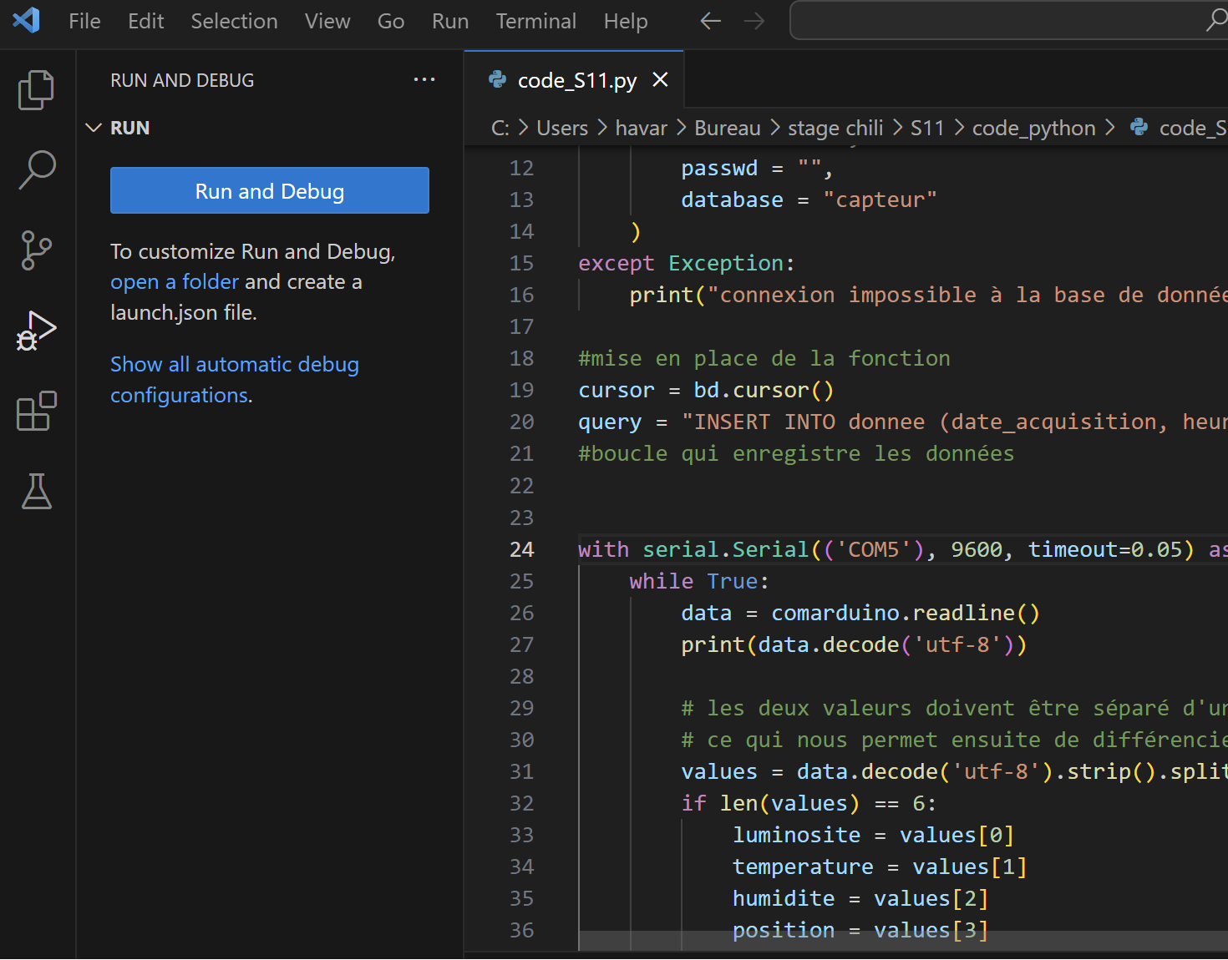

Be careful not to launch the Arduino code at the same time, as the two cannot run simultaneously, as they are trying to read from the same serial monitor. The aim here is to first send the Arduino code as explained above. Once on the board, the software must be closed (it has no further use). Only the Python code should be running.

Le DashBoard

You'll need to open File Explorer and go to C:\xampp\htdocs Once in the htdocs folder, you'll need to move the site folder located in project_sensor \avec_expl\site into the htdocs folder. Then just open any web browser and go to this link. http://localhost/site/monsite.php.

Information

For any changes to the code or the project, please refer to the report for explanations of the project, and to the code with a corresponding explanation for each line. Remember to save the first version of the project in case of error.