**Simplified retirement age planning**

For Christmas this year, you visit your family and during a big family gathering, you meet a distant relative who describes his situation: He is unhappy with his job and would like to quit and retire as soon as possible. He tells you he just turned 55 and has $200,000 saved up. He plans to invest this money into a cheap (assume fee-free) S&P500 accumulating ETF in the next few days to save for this eventual retirement. Further, he tells you that once he retires his portfolio will be his only type of income (no other social benefits or pension rights) and he plans to then withdraw an inflation-adjusted fixed amount of money ($30,000) from this ETF at the end of each year to pay for his living expenses in the following year. As he acknowledges that $200,000 is not enough to retire now, he tells you that for the time he continues working, he will invest an additional $24,000 at the end of each year. In summary, his timeline boils down to:

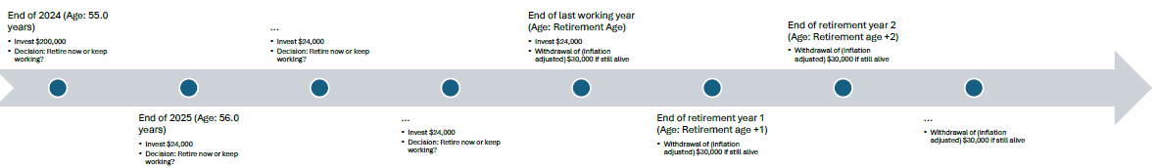

You tell him you study Management in a master’s program and recently learned Python programming and the basics of Monte-Carlo Simulations. Moreover, you promise to code a model suitable for his situation and promise to run it with his personal circumstances. The model should return the number of years that a male person should continue working. Since you plan to reuse the model in the future, it should allow the user to input the following variables, with the last value tailored to your relative's situation:

* Simulation Count (how many simulations is the program running to calculate the result; at least 50,000)
* Starting age (How old is he now; 55 years)
* Starting wealth (How much money has he saved up now; $200,000)
* Savings rate (How much money will be invested at the end of each year if he decides to keep working; $24,000)
* Withdrawal rate (How much money does he need each year once he is retired in End-of-2024 dollars; $30,000)
* Inflation rate (Which constant inflation rate is assumed to adjust the withdrawal rate; 2.5%)
* Uncertainty (How much uncertainty is he willing to accept regarding the possibility of running out of money while still being alive; 5%)

Your task:

* Code up the model and run it for your relative’s personal situation. How many years should he continue working?
* For his situation, plot the relationship between certainty (x-axis) and number of years the model suggests (y-axis).

Hint: The relationship should look similar to this (y-axis ticks hidden on purpose):

* Exclude taxes in your calculations (assume no taxes are due).
* Include lifetime considerations (death probabilities).
* Assume a limit of 120 years for the maximum age.