Xinlei Bian – SEC01 (NUID 002197091)

Big Data System Engineering with Scala  
Spring 2022   
Assignment No. 6



**-List of Tasks Implemented**

Finish WebCrawler.scala and MonadOps.scala

**-Code**

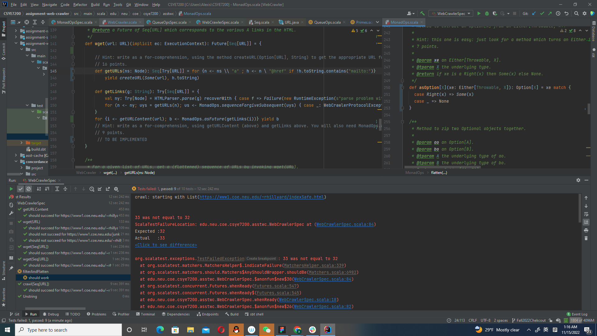

I do not know the reason why a unit test always fails. Sorry that I cannot solve it