**Tâche 1 : Visualisation des métriques de l’échantillon.**

Boites à moustache :

1. 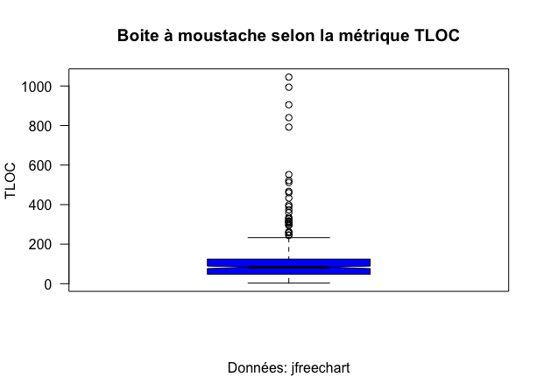TLOC

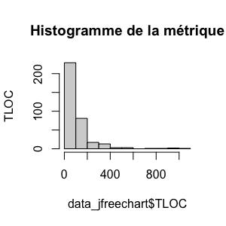

|  |  |  |  |  |  |
| --- | --- | --- | --- | --- | --- |
| Min | 1st Quartile | Median | Mean | 3rd Quartile | Max |
| 3 | 47.5 | 83.0 | 115.1 | 124.5 | 1045 |

1. WMC

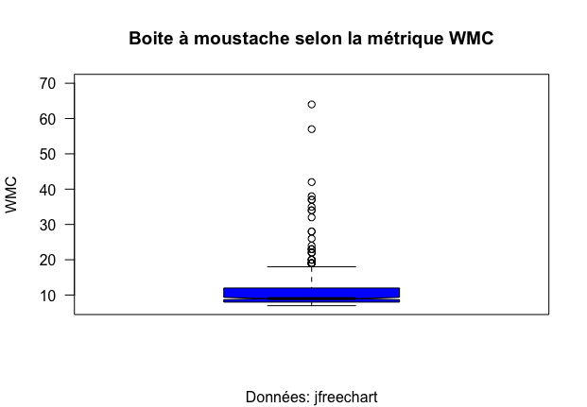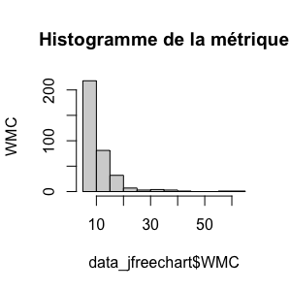

|  |  |  |  |  |  |
| --- | --- | --- | --- | --- | --- |
| Min | 1st Quartile | Median | Mean | 3rd Quartile | Max |
| 7 | 8 | 9 | 11,58 | 12 | 64 |

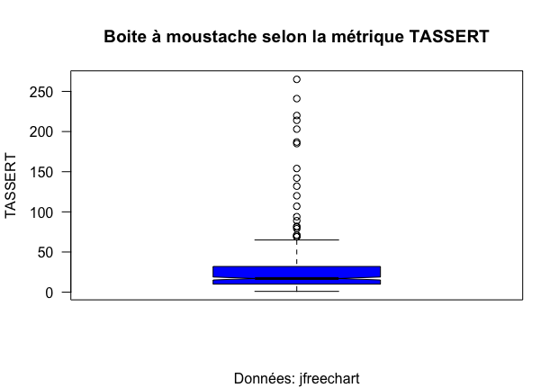3-TASSERT

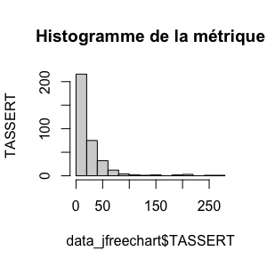

|  |  |  |  |  |  |
| --- | --- | --- | --- | --- | --- |
| Min | 1st Quartile | Median | Mean | 3rd Quartile | Max |
| 1 | 10 | 17 | 27.19 | 32 | 265 |

**Tâche 2 :**

|  |  |  |  |
| --- | --- | --- | --- |
| **Coefficient Corrélation** | **Tassert/TLOC** | **Tassert/WMC** | **Tloc/Wmc** |
| avec extrêmes | 0,938750574 | 0,768556631 | 0,783622162 |
| sans extrêmes | 0,774951952 | 0,48204681 | 0,594096225 |

Tâche 3 :