Oscillators

Technical analysis tools.



Figure : Sinusoidal design, [source](https://www.google.com/url?sa=i&url=https%3A%2F%2Fdribbble.com%2Ftags%2Fsinusoidal&psig=AOvVaw1hVgJi_mp9EA31GG8iqxML&ust=1640810751482000&source=images&cd=vfe&ved=0CAsQjRxqFwoTCPiK_Mauh_UCFQAAAAAdAAAAABAE).

This document is intending to make a review of main oscillators technical analysis tools.

# Oscillators

* An oscillator is a **momentum indicator** used as a technical analysis tool that **constructs high and low** bands **between two extreme values**, typically 100 and 0, then **builds a trend indicator** that fluctuates within these bounds.
* Traders use the trend indicator to discover short-term **overbought** or **oversold** conditions.
* **Combine with other indicator**, like moving average indicator, it **provides trades signals**.
* **Indicator > 70**, overbought: **bearish signal**, opportunity to sell.
* **Indicator < 30**, oversold: **bullish signal**, opportunity to buy.
* When a **price breakout** occurs, the signals may be **misleading**: either the resetting of the range by which the current sideways market is bound or the beginning of a new trend.
* During the **price breakout**, the oscillator may **remain in the overbought or oversold** range for an extended period of time.
* Technical analysts consider oscillators **better suited for sideways markets**.

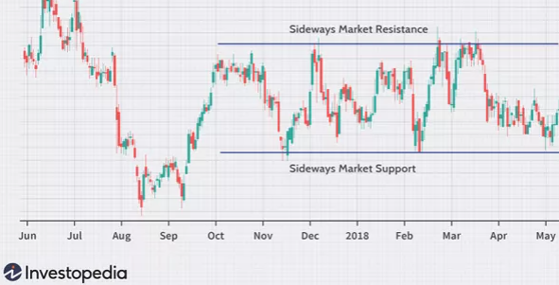

Figure : Sideway market.

# Stochastic Oscillator

* In technical analysis, the stochastic oscillator is a **momentum indicator** that uses support and resistance levels.
* Originally, stochastic refers to the property of being well described by a random probability distribution.
* Here the term stochastic refers to the point of a **current price** in **relation** to its **price range over a period** of time.

## Calculation





* %D is the N-day moving average (or exponential moving average when the volatility is high) of %K (the last N values of %K).
* Price is the last closing price
* ${Low}_{n}$ is the lowest price over the last N periods
* ${High}_{n}$ is the highest price over the last N periods

## Interpretation

* Stochastics attempts to **predict turning points** by comparing the closing price of an asset to its price range.
* Prices tend to close **near the extremes** of the recent range just **before turning points**.
* An **alert** or set-up is present when the **%K line crosses the %D line**.

# Relative Strength Index (RSI)

* RSI is a **momentum indicator** used in technical analysis that measures the magnitude of recent price changes to **evaluate overbought** or **oversold conditions**.
* Used for middle term.

### Formula

* The average gain or loss used in the calculation is the average percentage gain or loss during a look-back period, usually 14 days.

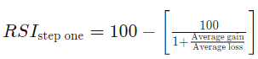

* Example: 7 days with an average gain of 1% and 7 days with an average loss of -0.8%. The calculation would be:

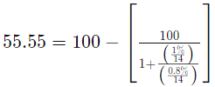

* The indicator can stay in the overbought region for extended periods while the stock is in an uptrend. The indicator may also remain in oversold territory for a long time when the asset is in a downtrend.
* **During a long uptrend** an **oversold reading** is **much higher than 30%**.
* During a **long downtrend** an **overbuy reading** is **much lower than the 70%** level.

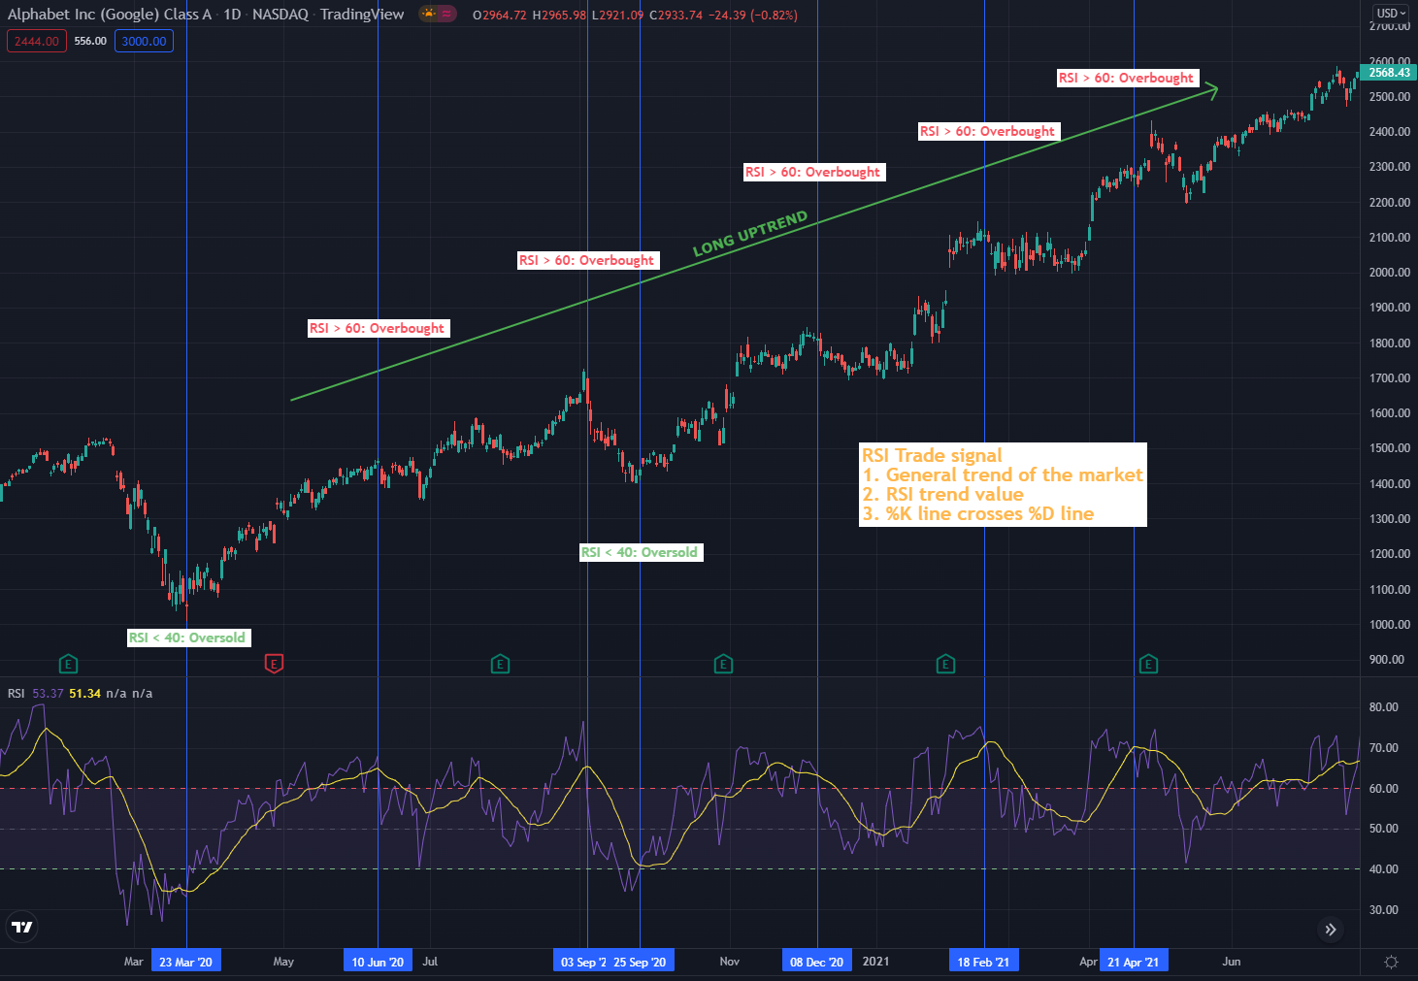

Figure : RSI trades signals

# Stochastic RSI – StochRSI

* The Stochastic RSI (StochRSI) is an indicator used in technical analysis that **gives** traders an **idea** of whether **the current RSI value is overbought or oversold**.
* **StochRSI** is created by **applying** the **Stochastic oscillator** formula to **a set** of relative strength index (**RSI**) **values**.
* **Overbought doesn't** necessarily **mean** the **price** will **reverse lower**, just like **oversold** **doesn't** **mean** the **price** will **reverse higher**. Rather the overbought and oversold conditions **simply alert** traders that the **current RSI** is **near the extremes of its recent readings**.
* That’s why it is used for **short term compared to RSI**.
* A reading of **0 means** the **RSI** is at its **lowest level over the period** (typically 14 days).
* A reading of **100 means** the **RSI** is at the **highest level over the period** (typically 14 days).

### Calculation

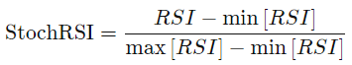

* RSI is the current RSI.
* min [RSI] is the lowest RSI over the period (typically 14 days).
* max [RSI] is the lowest RSI over the period (typically 14 days).

### Difference between StochRSI and RSI

* They **seem similar, but** the StochRSI **relies on a different formula** from what generates RSI values.
* One of the **key differences**: **StochRSI moves** very **quickly** from overbought to oversold, or vice versa, while the **RSI** is a much **slower** moving indicator.
* One isn't better than the other.

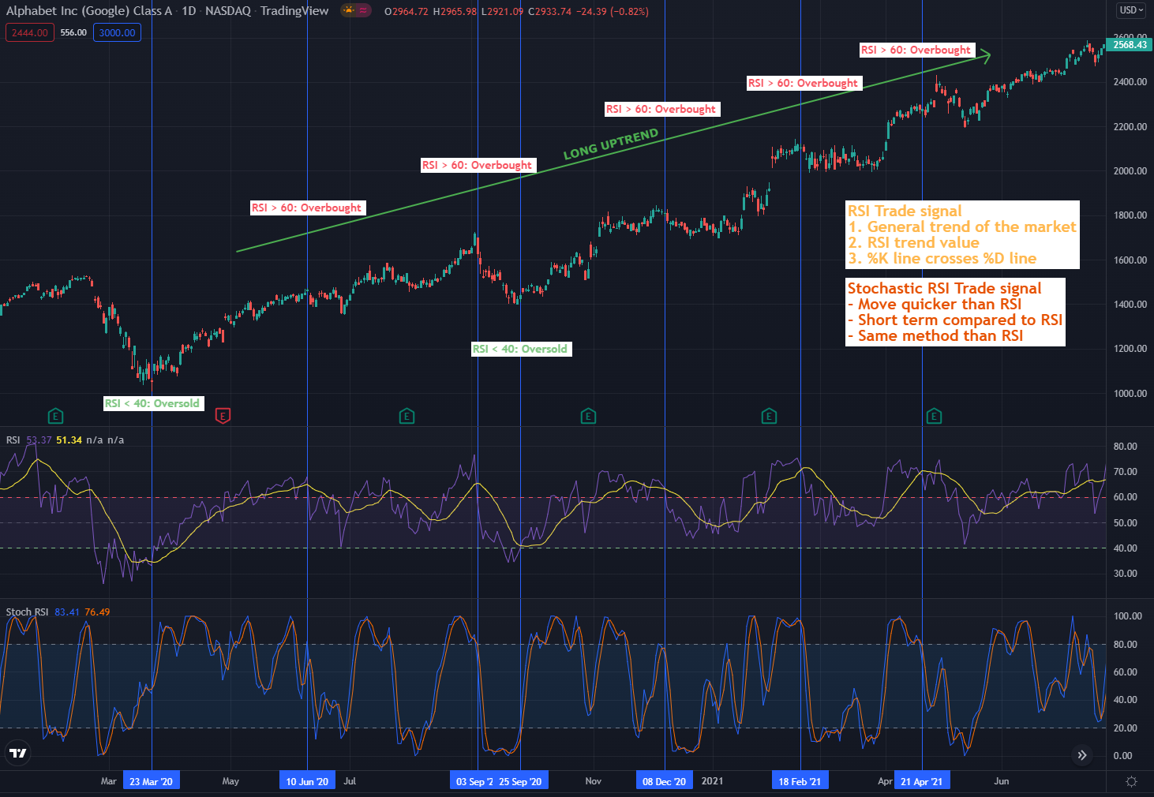

Figure : Difference between price, RSI and StochRSI.