Capstone Project #3

Name: Alexis Demetriou

[ADemetriou5@uclan.ac.uk](mailto:ADemetriou5@uclan.ac.uk)

CO1417: Explorations in Computing 2021-22

Figure 1: Start output terminal

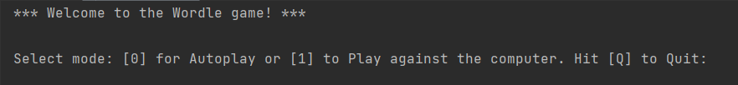

Figure 2: Auto play mode

Figure 3: Play against the computer

Figure 4: Error message

Figure 5: Quit from the game

