Medicare Bulk Billing Process

Medicare online patient verification
Search Bar and type PT’s name
Create
Coreplus

1. Go to Coreplus and search for patient’s name (refer to red arrow below)



2. Check that the patient has the necessary information (refer to red arrow below)
3. Verify by clicking on the “Medicare Online Patient Verification” button (refer to red circle)
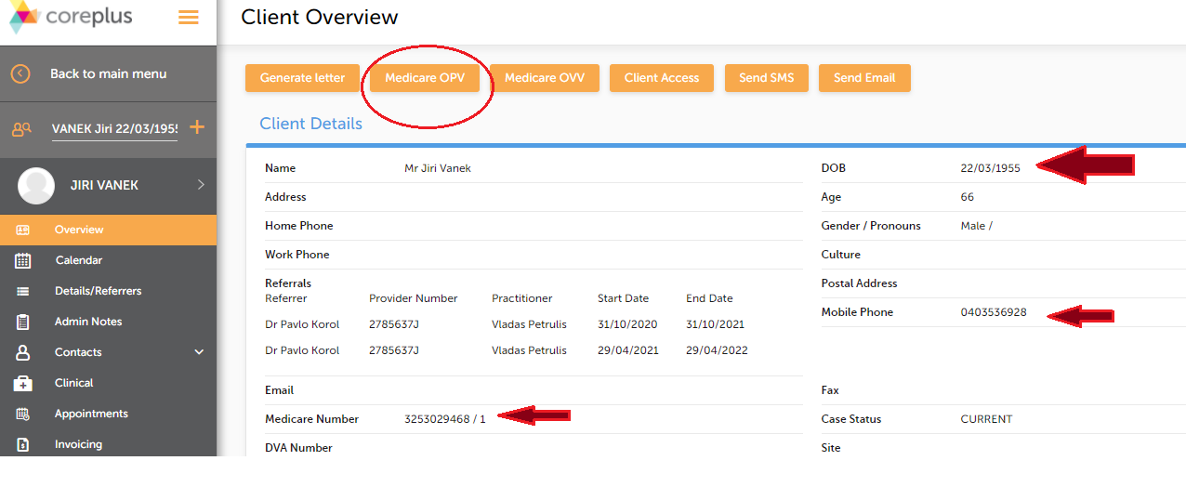
4. Go to “Select a store” (refer to arrow) and pick ”247203KB – hic4.psi”. Note: this may change in the future.
5. Tick the “verify” button (refer to arrow)

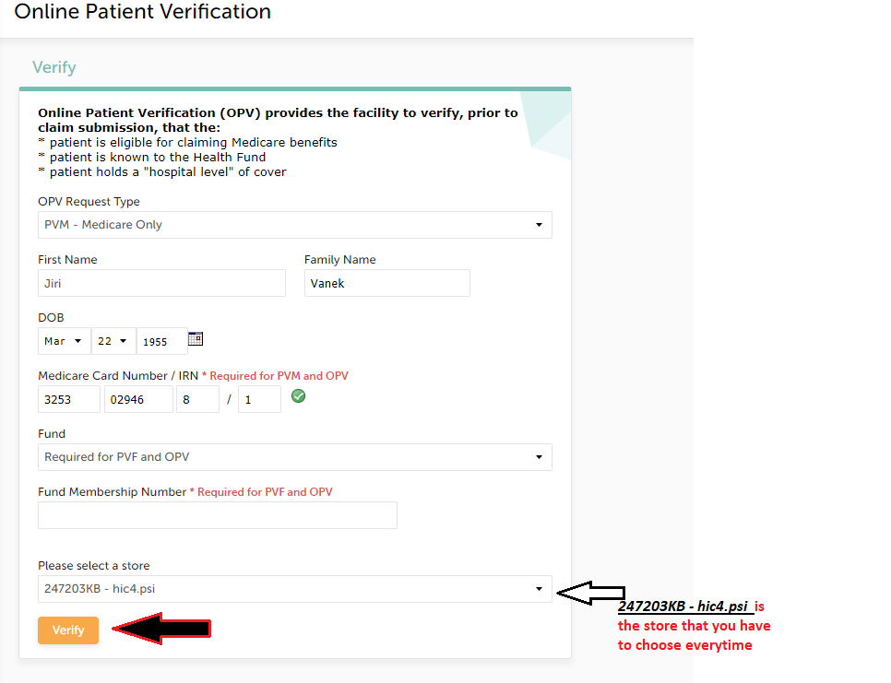

6. If eligible, the following message should appear (refer to green circle below)
7. Click on “Appointments” (refer to purple arrow)

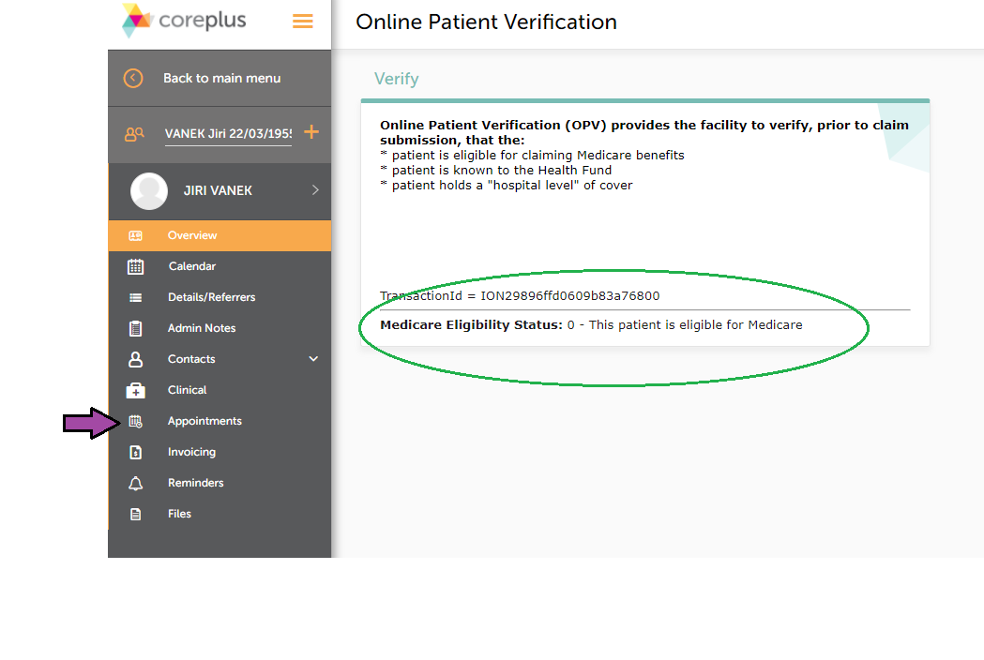

8. Check which appointment you are creating an invoice for and click on “Create” (refer to blue arrow)
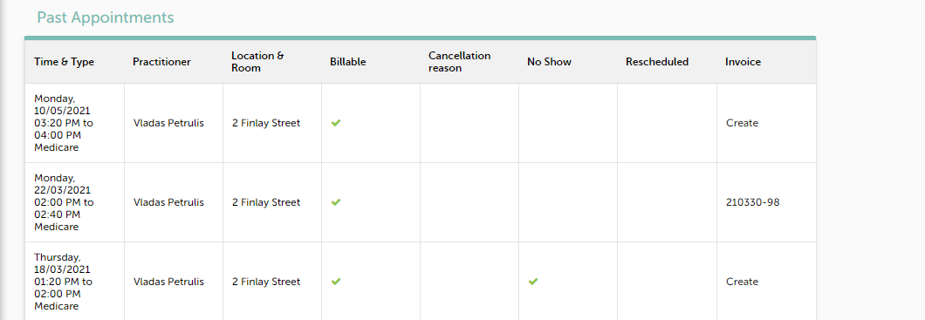

9. Go to the “Medicare Claim” drop down menu (refer to yellow arrow)
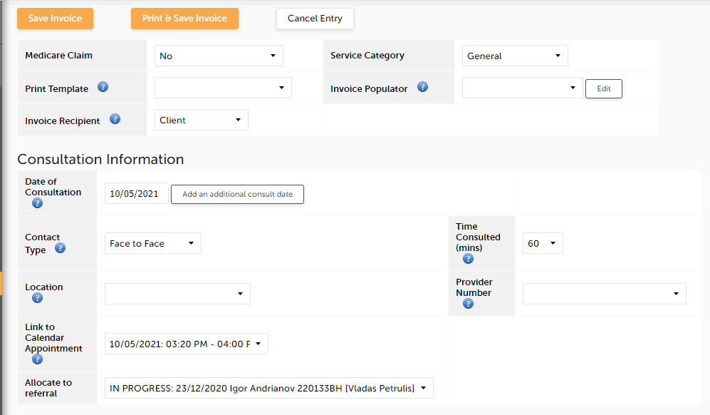

10. Select “Bulk Bill Claim” (refer to red arrow)
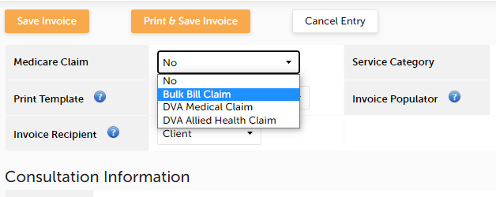

11. The following declaration will appear. Select the “Accept” button (refer to orange arrow)

12. Under the “Consultation Information” section, some of the fields would be pre-filled. Check the “Time Consulted (mins)” field and change according to the actual appointment booking (refer to black arrow)
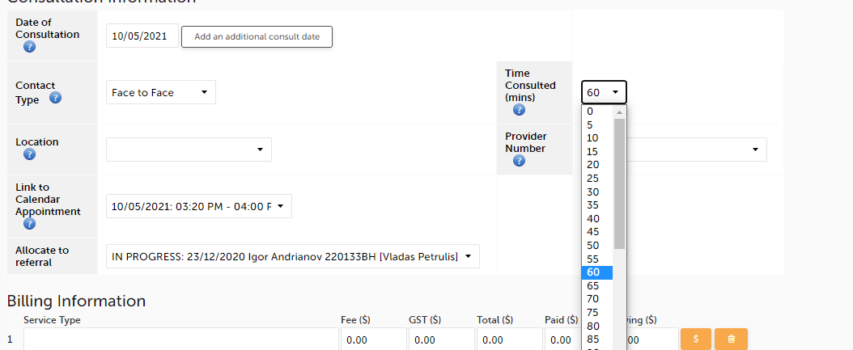

13. Under the “Consultation Information” section, some of the fields would be pre-filled. Check the “Time Consulted (mins)” field and change according to the actual appointment booking (refer to green arrow)

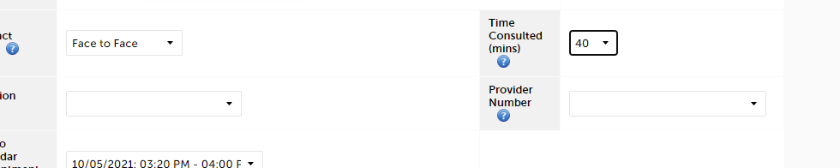

14. Go to the “Provider Number ” field and select the professional that the appointment is for (refer to yellow arrow)
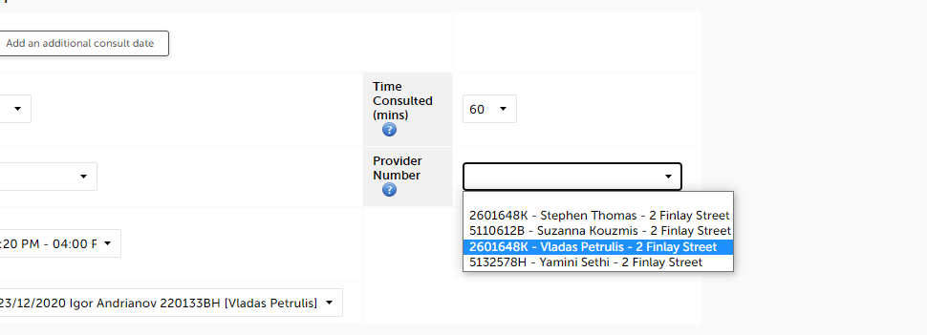

15. Go to the “Allocated to referral ” field and select the referral doctor that the appointment is for (refer to blue arrow)

16. Under the “Billing Information” section, in the “Service Type” field, type in the service id the appointment is for (refer to red arrow).

17. When you select the code, the amount fields will populate.

18. Tick the “Transmit” box (refer to orange arrow)
19. Under the “Client Information” section, the fields should be populated based on what was selected in step 15.

20. Under the “Claim Information” section, the fields should be defaulted to “Yes”. Except for “Send request now” field. Select “Yes” (refer to green arrow)

21. Under the “Additional Information” section, click on the “Send Invoice” button (refer to yellow arrow)

22. Once completed, the “Invoicing” page will appear, providing status stating “Locked - The task has been successful”(refer to blue circle)
