**Call Handling Task Process**

**Step 1**

**Spiel:**

**‘’ 2 Finlay Street, Allied health this is ____________ how can I help?’’**

**Step 2**

**Know the callers concern:**

* 1. **Whether it is about booking, cancellation and inquiry.**

1. **If it is about booking / consultation, ask if it’s a first consultation or follow up with one of our practitioners;**

*(****Note:*** *The answer from the above question, will determine the length of the appointment. Refer to table below. Complete the appointment remembering to tick the “automatic SMS”)*

|  |  |  |
| --- | --- | --- |
| Practitioner | Field of practice | Length and schedule of appointment |
| **Dr. Vladas Petrulis** | **Psychologist** | ***40 minutes - Wednesday and Thursday*** |
| **Dr. Stephen Thomas** | **Podiatrist** | ***20 minutes – Monday and Wednesday*** |
| **Ms. Suzanna Kouzmis** | **Mental Health Nurse** | ***40 minutes - Tuesday*** |
| **Dr. Yamini Sethi** | **Physiotherapist** | ***40 minutes for initial consultation and 20 minutes for follow-up consultation – Tuesday, Wednesday, Thursday, and Saturday*** |

1. **Check Calendar for existing appointments, other available time and day (Figure 1.1). Offer options to the patient.**

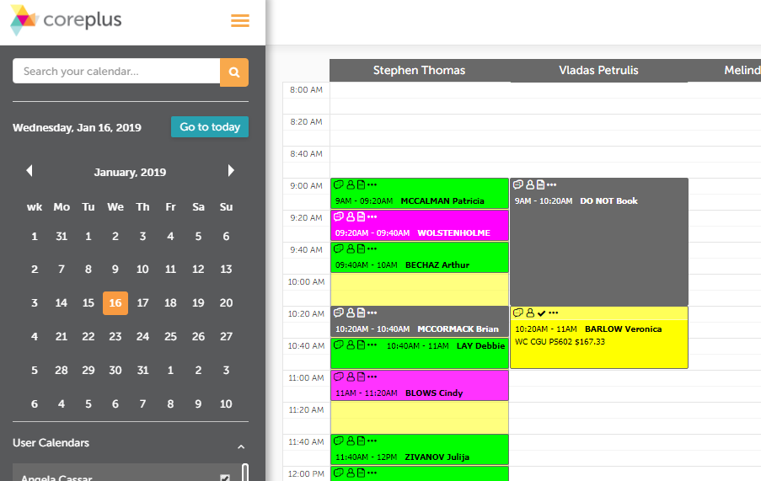

*Figure 1.1*

* **For cancellations, proactively offer rescheduling of appointment.**
* **For inquiries, proactively offer to book an appointment.**

**Double tick on the calendar to open the Appointment Page (Figure 1.2). Make sure to click on the column under the correct physician.**

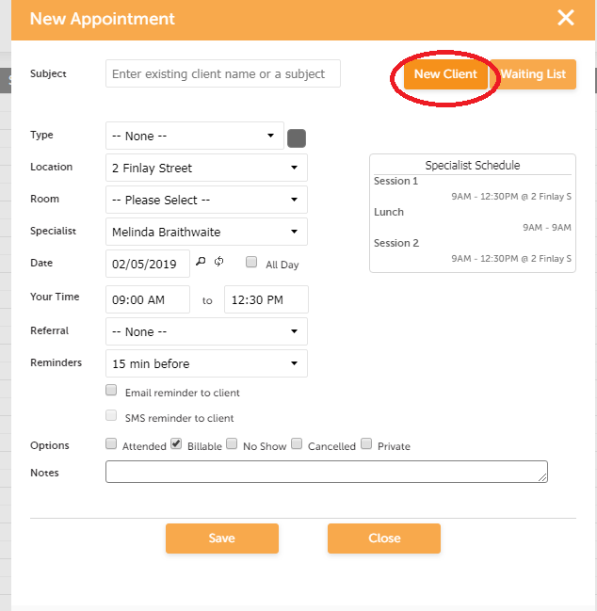

*Figure 1.2*

Enter customer’s surname on the subject field.

* If patient’s details are already in the system, field will auto populate with matching surnames.
* Ask for customer’s name and repeat the spelling.
* Tick on the name matching the patient’s name.
* Make sure that *Practitioner Field* reflects the correct name of the Physician

If patient mentions she has a Care Plan, ask the patient if it is covered by Medicare or ask if patient has referral from Medicare or if it will be a private appointment.

* If patient details are not in the system, tick on the **new client** **button** (refer figure 1.2) and fill out the following fields:
  + First Name
  + Surname
  + Gender
  + DOB
  + Medicare – *It’s completely fine if the patients refused to give this specific information over the phone, you can leave it blank since the doctor will have such information on patient’s referral form.*

*\*make sure to double check if the patient is on the system already even if they said it's their 1st time to see the practitioner.*

**Step 3**

Click “**Create Client**” button as shown below, right after you filled out the information.

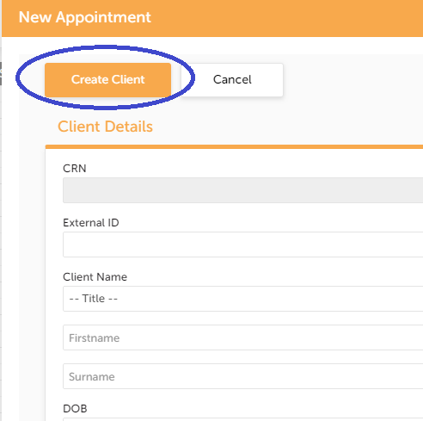

*Figure 1.3*

Confirm the date, time and physician.

***Example:***

“OK John, you have been booked Thursday 24th at 2.30pm with xxxx. Is there anything else I can help you with?”

* after confirming the appointment date and time do not forget to remind them of the no show fee of $55 for **Ms. Suzanna Kouzmis** unless the reason for missing the appointment is an emergency, make sure to remind the first-time patients.

**Other Important details**:

1. Always notify Ms. Suzanna Kouzmis and Yamini Sethi through email for any cancellations and updates regardless of the date including new appointments within the same day.
2. Always open your messenger account for Yamini’s sudden instructions.
3. Notify physicians through webmail if patient cancels or makes changes on the same day of the appointment.
4. **Vladas Petrulis, prefers to be notified through SMS if it is same day cancellation or any matter that requires urgency. His phone no.** 0415722712