

**WORK COVER INVOICE PROCESS, 2021**

Send copy to the insurance company or to Davy

Client’s Name

Details

Appointment

Save copy of invoice

Coreplus

**Invoice Billing Process**

There are many reasons why patients come and see Vladas. Depending on the circumstances, we need to create invoices accordingly.

This document will show how to create invoices for non-Medicare billings. They include;

* Work Cover

**Work Cover Billing Process**

Work Cover patients are those who get injured during work. Either the employer or the insurance company pays for the treatment.

**Examples of Vladas’ notes:**

* *“WC PS602 1h $156.12”*
* *“WC CGU Claim #08110019965 PS602 1h $156.12”*

**Information required to create invoice:**

* Patient’s Address
* Service Type
* Booking details (date, time, etc.)
* Claim Number
* Date of Injury
* Employer details and/or Insurer details (depending on what information is provided)

**Invoice Recipient: “**Employer” or “Insurer”.

**Print Template:** Vladas - WorkCover

**Service Type:**

* “*PS602 - workcover*” (most common)



**Payments:** Either the employer or insurance company will pay by bank transfer (details on the invoice)

Note: There are only a limited number of insurance companies that deal with WorkCover. Below is the list and indicates where to send the invoice to. If there is no insurance company, then send the invoice to the employer.

|  |  |
| --- | --- |
| **Insurance Agent Name** | **Where to send invoice** |
| Allianz Australia Workers' Compensation | Email: wcvicacc@allianz.com.au |
| CGU Workers Compensation | Email: wcvicinvoices@cgu.com.au |
| Gallagher Bassett Services Workers Compensation | Email: gb_paymentsteam@gbtpa.com.au |
| QBE Workers Compensation | Phone: 1800 817 820. Call provide claim number and they will tell you who the case manager to send the invoice to. |
| Xchanging | Phone: 1800 801 070. Call provide claim number and they will tell you who the case manager to send the invoice to. |
| WestFarmers | Email: [mail@eml.com.au](mailto:mail@eml.com.au) |
| EmployerMutual | Email: gtc.vic@westfarmers.com.au |



**Entering Information**

By referring to information stored by Vladas (booking notes and registration forms), we can determine which invoice to create and who to send it to.

**For WorkCover**

It may be necessary to update the “**Employer**” and/or the “**Insurer”** section before creating an invoice (refer to red arrow below).

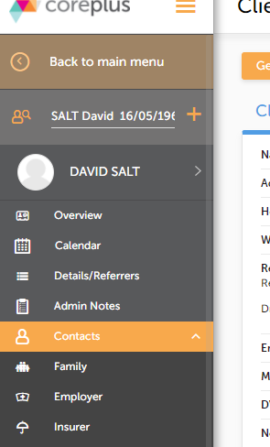

It will be necessary to enter the “**Claim Number**” (via “**Details**” section). Refer the picture below, particulary the encircled red part. If the “**Claim Number**” is not provided, then request it from Vladas.

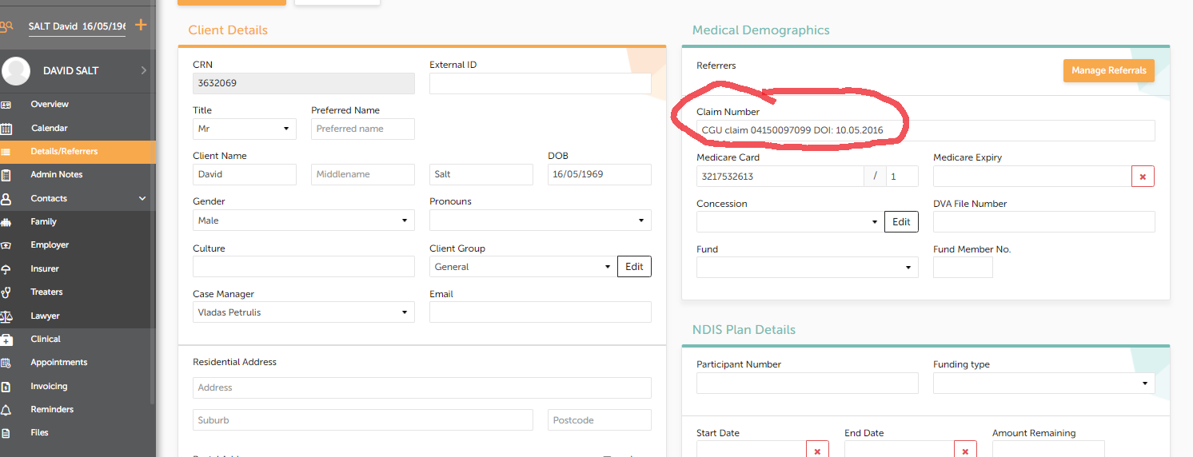

**Note**: Most of the time, when a client is under WorkCover Dr. Vladas will update the information on coreplus, since the paperwork are directly sent to him by the Insurer.



**Creating an invoice**

There are 2 ways to creating an invoice. The first is through the calendar and clicking on the invoice icon (refer to red arrow below).

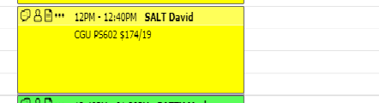

The second way is by searching the patient’s name, clicking on “**appointments**” (refer to green arrow below)

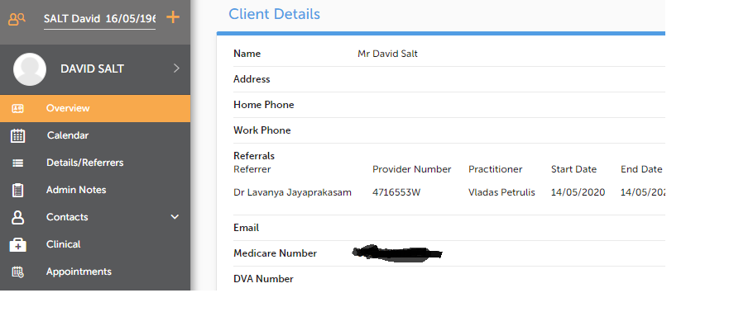



Then, based on which appointment, click on “**Create**” (refer to blue arrow below)

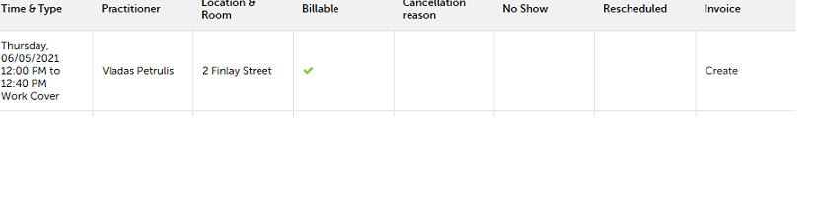

**Populating an invoice**

Select and populate the fields in the following order (refer to yellow circle)

1. “Invoice Recipient” (who the invoice is to be sent to)

2. “Time Consulted(mins)”

3. “Provider Number”

4. “Link to Calendar Appointment”

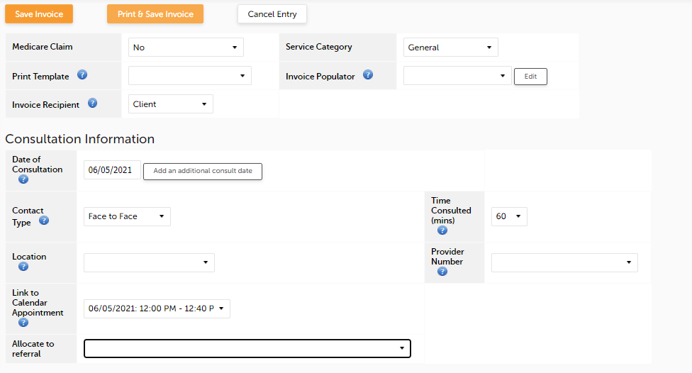

**Below is the filled version**

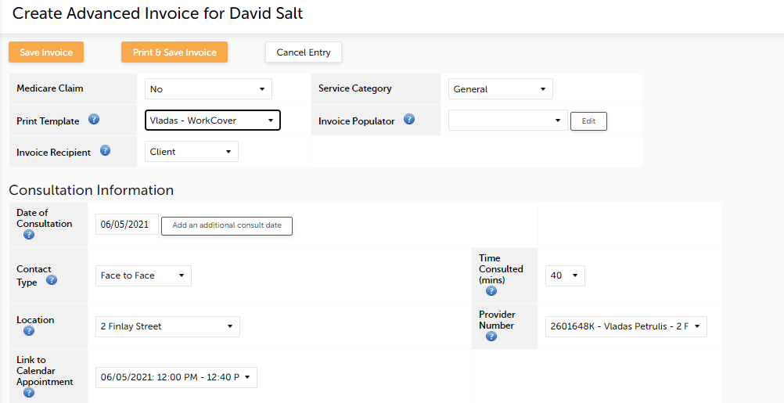

Populate the “**Service Type**” field and then click on “**Save Invoice” (**refer to black circle)

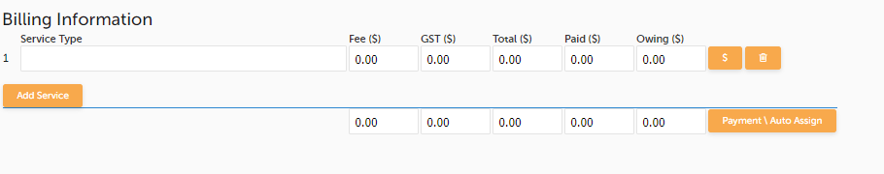

Be it noted that the service type information is placed on the **calendar on the date of the appointment**, the encircled information is the service type or otherwise called as Item no. (see picture bellow)



Ergo, the item no. is PS602 – The CGU is the insurerer, so this is how it should be done (see picture below)

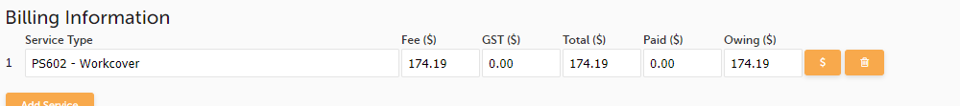

**Accessing an invoice**

To view an invoice, click on “**Invoicing**” (refer to BLUE arrow)

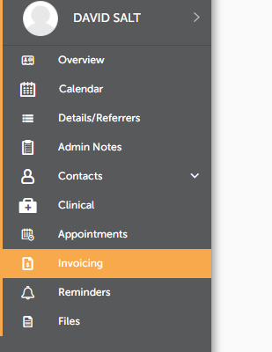



For any invoice, go to “Actions” and select “PDF” (refer to blue arrows)

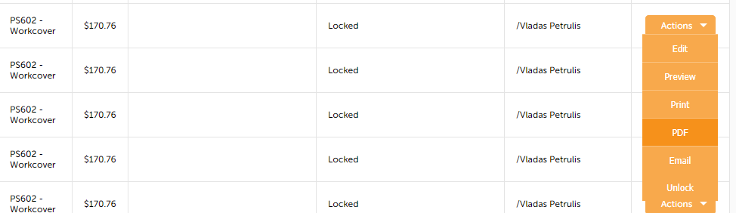

Last steps:

The PDF version will be downloaded, thus you have to save the file on the folder you’ve created intended for the workcover invoices, billed on that specific date.



After such action, the next thing you should do is to send the invoice to the insurer. Given the example below you; Obrien Marty and David Salt are both patients under WorkCover but under different companies, Obrien is under Gallagher Bassett whilst, Salt is under CGU. Consequently, after creating the invoice you have to send it to the company’s corresponding email provided on the second (2nd) page of this sheet.

