**FILING INVOICES CONNECT TO CITRIX DESKTOP**

  
**Citrix – Connect to Citrix Desktop**

1. Connect to Calibre Citrix Desktop [http://citrix.calibreglobal.com.au](http://citrix.calibreglobal.com.au/)    
     
   Enter your Calibre login details.

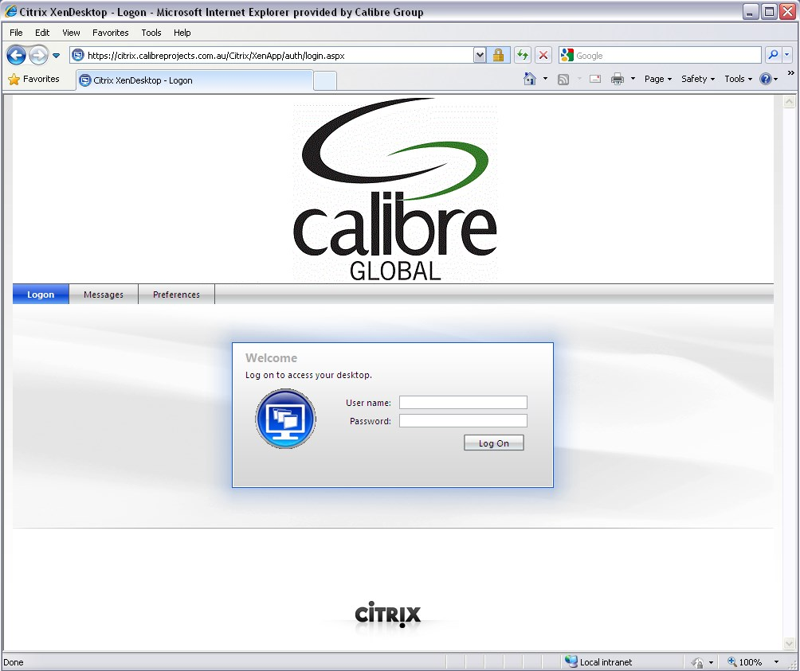

1. Click on Desktops tab and open **Xenapp Desktop – 95%**

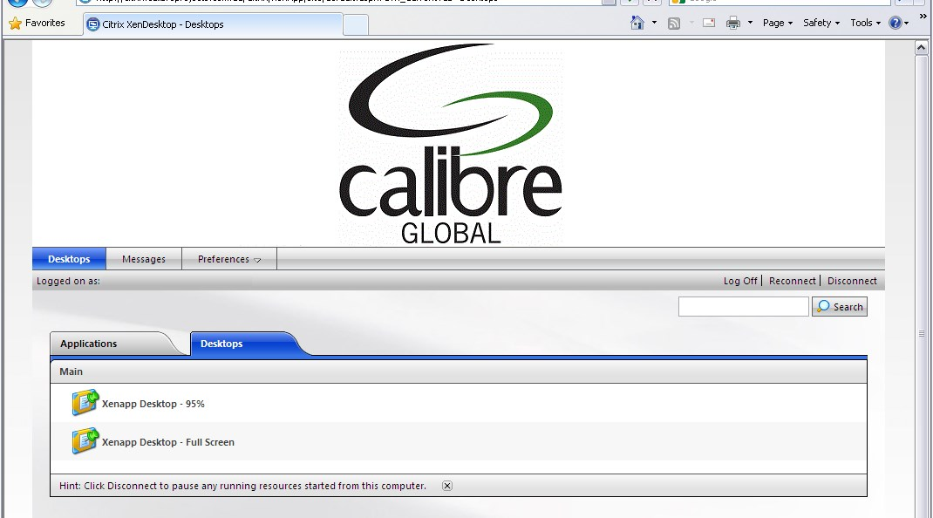

1. Citrix Desktop will be loaded and ready to use.

Citrix - Connecting to Citrix Desktop.docx

**Notes**:

The below screen may appear if you use this device to log on to Citrix for the first time.

If you don’t have a Citrix receiver client installed, please select the check box to accept Citrix license agreement and Click **Download** to install the client. Alternatively, the Citrix Receiver can be downloaded directly from Citrix website.

<http://receiver.citrix.com/>

IF you already have Citrix Receiver installed, please click “**Already installed**” under “Other options”.

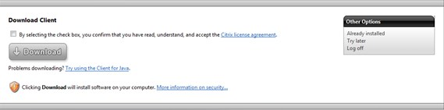

1. Opening Launch.ica

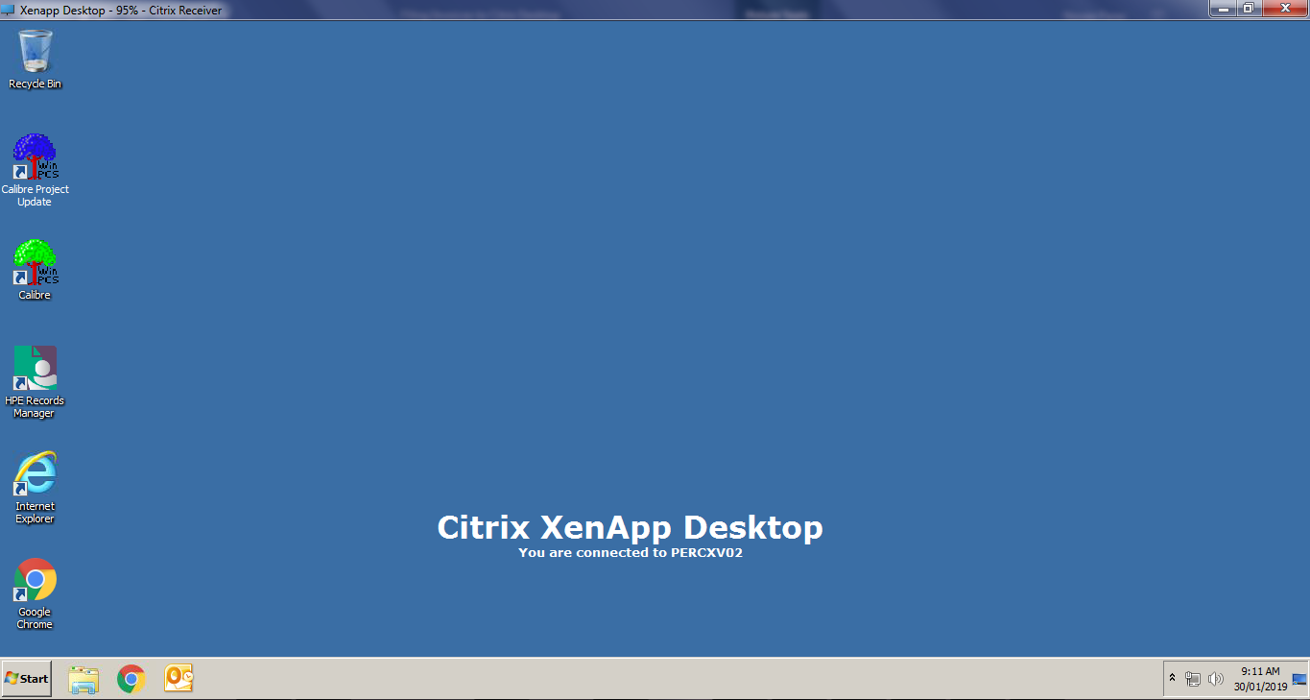

1. Open Microsoft Outlook inside the Citrix Environment

Look for Invoices for filing attachment in MS Outlook and Open the File attached  
  
Example:

CPS1-SINV001207-CICP16149.pdf

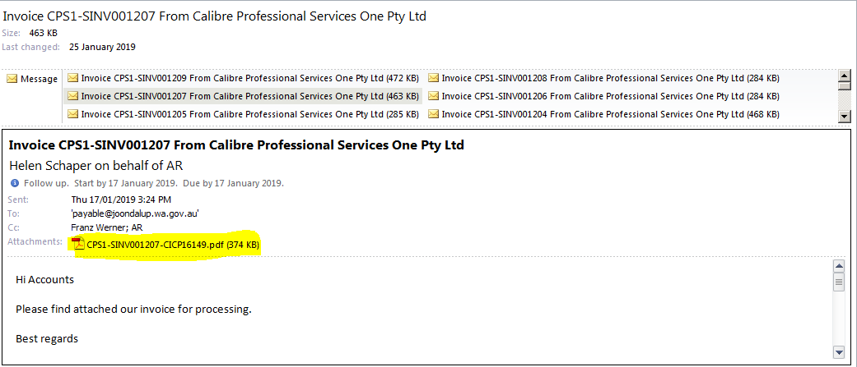

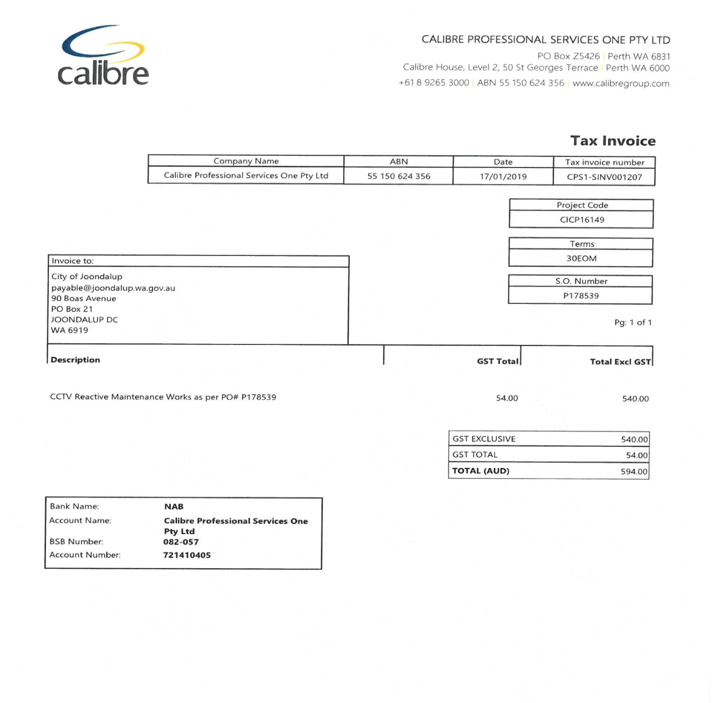

1. Go to Documents Search Bar Copy and Paste \\calibre.network\projects\CIC\PER\Projects then Look the FOLDER CICP16149

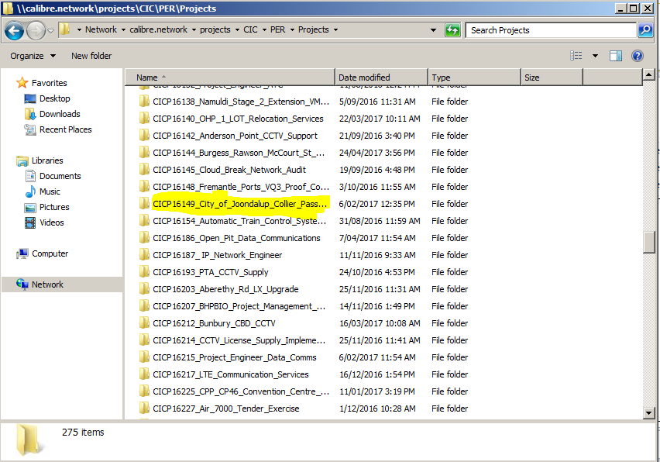

1. **Encoding details to EXCEL**  
   - Open Folder CICP16149

* 02_Project_Controls
* 0203 Project Cost Control
* CICP16149 - Project Cost Tracking & Reporting

From PDF encode details to Excel but before that, there will be a pop-up file in use Click “Notify”

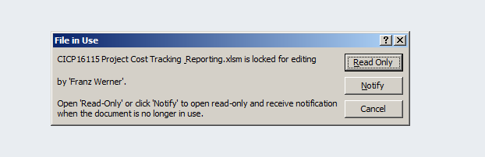

Encode Invoice No. (Green Box) and Date – Final Invoice (Red Box) in PO’s & Invoicing Sheet. The rest of the information are already encoded in the excel. After you put the details SAVE (Ctrl S) the information.

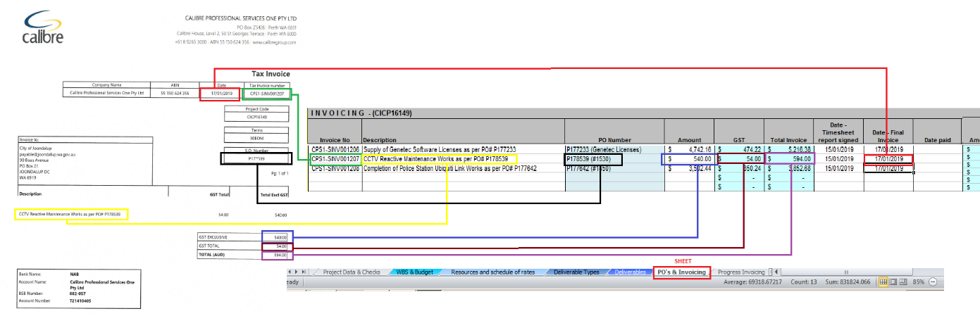

1. **Saving PDF**   
   - Open Folder CICP16149

- 13_Invoices_and_Accounts_Payable  
- Client Invoicing  
 - Month of the Invoice taken

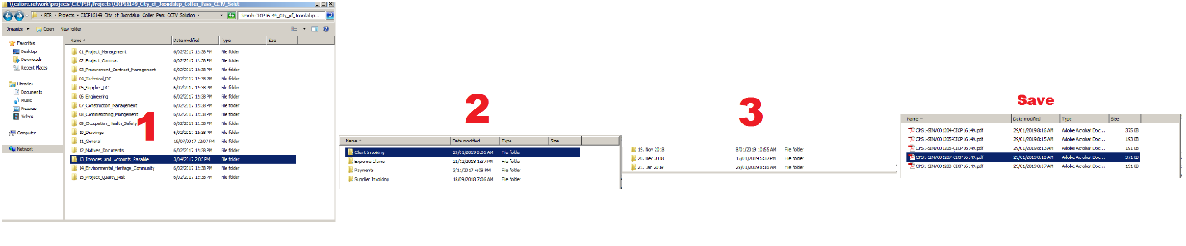

1. Click **Log off** at Start menu when finish.

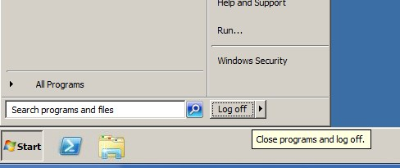

**CIA MONTHLY REPORTS**

**FOR OPEN OPPORTUNITIES REPORT**

1. Open excel FOR Open Opportunities Report

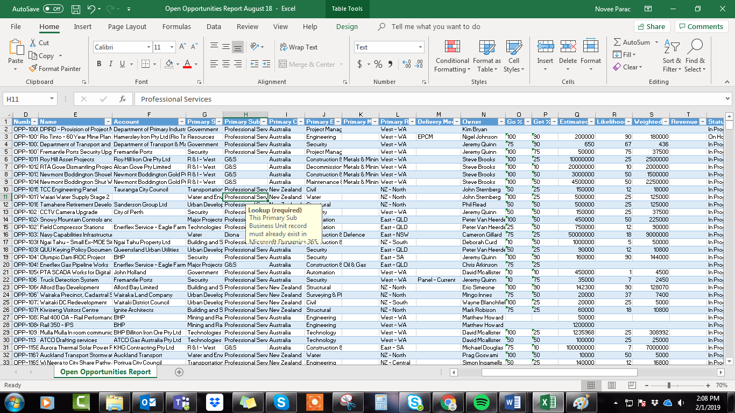

1. Filter Column N to be “Jeremy Quinn”
2. Filter Column R to be only those Likelihoods greater or equal to 50% (so go through an untick all those that are less than 50)
3. Filter Column S to be only those records greater than or equal to $50,000

**FILTERED**

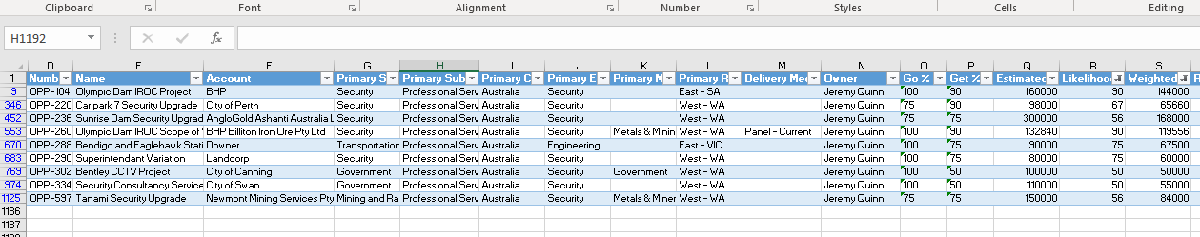

1. Then copy that information into the report into section 6, you must only choose the columns you need and then put them in the right order

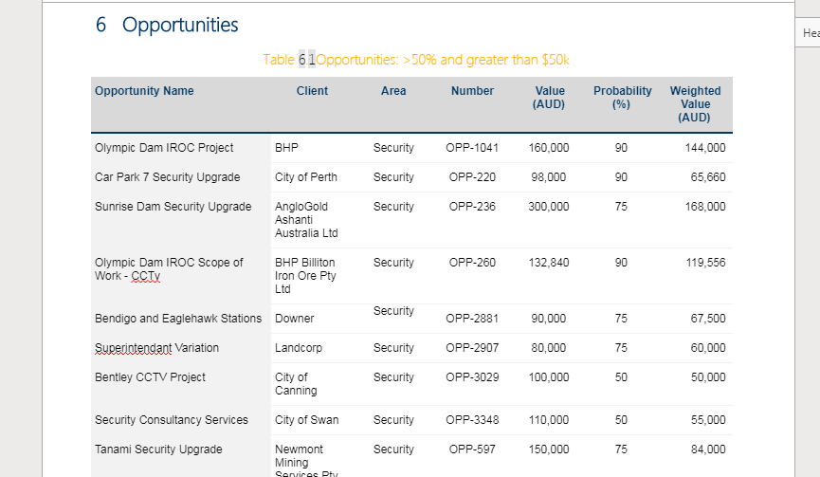

**For XTRACT_OPPORTUNITIES**

1. Open Excel for **XTRACT_OPPORTUNITIES**

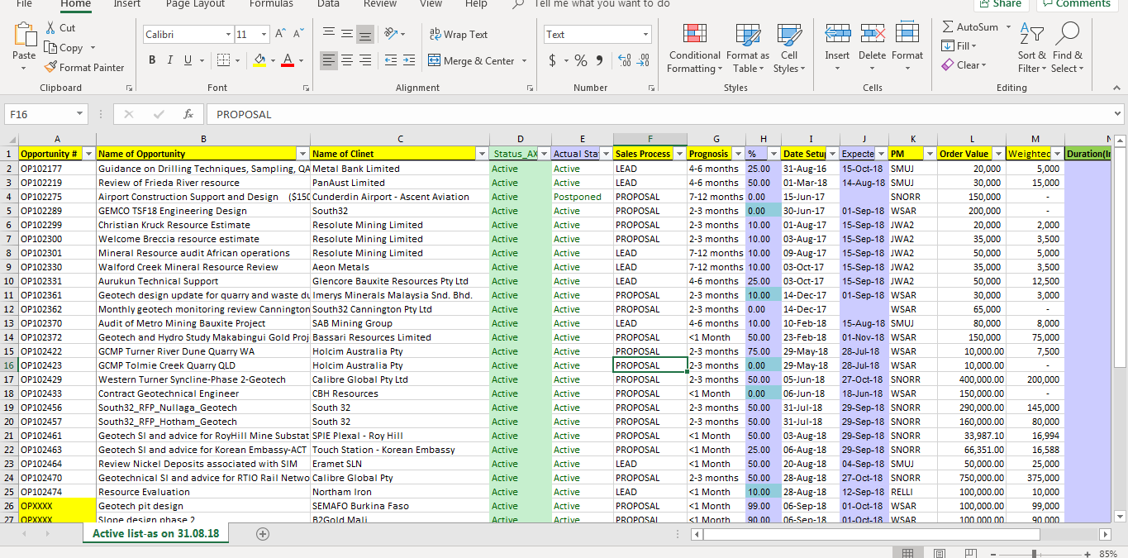

1. Go to column **%** and filter everything 50% and above
2. Go to column **WEIGHTED**and filter everything 50k and above

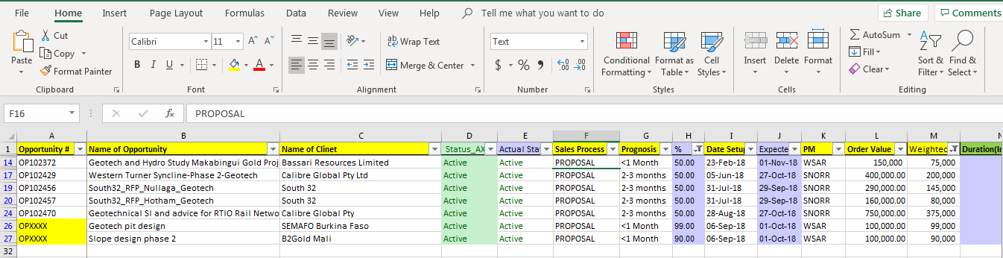

1. Copy the required data into the report into the same table as the other one

