# CS8803 – Special Topics | Mobile Apps & Services

## Peer programming

### Alexis Durocher – MSCS Georgia Tech & Vanessa Servais – MSECE Georgia Tech

*In this third assignment, the goal is to build, from scratch, a complete mobile APP. This project includes a front end part (Android in our case) and a backend part (NodeJS & MySQL embedded in a REST API).*

## General Overview - YourFav

**YourFav** is an Android mobile application that allows any users to connect and see a list of pictures from an external API (pixabay) with a tag predefined (here, we displayed pictures of puppies). The user can scroll among the list of pictures and choose some favorites which will be saved in his profile (our app’s database).

A **pseudo-code** version of our app’s main workflow:

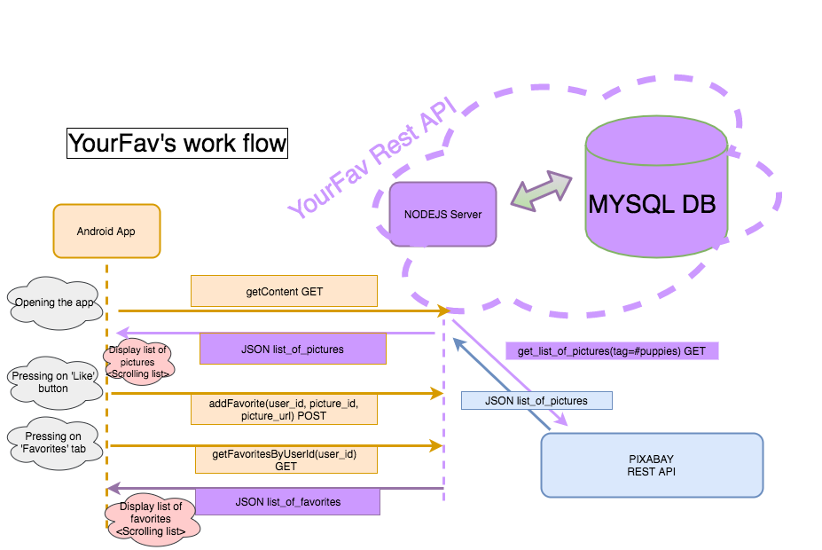

There is an interaction between our NodeJS server and the Pixabay API before storing information from this external API in our own DataBase.

This app is not deployed yet, it works locally on a Localhost:3000.

Requirement & set up:

* MySQL DataBase | *the credentials to connect to the database are set in the file src/dbconnection.js*
* NodeJS with npm | ***npm install*** *&* ***npm start*** *in the root folder to launch the server locally.*
* An Android emulator to run the front-end app.

## Backend

Our Backend runs locally and includes a webserver base on NodeJS and a MYSQL database.

#### Webserver

We chose NodeJS to build our backend because NodeJS provides many libraries to make an easy set up (express-generator for instance) of a complete running server. From this, we could scale up our server and fit it to our needs.

* **./public** : Every files that can be publicly accessed. Here, only the report.pdf and our postman collection (API docs) are available. But this folder only makes sense during the deployment phase and can, then, be ignored here.
* **./node_modules** : All NodeJS dependencies linked with npm and managed via the package.json file**.**
* **./bin** : All executable files.
* **./sources:** Our different routers ( where we define the actions resulting from calls to certain endpoints of our API).
* **./src** : Contains the model of our data. The SQL command to be executed from the NodeJS server to the database. The DataBase connection’s parameters. Some .sql files to build and keep our database consistent on our different computers**.**
* **./views** : Can be ignored.

The main app is defined on **app.js**.

### REST API

Our REST API doc can be automatically generated with our Postman collection. All our features are not used in the app.

**Feature 1**

POST a new User | *when a new user sign up in the app*

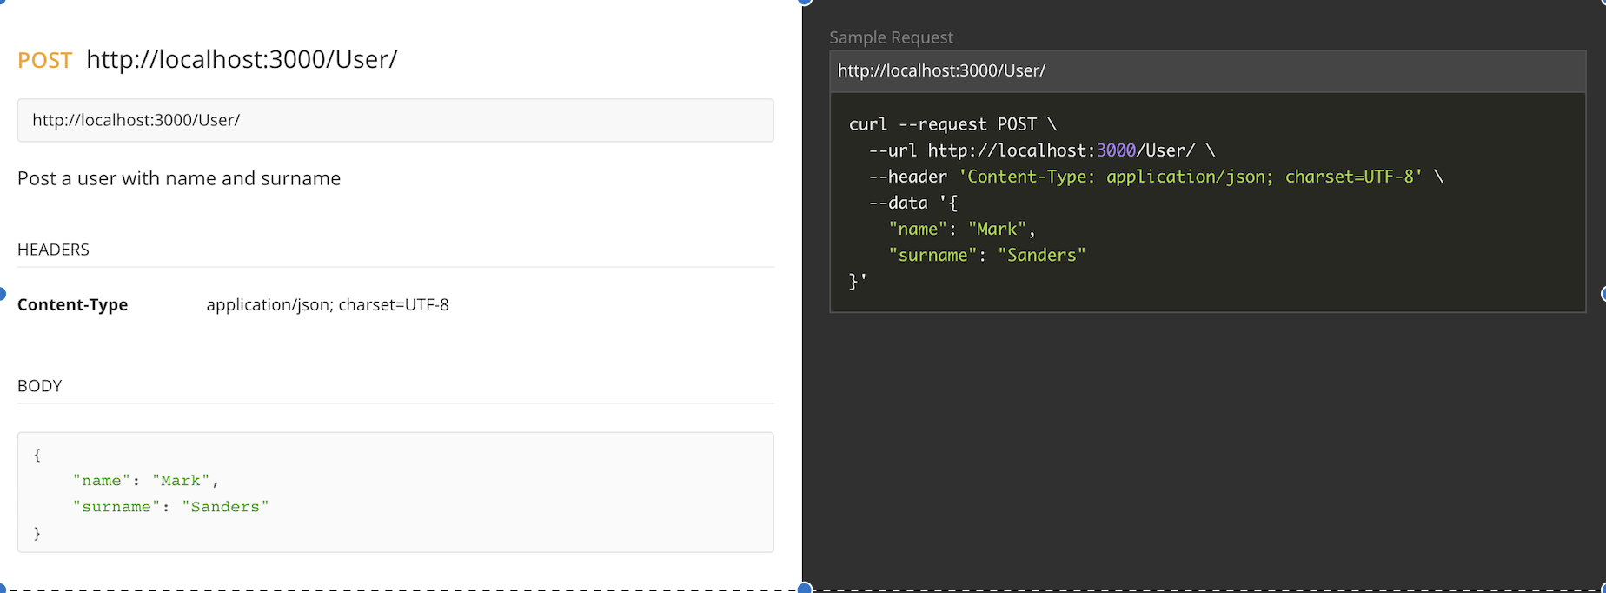

**Feature 2**

POST a new Favorite picture | *When the user (here id = 2) click on ‘like’ button, the picture is then stored as a new user’s favorite in the Database.*

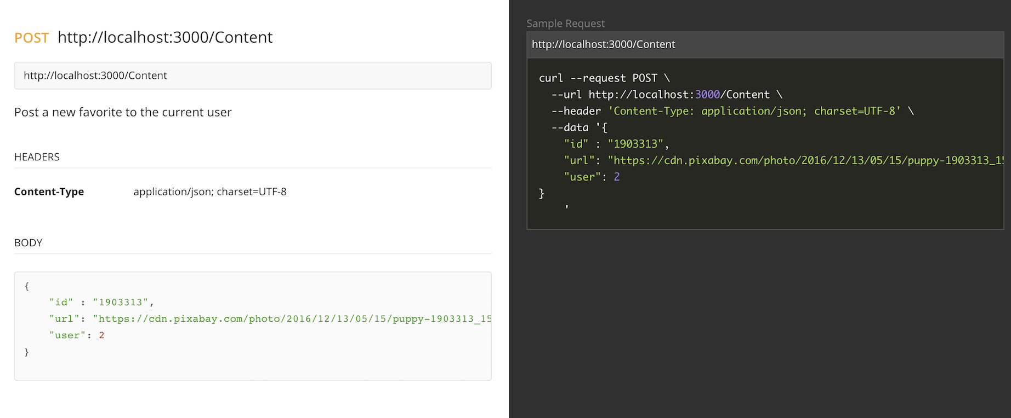

**Feature 3 & 4**

GET all contents if no id is provided OR user’s list of favorites if its id is provided | *Depending on which tab the user click, he will see either the complete list from pixabay API, or his own favorites.*

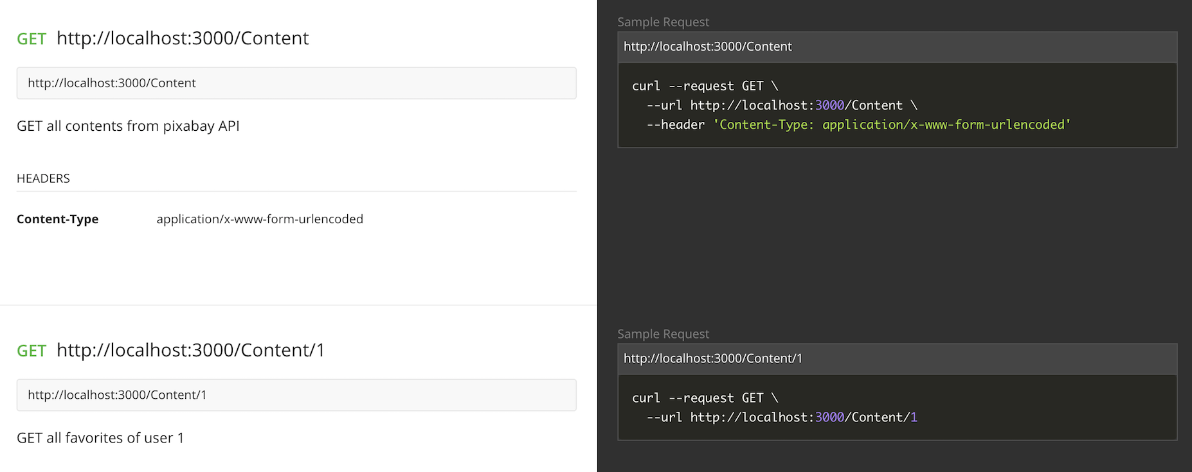

## Front-end: Android application & Design.

Our Android application has a very simple design. When you open it, it displays you a list of all the pictures on pixabay with a special tag (it is set to “puppy”). Next to each picture, there is a ‘like’ button, so that you can add this picture to your favorites’ list.

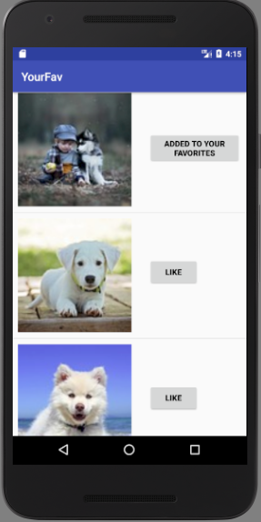

When we the user clicks on one of the buttons, the picture is added in his list in the database. We tried to implement a design with tabs, so that you can choose between the first tab with all the pictures and the second tab only with your favorites. This code can be found on the branch androidTabs, however we haven’t yet got this part working.

On the master branch, we have the working app. Therefore, we first implemented a RecyclerView (with it ViewHolder and Adaper) to view the pictures dynamically. Then, we added the GET request (via volley) to get the content via our REST API. The information retrieved is stored in a list of pictures that will be displayed in the ListView. (As it takes some time to retrieve all the data, it will not display the pictures. So, we cheated a bit and added a few pictures of cities whose url does not have to be retrieved via the REST API.) We do not store the pictures themselves, but rather their url and each time it should be displayed, we download it via Picasso. When the like button is hit, the app makes a POST request with the picture id, its url and the user id, to add it in the database.

## Git History

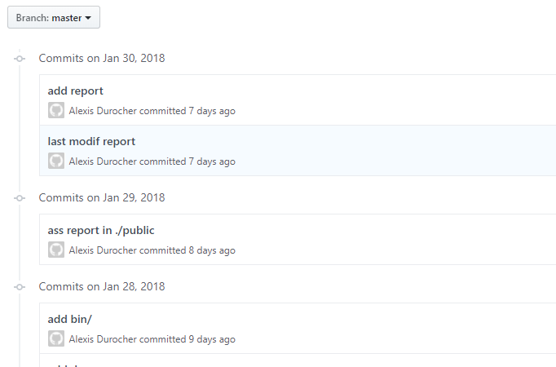

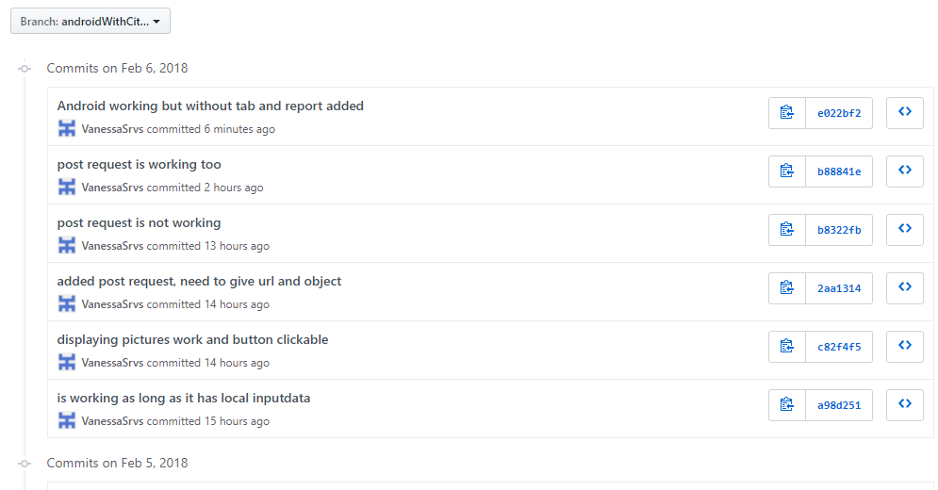

## References

Here are the tutorials and references we used to build our app.

REST API tutorial for NodeJS and Mysql :

<https://medium.com/@avanthikameenakshi/building-restful-api-with-nodejs-and-mysql-in-10-min-ff740043d4be>

<https://jinalshahblog.wordpress.com/2016/10/06/rest-api-using-node-js-and-mysql/>

Android tutorials:

* recyclerview: <http://tutos-android-france.com/material-design-recyclerview-et-cardview/>
* click item in listview: <http://androidforbeginners.blogspot.fr/2010/03/clicking-buttons-in-listview-row.html>
* POST request: <https://stackoverflow.com/questions/33573803/how-to-send-a-post-request-using-volley-with-string-body/33578202>
* viewpager: <http://www.gadgetsaint.com/android/create-viewpager-tabs-android/#.Wnm-DKjibIU>