**Identify the best place to open a business in Nuevo León, Mexico**

## Introduction

Nuevo Leon is a state in the north of Mexico where an arid and extreme climate prevails, it has the financial and business center of the country, so it is always an attractive place for investments, but which municipality will be the best to open a factory? Or which county will be the most suitable to have access to basic services or venues?

## Data

I will use the information available at https://es.wikipedia.org/wiki/Anex:Municipios_de_Nuevo_Le%C3%B3n

and then it will be reviewed on Foursquare

## Methodology

First we read the information on Wikipedia

Then we transform the columns to consult them better

We get the coordinates, latitude and longitude

We generate the map based on the coordinates

We verify the venues for each municipality

Check how many venues were returned for each county

Next, lets group rows by neighborhood and by taking the mean of the frequency of occurrence of each category

We validate the top 5 venues for each municipality

Then we observe the results for the first 5 clusters

Cluster 1

Cluster 2



Cluster 3

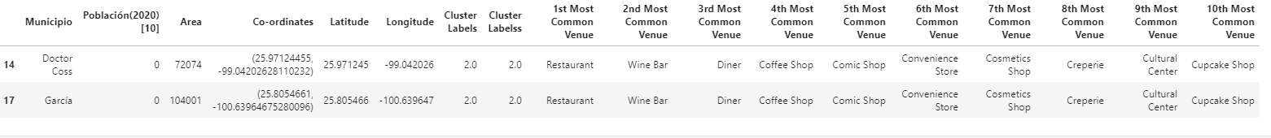

Cluster 4



Cluster 5



# Results

The biggest clusters are the best for making investments, something that happens in real life because the municipalities of Apodaca and San Pedro Garza Garcia are the most required for this type of growth.

Apodaca for factories and San Pedro Garza Garcia for companies and entrepreneurship

# Discussion

There are places that seem suitable to grow but somehow, they have not succeeded, either due to lack of state resources, the lack of population, the lack of roads or the distance from the center of the state.

# Conclusion

It is interesting that by reviewing free information on the internet and with the appropriate sentences, real and truthful results can be obtained to make a good business decision