Clutter loss at 7GHz in London using

Ray-Tracing simulations

* 1. **Introduction**

As discussed during the previous online session, there is a need to further investigate the big difference (around 15-20dB in the median values of clutter loss cdf) in the results from RT simulations achieved from documents CG-3K-3M-12_2020_21_ClutterLossRayTracing_Huawei and CG-3K-3M-12_2020_23_ClutterModel_France.

That’s why it is proposed to replicate the studies (i.e. using the same assumptions) performed by Huawei in order to understand and interpretate those deviations.

Please note that taking similar assumptions as in Huawei document **does not mean all of them are agreeable**.

* 1. **Baseline assumptions**

Max number of Reflections and Diffractions of the Tx-Rx path :2R1D

IMT terrestrial station height : 5m

Centre frequency : 7 GHz

Angles of the slant path

|  |  |  |  |  |  |  |
| --- | --- | --- | --- | --- | --- | --- |
| ϕ azimuth | 6° | 11° | 16° | 19° | 26° | 30° |
| Θ elevation | 249° | 242° | 235° | 133° | 150° | 170° |

IMT stations are deployed in façade of the buildings for this height.

This analysis aims at understanding the difference between results presented in doc #CG-3K-3M-12_2020_21 and document from France, that’s why a large portion of the simulation area taken by Huawei has been considered in the analysis (see the red rectangular capturing the selected area in left picture). The whole area was not taken because the timeline to align assumptions and results presented two weeks along was not sufficient to do so.

As the coordinates of survey points are not available in the doc CG-3K-3M-12_2020_21, it is proposed to manually select points that are in the close vicinity of the red points ticked in slide of doc CG-3K-3M-12_2020_21.

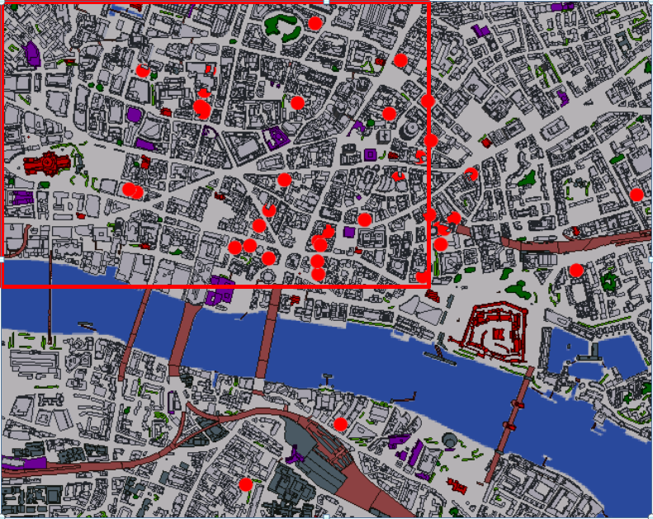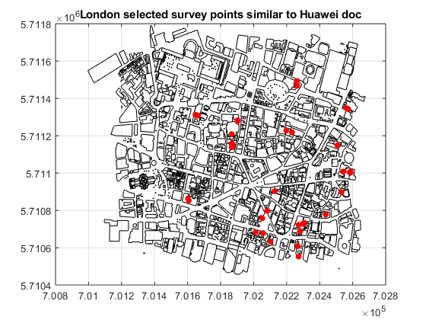

* 1. **Chinese replications (close to the buildings <2m)**

This section aims at presenting Ray-Tracing simulation results performed on area described in the previous section (red rectangular of the left hand picture above) for an area of London city. These results are captured in the left hand figure through clutter cdf curves for different scenarios of elevation angles (from 6° to 30°) between Tx and Rx for 35 different survey locations within the red rectangular area.

Right hand picture recalls the results presented in Doc from Huawei under similar assumptions (IMT station 5m height for – almost – similar area -, same elevation angles).

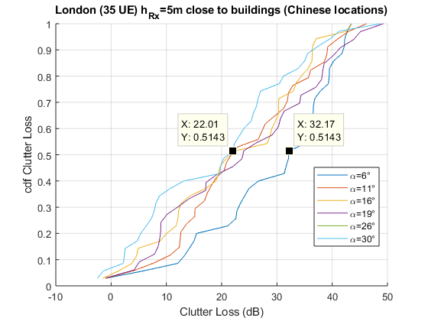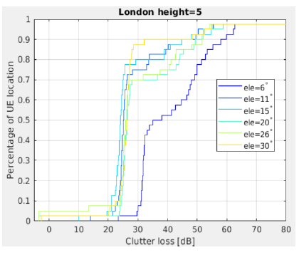

When comparing the results of the replication with those presented by Huawei, one could notice :

* that the shape of the curves differ. This may be affected by one or/and severals factors :
  + the lack of accuracy in the coordinates of the survey points selected in this study compared to the original one as they are not provided in the original document,
  + the lack of survey points (less than 40 points)
  + different clutter database
* that the median value of the clutter loss are similar as they are both ranging in 22..35dB e.g.
  + at α=6°, 35dB and 32dB are respectively achieved for this analysis and the Huawei’ones
  + at α=19°, 24dB and 26dB are respectively achieved for this analysis and the Huawei’s ones
  1. **Random locations within the simulation area (close to the buildings <2m)**

In order to evaluate the evolution of the clutter loss cdf curve with the random nature of the survey points (still close to the buildings) as well as the number of samples used to compute the distribution of the clutter loss, the sensitivity analysis is performed with different numbers of (random) survey points within the map grid : 40, 100, 1000 and all points.

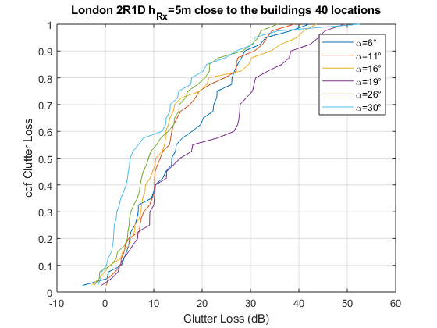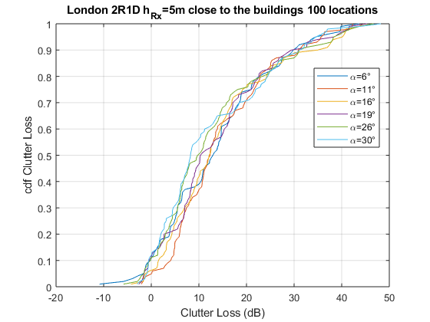

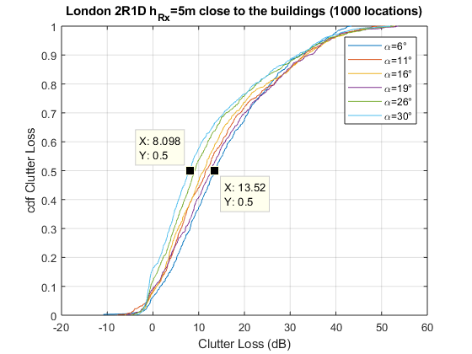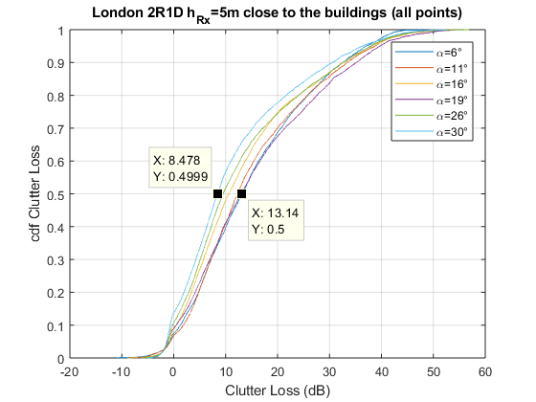

On the one hand, cdf curves for low number of samples (40 and 100) exhibit lack of smoothness and suggests that the distribution of clutter loss needs more sample to be considered as « stable ». On the other hand, curves using 1000 random survey points the clutter loss show more regularity and it features of sigmoid family curves for any (azimuth,elevation) couples scenarios.

The results depicted in last figure (right down corner) is provided for sake of comparison and relates to the scenario involving 7000 sample locations are pretty similar compared to those from 1000 survey points (less than 0.5dB difference for the median value of the cdf of each curve), showing the need to have sufficient number of survey points to achieve reliable statistic of the attenuation due to clutter.

* 1. **All locations within the simulation area (close to the buildings <2m and in the street)**

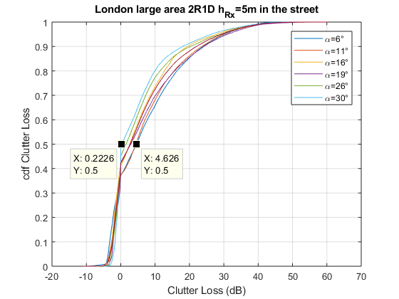

As expected, the attenuation due to clutter increases (around 8dB increase observed in the median value of the clutter loss cdf for 6 elevation angles) when the survey points are closer to the buildings due to the limitation of the visibility with the airborne/satellite radio device caused by the buildings.

* 1. **Conclusions**

This analysis investigates the results presented in Huawei document #CG-3K-3M-12_2020_21 regarding the cdf of clutter loss for one city :

* It shows that with different map grid database but survey points selected in the same area within a region of the city, results related median values of clutter loss cdf are aligned,
* It shows that a small amount of survey points can lead to a distribution of clutter loss highly varying with their locations within the urban environment. This observation suggests the need to work with high number of input data (IMT stations locations) in order to establish reliable statistic of clutter loss.

These results shows that the calculations made in both analysis can be considered as similar and that the most important parameters is the number of input data taken into account. On this basis, it can be concluded that in order to establish reliable statistic of clutter loss, a high number of input data (IMT stations locations) is essential..