**Name: Alexis V. Sagusay**

**Course&Year: BSIT 3-A**

**CODE:**

const express = require('express');

const mysql = require('mysql');

const multer = require('multer');

const bodyParser = require('body-parser');

const ejs = require('ejs');

const app = express();

// Configure MySQL connection

const db = mysql.createConnection({

host: 'localhost',

user: 'root',

password: '',

database: 'students'

});

// connect to MySQL

db.connect((err) => {

if (err) {

throw err;

}

const PORT = process.env.PORT || 4060;

app.listen(PORT, () => {

console.log('Server started on port ' + PORT);

});

console.log('Connected to MySQL');

});

// configure multer file upload settings

const storage = multer.diskStorage({

destination: (req, file, cb) => {

cb(null, 'public/uploads');

},

filename: (req, file, cb) => {

cb(null, file.originalname);

}

});

const upload = multer({ storage: storage });

// configure EJS view engine

app.set('view engine', 'ejs');

app.set('views', __dirname + '/views');

// configure body-parser middleware

app.use(bodyParser.urlencoded({ extended: false }));

// serve static files from public directory

app.use(express.static(__dirname + '/public'));

// define routes

app.get('/', (req, res) => {

const sql = 'SELECT * FROM addedstudents';

db.query(sql, (err, results) => {

if (err) {

throw err;

}

res.render('index', { students: results });

});

});

// display students

app.get('/add', (req, res) => {

res.render('add');

});

// add student

app.post('/add', upload.single('profile_pic'), (req, res) => {

const { name, major } = req.body;

const profile_pic = req.file.filename;

const sql = 'INSERT INTO addedstudents (name, major, profile_pic) VALUES (?, ?, ?)';

db.query(sql, [name, major, profile_pic], (err, result) => {

if (err) {

throw err;

}

res.redirect('/');

});

});

//update student through id params

app.get('/update/:id', (req, res) => {

const { id } = req.params;

const sql = 'SELECT * FROM addedstudents WHERE id = ?';

db.query(sql, [id], (err, result) => {

if (err) {

throw err;

}

res.render('update', { student: result[0] });

});

});

//update student through id params

app.post('/update/:id', upload.single('profile_pic'), (req, res) => {

const { id } = req.params;

const { name, major } = req.body;

const profile_pic = req.file ? req.file.filename : null;

let sql = 'UPDATE addedstudents SET name = ?, major = ?';

const values = [name, major];

if (profile_pic) {

sql += ', profile_pic = ?';

values.push(profile_pic);

}

sql += ' WHERE id = ?';

values.push(id);

db.query(sql, values, (err=> {

if (err) {

throw err;

}

res.redirect('/');

}));

});

// delete student

app.get('/delete/:id', (req, res) => {

const { id } = req.params;

const sql = 'DELETE FROM addedstudents WHERE id = ?';

db.query(sql, [id], (err, result) => {

if (err) {

throw err;

}

res.redirect('/');

});

});

**DATABASE CONNECTION INTERFACE:**

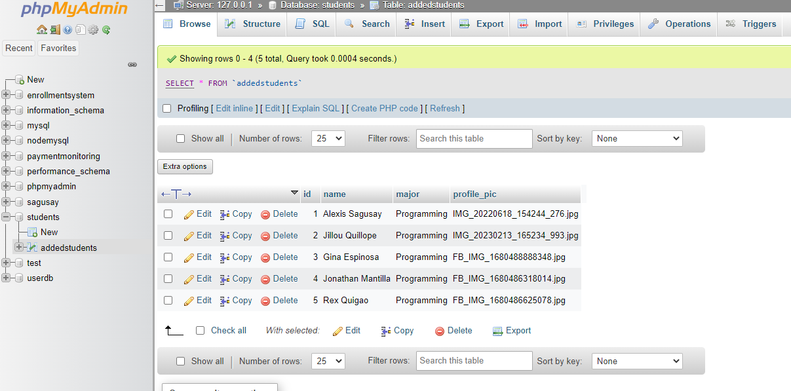

**OUTPUT:**

