ALEXIS // DJ 6LA
UGC Creator · Breast Cancer Advocate · Aspiring DJ
IG @ManifestingLex · TikTok @lexingtongee · Los Angeles, CA
“I manifested everything I have — and I’m manifesting beating cancer, too.”
ABOUT ME
I'm Alexis — known online as ManifestingLex, lexingtongee, and DJ 6LA. At 31, I was diagnosed with breast cancer and am currently navigating a double mastectomy, chemotherapy, and reconstruction. Refusing to let it slow me down, I'm learning to DJ, chasing music festivals, and building the life I always manifested for myself. My content is raw, hopeful, and honest — real treatment updates sit alongside GRWMs, wellness, and DJ practice, showing what it actually looks like to keep living fully through cancer. I manifested everything I have up to this point, and I'm manifesting beating this too.
CONTENT PILLARS
Beauty & GRWM · Cancer Journey & Treatment Updates · Learning to DJ · Wellness & Fitness · Day-in-the-Life · Mindset & Manifestation
Tone: hopeful · humorous · educational · raw
WATCH MY CONTENT
Scan any code to watch — a mix of GRWM, DJ practice, and real treatment updates.
  01 | 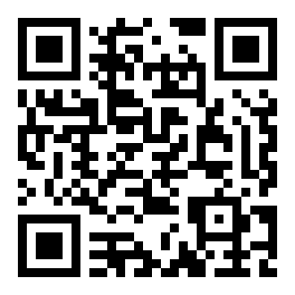  02 |   03 |   04 |   05 | 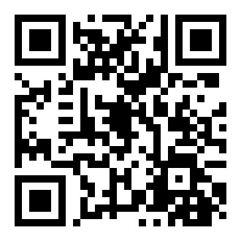  06 |   07 |   08 | 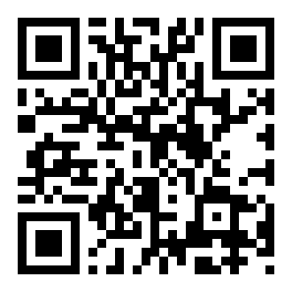  09 |   10 | 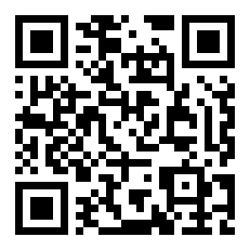  11 |   12 |   13 |   14
AUDIENCE SNAPSHOT
INSTAGRAM — @ManifestingLex  1K–5K followers  50K views / 30 days  +28 followers / 30 days | TIKTOK — @lexingtongee  1K–5K followers  12K views / 7 days  355 likes · +25 followers / 7 days | YOUTUBE  Launching soon  New channel — building out treatment + DJ journey content  Subscribe to follow along
Who follows me: Primarily women 25+, U.S.-based, who connect with a young (31) breast cancer patient who is still building a life she loves — through beauty, music, and everyday moments.
BEST-FIT BRAND CATEGORIES
Medical & adaptive makeup · Comfy / adaptive apparel · Wigs & hair · Skincare · Meal kits & wellness · Music & DJ brands · Travel & festival brands
Currently building my first brand partnerships — bringing a highly engaged, loyal audience and genuine, first-person storytelling to every collaboration.
SERVICES & RATES
Content Types | Instagram Reels · TikToks · GRWM videos · Unboxings & testimonials · Photo content · Day-in-the-life vlogs · DJ set clips
Turnaround | 1 week from receipt of product / brief
Compensation | Open to paid partnerships and gifted collaborations
Rates | Available on request — email sixela.6LA@gmail.com

LET'S WORK TOGETHER
sixela.6LA@gmail.com · IG @ManifestingLex · TikTok @lexingtongee · DJ 6LA

