State-Action-Reward-State-Action

State-Action-Reward-State-Action (SARSA) algorithm is a variation of Q-learning algorithm, but there are a few key differences between the two. One being that SARSA uses an On-policy method which estimates the value of the policy whilst using it for control, whereas Q-learning is an Off-policy method to learn the Q-value. Another difference is that the previous states and thus the previous rewards are not considered with SARSA whilst in Q-learning the states are considered.

## Explaining The Equation

To update the Q-function SARSA uses the following equation:

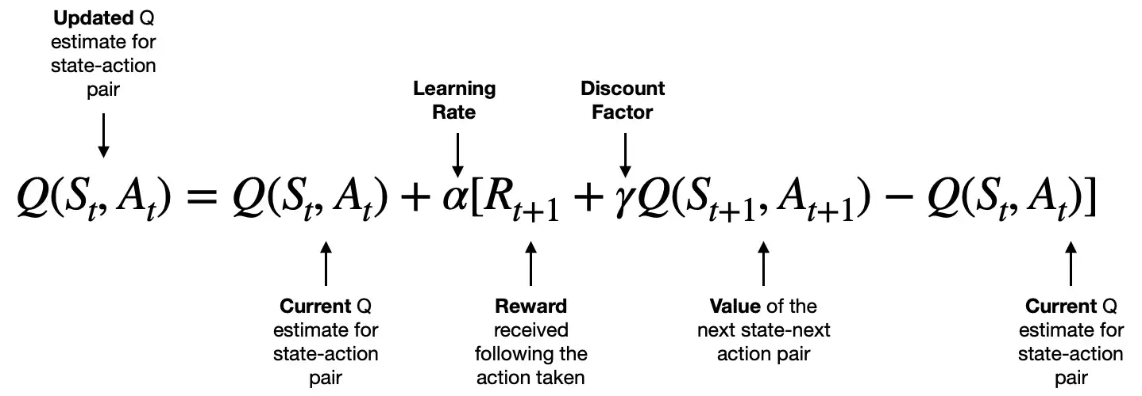

1. Dobilas, S. (2022)

In the current state (S) an action (A) is taken and rewards (R) the agent taking the action which then moves into the next state(S) and takes another action(A). The way this would work in a real-life example would be if an agent needed to cross a hypothetical frozen lake, as below:

The agent’s actions would be to move straight, diagonal left, diagonal right or backwards. The agent would start on one side of the lake and since it’s never attempted this, all State action pairs Q-value would be 0. If it went forward and the ice was solid the agent would receive a reward of 1 and its state would be updated. Following this the agent would choose its next action to go diagonal right. It then follows the prementioned equation for the state-action pair. This would continue until it has found its way across or falls in. Over time the Q-values for state-action pairs would be updated based on the reward received and by the end the agent would have learnt how to cross the lake in the “safest way” (maximum rewards possible).

In summary, (SARSA) is a powerful and widely used reinforcement learning algorithm that can be used to learn optimal policies for a variety of environments and is especially useful in situations where different paths may be dangerous as it’s more conservative than Q-learning.

1 - Dobilas, S. (2022) *Reinforcement Learning with SARSA — A Good Alternative to Q-Learning Algorithm*. Available at: https://towardsdatascience.com/reinforcement-learning-with-sarsa-a-good-alternative-to-q-learning-algorithm-bf35b209e1c.