State-Action-Reward-State-Action

State-Action-Reward-State-Action (SARSA) algorithm is a variation of Q-learning algorithm, but there are a few key differences between the two. One being that SARSA uses an On-policy method which is that it estimates the value of the policy while using it for control, wherein Q-learning is an Off-policy method to learn the q-value. Another difference is that the previous states and thus the previous rewards are not considered with SARSA on the other had Q-learning the states are considered.

## Explaining The Equation

To update the Q-function SARSA uses the following equation.

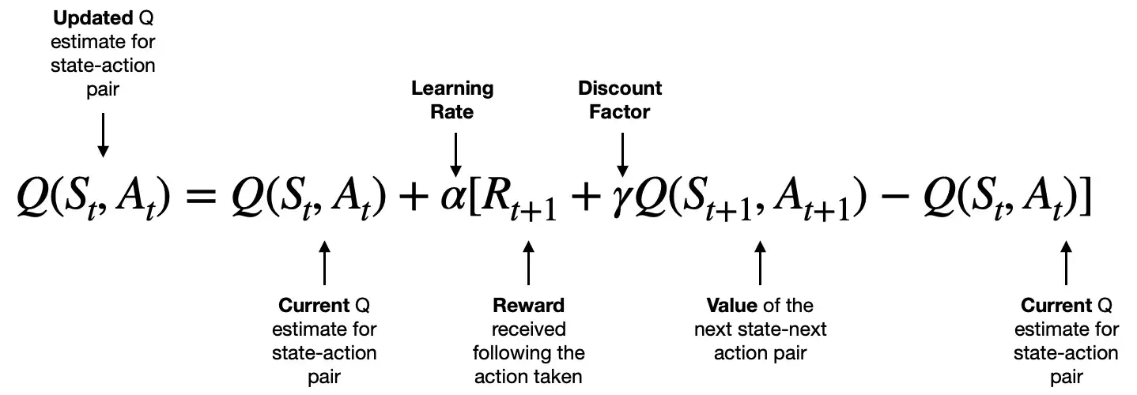

1. Dobilas, S. (2022)

In the current state (S) an action (A) is taken this then rewards the agent taking the action and move into the next state(S) and takes another action(A), the way this would work in a real-life example would be that if an agent need to cross a hypothetical frozen lake,

your actions would be to go straight, diagonal left and diagonal right and backwards. The agent would start on one side of the lake and since it’s never attempted this, all State action pairs Q-value would be 0. If it went forward and the ice was solid the agent would receive an award of 1, then its state would be updated after that the agent would choose its next action of go diagonal right. It then follows the prementioned equation for the state-action pair. This would continue until its found its way across or falls in. over time the Q-values for state-action pairs would be updated based on the reward received and by the end the agent would’ve learn how to cross the lake in the “safest way”/maximum rewards possible.

In summary, (SARSA) is a powerful and widely used reinforcement learning algorithm that can be used to learn optimal policies for a variety of environments and is especially useful in situations where different paths may be dangerous as it’s more conservative than Q-learning.

1 - Dobilas, S. (2022) *Reinforcement Learning with SARSA — A Good Alternative to Q-Learning Algorithm*. Available at: https://towardsdatascience.com/reinforcement-learning-with-sarsa-a-good-alternative-to-q-learning-algorithm-bf35b209e1c.