# UFCFTR-30-3/UFCF85-30-3

# Distribute & Enterprise Software Development

# Sprint Review Form

|  |  |
| --- | --- |
| Group: | 2 |
| Sprint: | 1 |
| Members: | Al-Ali Noora, Binti Tengku Anuar, Tengku,Janusz Alexander,Pine-smith Aaron,Sheridan-smith,Ethan |

<<Burn-down Chart>>

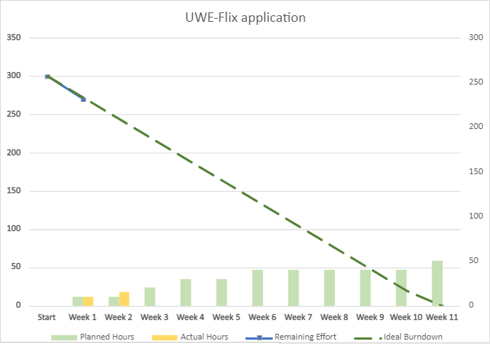

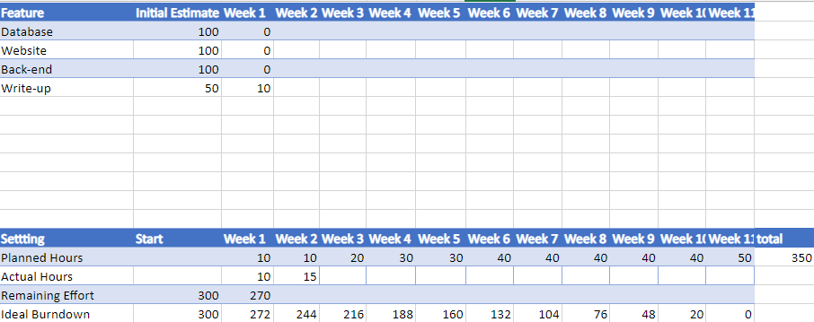

<<Backlog list>>

https://github.com/users/Alexj9837/projects/2/views/1?layout=board

<<Communication Issues>>

No communication issues.

<<Reflections>>

Currently working on, ERD for the database, this is good practise as it allows for a smoother creation of the website.

We broke down each other strengths and weaknesses, and assigned roles based on this. Putting Noora in charge of the database designing as Shes currently taking advanced database module.

<<Relevant Links>>

Provide relevant links such as GitHub link to updated versions.

https://github.com/Alexj9837/UWEflix_group