User Guide
To Notesie

Version 1.0
Table of Contents
Contents
Version 1.0 1
Table of Contents 2
1 Introduction 1
1.01 Signing up 2
1.02 Logging in 3
1.03 Viewing Your Notebooks/Bulletins 3
1.04 Viewing Tasks within a Notebook 3
1.05 Viewing a Single Task 4
1.6 Being a Tutor 4
1.07 Creating a Notebook 5
1.08 Edit a Notebook 5
1.09 Deleting a Notebook 5
1.10 New Task 5
1.11 Edit Task 6
1.12 Deleting a Task 6
1.13 New Bulletin 6
1.14 Edit Bulletin 7
1.15 Delete Bulletin 7
1.16 New Link 7
1.17 Edit Link 7
1.18 Delete Link 8
1.19 Edit Profile 8
1.20 Log off 8
1.21 Mobile Use 9
Installation/Setup 10

1 Introduction
This application was built to promote better communication outside of the class between tutors and their students.

Within this documentation you will find out how to use all sections of the application. You will have a good understanding of the purpose of the application. You will know what you can and cannot do as a tutor and as a student. Please read it fully.

1.01 Signing up
When you first visit the application you will see a large splash image with information. In the top right you will be able to see sign up and log in. An account is needed give you access to your own area.

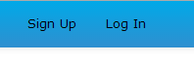

When you press sign up you will be presented with a number of field that you need to fill in. If you are a tutor then please tick the box for tutor to gain additional options. Once these have been filled in, press the sign up button and an account will be created for you. If it has been successful you will be prompted.
Note: If you are already logged in, the navigation will change. To choose your subject, click this button:
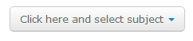
And you will be presented with a list of subjects.

Warning: If you select tutor and you are not a tutor, you account may be suspended, we take this extremely seriously and believe in our users being honest.
1.02 Logging in
Once you have created an account you will be able login to the backend. To do this click on the log in link:

Enter both your email and password; if successful you will be redirected back to the home page and a prompted will be displayed. If you click remember me, the application will remember your username and password for you. Please only select this on home computers where you are the only user as this could become a security risk.

Note: If you have forgotten your password, click the forgotten password link under the sign in button. Enter the email you used for your account. You will be sent an email and then follow the instructions.
1.03 Viewing Your Notebooks/Bulletins
As you can see, once logged in the navigation options have changed:

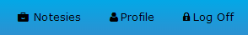

By clicking on "Notesies" it will direct you to the notebooks that have been created for your subject. From here you will be able to click any of the view buttons to look at the tasks within that notebook.

On the right side of the application you will see the news bulletin section. On here tutors will be able post new flashes of things that need to be heard by all of pupils within a subject. This could be an organized trip.
1.04 Viewing Tasks within a Notebook
Once on the Notebooks homepage you will see these buttons after each of the notebooks:

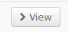

By clicking this you will be directed to the tasks page. On here you will be able to see tasks that have been set by tutors and the date due. On the right hand side you can see a link dump. Here tutors can create links to additional sites that will help students study.
1.05 Viewing a Single Task
When in the tasks view, by clicking the tasks name you will be directed a page displaying that single task. On the right hand side you can talk to your fellow users about the task.

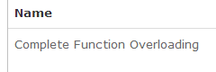

Warning: If anyone posts any inappropriate content, actions will be taken against that individual and the account will be banned.
1.6 Being a Tutor
If you selected that you are a tutor, you will have option to:

- Create a new notebook
- Create a new bulletin
- Create a new task
- Create a new link

If you are the tutor that creates any of the mentioned, you will have the option to edit, delete and update that task.
Note: Only the tutors who own the object will be able to edit, update and delete. So for example, if you create a notebook called Graphics, you will be the only one able to edit, update and destroy that notebook.

Warning: If anyone posts any inappropriate content, actions will be taken against that individual and the account will be banned
1.07 Creating a Notebook
When on the notebook homepage, at the top right of the first box, you will see this button:

Once pressed the new note books page will be displayed. On here you will have to enter the name, description of the task and what subject it belongs to. Then press create notebook which will redirect you to the single notebook view with a successful prompt.
Note: You have to input into all of the fields else an error will be displayed. Only the notebooks based on your course selection will be displayed.
1.08 Edit a Notebook
Now you have created a notebook, you have three new buttons:

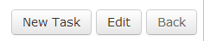

From here you will be able to create a new task for the notebook, edit the notebook that you are in or navigate back to the notebooks homepage.

Clicking edit with bring up a page that allows you to edit everything about the notebook. Once done, click the update button to complete the changes.
1.09 Deleting a Notebook
If you are the owner of the notebook, next to the view button you will be able to see a dropdown:

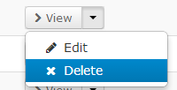

From here you can quickly delete a notebook. It also gives you the open to edit that notebook in this menu.

1.10 New Task
Once in the single notebooks view, you will see the same three buttons as before. When you press new task, you will be presented with a new task form. You have to fill in all of the fields in order to create a task. Once created, it will be displayed under the notebook that it was created from.
Note: You should never enter a date that is before the current date. To get to the single notebook view, navigate to the Notesies page via the navigation and click view on the notebook you want.
1.11 Edit Task
Now that a new task has been created, you will see a few icons to the right of it:

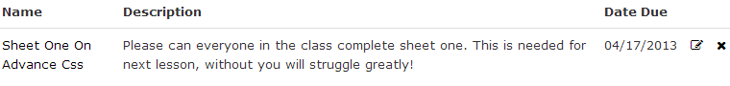

To edit the task press the first icon, this will take you to the edit page for that task. From here you edit its details and click update, which you will then be directed back to the parent notebook.
1.12 Deleting a Task
Once a task has been completed, it should be deleted. This can be done by pressing the second icon:

Once pressed that task will be delete and the page will be refreshed.
1.13 New Bulletin
To create new bulletins navigate back to your main Notesie page via the navigation bar. If you are a tutor, you will have the option to add bulletin post. Once pressed you will be taken to the new bulletins page where you must fill in every field. When this is done, you will be taken back to the notebooks homepage. Only bulletins based on your course selection will be displayed.

Warning: If anyone posts any inappropriate content, actions will be taken against that individual and the account will be banned
1.14 Edit Bulletin
If you are the owner of the bulletin, by clicking on bulletins name, you will be directed to the edit bulletins page. From there you can do the editing to that bulletin. After completion you will be directed back to the notebooks homepage.
1.15 Delete Bulletin
If you are the owner of the bulletin, there will be a icon to the right of the bulletin:

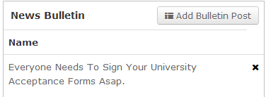

If this is pressed, the bulletin will be deleted.
1.16 New Link
Once navigated to a single notebook by pressing the view button on the Notesie homepage, if you are a tutor you will see the option to create a new link for that notebooks link dump, when pressed you will be navigated to the new links page. Once completed, you will be directed back to the single notebook view and the new link will be visible.

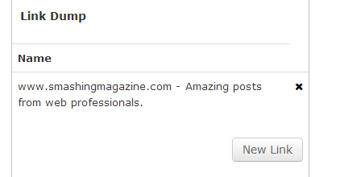
1.17 Edit Link
If you are the owner of the link, click on the link itself. This will take you to the edit page where you can do the needed changes. When updated, you will be directed back to the page where the link was.
1.18 Delete Link
If you are the owner of the link a cross icon next to the link will appear:

Press this to delete that link, the page will be refreshed and the link will be deleted.
1.19 Edit Profile
If you would like to edit your profile details, in the navigation bar press the profile link. This will take you to a page that looks like this:

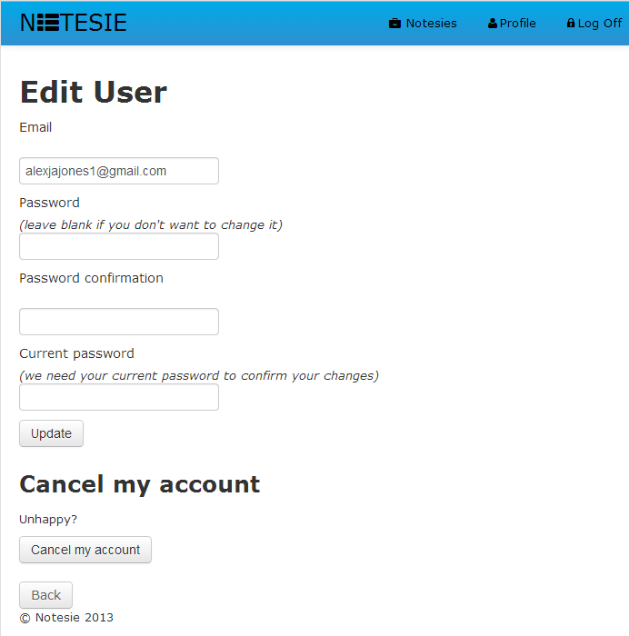

From here you will be able to edit any of your details. You are also about to cancel your account at any time.
1.20 Log off
Once done using the application, in the navigation bar you will see a log off link, when pressed your session will be logged off.

Warning: Do not leave yourself logged in; this could cause a security risk.

1.21 Mobile Use
The application has been made to be used across all different types of devices, from phones to desktops. The website will automatically react to whatever device you are using. Here are some examples:

Ipad: | Iphone:
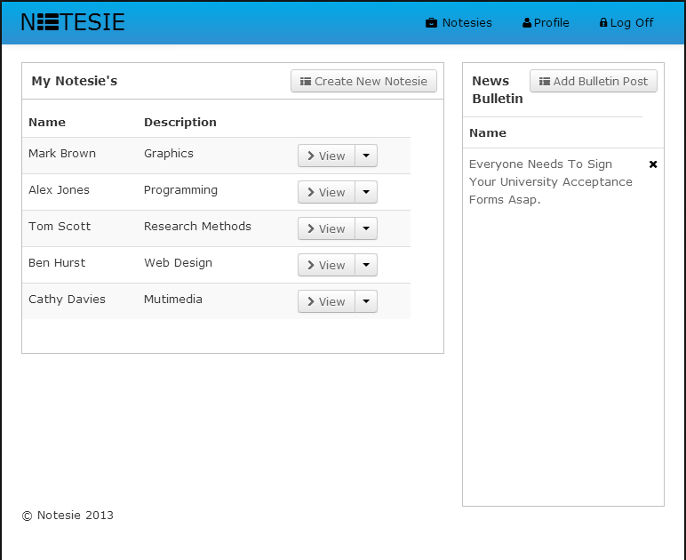 | 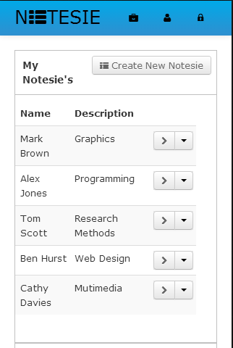

As you can see, when used on a mobile device, we have taken away anything that is essential to make the experience much more pleasing.
Installation/Setup
The site works best on the latest browsers and viewing experience may change depending on which browser you use. All of the tests have been conducted on the latest Chrome Browser. No installation is needed; just use the site as any other website.

