User Manual & Technical Architecture Guide: LLM Load Testing Tool

This document provides a structured table of contents followed by the operational user manual and technical guide for the LLM Load Testing Tool, updated to reflect the provided user interface and dashboard metrics.

Document Index
- System Overview & Architecture
- Key Technical Highlights
- Core Architectural Pipeline
- Quick Start & Installation
- Prerequisites
- Setup Instructions
- UI Configuration Parameters Guide
- Input Field Reference
- System Behavior Configuration
- Dashboard Metrics & UI Analysis

1. System Overview & Architecture

The LLM Load Testing Tool is a self-contained web application built to stress-test OpenAI-compatible Large Language Model (LLM) inference endpoints (e.g., vLLM, TGI, llama.cpp server, Ollama, TensorRT-LLM). It measures throughput, latency, and reliability under varying concurrent user counts and prompt token context lengths.

Key Technical Highlights
- Flask Web Server (app.py): Serves the UI, validates form input, manages background thread lifecycles, and exposes status polling endpoints.
- Load Engine (engine.py): Fires concurrent HTTP requests via Python thread pools, tracks usage statistics, collects GPU telemetry using nvidia-smi, generates charts with Matplotlib, and writes PDF reports using ReportLab.
- Thread Safety: Protects global state with threading.Lock() structures and uses threading.Event() for clean cancellation.
- Zero External DB: Operates entirely in memory during active runs and saves output files to runs/<run_id>/ (results.json, chart PNGs, and report.pdf).

2. Quick Start & Installation

Prerequisites
- Python Environment: Python 3.9+ installed.
- LLM Inference Server: An active endpoint serving OpenAI-compatible chat completion requests (e.g., http://localhost:8000/v1/chat/completions).
- GPU Monitoring (Optional): NVIDIA GPU environment running nvidia-smi for VRAM and power metrics.

Setup Instructions
- Clone the repository:
git clone https://github.com/Alexjmathew7/LLM_TESTING.git
cd LLM_TESTING
- Set up a virtual environment:
python3 -m venv venv
source venv/bin/activate
- Install dependencies:
pip install flask matplotlib reportlab
- Launch the web application:
python app.py
- Open the Web UI:
Navigate to http://localhost:5000 in your web browser.

3. UI Configuration Parameters Guide

The launch screen lets you configure target endpoints, user concurrency, input sweeps, and output settings.

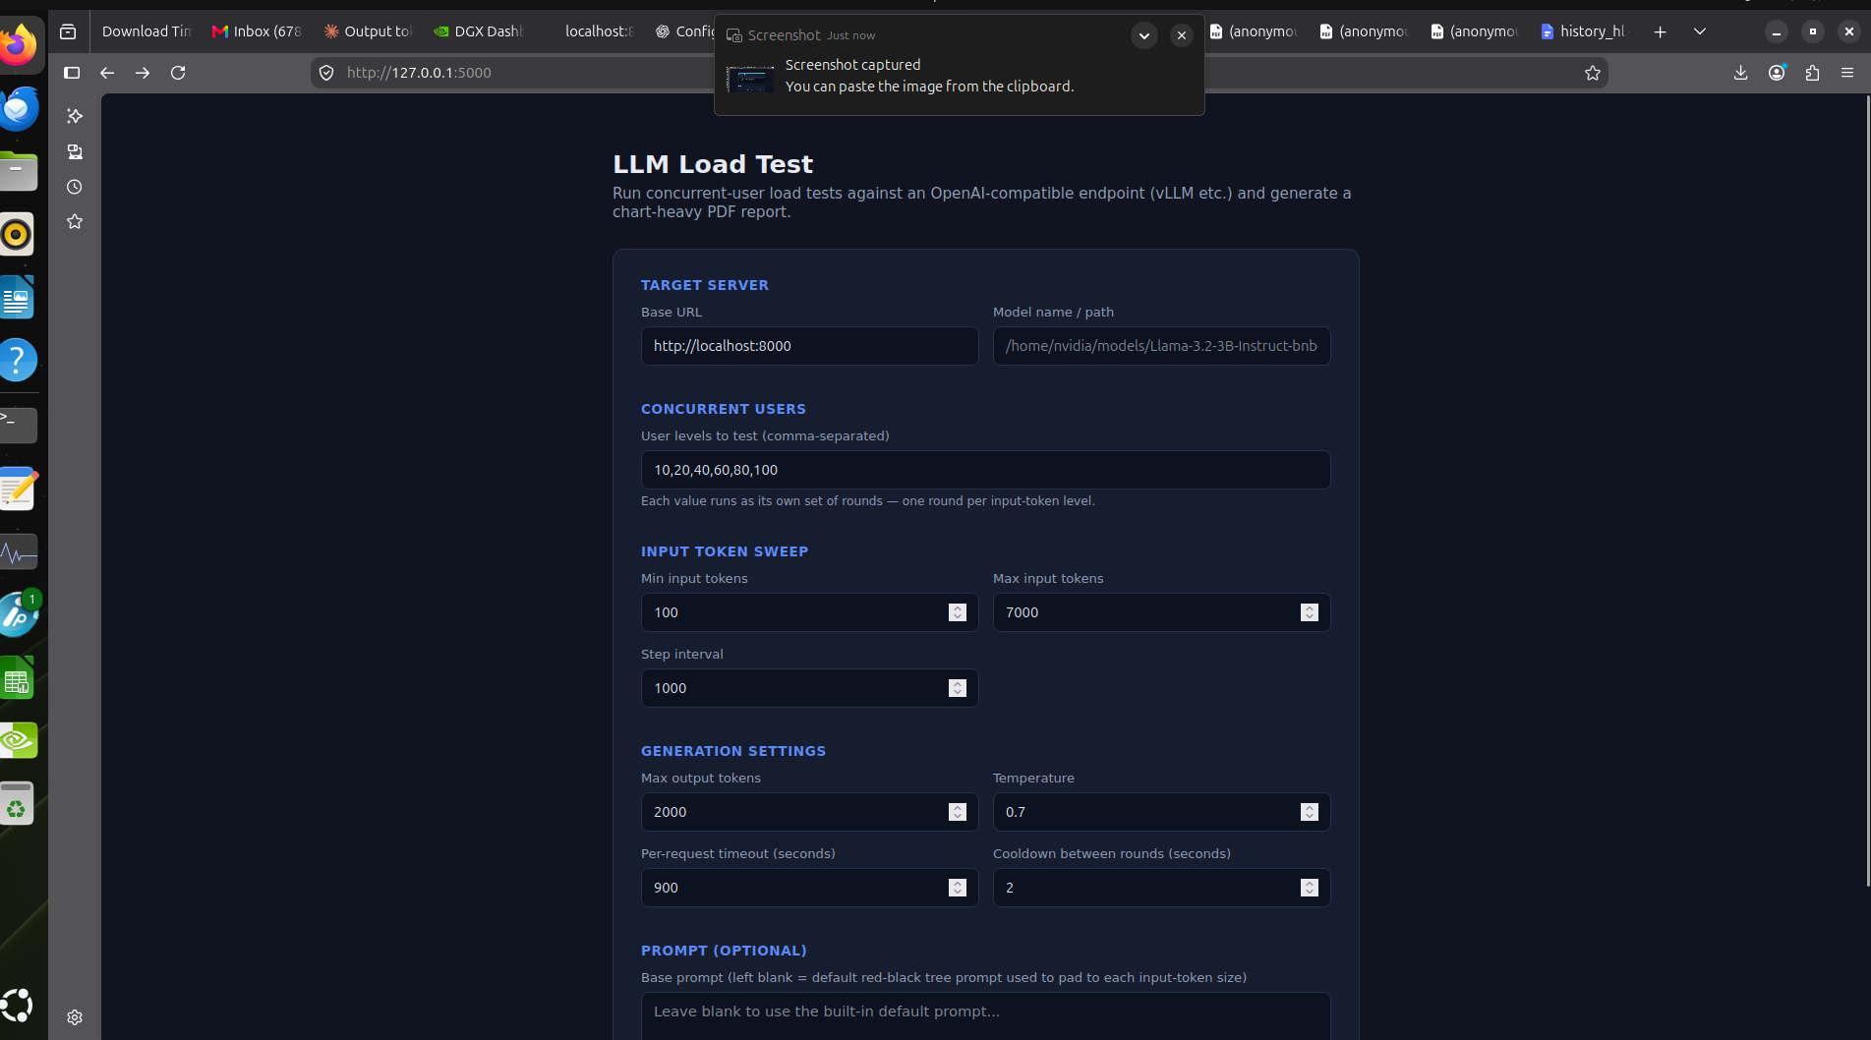

Parameter Name | Function | Typical / Example Value
Base URL | Target HTTP base address for the model server. | http://localhost:8000
Model name / path | Model path identifier expected by the server. | Qwen/Qwen3.8-27B-FP8 or local directory path
User levels | Comma-separated list of concurrent request workers per round. | 100, 120, 140, 150
Min / Max input tokens | Defines the bounds for generated prompt size sweeps. | 100 to 7000
Step interval | Incremental token size increase per test step. | 1000
Max output tokens | Maximum completion tokens generated per call. | 2000
Temperature | Sampling variance parameter. | 0.7
Per-request timeout | Maximum allowed response duration before failing. | 900
Cooldown between rounds | Delay (in seconds) between rounds to clear GPU VRAM. | 2

4. Dashboard Metrics & UI Analysis
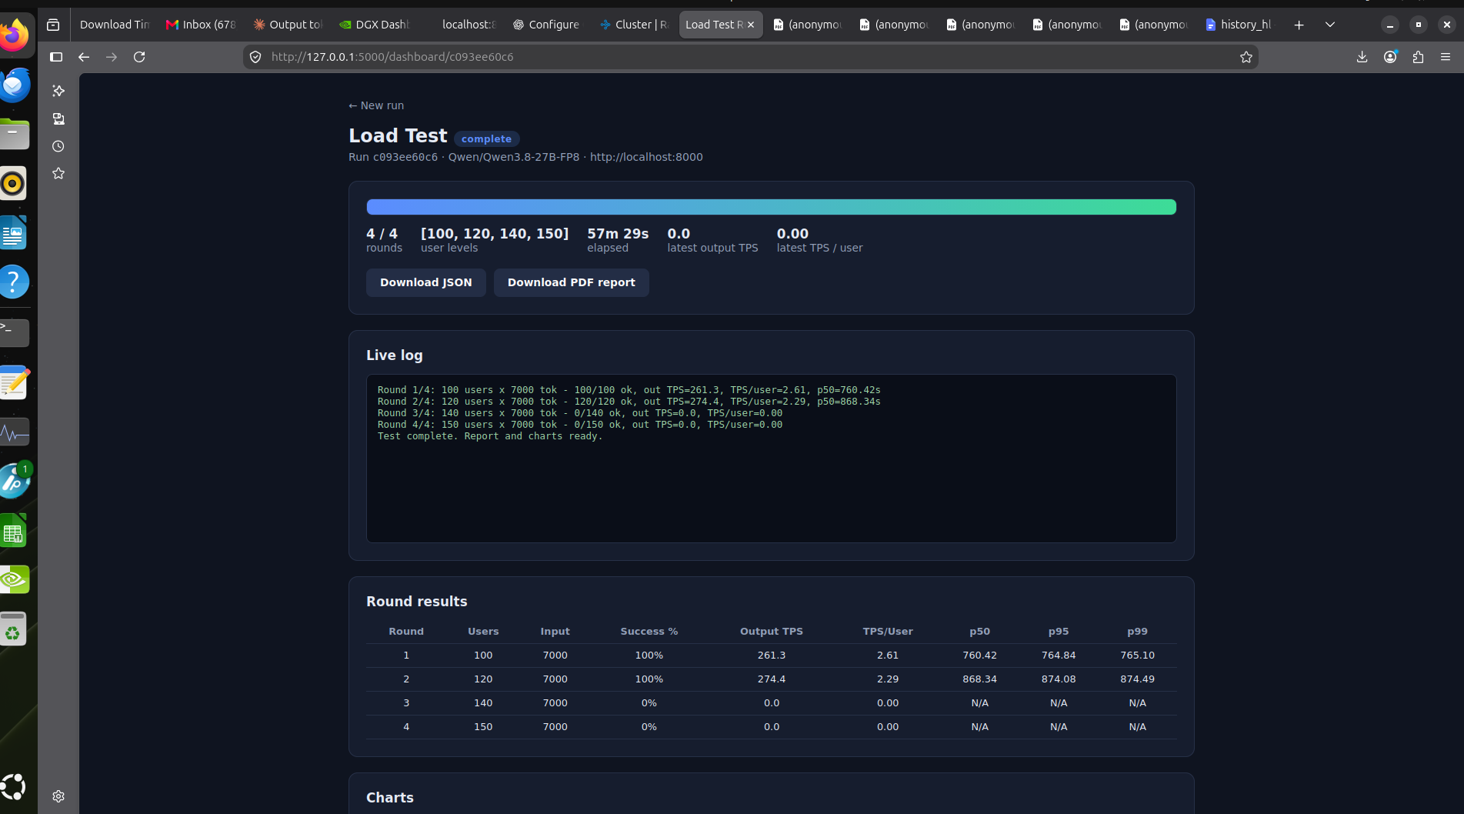

During or after a run, the UI presents metrics across four main sections:

Dashboard Elements
- Progress Header Cards: Displays total completed rounds, user level array, wall-clock time elapsed, and latest measured throughput numbers.
- Live Terminal Log: Text window streaming progress lines and errors from active testing rounds.
- Download Actions: Quick links to retrieve results.json raw data and the compiled report.pdf.

Metric Definitions (Round Results Table)
- Users: Number of simultaneous workers sending requests.
- Input: Prompt context length (in tokens).
- Success %: Ratio of requests completed successfully without timeouts or errors.
- Output TPS (Tokens Per Second): Aggregate system generation speed across all active threads
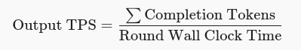

- TPS/User: Perceived individual user generation speed:



Prevent Request Contamination: Always keep Cooldown between rounds above 0 (recommended: 2 to 5 seconds) to let backend memory clear between rounds.
- Adjust Timeout for High Concurrency: Set Per-request timeout higher (e.g., 900 seconds) when testing large batch loads so requests waiting in the server queue are not cancelled prematurely.
- Diagnosing 0% Success Rates: If rounds fail entirely, check server logs for Out-Of-Memory (OOM) errors or context window limit violations.

The LLM Load Testing Tool provides an end-to-end framework for evaluating LLM inference engines. By combining lightweight concurrency, thread-safe background execution, real-time feedback, and automated report generation, it gives engineers the insights needed to optimize model deployments, size infrastructure accurately, and ensure high reliability under real-world traffic patterns.

