

Table Of Contents

Consolidated Wghllghts _ _ _ _ _ _ _ _ lcucr toShareholders_ _ _ _ _ _ _ _ _

_ lfC

_ 2

Best Ontimc Record- - - - - - - - - - 4

Best Baggage Handling_ _ _ _ _ _ _ _ _ 6

Highest Customer Satisfactio n- - - - - - - 8

Route Map - 1992fapansion - - - - - - - IO Outlook- - - - - - - - - - - - - - 12

Directors and Officers_ _ _ _ _ _ _ _ _ _ 14

Financial Re,iew FJ- Fl9

Corporate D:lla F20

Operating income $182,636 $62,936 1911 • Operating margin **10.8%** Li. 8 % (UI 11, Net income• $91,021 l(,,919 2,;x.1 Net margin• 5.4% 20% \ 111,

|  |  |  |  |
| --- | --- | --- | --- |
| Consolidated Highlights  (dollars in 1housandsexcept per share amounts) |  | | |
|  | 1992 | 1991 | Percl.'nl d1a 1 t· |
| Operating remmes | $1,685,178 | *S* IJ l.l,605 | *! K ,* |
| Operating expenses | $1,502,542 | ,S1 250.669 | !II l |

Net income per common and

common equivalent share• $.97 $J I *ll!*

Stockholders' equity $854,253 $628521 .:;, I

Return on ,werage stockholders' equity• Debt asa percentageof imcsted capilaJ Stockholders' equitypercommon share

**11.7%** ·1.-1% 'Jlh,

45.0% 49.5% ' I ; ph.

ou1s1:u1ding $9.24 *$:.*.j.i > I



Revenue passengers canied 27,839,284 Zl,669,<)Jl >' X

Reven ue passengermiles **(RPM)** (OOOs) 13 ,7870, 05 I1.296,18.l *!* ' I

Available seat miles (ASM) (000s) 21,366,642 lf\, ,91 00.1 h11 P:ts...engerloadfactor 64.5% 611 % I plS. Passenger revenue ield per RPM 11.78( 11.22( i O

Operating rerenue )ieldper ASM 7.89( 7.10( 11 I

Operating expenses per,ISM 7.03( 6 :6< I ii

Numberof employees at ycarend 11,397 9:PS H,H

* 1?92 excludescumulati, effect orchange inoccounting principleof $12.5m iWon ($.13 p<>rs hare)

**'Ute!frlpleCrown:** Won by-th'8 . tll:e·c·omblnattonof O..ntini'e**P rf{i** BestBagg e.Handfing; andHigh Satlsfactio,n inasJngle)llonth, as '



the US. Department of'fulnSP9. 011e airlinebas_everwon It- Soll '.And we'Vewoniteleveatlm .

19()2 mark.,!lieOtst ttnteeve( that(

Sollthwest - *has* won *the((f{fltla*·*l* le

Nmnber,One1h Ontlme,Ferfonruince;N

in Ba:ggage H"andling; andN1mlber Oniln·. '

Sa:tisfatlioo *-jbt l.oo,e11tlre"yem:*

I > @.Url 2 ,000 Employees no)v,pioudlyWeat'

'lfiipleCro:wn Medal forDistinguished CUsto·

, Service.tflris anm1a**l**l **/ifnJlJjj**

reponsts a tribUle **JI ..m?**

, tothem, and to ---

tfie,co-wihners, ***t*** '·

our <Justonters.

,

#### '

'

##### .,,



*Sofllliwl!sllJrl/1res,Co Is*

*1/Jelfdlio11's. fawf!UI, btgb Cr/Slo111er Salisfaelio11ai rl/1111. Weprltllarily S!/tttesborlbafll di)'pairs,,Prot1kli11s1g11g/q, classal , lta/l$/f0fldliolf wbkb ldrSfJSI/JJJ'bus/um oom11111ter aswellas1e1sr,r.e1m11e,lers 7l1eCo111Jx111y, /11rm/l<lfaflrl*

,,, *(X)llJll/11/Jced Cr/SloJ1JerServiceq11;/lfllll f8, IYJl 11/IJb lbte11B!JeJ11g 7 3 7*

*{l/rJ:J'aj)se1r1f11IgIJiwTIO'il$*

*cflli!$- Vd{/a$, llot/$10.11,*

*(Ill«$(11i /111/011{(). Al)Wlretld*

*l9'J2,S!J.rll/Jaw'Ofert(fed*

*f fl Bbe(11g737Jllrotll/lJIJld PfOtlidetl servKe.to36(l/r/1(Jrl$ 11131cU/tS* /11 */hi_11iklJ1¥§1J,lrll*

*$(}flfbwes1t 1r11, (1/ldd qrtt*

*reg{()11S Q/ill1eU11/ledSldltS. lff)eCiJlllfiitJq/JMOJ/8 fJ//be IJesl011ert1/I Crld1J111er Ser/lice*

*r«t)l'(/,s/lie'//JJIMS/1l/lfl'illlllg*

*iX!SIslrad/11'8,.JIIJ/tIXJJIS{s. fmftfy ojferslbelor/.18:d mid sl111ples1fares/11ff)edomf$1/c alill11e1tul11slzy. 'LOYIsour slid txdkr1rge symblJI, sdeattl:Lo re/fust!IIO(Ubonf#! alat/las /.IJ11ePiekf,asutef/ as,tlJeIhemeofiour1!t11filo;w mulCJ/Slunrer rt/(lfio11slif/1$,*

To Our Shareholders

TI1etl1r<o. eyc:1r.11990-92 presented tl1egrarest lln.utcial crisis in tl1e histo,yof tl1eairline indust,y.

During tltis relalll'elybrief period, approximate · 40 percrnt of the toL'll capaci ·ofour nation'slargest carrierseiOierceased operationsor bcgru1operating in Chapter**11.** And tlie m,issirelOSSt'Sincum'(! byour industryasawholechanged itscumulative lln:mcial restdlS - stenuningfrom its l'e1yinception - frmo an Ol'erall indust,)' profit10ru1Ol'emll iudu 11y loss. for these reasons, 1990.9211ill long:md unhappiyl**be** remembered asalimeofeconontic hool caust *in* tl1e Arnericru1:tirliue industry.

Although Southwest1111S theonly majorc-.u1ier reporting botl1operating ru1d net incomein 19()0 and1991, itsearnings we resel'erely im liroo in both iem;, fallings ubstantially below tl1oseof 1989.In ourLetter

10Shareholders in our 1991Allllu:tl Report,howcrer, we prophesied that 1992 wo1tld bea"Yearor •

Opportunity' forSouthwest, andsoiihasprol'en tobe, in temtSof botl1marketexp:msion ru1d

recuperationfrom fin:uicial malaise.

On behalfoltl1ewondrous ,u1d1ruorous people ofSoutl1wes1, I:1111 happy10 repo,1fo1111h quarter 1992 eamlogsof $27,170,000 ($.29 per share), a 207.3 percenli.mproremcnl01-er o ur lourth quarter 1991 profit ol$8,8420, 00 ($.10pershare).' lltese respectable res1tl1Sare prirnruilyattributable10 a rerenue incrroseol 27.4 percent, am,mpanied byanopemling cost increa.-;e of 20.0 pe1'CetJIonacapaci · ettlt:mcement of17.3 peroou.A 2.3percent rise inoperatingcxpm-;cs per araifablcseal mile (AS.\!), 10 $.o705 from $.0689,wassubst,u1tially ullluenced bya$5,700,000 iJ1C('("J.Se iJ1qu:u1erli·Company contributions 10emplorccprofitsl1ruingand smings pl:ms.

,\Lo;oon behalf of thesplen!lid p<.'OpleorSouthwest Airlines, I:m1l'c1y pleased 10 report year 1992 eantings of $91,021,000 ($.97 pershare), a2381 percent iJuprol'e111en101-er o ur 1991 profit <>f$26,199,000 ($.31pershare). The 1992 eantingsJlgureexcludes tl1e cunntlatil'e$12,5380, 00 one-timeclfl'<1of an accounting d1,uige, both because ii L rut " accountingchange" only:mdalso because iiwill not recur iJ1 fon,re)em;. Although belowour ugetoperating:md net income margins, our relatirely healthy1992 profits are, again, principally attributable 10a 28.3 percent iJ1crc:ise iJ1re--enue, as t'Omp,1r<.'(! toa20.1 percent u,crc:ise in opemting costs. fortl1e year, ouroperating expense perA&\l iJ1creased 4.0 percent to

$-0703from *$.o676,* primarilydue10 increased rumual profitsharing pa)lnents forour Employees;tral'el agencyco11mtissions;andairport temtinal costs. Our net nonoperatingexpenses rosefrom $19,096,000 *in* 199110 $35,799,000in 1992 asa consequencr ofadditional interest expenseincurred from the 1991-92 issu:mcesof $400,000,000 insenior unsecured debt, coupled \\ithlower interest rates on lm'CSted cash

during 1992ascompared to1991. OnJ:umary 20, 1993,11-e anuounctod theearly redemption, eft'ecti\'e March 1, 1993,of$J00,000,000in9percent senior unsecured notesdue 19')6, 10 be utded from cx.isting C'JSh resources.

In 1992,So11d1wes1 becametl1cl:u-gl'SIcarrier of inlmstale passengers *in* C.alifomia ru1dalso numberone in originating passengers in Phoeni.x, L1S Veg:tS,:u,d K:u,sasCity. A mc:tS11red by1L1i · flight departures, Phoenix isnowthe largest sel\ice pohll on our S) tem, ru1d werecen ycompleted construction ofour new main1emu1ce facili ·at itsSky Harbor Airport. Additional Califontia. .Phoenix, Las Veg.ts, and K:uL lSCi · sel\ice will bepro,ided in 1993.

Our 1992 expansion at Chicago's Mld1111y,liIJ>Ort h,ts pron'n 10 besuccessM,:md we11ill i11auugratc se"icc toat le.-ist one newcityfrom ,\ Jidll'J)'h11993,aswellasaugment St'l\iceon existing Mfd11ay routes. A Ud1myrese1vatio11S centerand pilot domicile were opened in 1992.

Underour present plw, we11·ill placeiJ1St'l\ice13new Boeing 737-300s and oneleased BoeiJ1g 737-300 in 1993, increasing ASM capacity byapproximately 13 percent We11ill also openournew Albuquerque rese1Vations center; more10a larger resem1tions facility in Houston;complete tl1e renol'ation olourg.11es at Oall.1S Lol'eField:md Houston's HobbyAirport;:md expandour Dallas FlightTraining Center10 accommodate anew ReOectonc Oightsimulator.

Southwest h:ts alwa)sstril'en 10 pro1ide"morefor le;;;"- superior Customer Se"icequ:tlilyfor alower fare

- mtlter tl1:u1"less lorless." \Ve hm·e been success6tl *in* achiC1ing tltisgoal, aseiidenced byourcapture of **11** ''TripleCro\\11s": best ontime perlom1:uice; fowest mish,u1dled bags;ru1d lowest mtio of Customer compl:tiuLs 10 Customers carried, allhtasingle montl1. Nootl,er major canierhaswon even asu,gle montltlyTripleCco1m,11l1ich is1>l1y Deltaru1d No11hwest hale' petitionedtl1eDepartment olTnutspoituJon 10docla.o;sify Southll'esl asa"major•·<1UTicr, despite *the*fat1th:tlwe 1\ill1nuisport rougb]y 30,000,000 originating Customers in 1993.Altl1ougl1 DOThas not yet rele-.tsed its final 1992 statistics, a of tllis

2





wrilillgiiappears that ourextmordinarilyw.t·f11i, welcoming, andCusiomer SC1\icc-0rien1ed people haveaccomplihsed a"moon l:uiding•·inthe field of Cus1omer Scnicc bywiJm.ing tl1elirslannual TripleCro111i altlined bya major aircarrier: best oniimepcrfonnance; best baggage handling record;

:md bestCus1omer complrunl record- **for** theentire year 1992.

Ourpeople are 001onlymyheroint'Sand heroes; tlieyaretlie heroes and heroinesof airlineQ1stomers and airlineCustomerScnice qualil)' tl1roughou1 our land!

Soudiwesl's people are, b1deed, veryspecial. Omingthe Jllldtn'C )'!'Mi, tl1eyhareworked assiduously and weU10 al'oid and10 a1-ert dieeconomic aftliclions dial have besel manyolher t'llfriers and manyotl1er comp:utiesin die l:niledSt11t'S. foa ma1erialsense, tllC)' have n mrnrdcd11idi jobsecurily milter lltan la)l)[and furloughs;11idi payincreases mtlier lh:m paym!ut1ions; \\id1profi!Sharing of$50,492,000 rather d1:uishared pri1:1tion; and11i1h :u1 increase in the1:\lue of tlieir l!.mplo)-ee O\\ned, bulC<>mp1my conlrib11100, slock10$246,223,000 al)l"Mend 1992, L,1e1ial rewardsareimportml-10 a poinl- bul tlieyalso prore hollow unless accompanied bydie psycltics1.1.is factionsof pride, e.xc1ei men1fu, n, and colleclil'c fulfillmenl. Ourpeople also p-101ide ess<.1ilial intuigibles:10each 01her and10our Cus1omers. lli:11ls 11iiy1 an1espooalJy gmlificd di:u Messrs. Robert Lel-e1ingand Millon MoskO\\ill,

in dieir 1993 edition or*Tbe /(X)&st C()mj)(mies to WorkPor i11America,* choseSoudiwest asone

or1he ten best rnmp1Uties 10workfor- in allof America. Southwestreceired eid1erfour or 61'e s1ars in thesix r.1tingca1egories of:Pa)1Be11efi1S;Opportunliics;JobSecuril)\ l ide iJl \Vork<tompany; Openness'Faimess;and Ounamdcrie'Fricndliness.IIour Emp!O)'t'CS' minc:l.s, hearu;,:md soulshad been mted, theywould each lm-e receil'ed 1en s1ars!

Mostsinccrelr.

/W J .

Herbert 0. KeUeher a1ainnan, President, and

auef E.xecntil'e Officer

January21, 1993 3





Bes t Ontime Record

Southwest w:isspecifically built tomeet the needs of our Customers. Ifs no wonder we wereon lime 92.1 percent of rhe limein 1992, the best among rhe major U.S. airUnes. In *fact,* weset an

a-ll time monrhly record inS(:prember 1992 wilh 94.9 percent olour more rhan 1,300 daily flights ani,ing on lime.

Sou1hwes!'s poin1--10po1i11roureS) tem, ascompared to hub-and-spoke,proi,d esfor more direct nonstop routings for shorthaul Customers and, therefore , minimizes connt'<:lions, delays, and101:\1

!riplime. In addi1ion, Sourhwesr se" ·es m:u1y co nl'enient-lylocated satellile ordo,mtown airport such as Dallas Lore Field, Houston Hobby, Clticago Midway, Oc1roi1 Cily, Burbank, and Oakland airports, which are typically less congcs1cd than other airlines· hub airpo11s and enhanceour ability toachiel'e reliable, high onlime performance.

Asa result ol ourfocuson theshorthaul, po1i11-10-poinlmarket, and thededicated efforts of our Employees, Sou1hwcs1 isconitnuall)' able to achieve the highest asset utilization and employee producli1il')ol any major U.S. airline. Aircraft arc scheduled to minimize theamount of time the aircraft isat thega1c, generally Jess1lian 20 minutes, thereby reducing the number of aircr.ut and gatefacWlies that would othemise be required. Al'oiding high-cost, congested airpo11s con1ribu1es signi6cantly toour ability to achiere high asset u1ili1.alion. Sowedon't hal'e tosacrifice alrcrafl u1iUzalion toacbie·e, high onlime performance.

The poinl-!o-poinl rou1e system, high aircraft utili11.1ion, and high employee productivity produce a rcry efficien t opcralioo with exceptional onlime performance.Also, westill operate only one aircraft type, rite Boeing 737. Al December **31, 1992,** we had **141** in our Oect. Thiscomn1ilmen1 toasingle aircraft type significantly simpllfles scheduling, maintenance,flight operations, :u1d training actil'ilics. l'he 737 has prol'cn tobeoneof a1iation·s mos1successful aircraft - ii is auractil'C and comfortable for ourCustomers and iscost-cffectil·e10 operate in theshort- 10

m ediu-mrangemarkers.

*11'ben !be Big 1breeairlines /Joasled Ibey were /011.w ing!heir fares, So11lb1t -esl re.,ponded 1dlb dJllraclerislichumilily.*



**WE'DUKE**

**TO MATCH THEIR NEW FARES, BUTWE'DHAVE TO RAISE OURS.**

**4**



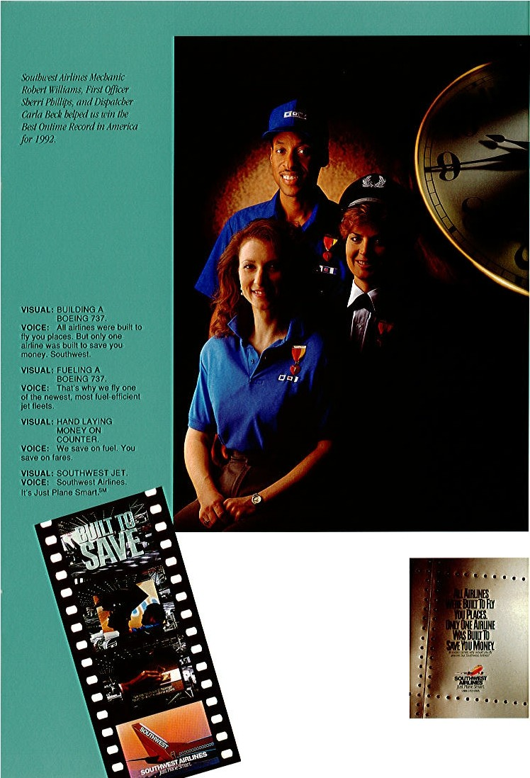

*Onlyoneairlinewasbuilt lo Stu.'/! youmoney.* /11*loday'slimes, 1d1y ll'Otdd youflymu'One but So11lb11•M Ail'li11es?*

5



Best Baggage Handling

Southwest wasspedficallybuih 10 meet the needs of our Customers. Ifs110 wonder wedon't lose many bags.In 1992, we had thefewestmishandled Customer bags of any major U.S. airline.

Southwest's marketing strategy isdirected tocommunities that benefit by hi-ghfrequency,low-cost air transportationand that ha1e·sufficient local traffic10 supportour operations profitably.

Because our focus Ison local, not connecting, !raffle, wedo1101 interline with other jet airlines or hal'C any commuter feeder relationship.sAs a consequence, approximately 80 percent of our Customers Oyon uson aoonslop basis.

Our supe1ior baggage handling isachiel'ed despite ourquick aircraft tumsat the gale. Soaircraft utilization isnot impai.red. ln addition, this record has been compiled ata lime when Southwest is Carl)ing record and ever-increasingamounts or cargo and U.S. mail. Combined, freight re1·enues grew faster than capacity in 1992, or 25.2 percent.

Our stre-amlined approach, coupled 11ith thecaring and dedicated altitudes of our Ground Operations Employees, enables us tocontrol and handle ourCustomers' bag_ age efficientli·

, ilh minimal loss.

Although outslauding baggage handling along with outstanding Customer Semceareobjecli es or our marketiug strategy, the net result of ourapproach is that we dominate our markest in terms of passenger tr.iffic. We consistently rank first in market sharein more than 90 percent of our lop 100 cil)·' pairmarkets and, in theaggregate, hold a market shareexceeding 50 percent.

*Aspar/ o/Soulhu·esl'suiild(J' st1<Xl'$S/11/ " FriendsFly Free" progmm in1992, tt'C i1114lt'd kids loJ!1rfreeduring the*

*Slllll lll lJI', tvbell flCCOlll/)allied by* ,111*lldult /J(IJ111gour regulllr low/are.*

6

*SQUl Air'llnes_Ratlf/>Age,1/ VimSilrgetJ'Sk)v:np <Ji.arks W1li011, and OlflPf' Servla II KathyNelton »JaMSIIYt tlial.)YJUI lul!K(lg,, fslrwl.ti!d wllbl!Jeldme rl!$pldU11,sliDw 11/lOM CtlslimJm.*

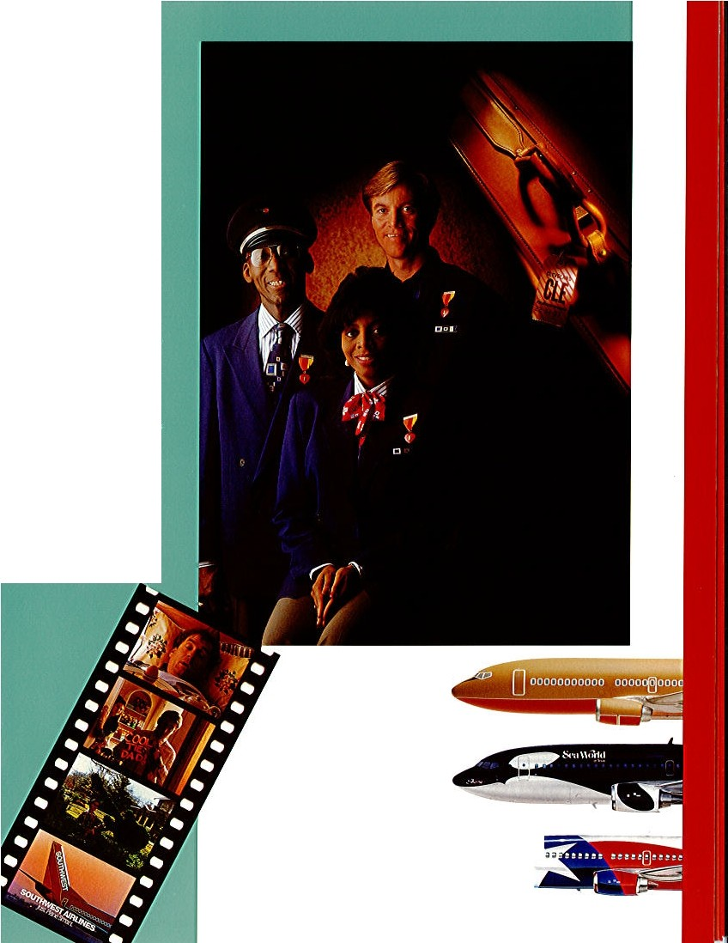

VJSlJAL: Mali! SERVIRO DAO

B.BWF.AST IN. BED,

VOICI!: It'sUmelorFtlendll Fly

Rree IQlln on$oulhwUI

Alillnes. Al!!Ipt,OplQam

fikllMllltr llilntYtr,

VISW.t: DAUGHTEII

OO"MT'l!IMENTS

DAD'S T.te.

Inad\1-.w ·a roundlrlp

'lOICf!: JOll maRe teuJYa®na

**ck• 8ll4I a ,fdend,llfeawtlh**

**yau free.**

**V!llmL}SOJI TRIM"S HEDOE**

**ORl:ATNECY.**

**VOICE: Yo., Dad.**

**Wlleddy11 thl k1**

**VJS:UAL: SOUJHWEST JET,**

**VOJCI: Rdellds Fly F!Hon lbweslAlitfnD.rlt•t U1111 Plane Sm.,i ,su,**

*So11lb11· l'sJIM of14 I Boeing* 7*37si11d11d1,s lhr eejlying td/111*- *Slx111111'" One, '/) r o, t111d 71Jree- incelebmlion*

*of 0111· p,1rh1c1 /Jip wibl Seti Worldsof Te.ms and Ctliifomia. Plus, LoneSiar One,®*, 1 *hi gb j(ringlribule*

*loour /Jomesk1teof faw1s.*

4' ···

7

Hi gh es t Customer Satisfaction

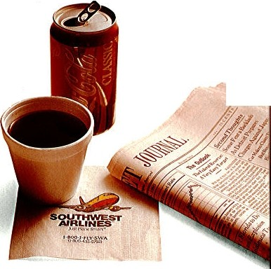

Southwest wasspeci6tall)' built to meet the needsof our Customers. It's no wonder we get few complaints. In 1992, we had 1he hesl (,\1s1omcr complaint record of any major U.S. airline.

Our outstanding Customer Sallsfaclion raling isa testament 10 the Positi,el)' Outrageous Ser.ice.

pro,ided byour Employees ona daily basis.

While our Emplo)'ees delirer our high-quality(,\1s1omer Senicc in acaring and enthusiastic manner, our unique marketing and operating s1rnlC8)', designed \\ lh our Customers' needsin mind, facilitates thisexceptional scnice. Since our inception, Southwest hasadhered 10 our poin-t 10-polnlser.icein shorthaul markets wilh thelowest fares; lrequcnt, ,co wenient·l·ilimcd Oigln;s and friendyl, reliable Customer Senice. We are unique in the airline indusl1')as the nation·s only shorlhau,lpoint-lo-ponit, low-fare, high-frequencyairline.

• : • I '

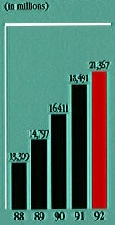Our faresare purposely low, asour principal competition insho,1haul markets isoften ground transportation.Sou 1wes1 isclearly the low-fare leader In the U.S. airline industry. We hama rery simple fare s1nicturc, maintaining low, unrestricte,dunlimited ereryday coach fares, wllich our Customersc:111 depend upon10 be thelowest arailable.

As aconsequence of our low-fare approach, we tend 10 grow our own markets, often sllmulating traffic three- and four-fold,·crsus traffic Je,·c lsex.isling prior10 oursenice- with few complaints. Of course, our low operating costsenable us10 offer these lowfares, which are,11al tothe shorthaul Customer, and still be profitable.

Finall)', our ticketing and boarding procedures, aswell as our in-Oight senices, aredesigned and built to meet the needsof shorthaul Customers. Quick and efficient ticketing and boarding procedures arcimportant 10 mininlize the total trip lime. Therefore, weoffer confirmed but open scaling inourall-coachcabin. Because the tripsarcshort, no mealsare practical or necessary, but superior bererageserriceis pro,idcd. While theser\<ices arc"low frills," the Customer Satisfaction rating is thebest in theindusll)'.

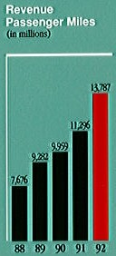*/11a <Xmti1111i11g Oort tohelpimpro//e thee1wiro11111e11t, So11th1re.l proud>(• recycles ourcoffee cups, r:m1,s11apli1i1s, and 11e1rspapers.711is entirea111111a/ report11·11s printed on*

-

*recycled paper.*

8

VISUAL: <!IFF£CIE 001>¥

**t.lACJ:(INI!,**

**VOIEC,; li1y_lno** I **ftQi/SlOll**

**M b\lJIMU 1**

**YJ8UAL1 COPIES SH0W**

**MUhTIPCEFtlGHTS.**

'lOlCE1 ll®lll)YtlJ Altllnet....

**$8v:tfllent ftlahls** frj\lJIDllllill

**Ii.ovafieldtVeTfbuslnm Y·'**

**'llS UAL1 SCREEN READS**

FL!l»ITS t O

**H(!)U$f ON'.**

VOlCl!: AncLlba:tls 80lllelblng

**nclbDcfy e11111can -r**

VIJUAL: SO.OTHWl:SJ' JET. .

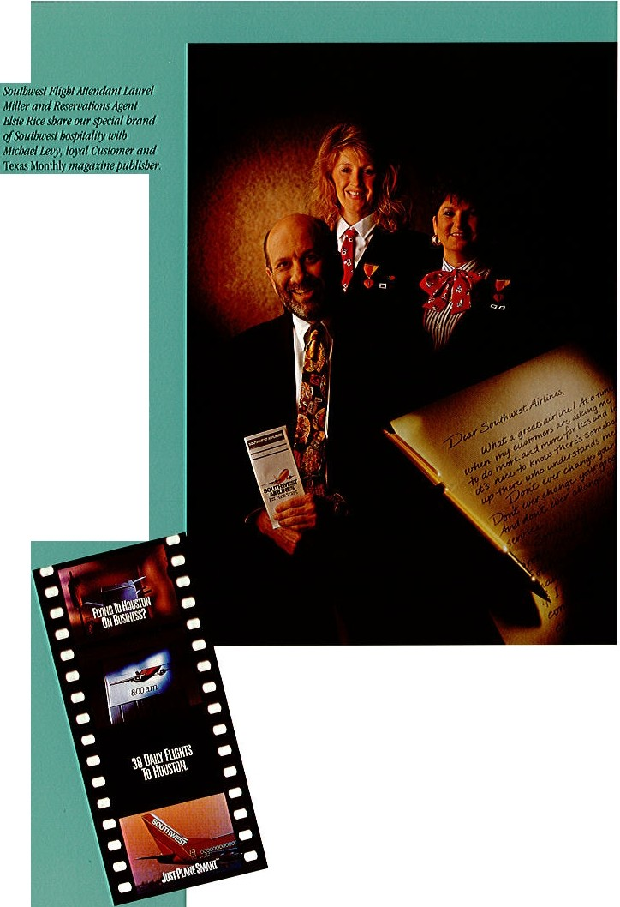

**V01CE1 S®lhWll t Alfflrt,H**

**It'sJustPlane Smart,llil**

*1beCo111pn11yClub, 011r fre111ie11t flyerprogmmtb11t re1mrds C11sto111e,4 orsborl ll'ips insteadof long mi!Mge, remainsthe slx,rtest routelo freetrips.*

9

*!Naliesteanuuotfl towi11J/!g aitlitreiud11sfl!)''sflr:,ta11111rdl 7'rf/>.le Cto1111Hwr,N1111iber: Ql(e4tJ Ot1/lnwPerjorma11re; Number 0Jtei11&(ggage Ha11dlf11g; aJJd Nt!JJ/ber:0t1e i11·C11S10111er8alisfadio11,fo,:all' of {992, Repcese1_1/i11g /he SoulhW&1.Team lfer.earepet:J/Jle*

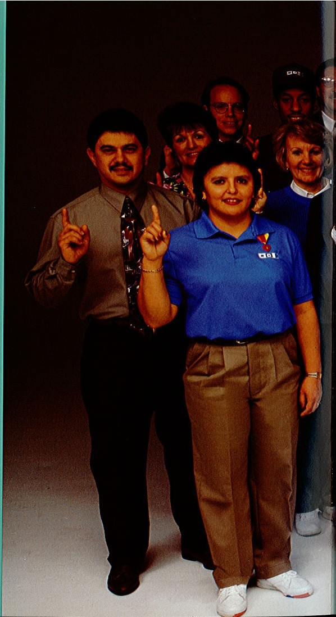

*:[ro111'euerydepallme11/.*

*7ba11k$ lo etfdJ andettmrJ 011e*

*<J.f,0111 [2, 0l)()•EmpiJlJWS,*

*Southwesl Alrb11er/x,s .111011 whal110 olh!ir:mlljor airline hasewnvo11 befo1e: 71te At111ual7'rl/>.le Crown.*

*81(/ we've011/y j11sf (Jfg1111. fltit.:off/0'/!Je/J(ISJ. Collis of/rfo i/Je/ufuro. Soulhwe.sl Airfl11e.tis N1m11Jer Ot1eallds/111 dlnihingt*

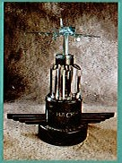

*'/1Je:flrsla11111ra·lTrip/e,Cro11111 trophy e,1er. Polished green 111ar6/e. f.Mde(/}111/IJCfJb'lill,*

*Ane>XJ11isite re111i11derof*

*!hi!hard1uolri,,deditallor1, m1de./jlrll ll/JCO,:/),$ I/Jal madeSoulhtuesJ NJ1m!Jer 011e il/'Otl(}Tll/1Custo,ner Sert1fce*

*ii) 1992.*

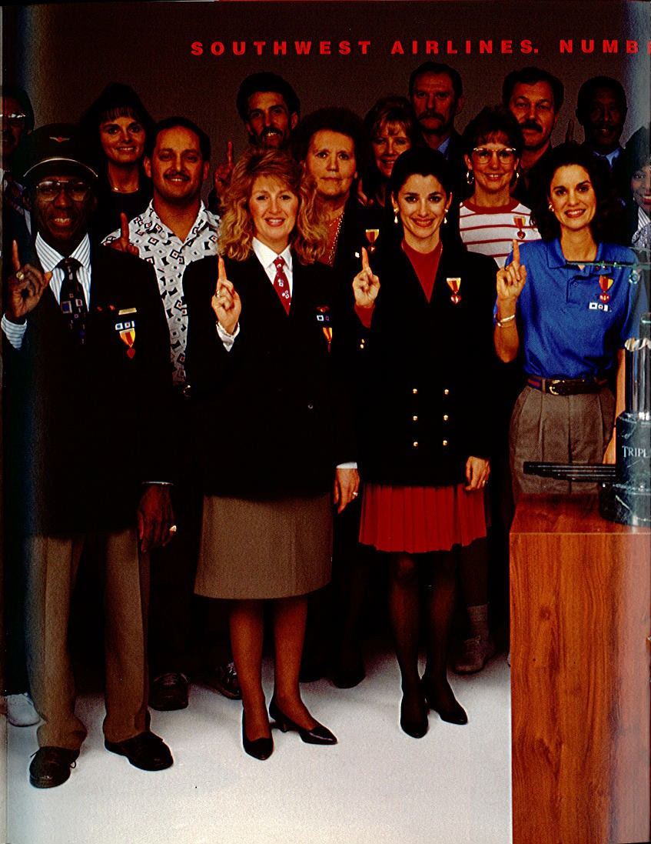



Cilrla lle(k, D1spalcher.

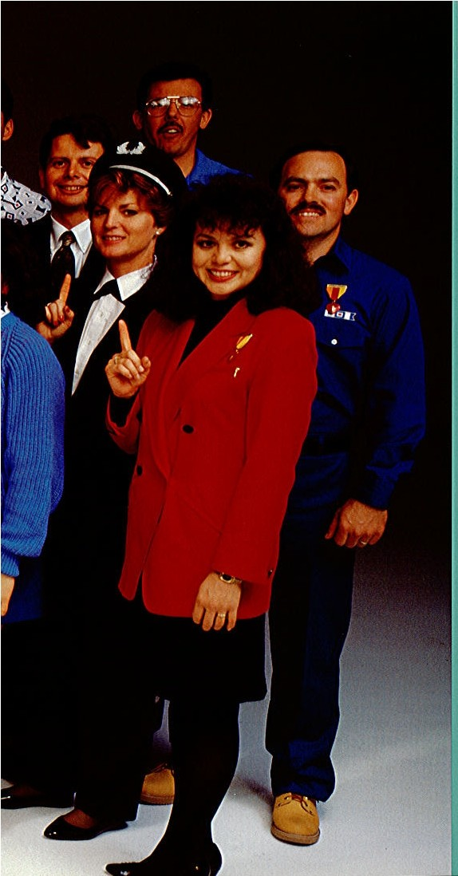

Rudy Bowling, Courier,,Maltand Wareb_o.useScn1tcsSupeo'i$0t.

**K.elth Bradt,** S(i)(jk Clerks **JellBr:o,oldtart,** Statlon,Manager. ZOiiie Chdstakos, Cargo Admlnlstcaill'eAnalys,t

**Mark Bndrlss,** Alwmft meaner. **Barri Fain,** Senlo.r customer Relatol ns'Rcpr olalh:e.

**Rocky** GonZlllez, FacWUcs Malntena,ncSejlect1illstJ. DannyGoulas, CrewSchedtilcr. Johnny Guizar, Offset Opecato1 Ii Do.n Harbour, Ellght·Crew TralnlngSupenisor.

HI Hamson, Senior Central

Bagg eSeoireReJ)resenlatil'e.

Charles Hei,nz Gtound

Opecatlons Supeo1sor. 'l.'Hty Ho(nbaker, S)'Stems AppUcatlon Supjl011Slanagcr.

Sandi HOUSO)ler,J.egal ASslstl!llt,

JoeHughts,'Flig t lnfocmation Agent. Herb Kel-leher, Chainuam Mike Kellogg, Pro11slonlng

Man era Char(eJte K.ostak, Clerk. Arle,neLeo.nard, Senior Conrpany Club,Writing Representati,-e. Jean J,ewJs, Manager Titketclly-Mall.

Unal,ore,!'ass Bureau Coordinator. Lldla,Mllrtlne"Z, Sales/MarkellngCoodlinato.r J.aure!Mlller,J:1Jglit,11«endaot. DollllnlqueMlssl,no, Rill'CIIUC lanagement Anal l11.

J{athy•NeJson,<;ustomer Sen1cc Agent. Anne Noonan, /fax Accountant. SberrlJ>hllUps, FirstOfficec Robert Qulntllllllla, Eforuonlctech DI. Blsle Rice, Reserratlons Sales Agent.

JlmmY'Ro)'bal,Senior Jntemal Audlto . Sao,dySambrano, Peqple D.epallment Flig!lt Ops CooJ:ilinator. DOJISargjlnl, Ramp ligcnt, Carol Sheff, llxecuti1'C Se<!ret:I!)'. **Brook** Soreru, Scheduel.Anal)'Sli l!d Stel\"8.l'I, Manager Publlll Relations.

Donna Swm·crland, Refunds lisslwtSUpeom , . ItmaTaube, Tol'Cntory Conll!otSpe. cialist,

Dana WIUlams, Manager

P1omtoion/El-ent,Marl<et1ng. Robert Wllllams, Mechanic. Cllllrles Wilson, Skycap.

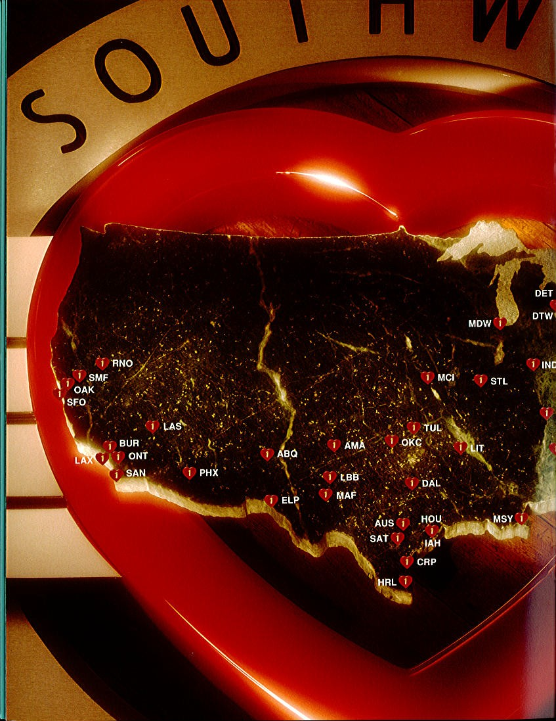

Route Map_- 1992 Expansion

1992was another year in which So111hwes1capilalizcd on manyof our :mlil:lblc oppor111nilies, despile America's sluggisheconomy.Our 11ni<1ue market niche, strongfinanci:d position, and " 1deCustomer accepi:rnce allowed us10 accelera1e ourgro"1h in shot1haul markets asour compclliors con1rac1dc in 1991 and *19')2.*

Soulhwesrs intr-a California traffic surged in 1992ascompared10 1991. USAir 's "i l11drawal from six f,alifornia airpo1 s in 1991,along with reduced in1ra-C'.11irorniascnice in *19')2* by United Airlines, Delta Air Lines, Amcric:m Airlines, rutd USAJr, allowed Southwesttoaccelerate ourex111: nsionIn these markets wilh very satisfac1ory results. Wesc1w seven California

ai111or ts, all opened prior to 1992,ru1d rank Orsi in 101al passenger boardingsalall of our

C. forni:1aJrpor1s except l.os Angeles ln1erna1ion:d and San Franciscolnlernational.As of second q11:u1cr 199 2, we had 1he highest shareof in1m-C.1lifornia1raflic:m1ong1he airlines, wilh 30.7 percent of lhemarkcl, crcn though wedo no1serve aU CaUforniaairports and city pairs. Of the ro111es weserved, howere,rwe had 1he highestshare of passenger traffic in e,·ery cily pair wilh an aggregate 7*l.5* pcrcem marketshare.

In contrast, our ma111re i111ra:rexasmarket grewasteady t8 percent in 1992, outpacing gro1\lh rates for 1he sluggish stateeconomy,in general. Texas still well exceeds California in tot:d1rallic. So111hwes1 ranks llrst in passengerboardings al1en of 1he 11Texas airports seowd and had anintra-Texas1rallicm arketshare asof second quarter 1992 of 72.0 percenl. We had1he number one ranking in crery intra-TexascilypaJr served.

Our Chicago Midway Airport del'elompenl began inearnest in 1992111th 1he acquisition of **18**galesfrom No rthwest Airlines.Southwestadded sel'>ic e 10 Indianapolisand successfuUy opened 1wo newcities in 1he 111idwes1, Clc·1eland andColumbus, Ohio, each 11lth nonstop scr,icc10 Midway and SI. Louis. Thus, our flight aclil'it)' 0111 of Midway was upalmost 40 percent \'Crsus 1991, and1raftlc, parti:dly as a resuh of 1heshutdown of Midway Airlines in Norcmbcr 1991,was upsubstantially in 1992. We were1hc largest car rier:II Udwayin 1992 bya11lde margin.

In 1992, wealso became1he largest airline in Phoenix, I.asVegas,and KansasCily, In termsof originating traffic. Phoenix also bccrune ourlargestoperation wilh 137daily departures.

**Southwest Airlines Destinations:**

Albuquerque (ABQ) Amarillo (A,\ H)

El Paso (Ef.P)

Harlingen (HRI.)

New Orleans (MSY)

Oakland (OAK)

Auslin (A L;s)

Houston Hobbv(HOli)

Oklahmo a City (OKC)

Birmingham (BIIM) Burbank (BUR) ChicagoMid11\y(MOW) Clel'eland (CI.E) Columbus (C lH) Corpus Christi (CRP) Dal.las I.ore l'ield (DAL) Detroit Ciiy (Oft') Dc1roil Meiro (OTW)

Ho uston lnlerconlinental(UH)

Indianapolis (I ND) Ka ns:tSCity (MCI) I.as Vegas (L\S) Ullle Rock ( UT) LosAngeles (LAX) Lubbock (LBB)

Midland/Odessa (MAF) Nashville (BNA)

Ontario (OYf) Phoenix (PltX)

Re no/Tahoe (Ri''iO) Sacramento (SMF) SI. Louis (STL)

S.1n Antonio (SAT) San Diego (SAN)

San Francisco (SFO) T11lsa (TL'L)





*Soulbll'esl ndded /11'011e11: mid1rl':il cilil!S. Clei:efnndmidCo1l1111b11s, Ohio, toour gro11,i 11g list oft/l''l,/i11a ti o11s* i11 *1992.*





Outlook

While1he lasl lhree years ha1c·been de.raslalingfor theairline lndustl)' and dismal, al best, for 1he economy asa whole,Sou1hwes1 has remained profitable and financially s1rong. Our profil margins Improved markedly in 1992. This was not only desirable but necessary for Sou1hwcs110 maintain our financial stabiliiy. These resul ts, while they represent atremendous accomplishment, also are Inadequate10 suppo1f1uture gro1,1h, combat unrelenting competilive pressures, and protcc1 agains1111devolatility in energy and capital markets. Therefore, wecmrnot besatisfied wilh these resuhs, which slill fall below our pro01margin mid rc1m11 on inwstment goals. Weare , howel'er, well positioned to meel thechallenges orthe 1990s and will continue ourstrategyof con1rolled gro111h, operaling cosl control, and outstanding Customer Service.

We have achicl'cd market dominance as the nation's only shorthaul, poinl-lo-point, low-fare, highf-requency, hig-h quaUiy airline.

From a Customer perspeclil'e, we beliel'e Southwcs1 is1hc bes1value forshorthaul1ransport:uion-

*J11sl l'frmeSmarf'.•* - asCustomers wan1 low fares and high-qualilysenice.

From anoperating perspecllve, Sou1hwes1isuniquely posilioned 10 expand insho11haul markes1 because oursef\icesarcspecifically and unique!)'designed tomeel the needs of shorthaul Customers.

From afinancial pen;pective, we have1he lowesl opera1ing costs, bes1 profit margins, strongcs1 balance sheel, and highest credi1 ratings in theairline industty, enabling us toaccess thecapilal markets toacquire new aircraJ1, hire more Employees, expand ouroperations, and continue the patienl dei·elopmen1 or new shorthaul city-pair markets.

orcourse, our Deel is l'ery young,100, wilh ana\'cragc agealtheend of 1992 of 6.9 rears, oneof 1he yo11nges1in theairlineinduslry. Thisenables us10 keepour maintenance coslslow and our aircraft in se1'>ice. Since ol'er 65 percent of1hc Deel hal'e lhe newer Stage 3engines, fuel consump­ lion is lower and noise is reduced.

We will acquire 13 new 737 aircrafrom Boeing in 19')3. Wehave fu1ure dclil'cry and option positions 1,ith Boeing for enough new 737aircrllft to adequately meet ourexp:u1sion needsand maintain a ro1111g Oeet. At ycarcnd 1992, we had 141 aircrah on hand, of which 44 weresubject tolong-1erm leases:u1d 23or1he •200s were subjecttoshort-lerm leases expiring Ol'cr 1he nexl sel'eral )'ears. We hare1he Dexibilily with respect 10 these aircraft either10 return 1hem 10 the lessorsorcontinue leasing1he111 allhe then-current fair market ,'alue.

We bal'e 6o Orm orders through 1997 and 53optionsfrom 1997through 1999, asfollows:

|  |  |  |  |  |  |  |  |  |  |
| --- | --- | --- | --- | --- | --- | --- | --- | --- | --- |
| Type | Seats | 1992 | 1993 | 1994 | 1995 | 1996 | 1997 | 1998 | 1999 |
| 737-200 | 122 | 49 |  |  |  |  |  |  |  |
| 737-300 | 137 | 67 | 13 | 13 | 12 | 12 | 21 | 21 | 21 |
| 737-500 | 122 | 25 |  |  |  |  |  |  |  |
| TOTAL |  | 141 | 13 | 13 | 12 | 12 | 21 | 21 | 21 |

As we begin 1993.our traffic dem:u1d Iss trong, despite :1 relalil'ely sluggish nalional economy. Whether this trend will continue or the economy will changecourse, wec:u11101 predicl.

Our unil cos1s (operating cost peral'ailable sealmile) increased 4.0 percent in 1992 asmore fully explainedin Management's Discussion :u1d Anal) is of Financial f,011dition and Results of Operalions. Weexpecl our unil costs10 incr<."JSe again in 1993aswecon1inue 10 experience pressure in sel'eral areas.

12

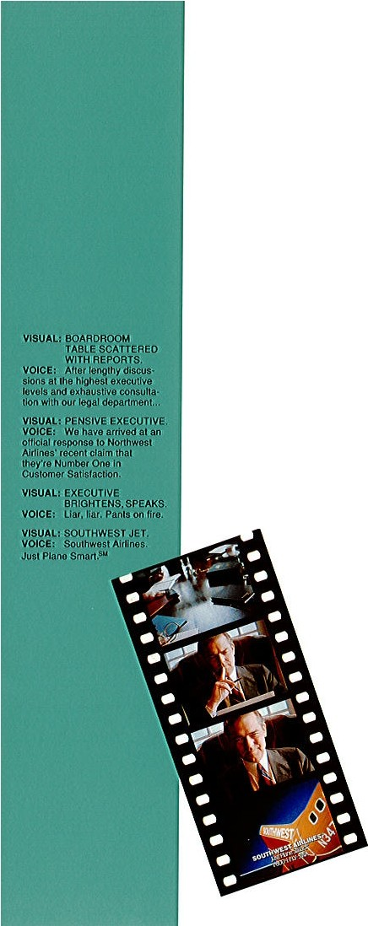

for 1993,salaties and wage,sour Jargl>SI coslcomponcnl, will be primarily a funclion of headcounl and should remain roughl)' consi s1eu1wilh aircraft capacily on anannual basis. Significanl increasesare expected from heru1h care , howcrer. Southwest's major labor con1rac1s harefire-rear ienus, 1111h nonescheduled for rcnegoilalionunliJ 1994.

Je1 fuel rcprcscms 1he second higheslcos! componen,l which, on acos1-per-gaUon basis, is ex1remelr rolatile and unpredictabel.As our aircrafi fleet conlinues togrow, howcrer, ii becomes more fuel-cfficicnl with 1he addillon of·300s. These aircraft aremore expensl·,e

10 mainlain, !hough, wltich resulled in an incre.-1s c in m,tinlcn:mce unil coslsin pre1ious years and isexpec1ed 10 conlinue in 1993.

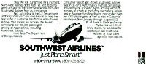Finall)', airpo11 un.it cos ls "illconlinue to rise if airports continue 10 expand or if olhcr airlines reduce sen1ce al airports wesen·c.

- - - -• '- - ==

After lenglhy dclibrr• lion

at thr highest exeru ti"c !err.ls,

•nd rxlr11si,-c consultation wi t h our legal depa1•lme11f, ff E:' **h an 11rriw•d at**

Ml official torpor•tc respo11se to Nor1hwcst Airli11es' claim

to be numbrr on

i11 Cnstomcr Sat isfaci ion.

'-""'

"Liar, liar. Panis on fi,.c

*Sculhu-es/'spithy resj)OnseloNorlhu:eslt1irli11es' claim lobe Number Onein Customer Satisfaclion.1\'Q1•/b11: / co11i:c11ie11I()'e.rcl11ded So11//111•es1from ifscomp,1ri:Y,J11.*

13







*'/6lt'1!»2AmwafRf/l(lrl Isd«limef di/o011,t2,(J{)f) B11,ployl!1/SS 011wlflal/ilOJ'S* ***beNumber*** *0111J./11OJI!****:bmr#.***

Directors

SAMUELE. BARSHOP

Chairman of1he Board, La Quinla Molor Inns, Inc.

Sru1Antonio, Texas; Audil and Compensation Comntiuces

GENEH. BISHOP

Chairman and Chief Execulil'e Officer,

We Partners Grou p, Inc., DaUas, Texas;Audil, Compensation, and f.;,:cculi,·e Commitcces

\VO.I.IAM P. HOBBY, JR.

Fonner Lleu1enant Gol'cmor of Texas; Chairman or1he Board, H&CCommunications, Hous1011, Texas; Audit ru1d Compensation Commiltces

TRAVIS C. JOHNSON

Partner,Johnson& Bowen, Anorne) al I.aw, El Paso, Texas; Audit Comnunee

H.ERBERTD. KELLEHER

Chairmru1 of the Board, President, and Chief F-xecutive Officer orSoull1wes1 Airlines Co., OaUas, Texas;Exccutire Commiuee

ROI.I.IN W. KING

Consuhan,1Exen11i1·c Educalion, OaUas, Texas; Audit and E.xccutive Comn1inccs

WAI.TF.R M. MISCHER, SR.

Chairmru1of the Board and Chief Execuli,e Officer, The Mischer Corporation, Hous1on, Texas (real es1a1c dcrclopme111) ; Audit ru1d C'A>mpensationComminees

Officers

HERBERT D. KELLEHER'

Chairman of the Board, President, and Chief Ex. ec111i·1e Officer

COttEf:N C. BARRET!'•

Executire Vice Prcsident­ Cuslomcrs and Corporalc Sccrctal)'

GARY A. BARRON"

Exccutire Vice President, Cbiel 011crations Officer

JOHN G. OENJSO:{•

Excculirc Vice Presiden­t CorporaleSenices

AIANS. DA\ S

Vice l'res ident- lntcmal Audil and Special Projects

C,\;\l(L!Jl T. 'EITH

Vice Presiden-tSpecial Marketing

GARY C. 'EI.I.Y•

Vice President- f iJ1ance, Chief Finru1cial Officer

WILLIAMQ. MD.trR

Vice Prcsident- lnllighlSenice

JAMES F. PAR.KER '

Vice President- General Counsel

ROBERTIV . RAPP, JR.••

Vice President- S)1items

URGARET AXN RHOADES

Vice Presiden-ll'eoplc

RON RICKS'

Vice Presid1e11- Govcrn111c n1: Aff,urs

ROGER W. SAARI

Vice Presiden-1Fueland Administralire Purchasing

PAULE. S'J'llRBENZ

Vice President- FlighlOpera1ions

JOHN A. VIDAi.

Vice Presiden-tMaJntenance

JM(F.SC. "1MBERLY•

Vice President- Ground Opcra1ions

WIU.IAM D. LYO;>;S

ControUe r

JOHN D. OWEN

Treasurer

' Member of Executirc Planning Commiltee

.. Effcc1i·1c March I, 1993

1 4

#### '

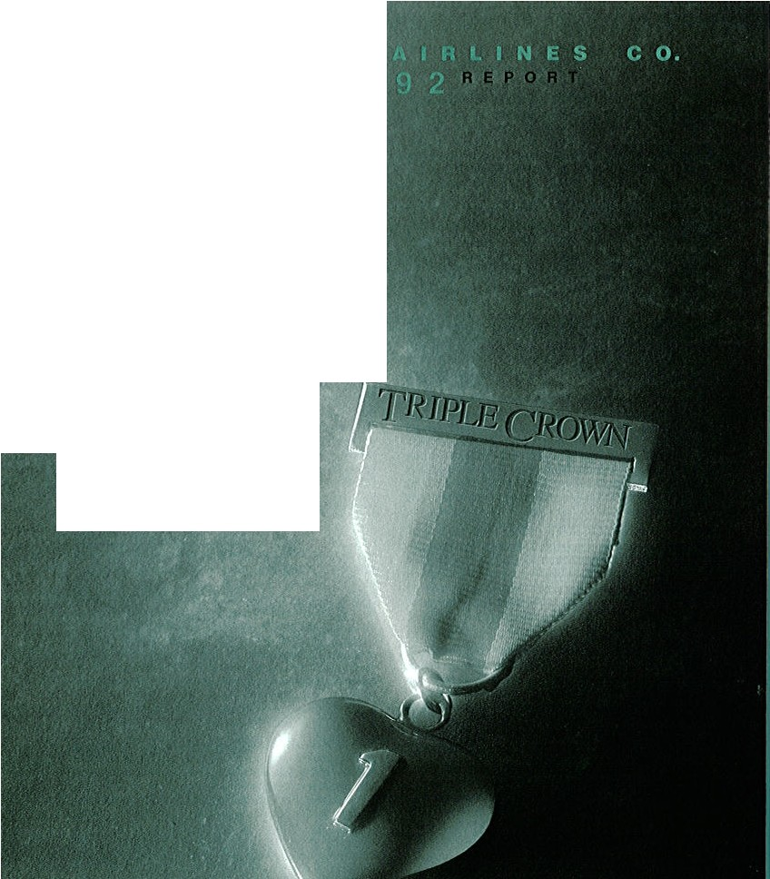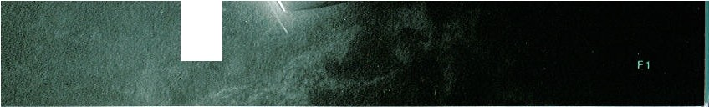

**A N N** U A L

Jl2,

F6

PIS ·

Fl6

- · FJ7 '

Fl8

,.- - - - - - - ·- - - &o

j ..

,.

! *I* •'

.,..I

, ....

# SOUTHWEST

**Management's Discussion and Analysis of Financial Condition and**

**Resultsof Operations**

INDUSTRY CONDITIONS

The recession in theairUne industry continued in1992, resulting in threeol the most financiallydevastatingyears in the historyor theairlines. The industry changed its oreralJ financial position from a cumulative industry profit 10 an oreralJ industry loss duringthis threeyear period.Domestic competition waschara­ c tcriZed b)' heatedfare warsin 1992, which exacerbated industry losses. Howerer, despitethese adverse industry conditions, Southwest reporteda profit for its 20th conseculil'e year.

The Company's low operating costs and shorthaul,low-fare market niche ha,·e allowed the Compan)' to profit during this period.Southwest hascontinued tomaintain steady growtlt in its mature markets, suchasTexas, and toexpand in markel where other carriersare reducingsenice. In 1992, SouthweM became the largest carrierorintrastate passengers inCalifornia and also numberoneinoriginating passengersin Phoenix, l1tsVegas,and KllnsasCU)•.TheCompany's expansion efforts at Chicago Midway airport were successful in 1992. Southwest added SCf\'iceto Indianapolis andopened twonewcities inthe midwest,Cleveland and Columbus, Ohio, each with nonstopscf\icc to Midway and St. Louis. A resef\'ation center and pilot domicile were also opened in 1992 at Clticago Midway. In May 1993, the Company will begin se"·iceto louiS\illc, Kentuck)' \\ith nonstop Oights to St. Louis, Chicago, and Birmingham. In Febmary 1993, the C.'ompany began taking calls at the Company's new resel\-ation cen ter in Albuquerque.

During1993, theCompany plans tocontinueexpanding itsshor­t haulmarkest, particularly through addedsenice toexistingcity­ pair marketsinCaliforniaand thewestern region olitss) tem. In

**AIRLINES C 0.**

The increase in passenger revenues, which accounrcd !or 96.4 percent ortotal operating rcrcnues, resulted lroma22.1percent increase in re,·enue passenger miles (RPMs) in 1992and a S.O percent increase in rel'enue passenger )ield per RPM.

The increase in RPMs o( 22.1 percent in 1992 exceeded the increaseinASMsol1S.6 percentfor thesameperiodand resulted inanincrease in theload!actor Crom61.1percent1064.5 percent. The 1992 AS I increase resulted from theaddition or17aircraft, which were primarily used to expand California, I.as \'egas, PhoenL,xand Chicago markets.

Freight rC\'enucsincreased in 1992 to $33.I million from $26.4 million in 1991. The 25.2 percent increase in freight revenues exceeded the 15.6 percent ASM increase for the same period primarilydue10 lunhcrexpansion of UnitedStates mailscnices and increased freight marketing programs. Other rel"enucs increased 46.6 percent primarilyasa result o(charter rel'cnues. Charter rere.nues increased 91.9 percent due to a significant increase in commercialcharters.

*Operating E.\/11'11ses* ConsoUdated ope ratingexpensesincreased

20.1 percent to$1,502.5million from $1,250.7 million in 1991. The primary factors contributing to the increase were the 15.6 percent increaseinASMsresu ltingfrom theadditionorserentecn 737 aircrah; incre-ased contributions to profit sharing and employee sal'ings plans: higher agency commission;s higher aircralt rentals;and increased maintenancecosts. Ona p-er AS)I basis, operating expenses increased 4.0 percent in 19')2 as lollows:

Opcr.11ing expenses per ASM

Increase Pc-rccnt

*199l* 199 1 (decrease) chaneg

Salaries, "'tges and benefits 'l. 17< 2.tl l .05< l_.j%

Pn:,f,t sharing and emplorec

addition, theCompanrwill continueitsfocuson controWngcosts

sa1ings plans .18 .09

,09 10(1.0

and maintaining high q uaUt)' Customer Scnice 10 protect its

Fuel and oU l.l ·l *l.ll* (.08) (66)

financial and competitil"e position within the industry.

**Maintenance materials and**

repairs .56 .5j 03

.

,

) . ,

RF.SULTS OFOPERATIONS

1992 COM PAREO WlTH 1991The Company's consolidated net

Agenc)' commissions .so .H 06 1.16

Aircrart rent,ls .30 *.l6* .O·! IS-i

I.a ndingfees and other

income for the year 1992 was $91.0 million *($.97* per share),

rentals

.48 .H

.04 9.1

bclorethe cumulalil"e effect orachange inaccounting principle,

Depreciation .47

- .17

compared to *$26.9*million ($.31pershare)!or1991,anincrease or238.1percent. 'Ihe1991earningspershare hasbeen restated for the 1992 two-for-onestock split (see Note 8 to the Cons­ol idated financial Statements). The increase in earnings "11s attributable toanincrease inoperating income o(190.2 percent.

*Operating Re11e1111es* Operating rcl"enues increased by 28.3 percent in 1992 10 Sl,68S.2 million. Operating rcrenue per available seat mile (ASM) increased in 1992 to $.0789lrom

$.0710in 1991. Operating re,·enues increasedasfollows: a 28.1 percent increase in passengerrc cnues;a 25.2 percent increase infreight re,·enues;anda 46.6 percent increaseinother rel"enues.

F 2

Other U3 1.19 .04 34

Total 7.03< 6.76, .27< , i 0 %

Theincreaseinsalaries,wagesand benefits perASMin1992of2.4 percent resulted Crom a 16.1 percent increase in employee benefits perAS)I.SalariesandwagesperASMremained constant. The increase in employee benefits **per** ASM resulted from increases in workers' compensation and health benefit costs. Although the Company hasimplemented, and plans tocontinue implementing, various cost sa1ings programs 10 attempt to control the annual increase in these benefitcosts, thesecostsarc expected to continue to increasein the near term. Jleadcount increased 16.6 percent in 1992, slightly more than the 15.6

percent increase in ASMs. Howere r, employee productivity improredfrom 2,451 passengers handled peremployeein1991to l ,597 in 19')2. Arerage salary and benefit costs per employee increa5ed 3.7 percent from 1991 to 1992.

InJanuary 1992, theCompany s igned anewcoUectire bargaining agreement with the Transportation \Xbr kcr's Unionof America, which represents the Company's flight attendants. The contract extends into 1996.

Profit shal'ing and employee sa11ngs 11lan expenses per ASM doubled In 1992.Thissignificantincrease wasprimarily theresult orasignificant!)' more profitable year. Foradditionalinformation, sec Note IOto the Consolidated FinancialStatements.

fueland oilexpenses perASM dccrc:L d 6.6percent in1992due toa 7.4 p<,rcent reduction in thearernge jct foci cost per gallon from1991.Thearcrage priceor jetfueldecreased from 65.69< in 1991 to60.82i in 1992. A co mbinationofa relatireyl mild winter and unus ually high iowe ntorics at the end of 1991 precipitated a rapiddeclineof jet foci prices beginninglatefourthquarter1991, which resultedin an arcrage of 54.96< pergallon in first quarter 1992.Jetfuel prices rose insecond quarter19')2toan arerageof 60.68¢per gallonasa resultof unusuallycold weather late in the season, aglobal firmingof suppl)'·demand fundamentals, and a recognitionthat the Iraq-UNsituation would not produce imme­ diate oil expons. Jet fuel prices remained relatirely s1ead)' throughoutthe remainderof1992 with anarerageor64.46( and 62k H pergallon in third and fourth quarter 1992, res pectircly.

\laintenancc materials and repairs per ASM increased 5.7 percent in 1992. This incrca was primaril)' the result or performing more airframe and engine overhaul work in 1992. The Company performed 13 scheduled airframe overhauls in 1992, as compared to three in 1991, as a result of the recent

The increase in landing fees and other rentals p<,r ASM of 9.1 percent resultedfrom an increaseof 121. percent in landingfees per ASM, or.03<. anda 2.1 percent increase in other rentals per ASM, or .OH. The increase in landing recs per ASM is primarily attributable tooverall rate increases, withsignificant increases in NewOrleansandChicago.Theincrease inother rentalsperAS\1is also primarilydue to rate increases.

Depreciation expense per ASM remained constant in 1992. llowe\'er, had the Compan)' not changedtheestimated remaining useful lires of iLs 737-200aircraft asdiscuss.cd in Note 2 to the ConsoUdated financial Statements, depreciation expense per ASMwould hal'eincerased4.3 percent, or$.02 per ASM in 1992. Theincrease is primarily the resultofacquiring moreaircraftand cerL1in leaseholdinterests as described in Note 7 to the Consol­ idated Financial Statements.

Other operating expenses per ASM increased 3.4 percent pri­ marily due to increasesin ad valorem tax ratesand pa.s.,;cngcr­ related costs. l'asseng-errelated costs increased per AS\I due to the22.8 percent increase in passengerscarried, whichexceeded ASM capacity gro111h for 1992.

*01/JCr* " Other expenses (income)" included interest expense, interest income and nonoperatnig gains and lo s. Jnteresl expense, net of capitali1.ed interest, increased 52.2 percent in 1992 due to 1991-92 issuances of $400 million in senior unsecured notes. See Nole S to the Consolidated Financial Statements ror further information. Interest income decreased

$287,000 in 1992 due to lower interest rates offset by higher investment balance.s. Net nonoperating los. sconsisted primarily of pa 1nents related to deficiency guarantees as discu d in Note 7 to the Consolidated Financial Statements.

*Income·raxes*The pro1ision forincometaxesdecreased in1992, asa percentage of income before income ta.xes and cumulatirc

modification of itsairCmra e orcrhaul maintenance progra111 \\1th

effect of change in accounting principle, to 38.0 percent from

the Federal A1iation Administration (FM) and gro111h of the Company'sfleet. Inaddition, theCompany changed itsmethodor accountingforscheduled airframe orerhaul costsfro111 thedirect expense method to that of capitali1.ing and amortizing the costs Ol'er the periods benefited. e Note 2 to the C-0nsolidated f1m1ncial State111c ntsfor further information. Airframeorerhauls werealso morecostlyin1992 ascompared to1991.Consequent!),' amortization or 1992 capitalized airframe orerhauls, along with amortization of thecumulati1·e adjustment rd ated tothe account· ingchang,eexceeded overhaulsdirectlyexpensed in19')1. Engine orer haulswerealso moreexpensil'ein1992 duetothehigher cost to repair737-300and-500high-bypassengines, which represent an Increasing percentage of the fleet.

Agency commissions per ASM increased 13.6 percent in 199l primarily due to passenger rC\'Cnue gr0\\1h exceeding AS I growth coupled with a highermix of trarel agencr sales.

Aircrart rentals per AS\I increased 15.4 percent in 1992.111e increasewas theresultof the C.ompany leasingfour used 737.300 aircraft in 1992 under long-termoperating lea s. along 111th incurring a fuU year's rent on the 14 aircraft acquired, or converted to operating leases, in 1991 through 1•arious leasing arrangements. On December 31. 1992, the Company completed the financing through sale/leasebacks of four 737-300 aircraft delirercd in 1992: howerer, no rent expense will be recorded on these leases until 1993.

38.6 percent in 1991.The decreasewas primaril)' the result ora reduction in state income t:txes rersus prc1ious estimates. e Note 12 to the Consolidated Financial Statements for further information.

1991COMPARED WITH 1990 The Company's consolidated net income for the year 1991was $26.9 million, or $.31 pershare, compared to $47.1 million, or S.55 per share, for 1990, a decreaseof42.8 percent.Thedecrease inearnings primaril)'1111S attributable to: I) adecreaseinoperating Income of23.I percent;

2) a S7.3 million increase in net interest expense; and 3) a $4.6 million decrease in nonoperating gains, before the effects of Income taxes.

*0/1emti11g llc v(m11es* Operating rc\'enues increased by JO. 7 percent in 1991 to $1,313.6 million. l'asscnger rerenues, wltich accounted for96.S percentof totaloperating rel'enue,sincreased

10.8 percent to$1,26.79 million while freight rerennesincreased

19.1percent toS26.4million andother re\'enues decUned by4.3 percent to$19.3 million.

F 3

Passenger revenuegrow1h was nega1ivdy im1iac1edin 1991 by lhe warindte PersianGulfand1hedomes1iceconomicrecession. Asa resuli,opcralingrcrenue p<'rAS)Ideclined in199110$.0710from 199o·s $.0723, or 1.8 percent The 1991 passenger revenue incre:lse was :111ribu1able 10 a 14.3 percenl incre-.ise in revenue passengers carried,which resuhed lromaggressivediscounland promo1ionalprograms 1os1imula1e an 01herwise weak domcs1ic 1rarel market However, lhe promolional programs 1ha1 were successful in slimul:uing1ralfic caused passenger rerenue Jield per RPM lodecline10 $.112l lrom$.1149 in1990,or2.3 p<'rcent

The increasein RPMs was13.4 percenl in 1991 as compared10 1990 versusa12.7pcrccnl increase inAS)ls!or lhe same period, rcsuliingin an increasein lheload fac1or lrom60.7percenl1061.1 percent The 1991 AS)! lncmise primarily rcsuhed lrom 1he addilionol**18**aircraf11ha1 were used 1irimariJy10 ini1ia1esenice in Sacramc1n0, California 10 Onlario, llurbank, and San Oiego, Calilornia; expand sen•iceinOakland,tosAngeles, Phoenix, and Las Vegas; and inili:ue senice between Kansas Cily/St Louisand be veen LosAngelcs/J.asl'ega.s

Ouring1he lhirdquaner19')1,1rafficdemandbegan10 improveas compared 10 1he preceding mon1hs or 1991,considering sea­ sonalily.Asa resuh, RP)I Jiclds began10 improveascompared to earlier 1991 resulls and load fac1ors were upascompared 101he corresponding mon1h ol1he prior year for1he periodScp1ember dirough Oece111ber 1991. Rcl'enues per ASM increased in fourih quaner 1991versus fourlh quarler1990. lhefirsl such fal'orable quane rlycomparison in1991. 'l'heCompanybelicl'esii bencfi1ed from slighdy i111prol'ed econo111ic condi1ions in ilS marke1s; successlul expansion in10 new f dilornia m:uke1s; and service reduc1ionsfrom cornpe1i1ors in ilSCalifornia, Phoenix, LasVegas, and Chicagomarke1.s

frcigh1revenues increased 19.1percen1in199110$26.4 million fro111 $22.2 millionin 1990. freighl rerenues grew 83.1 percenl fro1111989101991, more 1han double1he rateorAS)I gro\11h orer diesa111c period. Thisgro11h1primarilyresulled from expanded Uni1edS1u:esmailsen·iccsand increased cargo111arkc1ing effor1s. 01her rcl'enucsdccre:tscd 4.3 percenl primarily due10 a 20.7 p<'rceul decrease in charierrevenues resuhinglrom adecline in mililary ac1M1ies requiring do111es1ic char1res.

*Opemting*/:'.\jJe11ses Consolida1edOp<'r:Uingexpensesincreased

Profi1sharingand e111ploycesa,ings plan expenses ona per-ASM basisdecreased18.2 pcrccnc in1991.The decrease wasaresuhof decre-.ised profi1abill1y offse1 by increased employee eligibUi1y and rcsuhing parlicipalionindieemployeesavingsplan ma1ching con1rib1uions program. Foraddi1ionalinlormalion,seeXo1e1010 1he Consolida1ed financial S11aemen1S.

fuelandoil expenses per AS)! decreased 17.0 percenl in1991as 1he je1 fuel al'erage cos1 per gallon decreased 15.7 percent to 65.69< in 1991 from 77.89< in 1990. During 1990. crude oil pricesand,1herelore,jCIfuel prices, wereve11·1·ola1ile asaresuh or1he invasionof Kuwail and resuliingwar in the Persian Gulf.Je1 luelpricesdeclined10pre-invasion lcl'clsbysecond qu:mer1991. In addilion, fuel conseivalion measures implemen1ed following 1he Iraqi i,wasion of Kuwail were cominued d1rougho111 1991 reducing luel burn approxima1ely 4.0 perce111 from 1990 pre· invasionlel'els. As a resuh oldeclining produc1ion ra1cs in 1he for111er Sol'iel Union,coupled wilh Ol'eraU supply concerns, jel fuel prices escala1ed in lhirdmid four1h <1uar1ers 1991. In la1e four1hquar1er 1991,asa consequenceof con1inued high OPEC produc1ion and a rel:Uil'Cly mild winier,1he supply concerns disappearedbased on high inl'enlOriesolc.rude oil and refined produclS, 1hus precipila1ing a rapid decline in jel fuel cos1s.

)l ain1enancc ma1erials and repairs per AS I increased 3.9 1ierce111 in1991. This increasewasprimarilya resuh ofchehigher cos1olengineol'erhaulsfor1he111ore expensive737·300and· 500 high-hypass engines.

Aircrall re111als increased 62.5 percen1 in 1991asa resuh ol1he 1991 sale/leaseback financing of 1hrce new aircral1 wilh long- 1erm oix:raling leases and lil'e older aircralt wilh shorHerm operaling leases. In addilion,in 1991 lhc Company leased 1hree used 737·300aircnlf1underlon- g ter111o pera1ingleaseasnd1hree used 737-200aircraf1under shorHerm operaling leases.

I.anding leesand 01her rentals increased on a per-AS)! basis by

18.9 percen1 in 1991 as a resuh ol rale increasesand expanded 1ermlnal facililies, principallyPhoeni,xSky HarborAirport 01her operaling expcnse.s increased primarily due 10 increases In adver1ising and promolional expenses 10 s1imula1c 1raffic and increasesin ad l'alore111 1a.x ra1e.s

*OthN* " Olhcr exp<'nses (income)" included in1eres1 ex pense,

13.2 pcrce11110 $1,250.7 millionfro111 s1, 1ot 9 million in 1990.

in1eres1 incmo e and nonoperaling gains and losess. l111c r es 1

' fhe primary fac1ors conlribuling10 1he increase were 1he 12.7 J>Crce nlincreasein AS)ls resuhinglrom1he addilion ofeighteen 7:\7 :1ircral1and increases in aircraf1ren1: s. 1errninal re,uals, andlandingfees. Theseincreaseswere offsc1bra largedecrease in jet luel cosLs. The nel resull was ,Ill increase in opera1ing cxp<'nses per ASM olonly.4 percc111 01-er 1990le,·els.

Salaries, wages and bmcfiis per AS)! incre,tSed 2.4 percenl in 1991 resuhingfrom a 1.8 p<'rCcnlincrease insalaries and wages p<'rAS)Iand a4.7percem increasein employeebenefi1s per ASM. Hea<lcounlincreased 13.4 percen1 in 1991, slighdy more1han the

**12.**7 percen1 increase in AS)ls. Des pi1e 1his increase in head· coun1, e111ployee11roduclivily incre-JSCd lro111 2.393 passengers handled per em11lorce in 1990 co l ,451 in 1991. Al'crage salary and bencfil cos1s per emplo)'ee iltcreased 3.2 ix:rcen1 from 1990101991.

F4

expense, ne1 of capilalized in1eres1,increased 56.8 J>Cr,ce u in 1991due10 issuancesor$,100m illion insenior unsecured noies. See Nole 5101he Consolid:11ed Financial S1a1em1csnlor fur1her inlonnalion. lmeresl income increased *$.,.0* million In 1991due 10 higher in..es1men1 balances, offse1 bylower intcres1mies. Ne1 nonoix:ra1inggains declined St6 milJion in 1991,as more fully described in Nole 1110 1he f,0nsolida1ed financi,tlS1a1emen1s.

*IncomTe(lxcsAs*apercen1ageolni comebeforeincome1axes,1he prorisionforincomelaxesincreased in19911038.6percem from

37.0 p<'rce111 in 1990. The inc,·case primarily resnhed from increasesin es11i11:11cd s1a1e income1ax. ra1es. See Xote t *l* 10 1he Consolida1c<l financial S1a1cmcn1s for lurlher informalion.

UQUIDl'JY ANO C PITAL RF.sOURCES

Cash prO\'ided from operations was $264.5 million in 199Z as compared to $103.2 million in 1991. During 1992, additional fundsof $98.5 million weregenerated from the p1ember1992 issuanceof $100 million insenior unS('Cured 7 % notesduein 2007 (sec Note 5 10 1he Consolidated financial S1:1temen1S for additional information). In addition, $120.0 million wasgener­ ated from the sale and leaseback of four new 737-300 aircraft subject to long-term ope ratingleases (increasing 101al commi1- men1Sforoperating leasesby$245.0 ntillion.)TheC,0mpany also receil'ed ne1proceedsof S86.9millionfrom thesaleof 2,500,000 pre-split sharesofitsconunon stock inapublicoffering (see Note 8 totheConsolidated FinancailS1a1emen1S). These proceeds were primarily used to finance aircraft-related capital expenditures and pro,1de working capital.

During 1992, capital expenditures of $409.2 million were pri­ marilyforthepurchaseofsix new737-300alrcraft andsel'en new 737-500 aircraft delirercd during 1he year along wilh progrses payments for future aircrafl delil'eries. At December 31, 199Z, capital commitments for the Company consisted primarily of scheduled aircraft acquisitions. At ycarcnd, Southwest had sLXI)'

7.ns on firm order with options 10 purchase ano1h.er fifty-three

TheCompany has>'ar iousoptionsavailable to meetitscapitaland operatingcommitments, includingcashonhandatDecember 31, 1992 of **$•ill .0**million, internally generated fundsandarc\'olling credit line with agroupof banksof upto $250 million (none of whichhad been drawn at December 31, 1992). In addtiion, the Companywillalsoconsider various borrowingorleasingoptions 10 maximize earnings and cash flows.

During1991, cashgenerated from operations was$103.2 million. Additionalfundsof*$l96.*4 millionweregenerated fromissuances of a total of $300 million insenior unsecured notes. Inaddtiion,

$132.4 million wasgene.ratedfrom thesaleand leaseback ofeight aircraft: three were new 737-500 aircraft subject to long-term operating leases and lil'e were older737-200 aircraft subject to short-termoperating leases (increasing total commitmenlS for operating leases by $218.8 million). These proceeds were pri­ marily used 10 finance aircarft-relatedcapital expenditures, pro1ide working capital, and retire long-term debt.

During1990, cashgenerated Crom operations was$111.9 million. Additional funds of $200.0 mi!Jion were generated through 1he sale and lea cback of **10** aircraft:slx were new 737-500 aircraft subject to long-term operating leases with four older 737-200 aircraft subject to short-termoperating leases (increasing total

737sA. ggregatefundingrequiredfor1hesecmo mitmen1Sapprox­

commitments for operating leases by S381.1 million). These

imatcd $1,497.1 million at December 31, 1992. e Note 310 the Consolidated Financial Statements for further information.

As of December 31, 1992, the Company had 2,500,000 shares available from a 1990 authori1.ation bv *its* Board of Directors to purchase shareso[ilS common s tock lrom lime to timeon the open market. Noshares hal'e been purchased since1990.

See Note5 totheConsolidated financialStatements regardingthe 1992 co,wersion of the outstanding 6Jl.i% con\'ertiblc subor­ dinated Debentures issuedbyS0u1h1\'estAirlinesEurofinanceN.V. intoSouthwest's common stock.

During 1992, the Company satisfied certain ·'deficiency guaran­ tees:· &e Note 7 to the Consolidated financial StatemenlS for [urlher information.

InJanuary1993, the Company's Board of Directorsapproved the early redemption, effective March I, 1993, of $JOO million 9% senior unsecured Notesdue1996. e Note5 to theConsolidated financial Statements for further discussion.

The Company will adopt Statement of financial Accountnig StandardsNo.109."Acco untingfor IncomeTaxes;·andStatement of financial Accounting Standards No. JOo, " Accountingfor Postretiremenl BenefilS Other Than Pensions;• in first quarter 1993. &e Note I to the Consolidated Financial Statementsfor additional information.

The Clinton Administration has proposed certain deficit reduc­ tion measures. These measures, among other things, presentl)' includean increaseinthefederalcorporate income ta,rateanda broad-based energy tax. If put into law, these measures would incerase the Company's costs and, potentially, reduce ilS net earnings to the extent that the increased taxes cannot be recol'ered through increased rCl'e nucs. Management cannot predict the ultimate outcome of any changes in taxes.

proceeds were primarily uS('d tofinance aircraft-relawd capital expenditures, prol'ideworkingcapital,retirelong-termdebt.,and purchase treasury stock.

F5

# SOUTHWEST AIRLINES CO.

**Cosnodli teBdalancSeheet**

**(inthousandstxceptshare and per sh,u e amounts)**

Ass eis

Current assets:

Cash and cash equlvalenlS - - - - - - - - - - - - - - - - - -

December 31,

1992 1991

s 411,0:16 $ 260,856

Accounts receivable _ _ _ _ _ _ _ _ _ _ _ _ _ _ _ _ _ _ _ _

51,787 **47.;07**

lnrentoriesof parlSandsupplies, at cost - - - - - - - - - - - - - ­ Prepaid expensesand othercurrent assets- - - - - - - - - - - - - -

30.758 2:1,036

1l ,505 8,602

Tot al current asset,; _ _ _

_ _ _ _

_ _ _

_ _ _ _ _ _ _ _ _

506,086 340,001

Propert)'and equipment. at cost (Notes 3, 5 and 6):

|  |  |  |  |
| --- | --- | --- | --- |
| F gliht equipment _ _ _ _ _ _ _ _ _ _ _ _ _ _ _ _ _ _ _ _ _ | l,,8 i2,517 | | 1,55 1,519 |
| Grou nd property and equipment- - - - - - - - - - - - - - - - - | 287,923 | | 218,5Z2 |
| Depositsonflight equipm ent purchase contracts _ _ _ _ _ _ _ _ _ _ _ _ | 212,904 | | 182,932 |
|  | 2,3'13,344 | | 1,952,9 73 |
| LessaUowance for depreciation - - - - - - - - - - - - - - - - - 559,052 | |  | 458,779 |
| 1,784,292 | |  | 1,49 ,194 |
| Other assets- - - - - - - - - - - - - - - - - - - - - - - 2,599 | |  | 3,096 |
| $2,292,977 | |  | $1,837.291 |
| 1.iahilities and Stockholder·s f.<111i ty Cur,·cnt liabilities: |  |  |  |
| Accounts payable - - - - - - - - - - - - - - - - - - - - ­ | *$* 78 ,3 58 | $ 54,970 | |
| Accrued liabilities (Note 4)------------------ | 216.64S | 150,870 | |
| Air traffic liability _ _ _ _ _ _ _ _ _ _ _ _ _ _ _ _ _ _ _ _ _  Income taxepsa 1 1b el _ _ _ _ _ _ _ _ _ _ _ _ _ _ _ _ _ _ _ _ | 55,850  6,744 |  | 42,069 |
| Current maturities of lo,ngterm debt_ _ _ _ _ _ _ _ _ _ _ _ _ _ _ _ | 10,760 | 6,583 | |
| Total current liabilities _ _ _ _ _ _ _ _ _ _ _ _ _ _ _ _ _ _ | 368,360 | 254,869 | |
| Lon-g termdebt less currentmaturities (Note 5) - - - - - - - - - - - - - | 699,123 | 617.016 | |
| De ferred income taxes _ _ _ _ _ _ _ _ _ _ _ _ _ _ _ _ _ _ _ _ | 133,430 | 105 ,7 57 | |
| Deferred gainsfrom s'.lleand leaseback of aircraft- - - - - - - - - - - - ­ | 224,645 | 222.818 | |
| Other defe rred liabilities - - - - - - - - - - - - - - - - - - - - | 13,166 | 8,310 | |
| Commitmeuts and contingencies (Notes 3, 6 and 7) |  |  | |

:l7i

Stockholde'rsequity ( Notes8 and 9):

CommOA stock,$1.00 par ralue: 200,000,000sharesauthorize;d

92,472,755 shares issued in 1992 and 42.437,922shares in 1991 - - - - - - - Capital in excessof par value _ _ _ _ _ _ _ _ _ _ _ _ _ _ _ _ _ _

**92,473** 42,438

1ss ,9:;s 81,98 7

|  |  |  |  |
| --- | --- | --- | --- |
| - - - - - - - - - - - | 605,928 |  | 507,259 |
|  | 854,339 |  | 631,6, 8i |
| - - - - - - - - - - ­ | 86 |  | 3,1,6. |
| - - - - - - - - - - - | 854,253 |  | 628,521 |
|  | $2,292,977 |  | SI,83 7.291 |

Retained ea rnings- - - - - - - - - -

Less treasurystock. at cost (2,904shares in 1992; 217,732 sharesin 1991)- - - - - - -

ToL1l s tockholder·s cquit)' - - - - - -

Sec accompanii ng notes.

F6

# S O U T H W E S T A I R L I N E S C O.

**Consolidated Statement of Income**

**(in1hoos'lnJ.s exc<p· t1:ier $h:1rc·:iniounisl**

Opera1ing rcrenucs:

Yearsended December :; I,

1992 1991 1990

Passenger _ _ _ _ _ _ _ _ _ _ _ _ _

_ _ _ _ _ _

$1,623,828 $1,267.897 Sl.1-H..ill

Freight _ _ _ _ _ _ _ _ _ _ _ 01her _ _ _ _ _ _ _ _ _ _ _

_ _ _ _ _ _ _ _ _

_ _ _ _ _ _ _ _ _

:B,088 l6,428 22.196

28,262 19.280 20.,,,2

Total operating rercnues- - - - - - - - - - - - -

Operating expenses:

Salaries,wages and benefits (c'io te 10) - - - - - - - - - - -

1,6851, i8 IJ l.\.605 , 1 186,759

501,870 407.961 .'5 7,.157

Fue l and oil _ _ _ _ _ _ _ _ _ _ _ _ _ _ _ _ _ _

243,543 Z25A6:I H2,001

Maintenance materials a nd repairs- - - - - - - - - - - ­ Agent,·commissions - - - - - - - - - - - - - - - ­

Aircraft rentals- - - - - - - - - - - - - - - - ­

, l1nding fees and other ren1als------------­

Dep recia1ion - - - - - - - - - - - - - - - - - ­

Other operaling expenses - - - - - - - - - - - - - -

Total oper atingexpenses- - - - - - - - - - - - - Opera1ingni come _ _ _ _ _ _ _ _ _ _ _ _ _ _ _ _ _

Other expenses (income):

Interestexpense - - - - - - - - - - - - - - - - ­

Capitalized interest - - - - - - - - - - - - - - - - Interesti ncome _ _ _ _ _ _ _ _ _ _ _ _ _ _ _ _ _

120,578 97.598 82,88i

106.372 S I.H S 72,084

64.169 49,171 26,085

102,717 83.177 61,16 7

!01.188 86,202 79.429

262:105 219,852 183,870

1,502,542 l,ZS0,669 1,10 4,880

182,636 62,936 81.879

58.941 43.939 .12.001

(I 5,350) (I 5JOI) (l .l,7.l8)

(10,344) (10,631) (7.595)

Nonopernling losses(gains),net (Note **11)**--------- 2,552 1,089 C\,;.12)

' Iota!other expenses - - - - - - - - - - - - - ­

Income before income 1:txesand cu111ulatire effect of ch:rnge

in acrounting principle- - - - - - - - - - - - - - ­

Provisionfor income t:txes (No1e 12)- - - - - - - - - - - -

Income before cu111ul:ttiveeffec tofchangein accounting principle _

35,799 19.096 7,126

146,837 4.l,840 74,75.1

55,816 16.921 27.670

91,021 26.919 47,08:1

Cumulatil'Ceffect of change in accounting principel (Xo1e l) ----- 12,538

:'\etinco 1c11 _ _ _ _ _ _ _ _ _ _ _ _ _ _ _ _ _ _

_ .s;.103,559 s 26,919 $ 47,083

Per s hare amounts (:'lotes *l ,* 8and 13):

Income before cu111ulati1·c effect of change in accounting principle *$* .97 *$* 31 $ .55

Cumulatireeffect of change iuaccounting principle 13

Ne1 income s 1.10 *$* .31 $ .55

Proforma amounts :Lssumingthe new 111e thod is appliedretroac1il'elr:

Net income - - - - - - - - - - - - - - - - - S 91,021

Net income pershare S .97

*$* 27,109

$ *32*

S '17.538

S .56

See accompaniing notes.

F7

## SOUTHWEST AIRLINES

**C O.**

**ConsolidaetdStet mnetof Stockholders' Equity**

Three rearsended December31, 1992

**(inthou tnds f '(«' pt pershare :unounb )**

C.ommon stock

IJ:, lance a1December J I, 1989- - - - - - S.12,,!S 1 Thred or-1wo stock splil (;,;01e 8) I•i, I'I_ l\ irchasc of 1rcas11f')· s1ock - - - - - - -

Capilal in excess or par value

$ 17S,1"0

( l a,135)

Relained earnings

$-i41,591

Treasury stock

$(61.69'))

(25.560)

To1al

$587,316

*(l)*

(lS,560)

Rctircmcm or1reasu1)' s tock ( Note 8) _

lssu:rncc of common siock uponexercise of cxccuii,e s1ock options (Xoic9) _ _ _ _

(5,996)

(79,785)

197

8.l.781

(89)

Cash diridcnds. $.0 835 per share _

Net income- 1990- - - - - - - - - ---

(; ,115)

a7,08.I

*( .*115) 47,08.l

Ilalance at December 3, J 1990 - - - - - - al ,a l *l*

•i8 ·t5 59

0 567)

60; ,851

Iss uance o f common and treasurystock upon exercise of cxccutirc s1ockoptions and purs uam 10 emplorecstock option and

purch,t$e plans (;,;01c 9)------ *16*

970

Cash dhidends, $.OS persh,1re _ _ _ _ _

(-t.219)

(-t,l 19)

Net incmo

|  |  |  |  |  |  |
| --- | --- | --- | --- | --- | --- |
| 1.lalance at December .I 1. 1991------ | 2,. _ s | 8 1.987 | 507,259 | (.l,16.1) | 618,521 |
| P11blic common siockoffering ( Nole 8) _ _ _ | 2,:12s | 82,,019 |  | 2,524 | 86,946 |

c- 19)' 1 - - - - - - - - - ---

16.919

26,919

C.onrcrsion of debcnlures ( Note 5) _ _ _ _

1.371

li,678

:16,0 49

1\rn-for-onc s1ock splil (Nole 8)

Issuance of common and 1reas11ry siock upon exercise orcxecuiirc stockoptions and pursmml 10 cmplorce stock option and

·16,180

(46,180)

purchase plans (Note 9) _ _ _ _ _ _

156

3.359

553

4,068

Cash di,idcnds, $.053 pershare- - - - -

Xe1incomc-199l _ ---

(4,890)

10:1,559

(4,890)

103,559

Balance al December 31, 1992- - - - - - S92. 73

$155,938

$605,928 S (86)

$854,253

See accompanring no1es .

F8

**SOUTHWEST A I R L I N E S**

## C O.

**Consolidated Statement of Cash Flows**

**(indwu:.-:mJs)**

Cash flows fromopem1ing:te1ivilics:

\'ears ended December .>I.

1992 1991 1990

Net income _ _ _ _ _ _ _ _ _ _ _

_ _ _

_ _ _

_ _ *$* 10:1,559 *s* u, .919

Cumul:uive effect of change inaccounting p.-inciple (.Xotc 2) (12,538)

Income before cumulative effect of change in accounting prinCiJJle 9 I ,02I Adjustmems to reconcile nei income to cash pro1ided by

operating ac1i111ies:

l(,.919

i 7,08.I

Deprecialion _ _ _ _ _ _

_ _ _

_ _ _

_ _ _ _ _

101,188 So,201

79,i l?

Dc!cm'<li ncome l:t,es _ _ _ _ _ _ _ _ _ _ _ _ _ _

Amortizacion of deferred gains on sale and leasebackof aircraf1_ _

21,260 (.\ 516)

(.H,719) (31,'18·1)

(9 . ll .l)

(2 1.626)

Amortiza1ion of sc heduled airframe overhauls (.Xocc. 2) Gains from saleand leaseback of aircraft (.Xo1e 11) Changes in certain asse1s and liabililies:

|  |  |  |  |
| --- | --- | --- | --- |
| Increasein accounts receivable - - - - - - - - - - ­ | (4,280) | (3.6l0) | (5.916) |
| Increaseinocher currenl :L<;'>. l'tS - - - - - - - - - - ­ | (11,525) | (5,205) | (6.870) |
| Increase inaccounts parable and accrued liabili1ies- - - - - | 6S.i06 | .l8.97l | W.666 |
| Increaseinair lra!fic liability _ _ _ _ _ _ _ _ _ _ _ _ | 1.1.781 | 3.507 | 5.C,2i |
| Oc h Increase (dec.-ease) in other current Jiabili1ics------ | 6,881  6.092 | (9..1.19)  l.l i O | 5,726  093) |

6,930

<4S·iJ

(2.615)

er _

_ _ _

_ _ _ _ _

_ _ _ _

_ _ _ _ _ _

e1cash pro11dcd by oper:ningaclli'ilics _ _ _ _ _ _

Ca.sh flows frominvcs tinK:tctirilies:

264,5.15 IO.UU

111,'):\5

Plirchasesof propertyand equipmc111 _ _ _ _ _ _ _ _

_ _ _ _

(ti09,I 54) (5·11.1!7)

(.117,i,\O)

Proceeds Crom sales of ocher 11ropcr1y and equipmcn1------­ 251 9 7

l ,'16-t

Net cash used in inrestingac1ivilies - - - - - - - -

Cash flows from financingactivities:

Issuance of long-ccrm debt- - - - - - - - - - - - - - ­ Proceeds from public common s1ock offering ( Note 8) - - - - - ­

(!iOS,90.l) (}1 I.O.lO)

98,510 l96J78

86,946

(3 I'i,266)

Proceedsfrom aircraft sa.le and leaseback1ransactions- - - - - - ­

Proceeds from notereceviable- - - - - - - - - - - - - -

120,000

, 1i,2. i50

l00.000

### - uoo

Purcha.-;e of 1rcasury ts o ck _ _ _ _ _ _ _ _ _ _ _ _ _ _ _

(86)

(25.5&0)

l'Aymen1 of long-1enndeb1and capiatl leaseobliga1ions _ _ _ _ _ _

(9,449) (13,63i)

(29.8.12)

Pai·ment or c,tSh dil'idends - - - - - - - - - - - - - - ­

Procccds from employee s tock plans - - - - - - - - - - - - Other _ _ _ _ _ _ _ _ _ _ _ _ _ _ _ _ _ _ _ _ _

Net cash proridcd by financing acti,ilies- - - - - - - Net increase(dccre:1.1<.') in c:ish and rnsh c1< uivaJen1S _ _ _ _ _ _ _ _ Cash and cash equil'alents :u beginningof 1>criod- - - - - - - - ­ C:ish and cash cquirnlcnts :H end of period - - - - - - - - - - ­

Cash pa)incnlS for:

ln1eres1, net of amountcapilalized - - - - - - - - - - - - ­

Income ttlxcs- - - - - - - - - - - - - - - - - - -

&c accmo panying notes.

(4,890) (1,219)

3 , 517 970

(688)

29ti,548 -i1I , 157

150.180 1 7.U i9

26o;s56  **87,507**

S 41),0:\6 S 260,856

s 39,395 s 16.96.1

27,728 l9 .79<J

(4,115)

(219)

, J H,47•i

(58.857)

1. i6,.16'1

s 87.507

*$* 19..Hl

,l1,1} i

F9

# SOUTHWEST

**Notes To Consolidated Financial Statements**

Oecember 31, 1992

* 1. SUMMARYOf SIGNIFICANTACCOUNITXG POLICIES

*&isis of firese11talio11* The consolidatedfin:mci: statements include the accounts of Southwest Airlines Co. (Southwest) and its wholly owned subsidiaries,TranStar Airlines Cor1>0ra1ion (TranStar, see Note7),SouthwestJet t\ielCo., Southwest AIIQRes

**AIRLINES C O.**

or benefit is recognized asa result of the change in 1he asset or UabUity dtiring the year. SFAS 109 requires adoption for fiscal years beginning after December 15, 1992. The initial effect of appl)'ingSI\\S109maybeeither reportedasthecumulatil'e effect ofan accounting changeorthrough retroactire restatement of the financial statements of prior years.

11te Company is currently accumulating the necessary data and will applySF..\S109 beginning infirstquarter1993.The Company

Center, Inc., andSouthwest AirlinesEurofinance N.\'. (collectirclr

iscurrent!)' planningtomakeaone-mti eadjustmentreHectingthe

referred to as the Company). All signi/icant intercompanr bal· ances and transactions hal'e been eliminated. Certain prior year amounts hal'e been reclassified for comparison purposes.

*C,,s/J ""d c"sl, eq11imle11ts* C.1Sh equivalents are primarily i,westment grade commercial paper issued by major financial institutions thatarchighlyliquidand hareor iginal maturitydates of three months or less.Cash andcash equivalentsarccarriedat cost, which approximates fair value.

*/11ve11/ories* Inventories of flight eq uipmentexpendable parts, m aterialsand supplies are carried at cost. These items are charged toexpense when issued for use.

*Proficrty and eq11ifime111* Oepreciation is provided by the straight-line methodtoresidual valuesover periods ranginglrom 15to20years for flightequipment (see Note 2) and three to30 years forground propertyandequipment. Properyt undercapital leasesand related obligationsarerecordedat anamountequalto thepresentvalueoffuturc minimumleasepaymentscomputedon

cumulatire e ffec tofthisaccounting change.Basedon preUntinary estima1es, the cumulative effec1 of the. accounting change at January I, 1993 is expected to rednce repor1cd deferred tax liabilities b)'approxmia1e·lSi IS10 $20 million.

*/>ostretirtmenl be11e,(its* In December 1990, the Financial Accounting Standards Board issued Statement of financial Accounting Standards No. 106, "Employers· Accoun1ing for Postretirement Benefits OtherThan Pensions" (SFAS106), which requires the projected future cost of pro,1ding postrcti.rcment nefits,such ashealth careandlife insurance, be recognized as an expense as employees rendersenice rather than when the benefi1s are paid. Companies can elect to recordthecumul:uive effect of the accountingchangeasachargeagainslincome in the

)'ear the Standard isadopetd or, alternativeyl, on a prospectil'e basis asa part of the future annual benefit cost.

The Compan)' is currently accumulating the necessary data and will apply SE S 106 ginning in the first quarter of 1993.

the basis of the les.cc's increment:tl borrowing rate or, when

The Company is currently planning to utili1.c the cmu ulative

known, the interest rate implicit in the lease. Amorti.zation of property under capital le-.ises isonastraightl-ine basiso,·er the lease term and is included indepreciationexpense.

*Aircmjl muf e, 11qi11e111ai 11te11m 1ce' fhe*cost of engineOl'erhausl and routine maintenance costs for aircraft and engine maintC· nancc arc charged to maintenanceexpense as incurred. Sched· uledairframe Ol'erhaulcosts arccapitalized and amortized orer theestimated periods nefited (seeNote Z). Modifirntions tl1at signific-dntly enhance the operating performance or extend the usefullile' s of aircraft orenginesarc capitalized andamortized Ol'er the remaining life of the asset.

*Reve1111e reco, 11itio11* P.JSscnger rcl'enucis recongized when transportation is pro,ided. Tickets sold but not yet used are includedin "Alr 1raffic liability:·

*frequent J(rer mmrds*' fhe Company accrues the estimated incremental costof pro,iding!rec1ravel awardsearned under its Company Club frequent Hyer program.

*l111'est111e1111,1xcredits* Jnle' stmentta.x creditsareaccounted for by the Oow-1hrough me1hod.

*Income /(lxes* Infebruary1992, the financialAccountingStand­ ards Board issued S1atemcnt of Hnanci:d Accoun1ing Standards Xo. 109, "Accoun ting !or Income faxes" (SFAS !09), which requires1he es tablishment of a deferr edL1x asset or liability for the recognition of future deductions or taxable amounts, and operatinglossand t:txcredit carryforwards.Deferred taxexpense

F 10

effect method. Because the Company currently offers only Jim· iled postretirement benefits, the effect on the Compan(s future e:irnings from appl)fog SE S 106 is not expected to be ma­ teria.l Based on preliminary estimates, the cumulative effect of the accounting change atJanuary I, 1993 is expected to ap­ proximate $1 10 *$Z* million. The application of SE.\S 106 is an1icipa1ed to increase 1993 postretirement benefit expense approximately $500,000.

2. ACCOU\1'1 NGCHANGES

*Change in Acco1111/i11g Princifile* Prior toJanuary I, 1992, the Com11any expensed scheduled airframe overhaul costs as incurred.This practice was adopted ata time when costs were relatively constant from year to year and consistent with the gro111h of the Heel.

Gircn thesignificantgr0\\1hof theCompany's Hectoverthepasl10 years and the Company's recent modification of its airlrame Ol'erhaulmaintenance program with the Federal Aviation Admin­ istration (FA ), Southwest changed itsmethod of accounting for scheduled airframe overhaul costs from lhe direct expense methodto that of capitalizingand amorti2iog thecosts Ol'Cr the periods benefited, currentli·es1imated tobe JO years. At Decem­ ber.ll,199·2, amountscapiat lizcd,includingthe netbookvalueof the aircraft, were below the fair market l'alue of the related aircraft. l'heCompanr liel'es thismethodis preferable muse ii resultsincharges toexpense1ha1areconsistent\\1th thegro\\1h in the Hec t; improres fin:mical reporting; and bencr matches rcl'enues and expenses.

For1he r e11rsended December 31, 1991 and 1990,1he Comp,1nr incurred and expensed approxima1ely $3.7 million and $4.2 million, respcc lirely, inscheduled airfnimeorerlmul coslS using the direct expense method. Had the Company capitalized and amortizedairframe ol'erhaulcos tsOl'er theperiodsbenefited, the expense recognized would hal'e been approximately $3.4million in each of rears 1991 and 1990. The Company recognized approxiamtely$6.9 miUion during the i-e-ar ended December 31, 1992 inamortizationorairframeorcrhaulexpense.Had thedirect

5. LONG-TERM OEBl'

(in thousands) 1992 1991

9% Notes due 1996 $100,000 $100.000

|  |  |  |
| --- | --- | --- |
| 9 !1.!% Notes due 1998 | 100,000 | 100 .000 |
| 9.4% Notes due 2001 | 100,000 | 100 .000 |
| 8Yi% Notes due 2003 | 100,000 | 100.000 |
| 7 % Notes Due 2007 | 100,000 |  |

6!1.i% Co,wertible Subord inated

Debentures due 1998 35.000

expense method been used 10 pro11de for scheduled airframe

French Ex1>0rt Credit Agreement

2,52S 5.051

orerhaulcostsduringtheyearended December 31, 19')2,income before cumulalile' effect or accounting change would hare been reduced by approximately S9.8 million (net or pro,ision for income taxesand profit sharing of approxmi ately S8.8 million), or approximately $.10 per share.

This change inaccounting principle had the effect of aon-e time adjustment increasing net income for the year ended December 31, 1992 by approximatyel$12.S million (net of pro1siion for income,a esand prolil sharingof approximately SI1.5 million).

*C/J,m gein Acco1111ti11g l islimale* Effectil'e January I, 1992, the Companr revisedtheestimated userullires of its737-200aircraft rrom **15** years to **1;.19** years. This change was the result of the Company'sassessmentof the remaining usefullil'esof its737-200 aircraft following the recent promulgations of rules by the **F..\A** for the phase out of stage 2 aircraft b)' December 31, 1999. The effectof thischange was toreducedepreciation expenseapprox­ hnately $3,680,000, or $.02 per share, for the year ended December 31, 1992.

1. COMMITMF.XTS

At December 31, 1992, the Company's c<mtr.1c1u:d commitments consisted primarily orscheduled aircraft acquisitions. Thirteen 737-300sare scheduled for delil'el)' in 1993, 13 in 1994, 12 in 1995, 12 in 1996, and 10 in 1997.In addition, 1he Company has options to purchase uptofiJty-three737-300sduring1997-1999. TheCompany has theoption tosubstinite 737-400sor 737-500s for the 737-300s to be delirered during 199S·1999. Aggregate funding needed for these commitments was approximately

$1,497.1 million at December 31, 1992 due as follows: $.B0.3 million in1993, $339.9 million In 1994. $338.5 million in 1995,

$288.7 million in 1996, and $199.7 million in 1997.

1. ACCRUf.D LIABILITlf.S

( in thousands) 19')2 1991

Aircraft maintenance costs *$* 48,522 $ 21,203 Aircrart rentals l,71l 40.-103 Profit haringand sa,ings plans

Capital IC11Ses ( Note 6) 21l,M9 18 53 7'1

Industrial Rel'enue Bonds 1,075 1.725

Other **11** 22:\

714,660 627,.17:\

Lesscurrent maturities I0,760 6.583

Less debtdiscount 4,777 **J> 7, 7 i**

$699,123 S617,016

In March 1986, Southwest issued $100 million of senior unsecured 9% Notesdue March I, 19')6, with interest duesemi· annuall)'. In January 1993, the Company's Bo,ud of Directors approred the early redemption, effectireMarch I, 1993, of the Notes at par plus accrued interest. For financial presentation purposes, these Notes areclassified aslong-term based on their s1:11edmaturity dates.

During 1991, the Company issued SIOO million of se nior unsecured *9V.%* Notes, $100 million of senior unsecured 9.4% Notes and $100 million or senior unsecured 8Yi% Notes due Fcbrua11· 15 , 1998 , JulyI, 2001and October 15, 2003, respec­ tircly. Intereston the Notesispayablcsemi-annuall·.iThe Notesare not redeemable by the Company prior to maturity.

On September 9, 1992, Southwest issued $100 million in senior unsecur ed7ii% Notes dueSeptember I, 2007.Interestispayable semi-annuall)' on March I and September I. The Xotes are not redeemable prior tomaturity.

The fair ralues, based onquoted market prices,of these Notesat December 31, 1992 were as follows (in thousands):

9% Notesdue 1996 $100,463

*9Y,%* Notes due 1998 107,337

9.4% Notesdue 2001 108,575

*8V.%* Notesdue 2003 IOS,414

7%% Notesdue 2007 98,597

The6 Yi% C',0nrertiblcSubordinaetd Oebenmres issuedbySouth· westAirlines Eurofin:mce N.\'. wereredeemedduringfirstquarter 1992. Ihe principal amount of $35,000,000was conl'ertcd into

(Xote 10) 30,470 8,337

1,370,902pre-splitshares or Southwest'scommon s tock at the

Interest 24,947 2.\,110 Vacation pay 22,781 IR.530 Taxe,sother than income 14,907 I!.85 4 Other 33,309 26:-135

$216,648 SI50,870

pre-split conl'ersion price of $25.53 pershare. The conle'rsion was primarilyanoncash transaction and therefore11:isexcluded lrom 1he Statement of Cash l'lows.

F11

The French bport Credit Agreement requires sem- i annual installmentsof principal and imerest through December 20, 1993.The debt is secured by o ne 7. 7-300and one 737-200 aircraft and bears interest at 10.5% perannum.Since the debt is due in 1993, the carl)i ng va.lue of the rrench Export Credit Agreement approximates its fair value.

The Industrial Revenue Bonds manire in series annuallythrough

199.t Interest Ispayable semi-annuallronJanuary I andJuly I at an effective rate of6o% orprime but not less than*7Yi%* or more than 15%. The Bonds arc secured bvSouthwest's Resen ·a tions Center inSan Antonio. lhe carrying:, a l ueor the Bonds approxi­ mates itsfair value due to *its* variable rate.

Inaddition10 thecredit facilitiesdescribed above, Southwesthas a Bank Credit Agreement with a group of domestic banks that pemr its Southwest 10 borrow through December**14,** 1995 on a

ruture minimum lease payments under capital leases and non­ cancclable operat ing leases with initial or remainingterms in excess of one year at December 31. 19')2 were (in thousands):

fa1pital Opcrnling

leases leases

199.l- - - - - - $ 25,813 $ 113,661

1994 25,808 113,766

1995 25,802 104,525

1996 28,855 95,741

1997 26,8'13 88,614

Afte r *19')7* 244,870 983,343

'lblal minimum lease pa}ments 377,991 *$*I.499,650 Less amount representingi111eres1 _ 166,942

l'resen1value of minimum

lease payments- - - - - - 2110, 49

revolving credit basis up 10 $250 million. Interest rates on

tesscurrem portion_ _ _ _ _ 7,522

borrowings under the Credit Agreementcan be, a1 the option of Southwest, theagent bank·sprime rate, *V.%* o,cr LIBORor Yi,% o,erdomesticcertificate ofdeposit *rates.*The commitment foeis 0.15% per annum.Therewerenooutstanding borrowings under this agreement al Decem ber31, 1992 or 1991.

Long-term debt principal payments, excluding capit1l leases, but adjusted for the $100 miJlion ofsenior unsecured 9% liotes that will beredeemed effective March1, 1993, areduein the next five re:irs as foUows (in thousands):

.

Lon-g temr portion $20. ,527

Theaircraft le-.tsesca ngenerallyhe renewedalrates basedonfair marketralueattheendoh he leaseterm forone10firerears. Most aircraft leases hare purchase options a1or ne.ir the end of the leaseterm atfairmarketvalue, butgenerallr no11oexceed as tated percentage of the defined lessor's costof the aircraft

* 1. C0 1'1NGENT LIABILITIES

1993 _

1994 _

1995 _ _ _

1996 _

$103,238

375

In 1987,Transtar ceased operations andwasliquidated. Prior10 its liquidation, TranStar assigned its rights and obligations 1>ursuan110 s areharbor 1,tx benefit transfer ag reemems for four

aircraftandaslesseewith rcspcc11010 aircraft toa subsidiary of

1997 _

a majorU.S. airline. TranSw rme ained primal)' obligor on the

6. Lf..\SES

Totalrental expense foroperating leasescharged 10ope rationsin 1992, 1991 and 1990 was Sll5,335,000, $92,546,000. and

assigned agreementsin the e1·en1ora default by theassignee.

Oneoftheseassigned leases, a leasecoreringone 10-83aircraft, includes a " deficiency guarantee" *by*Southwest respecting debt

S55,726,000, respectiveyl.The majorityof the Company'stemr i·

secured *by*theleased aircraft Theguaranteepro,idcsthat, ifthe

naloperationss pace, aswellas54aircrart, were underoperaling leases. The amounts applicable 10 capital leases included in property and equipmentwere (in thousands):

1992 19?1

Jesseedefaultsand*the*lenderforeclosesonthelessorandseUs the aircraft, then, 10 the extent that the sales proceeds arc *not* sufficient 1oco·1cra defined portionofthedebt,Sou1hwse1is liable forsuchdeficiency. Al December 31,1992, *the*debtin theM0-83 lease amounted10 $14.4m illion. Southwest'sdeficiency guaran­

Flightequipment- - - - - - - $230,140

Lessaccumulated amortization 59,569

$170,571

$197,607

'16,599

$151,008

tee related10 thedebt in the MD-83 leascamounted10 approx­ imately $3.1 million. Based on current published market values for MD-83 ai rcraft,Southwest docs not believe its exposureon this guaramee is material.

Southwest had a similar guarantee al the end of1991 for a lease coreringfi1·e OC9·51aircraft.'Josatisfyitsguarantee and mitigate any potential losses, Southwest acquired *title* 10 thefive OC9·SI aircralt free and dear of any liability through a nonmonelal)· exchange transaction. Southwestcon\'e)'ed three737-200aircralt 10 the prc,ious owner or the fire DC9-51 aircraft and sim­ul

taneously leased back *the* 737-200aircraft pursuant 10 a SC\'en­ rear capital lease. A gain of approximate!)' S18.2 million "as realized on thlsexchange, which has been deferred and will be amortized into depreciation expense over the seven-year lease

F12

term. t'or purpoS<'s of the Stuement of <:ash flows, the capital leaseobligation ofapproXimatcly$31,691,000 wasconsidered a noncash transaction. The guarantee related to this lease was terminated upon completion of this transaction.

In April 1992, the Company closed a transaction with Northwest Airlines toacquire Itslease covering ISgatesand ticket counter spaceat Chicago Midway Airport. Southwestalso recei,ed a 10·

Southwest common s tock may begranted to key employees and non-employee directors. Under each plan, the option price per share may not beless than thefair marketvalue olashareon the datetheoption isgranted and thema.ximum termofanoption mar not exceed 10 i·ears.

lnfonnation regarding thestock optionplans, asadjusted for the tw- ofor-one stock split, is summarized below:

rear sublease from Northwest for two gates at Detroit Metro·

lncentire Non-Qu:iulied

politan Airport. As consideration, the Company transferred

Plan Plan

ownership of thefi,e DC.'9· 51aircraft to Northwest andassumed liabilitiesof S3.8 million. No material gain orloss resultedfrom

Granted 2,730,36o

Exercised (66,722)

192,Si O ( 4,320)

thisexchange.

Surrendered (31,000)

* 1. CO)IMON STOCK

AtDecember 31,1992, baseduponcurrcn yarailableauthorized shares, the C.ompany had common stock rese"·ed for issuance pursuant toemployee stock benefit plans (7,527,245shares) and upon exercise of rights pursuant to the Common Stock Rights Agreement (Agreement), asamended (100,000,000shares).

Outstandin,gDecember 31, 1991 _ 2.632,638

Granted 287.316

Exercised (167,878)•

Surrendered (74, ,1iO)••

Out5tandin,gDecember 31, 1992 _ 2,677,936

Exercisable:

188,550

65,300

(2,900)

(1,200)

249,750

Pursuant to the Agreement, each outstanding share of the Com·

1 992 _ _ _ _ _ _ _

132,316

95,050

pany's common stock is accompanied *by* one common share purchase right (Right). Each Right enti esits holder to purchase

one share of common stockat an exercise priceof $25 and is

1991 - ­

Available for granting in future periods:

I*7*IJ5t\

68.550

##### 243,o.,o

exercisable onlyin theeventofaproposed takeove,rasdefined b)' theAgreement. The Companr may redeem the Rights at $.01665 per Right prior tothetime that 20 percent of the common stock has been acquired by a person or group. If the Compan)' is

acquiredorifcertainself-dealingtransacitonsoccur,asdefined in

1992 3,087,464

1991 3,.100,6 0

Al'erage price of exercised options:

1992 $915

1991 S9.05

307,1.10

SI7,.0i S9.0.\

the Agreement, each Right will entitle its holder to purchase for

•includesS9.S7.1 p-resplit sharesand 48,tJl post·split shares, owr hich

$25 that number of the ac11uiring compan)'s or the Company's commonshares, asprovided in the Agreement, ha1ing a market l'alue of two times theexercise price of the Right.The Rights will expire no laterthan July 30, 199{,.

On May 20, 1992, the Company's Board of Directors declared a two. for-onestocksplit, distributing46,180,531sharesonJuly IS,

37,305 pre-spilt sharrs and 5,896 posi-spli1shares were issued from

ir.-.isu,y.

"' Includes tt.870 pre·spiltsharesand so,.100post·spllt shares.

Theexercise priceof outstandingoptions ranged from $9.0310

$18.09 in 199'!and was S903 in 1991.

In1991, theCompany'sstockholders alsoapprored theEmployee

1992. Unless othenvise s tated, all per share data included in

StockPurchase Plan thatpro11des ror tltesaleolcmo monstockto

theaccompanying consolidated financial s tatements hare been restatedto gire effect to thestock split.

In February1992, theCompanpold 2,500,000 pre-splitsharesof its common stock (2,327,892 new sha.res and 172,108shares from treasur)') ina publicoffering. Net proceedsfrom the saleof approximately $86,946,000 wereadded to the workingcapitalof the Company for general corporate purposes, including the acquisition of aircraft and related equipment.

On July 18, 1990, the Company's Board of Directors declared a three. for-twostock split effected in theform of astockdilidcnd. The distribution ol l<i,132,218 shares1111s made on August 29, 1990 to shareholders of record on August 13, 1990. Also, on July 18,1990, the Company's Board of Directors voted tocancel 3,995,800p-resplitshares of treasury stock.

* 1. STOCK PU ,\ S

InMai·1991, theCompany's stockholders approrcd thelncenti>e Stock Option Plan and the Non-Qualified Stock Option Plan. Under the lncentire Stock Option Plan, options to purchase a maximum of 6,000,000 shares ofSouthwest common stock may be granted to key employees.Under the Non-Qualified Stock Option Plan, options to purd1:1Se up to 500,000 shares of

employeesof the C.ompany ata price eqn:u to90% of the market ralue at the end of each purchase period. fA>mmon s tock purchases are paid for through p{'riodic payroll deductions. Participants under the plan receired110,957shares (29,700 pre· splitsharesand 51,557post-splitshares, of which 8,453p-re split shares wereissued from trcasu,y) in 1992 and 26.39l post-split shares in 1991 at a,erage purchase prices of $19.33and $1'2. IG, respectile' ly.

At December 31, 199'l and 1991, 1,0081,68and 742,500options to purchase the Company's common stock were outstanding related to employment cont racts with the Companys' president and chief executircofficer. E.xercise prices range from Sl.00 to

$17.00per share.Options for 15,000shares and 52,500shares were exercised in 1992 and 1991, respecti,el·i. In 1991,22,792 shares of treasury stock were recci>ed as lull consideration of theexercise price.The share amounts relating to theSf employ· m entcontracts have beenadjusted for the tw- ofor-one stocksplit.

F 13

IO. EMPLOYEE PROFIT SIIARL'liG ANOSAVl GS PLANS The pro,ision!or income t:txes included deferred taxes resulting

Suhstantiaffy all of the Company's employees are members of. thc frommti ingdifferences inthe recognitionof re,·enue andexpense

Southwest AirlinesCo. Profit Sharing Plan (the Plan). Total profit sharing expense chargedto opcmtions in 1992, 1991 and 1990 was $26,.163,000, $7.929,000and $12.59:i,00,0respccti1ely. TheCompany alsoelected tocontribute $3,6o5,000 in 1992 asa rcsultofan accounting change (sec Note2). In1990, the Company amended the Plan toincrease the profit sharing contribution by remo1ingan"earnings threshold" lrom thecalculation ofincome

for linanci: and tax reporting purposes. The pro,ision for income taxes consistedof (in thousands):

1992 1991 1990

Current S } i,556 *$* 20.437 s *%,i9.*

Deferred:

Depreciation 27,947 *20.l2l* I I.OlO

Deferre dgains on

subject to profit sharing (asdefined by the Plan).

The Company also sponsors employee sa,1ngs plans under

sale/lea. eback Scheduled airfmme

(4,275) (8,979) (18,075)

Section 401(k) of the Internal Rc·enueCode. The plans co,-cr

s11bs1antiaUy aUfi1U-timeemp loyees. Effecti1eJanuary I, 1990, the

overhauls 6,336

lm-estmcnt tax credits _

*.).,* 0))*....*

Company began matching employee contributions for certain employeescorered byacoUccti\'Cbargalning agreement. Match­ ingcontributions for additional employee groups were effccti1e January I,1991, withan:ulditionalgroupeffecti\'eJanuaryI,19)'2. Theamountofmatchingcontributions ,ariesbyemployeegroup. Company contr ibutions generaUy rest over fire years with credit for prioryears·sen·icegranted. C.ompanymatchingcontributions expensed in 1992, 1991 and1990 wereSll,611,000, $8,433,000, and $4,S00,000,respccti\'ely.

**11.** JiO/iOPERATINGGAINS

In 1990, a gain or $2,645,000was recognized on the sale and subsequent sho-rt term leaseback of four 737-200aircmft. The Company realized a gain of $:1,134,000in 1990 from thesaleol cerlain financial assets.

I Z. INCOME JAXES

The prOl'iSion for income t:txes differed from the amount that resulted from applring the statutor)' federal income tax rate

\'acation pay (I ,220) (1..106) (U 26)

Alte rnatil'C minimnm tax (10,645) (1·i.229) (3,H 2)

01her, net 3,117 776 (524)

|  |  |  |  |  |  |
| --- | --- | --- | --- | --- | --- |
| Total deferred pro,ision (benefit) | 21,260 |  | (5,516) |  | (9.I2.{) |
| Total | S 55,816 |  | *$* 16,921 |  | *$* 27,670 |

13. NET l\'CO IE l' ERCOMMON A'.'ID CO L\10 EQUll'ALENT SHARE

Net income per common and common equivalent share is computed basedon1heweighted aremgenumberofcommonand common cqui\'alent shares outstanding (93,870,128in 1992, 85,656,492 in 1991, and 85.435,077 in 1990). The weighted average share amounts ha\'e been restated for the1992 tw- ofor. one stock split. Fully diluted earnings pershare hare not been presented as the effect of shafeS issuable npon the exerc ise of options under the Compan(s Stock Option Plansor con\'ersioo of Con\'ertible Subordinated Debentures is anti·dilutire or is

(34%) 10 incmo e beforeincometaxesasfoUows (in thousands):

1992 1991 1990

not materia.l

Federal income t,tx pro,ision atstatutorv rate

\'ondcductibieexpenses

, s19,924 S14.906 $25.·116 1,n1 *&5* 613

Staet income t:tx prO\'ision, net

*:*

or federal hcnefit 5,124 l.•17*l* 1,967

Other 06.,) ) (326)

$55,816 St(, ,92 I S2i .670

F14

**Report of Ernst** & **Young Independent Auditors**

The Board of Directorsand Shareholders Southwest Airlines Co.

We hal'eaudited the accom11an)fogconsolidated balance sheetof SouthwestAirli11es Co.asof December 31, *19'-)l* and1991, andthe related consolidated statements of income, stockholders·equity, a nd cash flows for eachof the three years in the period ended December 31, 1992. These fin ancial statements are the respon­ sibility of the Compan'ys m:rnagement. Our responsibility is to express an opinion on these financial statements hasedon ou r audits.

\ '() co nducted our audtis inaccordance withgenerall)' accepted auditing standards. Those standards require that we plan and perform theaudit toobtain re:isonableassuranceabout whether the financial statcmenl5 arc free of m:ueri1:1 misstatement. An audit includesexamining,ona test basis,eridencesupportingthe amountsanddisclosures in thelinancl:tlstatements. Anauditalso includes :is. ssingtheaccounting principles usedandsignificant estimates made by management, aswell a 5 evaluatingthe orerall financial statement presentation. \l e beliere that our audits provide a re:isonable basis for our opinion.

Inouropinion, the financial st:itements refe rredtoabol'C present fair!),' in allmaterialrespects, theconsolidatedfinancial position ofSouthwestAirlinesCo.at Oecemhcr 31.1992 and1991, and the consol.idated resul tsof its011eralions and its cashnowsforeach of the three years in the period ended December 31, 1992, in conform ity wilhgenerally accepted :1ccoun1ing principle.s

As discussed in Note 2 to the linanci:tl s1atement5. in 19')2 the C'A>mpany c hanged its method of accounting for scheduled airframe Ol'erhauls.

Dallas,Tex:is January 25. 1993

f 15

# S O U T H W E S T A I R L I N E S C O.

**Quarterly Financial Data (Unaudited)**

**Un1J1ous:lndst '<<<'J)I re·, sharearno u,us)**

l hree months ended

1992

March 31

June 30 Sept. 30

Dec. 31

|  |  |  |  |  |
| --- | --- | --- | --- | --- |
| Opera1ing re,·enues | $373,878 | $416,828 | $447,29 t | $447,tSI |
| Operaling income | .ll ,150 | 45,42-1 | 53,8 79 | 52,183 |
| Incomebe[ore income taxes | 21,9H | 38,237 | 43,912 | 42,744 |
| Ne1 income | 13,484" | 23,479 | 26,888 | 27,170 |
| Xe1income per common and common eq11iralen1share | 0.15" | 0.25 | 0.28 | 0.29 |

•Excludescumulalire effecl of change in accounling principle of $12.S million (S.13 pershare)

1991

OpeJr-li ng rcrenues _ _ _ _ _ _ _ _ _ _ _ _ _ _ _ _

Operatinginco me (loss)- - - - - - - - - - - - - - ­

Income (loss) before incmo e 1a.xes - - - - - - - - - - - ­

.'lei income (l oss) - - - - - - - - - - - - - - - - -

.'lei income (loss) per common andcommon cq11il'alcn1s hare _

.\larch :11

$282.809

(10,192)

(1.\,0 57)

(8,21S)

(0.10)

Three mo n1hse nded June 30 Sep1. 30

S.IN .656 $355.256

W, 1·i9 31,1.12

,16877 25.790

10,568 15.7H

0 12 0.18

Occ. 31 S.l50.8ll4

21,847

1,1,230

8.8-12

0. 10

F 16

**SOUTHWEST AIRLINES C O.**

Common Stock Price Ranges and Dividends

Somhwesl's common s tock islisted on the New York Stock t change and is traded under the symbol U',\'.The high and lowsales pricesof the common stock on the Composite1l1pe and thequarterly dividends pershare paid M thecommon stock, as adjusted for theJuly 1992 "''o-for-one s tock split, were:

|  |  |  |  |  |
| --- | --- | --- | --- | --- |
| Period | | Dividend | lligh | I.ow |
| 19')2 | |  |  |  |
| 1st Quarter | | $0.0125 | $207.5 | *$16.19* |
| 2nd Quarter | | 0.0125 | 23.56 | 17.50 |
| 3rd Quarter | | 00140 | 22.19 | 20.00 |
| 4th Qua.rter | | 0.01 40 | 29.88 | n .13 |
| 1991 | |  |  |  |
|  | 1st Quarter 2nd Quarter  .\rd Quarter | $0.0ll S O.Ol l S 0.0Il 5 | $14.19  I4.8l 13.6i | S 8.19  I0.9•i  11.07 |
|  | 4th Quarter | 0.01 25 | 17.50 | 12.19 |

Asor Februarr 26,1993, there were 6,462holders of record of the Company's common s tock.

F 17

# SOUTHWEST

Ten Year Summary

**AIRLINES CO.**

$.O:i66s

|  |  |  |  |  |  |  |
| --- | --- | --- | --- | --- | --- | --- |
| SELECTEDCO:-IS0U0All 0 flN:\XCW, DATA  ( in lh o, u...1 n d s cx· cc1·llper share :11110111u ) | 1992 | 19 9 1 |  | 1990 |  | 1989 |
| Operating re1·cnues:  Passneger _ 1,623,828 | | S U 6 7.89 i | *$* l.l·M.i 21 | | s | 97.\.568 |
| Fteiglu __ 3.\,088 | | 26, , 28 | H. 196 | |  | 18,771 |
| 01her 28,262 19,280 20,142  *l l ) I )* | | | | | | |
| Total oper ating rerenues--------- 1,68S,l78 | | u 1. .6os | I,186,759 | | 1,01S,0Sl | |
| Operating expenses _ 1,SOl.S-i2 | | U S0,669 | l,IOt 880 | | 917,416 | |
| Operait ngi ncome _ 182,636 | | 62 ,9.{6 | 81.879 | |  | 97,626 |
| Other expense (lncome), net- - - - - - - - ­ | _ ,S ,799 | 19.096 |  | 7,l l 6W | ,(11.356)<9 | |
| Inco me bdorc income taxes - - - - - - - - ­ | 1-16,837 | 4.,\.8iO |  | 71-.75.) | 110.982 | |
| Provision ror income t.txes - - - - - - - - - - | 55,816 | 16.921 |  | 27.670 | 39AH | |
| Net income- - - - - - - - - - - - - - ­ | $ 91,0 21ii) | *$* 26,919 |  | *s* 7.083 | *$* 71,558 | |
| Net income per common and common equiratent share _ Cash dMdends per commonshare------- | *, 597m*  $.05300 | ,*S* . \1  $.0 5000 | s.o:S 55  ,s.15 | | S 79 | |
| T ot d, assets | S 2,292.977 | S 1.8.\7,291 | $ 1.471,158 | | $ 1,4IS,096 | |
| l.ong-termdebt- - - - - - - - - - - - ­ | s 699,123 | s 617,061 | $ .ll 6.9S6 | | '$ 5S .1 7 | |
| Stockholders' eqnitY - - - - - - - - - - - - | s 854.25:1 | $ 628,521 | $ 601,851 | | $ 587.316 | |
| CONSOLIOATED Fl ANCIAL RATIOS |  |  |  | |  | |
| Returnon al'eragc total assets- - - - - - - - - •L4%11) | | 1.6% | | :\..1% | 5. 2% | |
| Return on al'erage stockholders' equity _ Il.7%<1l | | •l.·1% | | i .9 0 | 12.-1% | |

Debiasa percen1:1ge of in,·es1ed capital- - - - - - COliSOLIDATED OPERATl G STATISTICS

Rcl'enuepassengerscarried--------­ Rl'Ms (OOOs) - - - - - - - - - - - ­

ASMs (OOOs) - - - - - - - - - - - - -

Load factor

Merage length of passenger haul _

Trips Rown - - - - - - - - - - - - - - ­

Al'cragc pas.,;engerfare - - - - - - - - - - ­ Passenger revenue ) eldper RPM-------­ Operating rerenue yield per,\SM - - - - - - - ­ Operating expenses per AS.\I - - - - - - - - ­ Fuel cost pergallon (arcrage)--------­ lumber of em11lyoees at yearend-------­ Sizeof Reet at yearend( >----------

45.0% •19.5% .\5 1% .\7.Mo

l7,839,!8.j *2l .6(,9,9 l* 19.8.\0,9 I 17.958,26.\ 13,787,005 11.296 183 9.958,9 0 9.llll,992

2I,366.6.j2 IS,.191,00.\ 16..1 11,11 5 l·i,796,7.\2

6-1.5 % 61.1% 60. 7% 62.7%

495 9ll 502 517

438,184 382,751 .\38,108 .\O·i,67I.

$58.33 SS5.9.1 S57.ii S54.l I I l. 78i I1.22< 11.i9< 10., 9 i .89{ 7.10< 7.l, \< 686<

703i 6.76< (>.7,\< 6.10<

60.82i 65.69< 77.89, 59.q(,c

I1,397 9.778 11h20 7.7(,0

141 IH 106 94

If:...;d udest un1uJa1i\e t"ffoo *of* <'hingt in:l('(Ounlini princip!t-ofSH .; million (SB pl'C hue)

(l) lnchkX'sS? 6 millivn ns*on*s.tl<'Sof ai rJJ111)d S.\.ImUUonCromdit-xtltof<ttUin liru nciJ.11- 15

(3) lnclOOt'S SI0.8 ntiUK)(lg.Linsoo salesof1i1cr.Ut Sl.9t1tiWoo ftom tht$..1.1('of« ru.intinJJ1<i'Jl lL-stti, 10d Sl .j millionfromI.he st'lllen ntof aroi11ingM ·

H) loch>dfs SS,6 ntlUklng.llnsoo s:J.lts ofair..:rJ/1rod $3,6m UUoo{,omlhf'S,:J.Je orcc-1u.1i 1fin.u'!Ciil l.'5e.'S

(S) l1Xl u<f<sTmSl,r's"""Ilhroogll Jun, JO, t981

16) fl'l(lu $JO.I mUHoont l g;iJnsfromthedlscontlnun<lif ofTrJn.. t's opetJ!k s 100*$* i..\ mUHoo b om!hes-JJeof Ct'1w ntinnd.ll*i..,*

(7) fn,clu<ks1p in*<:I*S4m ilJk>o bo rn lllt cl :1iJcr:e1' dfU\tr J po$1doos

(6) lnd ude$lhe xcountSof TrJn.."1r.l incf Junf JO, 19S 5 (9) lndudt'Slc1- . '<1 r,·r.lfl

F18

1.\,64.\ **1**l .115

|  |  |  |  |  |  |  |  |  |
| --- | --- | --- | --- | --- | --- | --- | --- | --- |
| 1988 | 1987 | 1986 | 198 5'6' |  | 198 |  | 1983 |  |
| s 8!8..H3  I.j,,133 | *$* 751,(,49  l.\,4l8 | $ 7 2.!87 1,\.621 | s 656,689 |  | $ 519,106 |  | '• 4.\.>,:\&  IOJ 57 |
| 17,658 | I:\)5I | **l** l.882 | 9..HO |  | -i.727 |  | U91 |
| 86,0,-i \" | 778.328 | *7(,S,790* | 679.67l |  | 535,9-18 |  | 4.jS,236 |
| **i i 4.45-t** | 7·i7.881 | 679,827 | 601.1-18 |  | .j6 7.451 |  | *579,7.\8* |
| 85.980  620''' | **.10 -i7' '**  **1J 74r111** | 88.96.1  23.517'' ' | 78.5!4  **r:\7 ,o** |  | 68.497  649 |  | 68·,198 |
| 85.360 | ! 9,073 | 65.·1'16 | (){),**784** | 67-,8i8 | | 63,Si l | | |
| 27, lOti | 8,918 | J;. 11 | I;1,506 | 18.12·1 | | 22.7-0 i | | |

4 927

*$* 57,952 *$* 20,155 $ 50,035 *s* • 7,278 9.72-l s ii0.867

'

$.61 $.21 $.SI $.51 $.56 $.46

$.04415 SOH35 $.O·i:135 S.OH .15 $.0•1.1:\5 $.043.15

*s s*

$ IJ 08J 89 J.OH.6:io *S* 1.061.-119 *S* 1,002.403 *s* 646,l-l4 587.258

*s* 369, S!i l *s* 251.1.l O *s* 359.069 $, \81.308 *$* 15.\,.\14 *s* 158,701 56 7,375 5l•,27S $ 511.850 $ 66.004 *s* .161,768 *s* 3 14,556

*s s*

|  |  |  |  |  |  |
| --- | --- | --- | --- | --- | --- |
| 10.s . | 4.0% | 10.3% | I IA% | J-1.7% | 14.2% |
| 39.4% | .12.8% | :198% | '15.0% | 29.8% | .I.\.5% |
| 14,876,582 U,50.l,H l | | 1.\,657.515 | 12,651.239 | 10.697.544 | 9,511 ,000 |
| 7,676.257 7.789.576 | | 7,:\88.401 | 5.971.-100 | ·1,669,HS | 3,893,821 |
| 13.509.0•i-i  57.7%  5)6 | 15..1.11,0 55  58 .-i%  )· -; .7 | 1 2,57·1,1$,1  58.8%  542 | 9.884,526  60 . %  472 | 7.983,093  58.5%  436 | 6,324,22  409 |
| l74,859 | 2705 59 | 262,082 | **l 30 ,227** | 200.I H | li S.421 |
| $55.68 | $55.66 | $54.43 | S5l.91 | S4S.51 | **-$i';.57** |
| 10.79(  6.47¢  5.82< | 9.65<  5.8.J<  56 1< | 10.05<  6.11<  ; .,11, | 11.00,  6 .88t  6.08< | 11.12(  6.71( S.86< | 11.13<  6QO{ |
| 5J..{7, | 5Ll 1< | 5**l.·12(** | **78. 1*i•*** | 82.441 | 8S.92< |
| 6.467 | 5.76S | 5.819 | 5,271 | 3.931 | 3,,j6z |
| 85 | **7S** | 79 | 70 | 5 | 46 |

5.1% J.9% **-t.8%** 5.6% 8 1% 8.1%

61.6%

7.09'

F19

F 20

**SOUTHWEST AIRLINES CO.**

**Corporate Data**

TRA,\SfER AGfa\'T A.\'0 REGISTRAR

ConlinenL1l S1ockl'mnsfer &

Tms1Companr

2 Broadwa)'

Ntw York. New York 10004

(212)50')-4000

STOCK EXCIL\.'iGEl.lSTI\G

Ntw YorkStock E.xchruigc Ticker S)mbol: Ll!V

AUDITORS

Emst & Young

()alias, Texas

GENERAL OHlC :S

P.O Box 36611

OaUas, Texas 7523S-1116

A,\'NU\L MllT XG

The Annmd ketingofShareholders ofSolllhll'est Airlines Co."illbe held a110:00 a.m. onMay 19, 1993 at die Soudiwest Airlines Co'l)Omle Headquar1ers, 2702 Love field Drive, Dallas, Tex'.lS.

SEC FORM 10-K

Shareholders mayob lin [rec orcharge a copy or the Com1a1ny·sAnnmd Report on R>rm10-Kas filedwith dieSecuri1ics :uid E.xchruige Commission by wriling to the Chic!financial Officer, P.O. Box 36611, Dallas, le.xas 752351-61L









 

