**Project**

**BEAMFORMING OR SPATIAL FILTERING**

**By: Kun Tang G20376961**

**Chenlin Wang G31170311**

**Feng Feng G40228074**

**Jiaxing Yang**

Introduction

By 5th generation network, the technique called beamforming is used. The most important thing is to obtain the position and direction of mobile station, or receive antennas. Then several parameters, α is the angle between incidental signal and the antennas array and d is the distance between neighbor antennas, should be given due to the position and direction. As the picture from slides in course 6520, the function of phase delay and amplitude attenuation can be easily calculated.

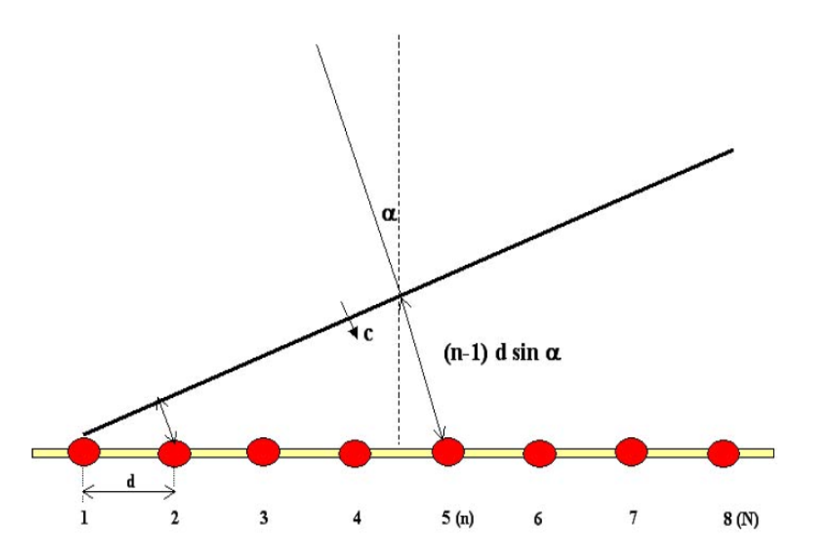

Figure from section 8

In this project, code to simulate how signals operated and aggregated and what do signals look like at the receiver side is divided into three part: SIMO, MIMO and alamouti. Under these conditions, the operations used to modify signals are different.

1. SIMO(single input multiple output)

Matlab code:

clc;

clear all;

f=6e+09 %frequency 6GHz

c=3e+08 %speed of light

d=0.01 %distances between receive antennas 0.01m

n=[1 2 3 4] %receive antennas

angle=linspace(0,pi/2,8) %transmit antennas' angle alpha

s=sin(angle.') %transmit antennas

for i=1:4

A(i)=2.*pi.*f.*(n(i)).*d.*s(2)/c %phase delay

B(i)=(4.*pi.*f.*d.*(n(i))*s(2))/c.^2 %amplitude delay

i=i+1

end

L=-2*pi:pi/100:2*pi

subplot(6,2,1); plot(sin(L+A(1))); title('fig.1')

subplot(6,2,2); plot(sin(L+A(2))); title('fig.2')

subplot(6,2,3); plot(sin(L+A(3))); title('fig.3')

subplot(6,2,4); plot(sin(L+A(4))); title('fig.4')

subplot(6,2,5); plot(sin(L+A(1))+sin(L+A(2))+sinc(L+A(3))+sinc(L+A(4))); title('fig.5')

subplot(6,2,6); plot(5.*sin(L+A(1))); title('fig.6')



Different phase and amplitude

Assuming one transmitter antenna and four receive antennas, Fig.1 to fig.4 are the signal received by four different antennas. We use sinusoid function to describe transmitted signal. In the picture, this single signal suffers different phase delay and amplitude delay. In fig.5, all received signal are added up without any operations. In fig.6, modified signals are added up, with the same phase and stronger power.

1. MIMO(multiple input multiple output)

Matlab code:

clc;

clear all;

f=6e+09 %frequency 6GHz

c=3e+08 %speed of light

d=0.01 %distances between receive attennas 0.01m

n=[1 2 3 4 5] %receive attennas

angle=linspace(0,2*pi,8) %transmit attennas' angle alpha

for t=2:7

x=2.*pi.*f.*(n-1).*d.*sin(angle(t))/c %phase delay

y=(4.*pi.*f.*(n-1).*d.*sin(angle(t))/c).^2 %amplitude delay

L=-2*pi:pi/100:2*pi

figure(t-1)

subplot(7,2,1); plot(L,sinc(L+x(1)))

subplot(7,2,2); plot(L,sinc(L+x(2))/y(2))

subplot(7,2,3); plot(L,sinc(L+x(3))/y(3))

subplot(7,2,4); plot(L,sinc(L+x(4))/y(4))

subplot(7,2,5); plot(L,sinc(L+x(5))/y(5))

subplot(7,2,6); plot(L,sinc(L+x(1))+sinc(L+x(2))/y(2)+sinc(L+x(3))/y(3)+sinc(L+x(4))/y(4)+sinc(L+x(5))/y(5))

subplot(7,2,7); plot(L,sinc(L+x(1))*(1+1/y(2)+1/y(3)+1/y(4)+1/y(5)))

t=t+1

end











In MIMO, two parameters to describe transmitters and receivers, α and n. The six pictures are with different incidental angle α, represents different transmitter antennas. In each picture, there are seven figures. They function as in SIMO. We use the sinc function to describe transmitted signal. Fig.1 to fig.5 are different receive antennas from n=1 to n=5. Fig.6 directly adds every signals up and fig.7 shows the modified signals.

1. Alamouti(simplified)

Matlab code

clc;

clear all;

f=6e+09 %frequency 6GHz

c=3e+08 %speed of light

d=0.01 %distances between receive attennas 0.01m

n=[1 2] %receive attennas

angle=linspace(0,pi/2,4) %transmit attennas' angle alpha

s=sin(angle.') %transmit attennas

j=sqrt(-1)

E1=(0+0.5)*rand(100,1)

E2=(0.5+1)*rand(100,1)

for j=1:2

for i=1:2

A(i,j)=2.*pi.*f.*(n(i)).*d.*s(j+1)/c %phase delay

B(i,j)=(4.*pi.*f.*d.*(n(i))*s(j+1))/c.^2 %amplitude delay

i=i+1

end

j=j+1

end

for k=1:2

figure(k)

subplot(2,1,1); plot(sqrt(E1).*exp(j.*A(k,1))./(B(k,1))) %E1 from A received by C/D at t1

hold on

plot(sqrt(E2).*exp(j.*A(k,2))./(B(k,2))) %E2 from B received by C/D at t1

hold off

subplot(2,1,2); plot(sqrt(E2).*exp(j.*A(k,1))./(B(k,1))) %E2 from A received by C/D at t2

hold on

plot(sqrt(E1).*exp(j.*A(k,2))./(B(k,2))) %E1 from B received by C/D at t2

hold off

end

figure(3)

subplot(4,2,1); plot(sqrt(E1).*exp(j.*A(k,1))./(B(k,1))+sqrt(E1).*exp(j.*A(k,2))./(B(k,2))) %received signal E1

subplot(4,2,2); plot(sqrt(E2).*exp(j.*A(k,2))./(B(k,2))+sqrt(E2).*exp(j.*A(k,1))./(B(k,1))) %received signal E2

subplot(4,2,3); plot(sqrt(E1))

subplot(4,2,4); plot(sqrt(E2))



The altamouti changes dramatically due to two time slots. We build a matrix to describe the space-time code. Transmit antennas transmit ith row’s signals in jth column’s time slot. Antennas are represented with incidental angle αand nth receiver.

Figure 1 and figure 2 show the signal received by different antennas and in each figure, the two charts are the different signals, represented by red and blue line, received by a certain antenna in different time slots. The transmitted signal is represented by power with random function of E. The phase delay can be dealt as exp(jφ(n)).



The last figure shows the signal which phase and amplitude delay are diminished by proper operations, also compared with the original signal from transmitters. We can see the output signal approximately equals original signal.