Microservice Architecture:
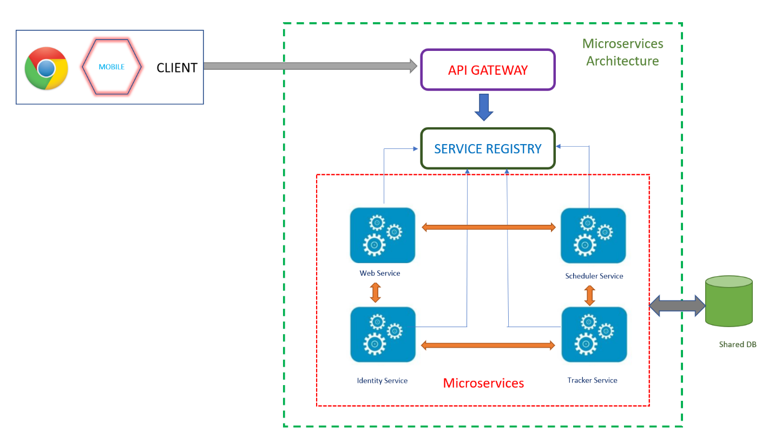

Technical Stack:
Sno | Requirements | Technology
1 | IODA | Docker, Tomcat.
2 | Environment | MS Azure
3 | Logging | Log4J, MDC and Zipkin
4 | Dev tools | GIT, JIRA, Jenkins & Sonar.
5 | Application management | Load balancing and Auto Scalling serives provided by Azure
6 | Authentication and Authorization | IDP (Open ID connect)
7 | UI | Angular, NPM & Angular CLI.
8 | Middleware | SpringBoot + REST ( Async API), Tomcat.
9 | Scheduler | SpringBoot Scheduler with Async API.
10 | Database | PostgreSQL
11 | API Gateway | Zuul
12 | Service Registery | Spring Cloud Netflix Eureka

Microservices:
Each Service should implement below mentioned dependencies.
- Eureka Discovery: for service registration.
- Feign: a declarative web service client
- Zuul: provides intelligent routing.
- Rest Repositories: to expose JPA repositories as REST endpoints.(if needed.)
- Web: Spring MVC and embedded Tomcat
- Hystrix: a circuit breaker to stop cascading failure and enable resilience.
- Lombok: to reduce boilerplate code.
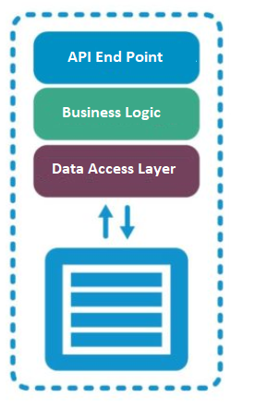

Detailed Architecture:
Tracker Service & Scheduler service:

- RabbitMQ / ActiveMQ along with JMS (Java Messaging Service) can be used for Message Queueing.
- Instead calling the API endpoints directly there some Queue worker endpoints, which receives the request and route them to the respective queues.
- A listener service will be listening for the message and process them when a new message enters the queue.
- The jobs can be monitored using an UI admin panel. (pending and completed jobs.)
- The same process can be applicable for the Scheduler services to monitor the campaign.
