Vue Debugging:

Use console and put debugger in the Chrome dev tools:
- Add a console.log wherever you want to debug.
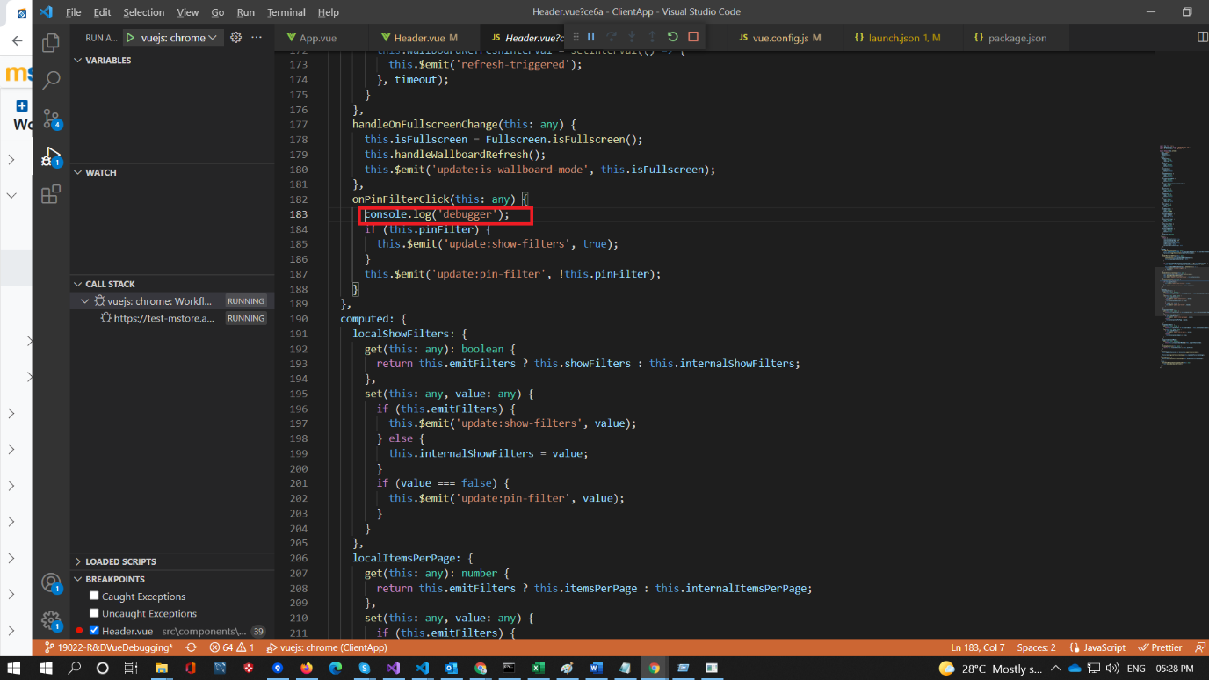

- Go to the browser(chrome) open the console and you can see the console text.
- In the same line you can see the stack trace( file name and line number).
- Click on the filename and line number.
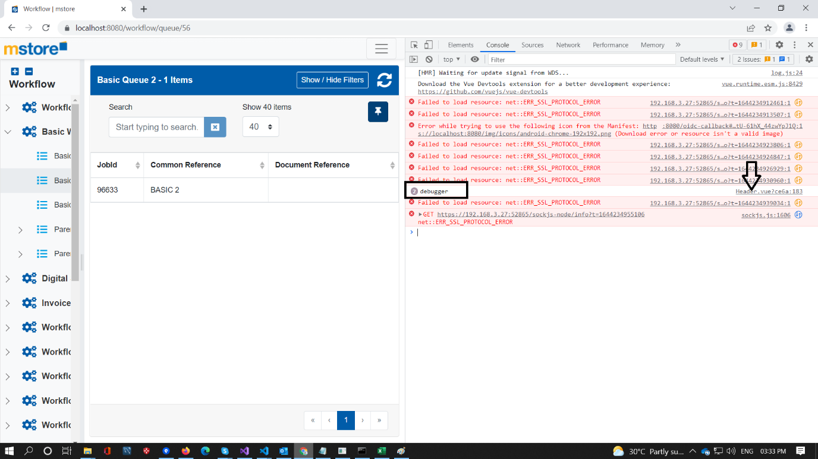
- It will take you to the respective source file.
- Right click on the line number and it will give couple of options add breakpoint, add conditional break point etc.
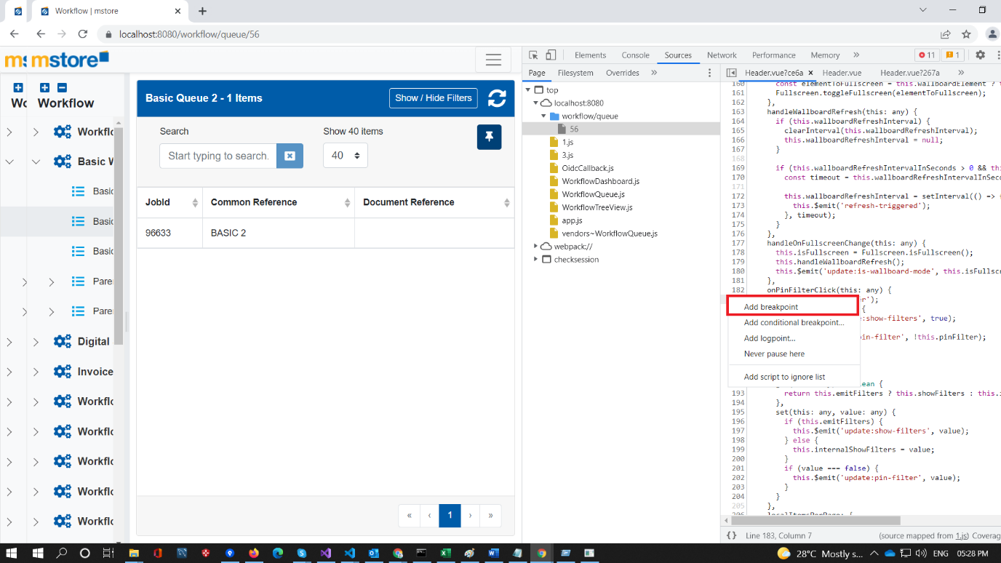
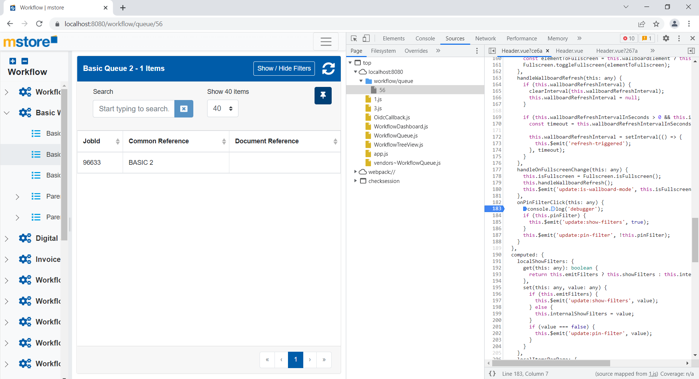
- It will add the break point in that place. In this use case I have set a break point on the onPinFilter click function.
- When you click the pin filter button it will break in the source and after this you can continue like you will debug in the Visual studio.

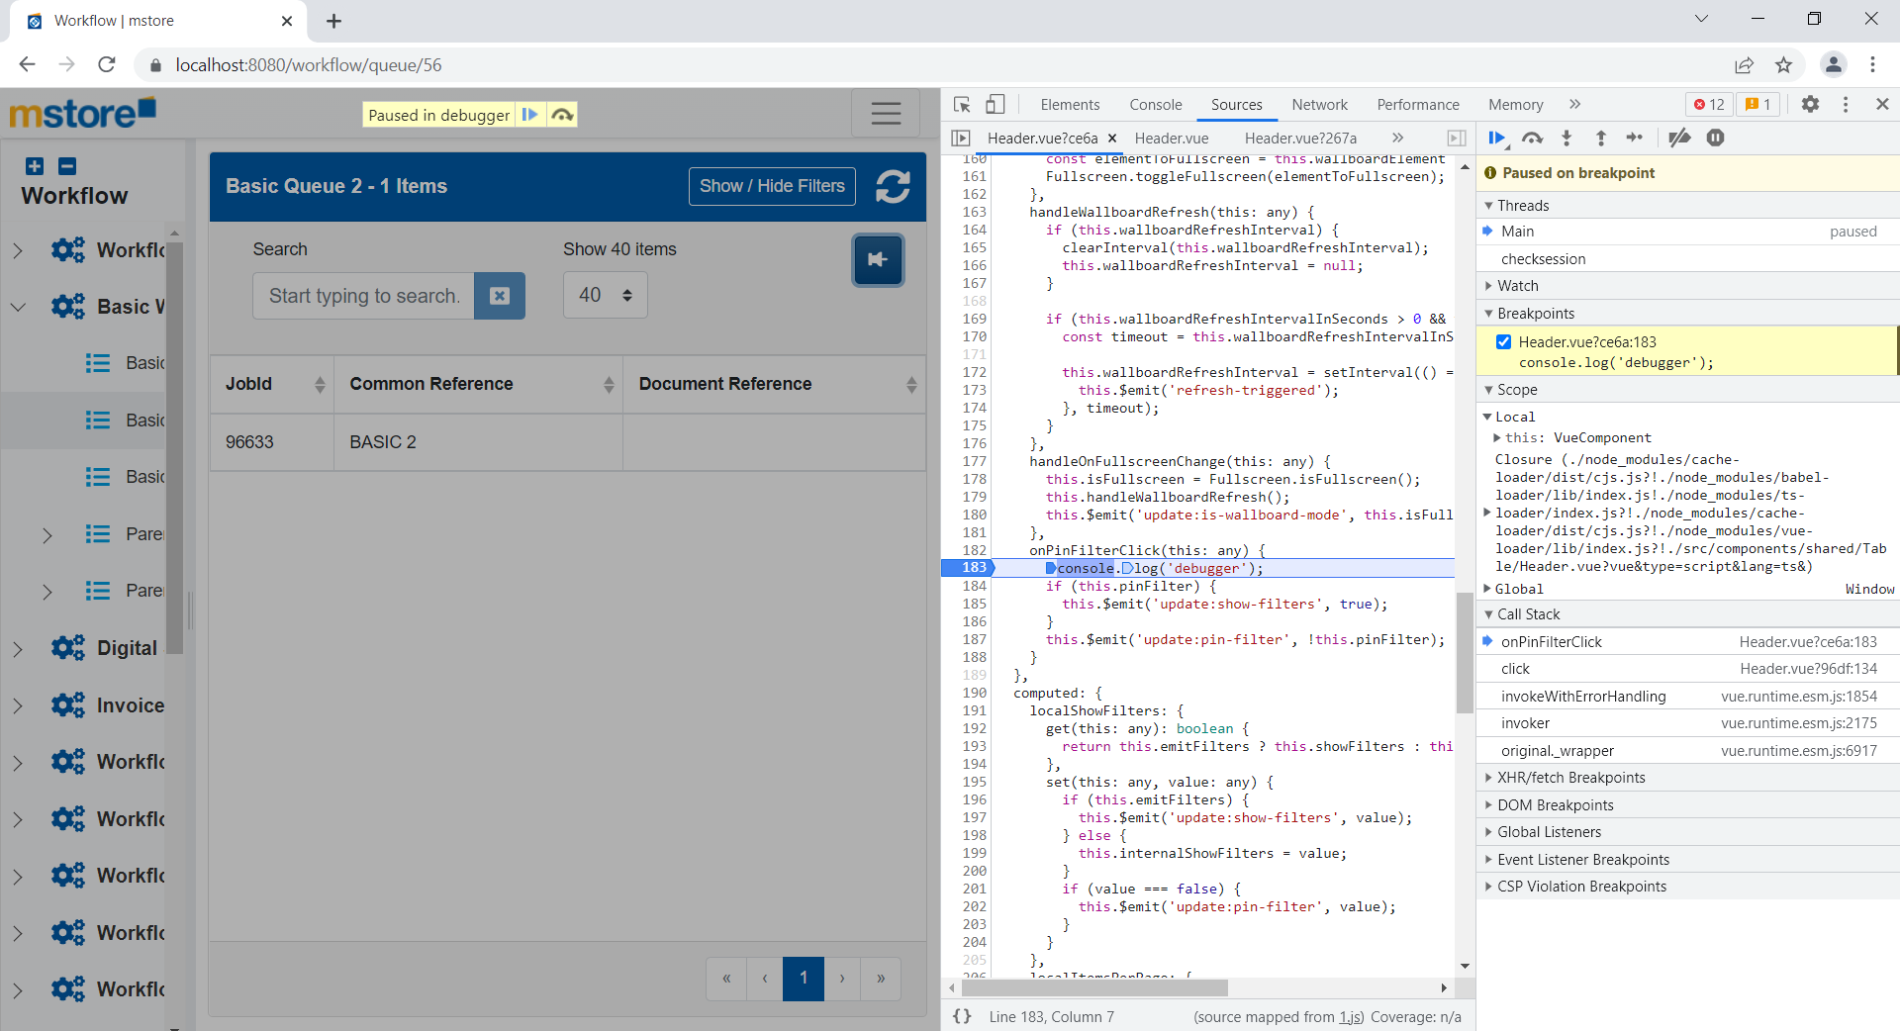

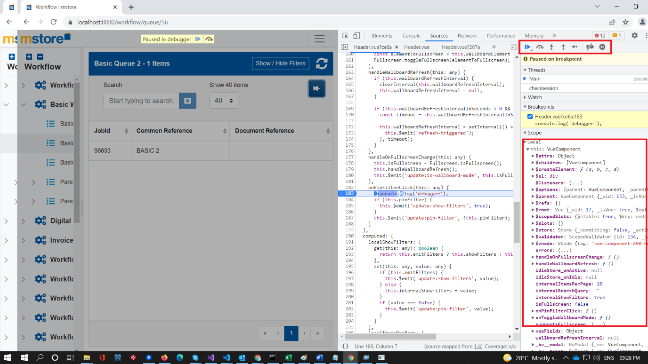

NOTE: Please remove the console.log after you have completed the debugging.

Debugger and browser developer tool:
- In this use case we are going to user debugger, instead of the console.log.
- User key word debugger; wherever you wants to break the code.
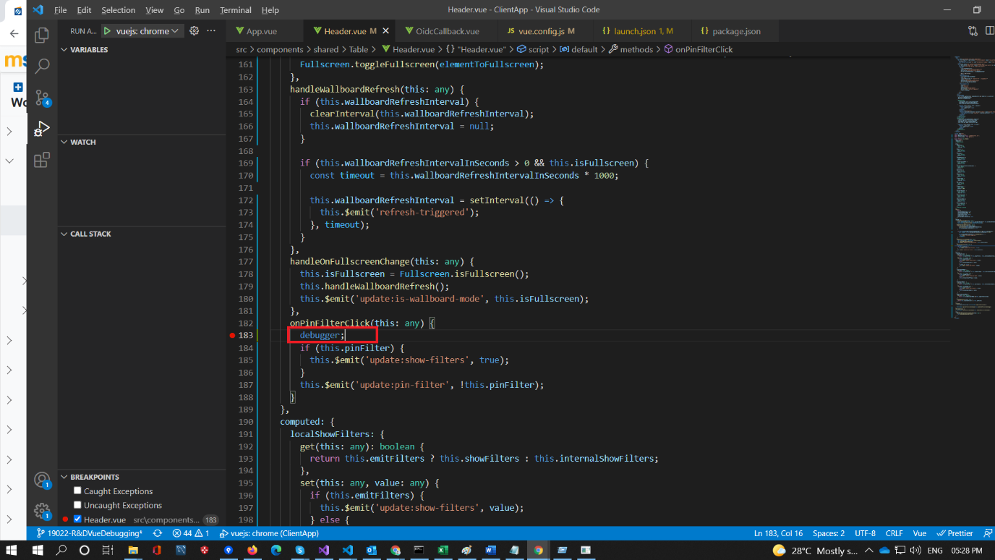

- Run the Application and open the developer tools.
- Follow the same scenario which we have used above.
- It will break at the debugger and can continue the debugging from there.
NOTE: remove debugger once you done with the debugging.

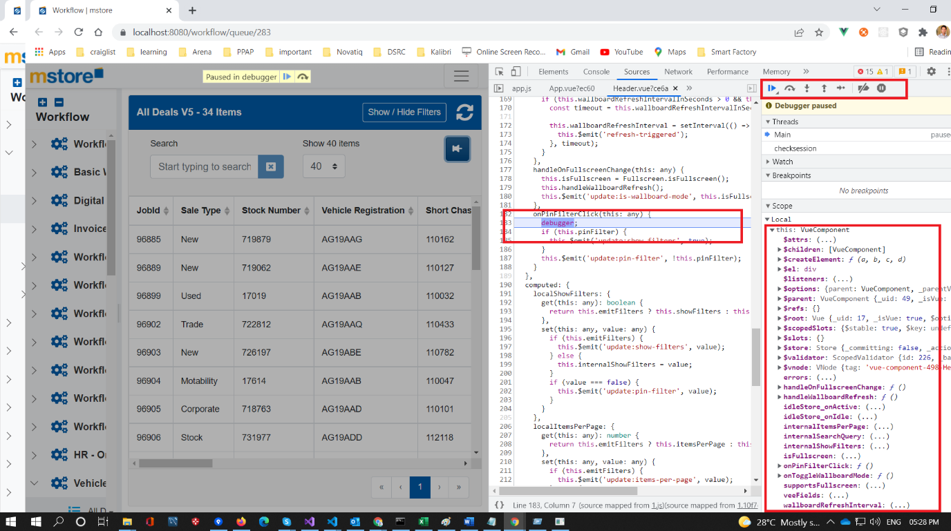

Debugger and Visual studio code:
- In this type also we are going to use debugger but instead of developer tools we are going to use visual studio code.
- Place debugger wherever you wants to break and start debugging.
- Change the url in in the Launch.Json file.
{
// Use IntelliSense to learn about possible attributes.
// Hover to view descriptions of existing attributes.
// For more information, visit: https://go.microsoft.com/fwlink/?linkid=830387
"version": "0.2.0",
"configurations": [
{
"type": "chrome",
"request": "launch",
"name": "Launch Chrome against localhost",
"url": "https://localhost:8080",
"webRoot": "${workspaceFolder}"
}
]
}

- In visual studio code in the left side panel, we can see the debugger tab, select that option.
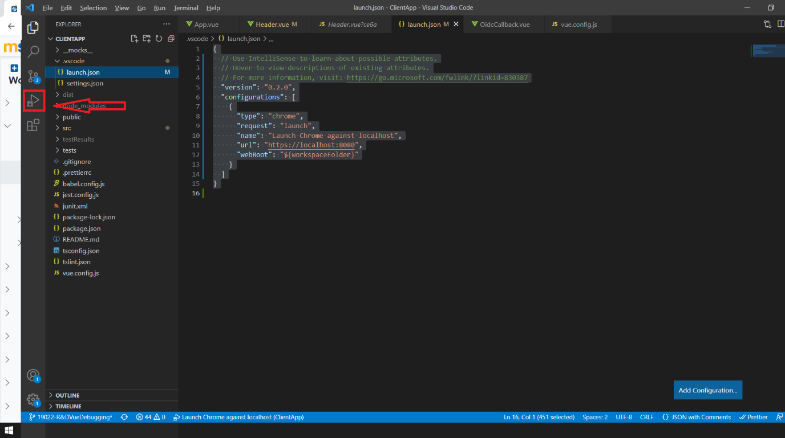

- Once you selected, it will open the debugging window with debugging options.
- Run the Application in the Visual studio. Once application is up and running.
- Click on the Launch button, it will open the application in the browser with debugging mode.

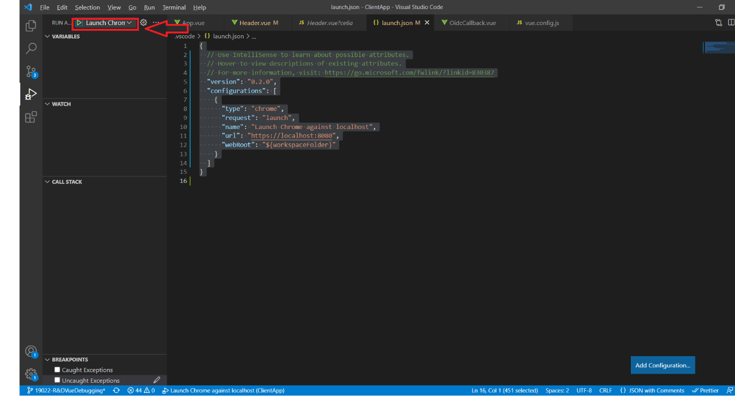
- Follow the above Scenario, it will break at the debugger;
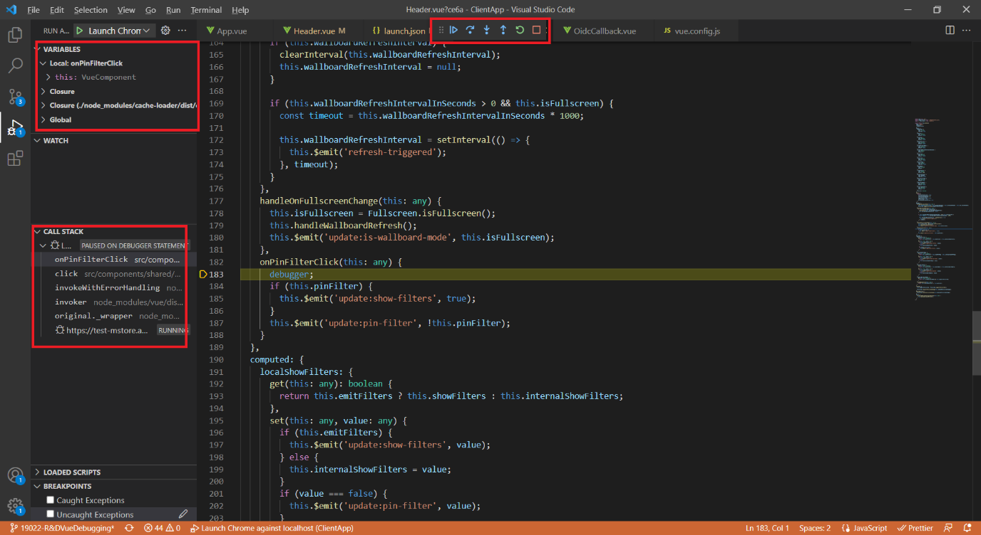

NOTE: remove debugger once you done with the debugging.

Webpack source-map and chrome developer Tools:
- Modify vue.config.js add the configuration devtool: ‘source-map’.
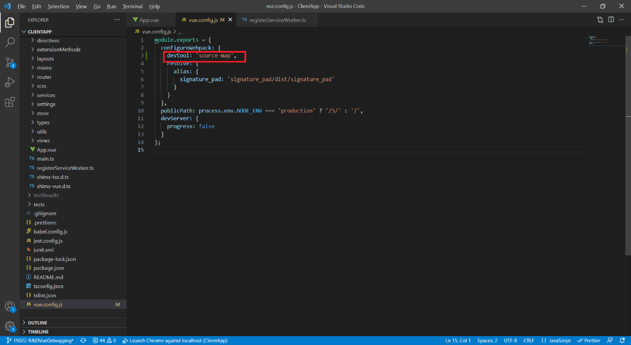
- Run the application in Chrome and Open Chrome developer tools.
- In sources tab, you can see a folder webpack and expand it, you can see a list of folders.
- Expand the folder “.”
- You can see folders node_modules and src.
- Open src and you can see all the source as well as mapping files.
- Go to the files that you want to debug put a break point and start debugging.
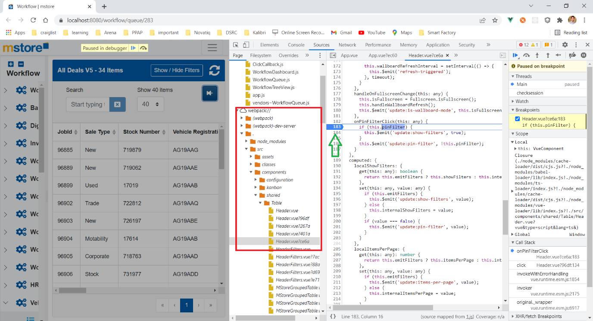

Note: The devtool setting is not advisable for production please remove when you are building for production.

Pros and cons of Browser Developer tools:
Pros:
- DevTools gives you a console for writing javascript code to interact with or change the behavior of the page you are currently working. This is particularly useful when debugging code.
- CSS edits. The ability to change the style of dom elements and see the effect those changes have in real time without having to switch to your editor, make the changes, and reload the browser window saves a lot of time.
- Providing a way to set javascript break points so you can see the runtime values of a variable.
- The network tab is also a life saver for inspecting what assets are being loaded on the page and in what order they load, how long they take to load etc...
- It can step into the Vendor code also.
Cons:
- Quicker access to common testing settings (e.g. disabling JavaScript).
- Limited customasation
- Google tracking
- High memory and CPU usage.

Pros and cons of VS Code:
Pros:
- We can debug as we do in the Visual Studio
- It will not step into unwanted vendor code.
- For all the methods that I have mentioned above doesn’t need any extensions.
Cons:
- Need separate extensions (chrome, firefox etc.
- We need to run the Application in the browser in debugger mode.
- We cannot debug the css and html changes.
Problems I faced when I used to debug the code is VS code using breakpoints:
- To debug the vue js using breakpoints and the vs code , we need to install chrome debugging extension in VS code and modify the Launch settings as below.
{
// Use IntelliSense to learn about possible attributes.
// Hover to view descriptions of existing attributes.
// For more information, visit: https://go.microsoft.com/fwlink/?linkid=830387
"version": "0.2.0",
"configurations": [
{
"type": "chrome",
"request": "launch",
"name": "vuejs: chrome",
"url": "http://localhost:8080",
"webRoot": "${workspaceFolder}/src",
"breakOnLoad": true,
"sourceMapPathOverrides": {
"webpack:///./src/*": "${webRoot}/*"
}
},
]
}
- In vue.config.js add the following configuration for webpack,
configureWebpack: {
devtool: 'source-map'
}
- Now run the application using npm run start.
- Then launch the chrome using the debugger option as mentioned above, it will open the application in the debugger mode.
- Put a break point in any place in the code and navigate to that place the break point will break.
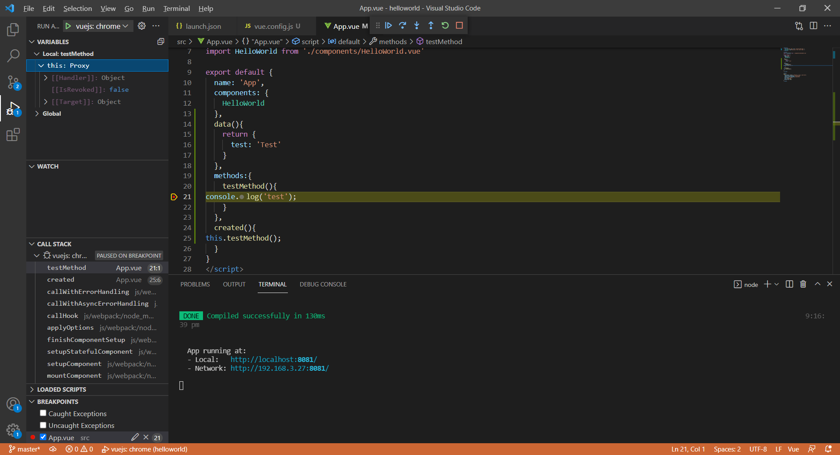
Problems faced in MStoreV5:
- We are running the vue using vue Development server in local.
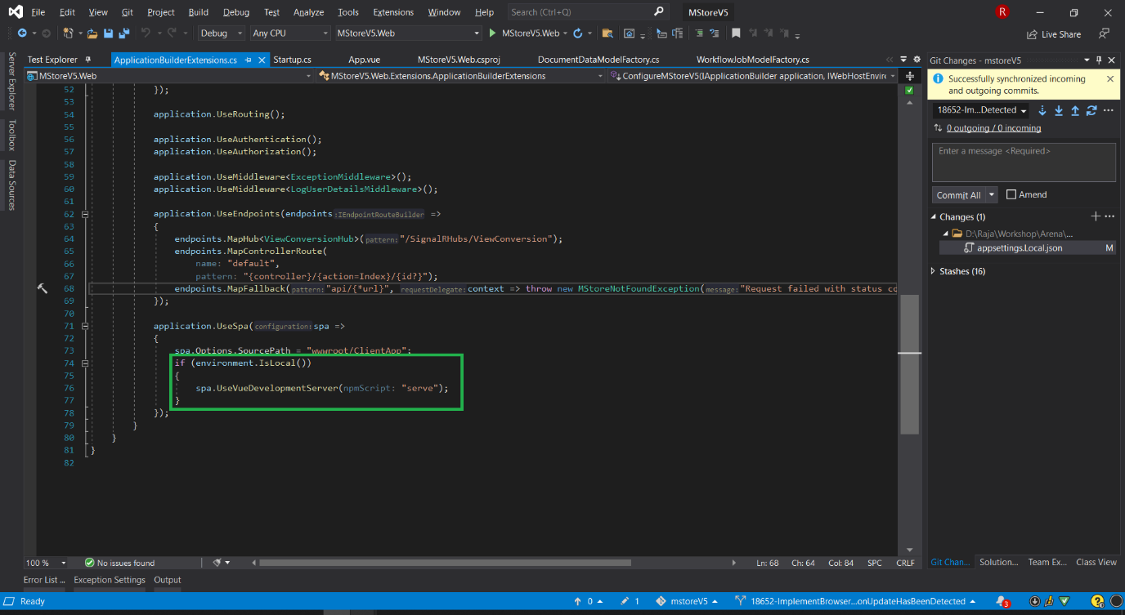
- When I comment the spa.UseVueDevelopmentServer(npmScript: "serve"); and ran the both application separately.
- Api is running https and port 8080 and vue is running in 8082 and http, so I got the CORS error, and we need to configure the api url to point the https://localhost:8080/.
- It needs more effort to make it work, since it is a R&D task I haven’t tried them and also not sure whether it will work.
References:
- https://blog.openreplay.com/how-to-debug-vuejs-with-chrome-devtools
- https://www.digitalocean.com/community/tutorials/how-to-debug-components-state-and-events-with-vue-js-devtools
- https://snipcart.com/blog/vuejs-debugging
- https://vuejs.org/v2/cookbook/debugging-in-vscode.html#Alternative-Patterns
- https://github.com/vuejs/v2.vuejs.org/blob/master/src/v2/cookbook/debugging-in-vscode.md
- https://docs.microsoft.com/en-us/visualstudio/javascript/debug-nodejs?view=vs-2022
- https://docs.microsoft.com/en-us/visualstudio/javascript/debug-nodejs?view=vs-2022#generate_source_maps
- https://devtools.vuejs.org/guide/installation.html#using-dependency-package
- https://vuejscode.com/debug-vuejs-from-vs-code-unbound-breakpoint-when-debugging-vuejs-app-in-chrome
- https://vuejsdevelopers.com/2018/10/16/vue-js-advanced-debugging/

