**Unlicensed version. Please register @ templater.info**

Pictures

Templater can copy existing pictures or inject new ones at the place of tag when Image type is provided (such as BufferedImage). Due to Java API restrictions Templater will assume picture have 72dpi and will inject them as is into the document. If we want to change the size we can resize it through the plugin before it’s inserted into the document.

# Cars on sale

|  |
| --- |
| Really fast car |
| Ford Focus |
| Regular car |

# Boats on sale

* Speadboat
  + 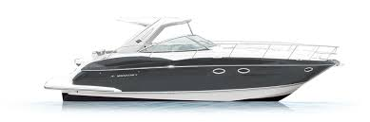
* Slowboat
  + 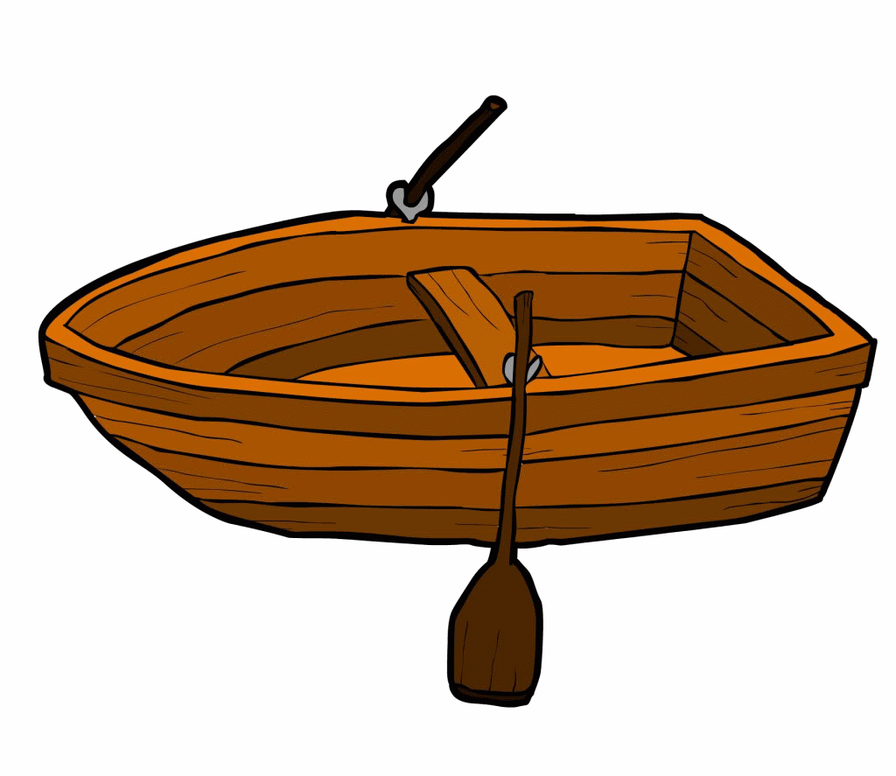
* Cruiser
  + 