Retail Banking Customer Churn
Prediction & Retention Strategy Report
Exploratory Data Analysis, Tableau Dashboard Insights, and Strategic Recommendations
Prepared for: Data Analyst Portfolio
Prepared by: Leung Hoi KitI
Date: 14 August 2026

1. Executive Summary
In the competitive retail banking sector, understanding and mitigating customer churn is vital for maintaining sustainable asset scale and profitability. This report presents a comprehensive analysis of a standardized retail banking dataset comprising 10,000 customer records. By combining exploratory data analysis (EDA), interactive Tableau visualizations, and descriptive segment modeling, this study examines the structural drivers of customer attrition.
The overarching churn rate across the portfolio stands at 20.37%. However, granular segmentation reveals extreme variance across geographies, age brackets, and member activity statuses. Notably, customers located in Germany, mature cohorts aged 51–60, and inactive members exhibit disproportionately high attrition rates. Based on these findings, targeted retention strategies and strategic recommendations are proposed to optimize resource allocation and safeguard high-risk customer segments.

2. Data Overview & Methodology
The underlying dataset contains 10,000 verified customer observations and 15 analytical fields, capturing customer demographics (geography, gender, age), financial indicators (credit score, balance, estimated salary, product holdings), behavioral flags (credit card ownership, active membership), and the target variable (churn status).
To ensure high analytical rigor and professional presentation, the data pipeline was validated via Python to confirm zero missing values and unique customer identifiers. An interactive Tableau dashboard was subsequently constructed to enable multi-dimensional filtering and cross-sectional analysis.
Core Metric | Quantitative Value | Business Definition & Baseline
Total Customers | 10,000 | Total active analytical sample size
Exited Customers | 2,037 | Customers who terminated their accounts
Overall Churn Rate | 20.37% | Portfolio-wide customer attrition benchmark
Active Member Rate | 51.51% | Proportion of regularly active members
Average Account Balance | $76,485.89 | Mean deposit and asset balance across cohort

3. Exploratory Data Analysis & Visual Insights

3.1 Overall Customer Churn Distribution
Among the 10,000 analyzed customers, 7,963 maintained their banking relationship (79.63%), while 2,037 churned (20.37%). This baseline indicates that approximately one in every five customers terminates their account, highlighting a significant exposure to acquisition cost erosion.
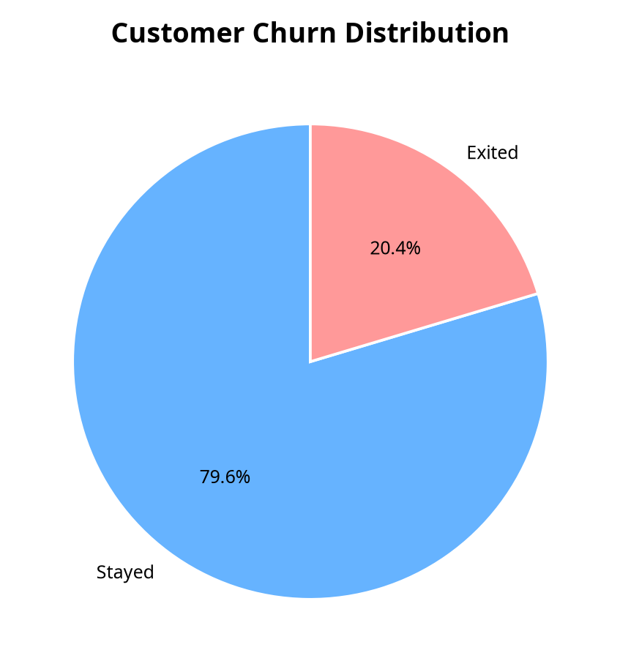
Figure 1: Customer Churn Distribution

3.2 Geographical Risk Analysis
Geographic segmentation reveals stark contrasts in customer retention. While France and Spain account for larger customer bases (5,014 and 2,477 customers respectively) with moderate churn rates (16.15% and 16.67%), the German market exhibits an alarming churn rate of 32.44%—more than double the rate observed in France and Spain.
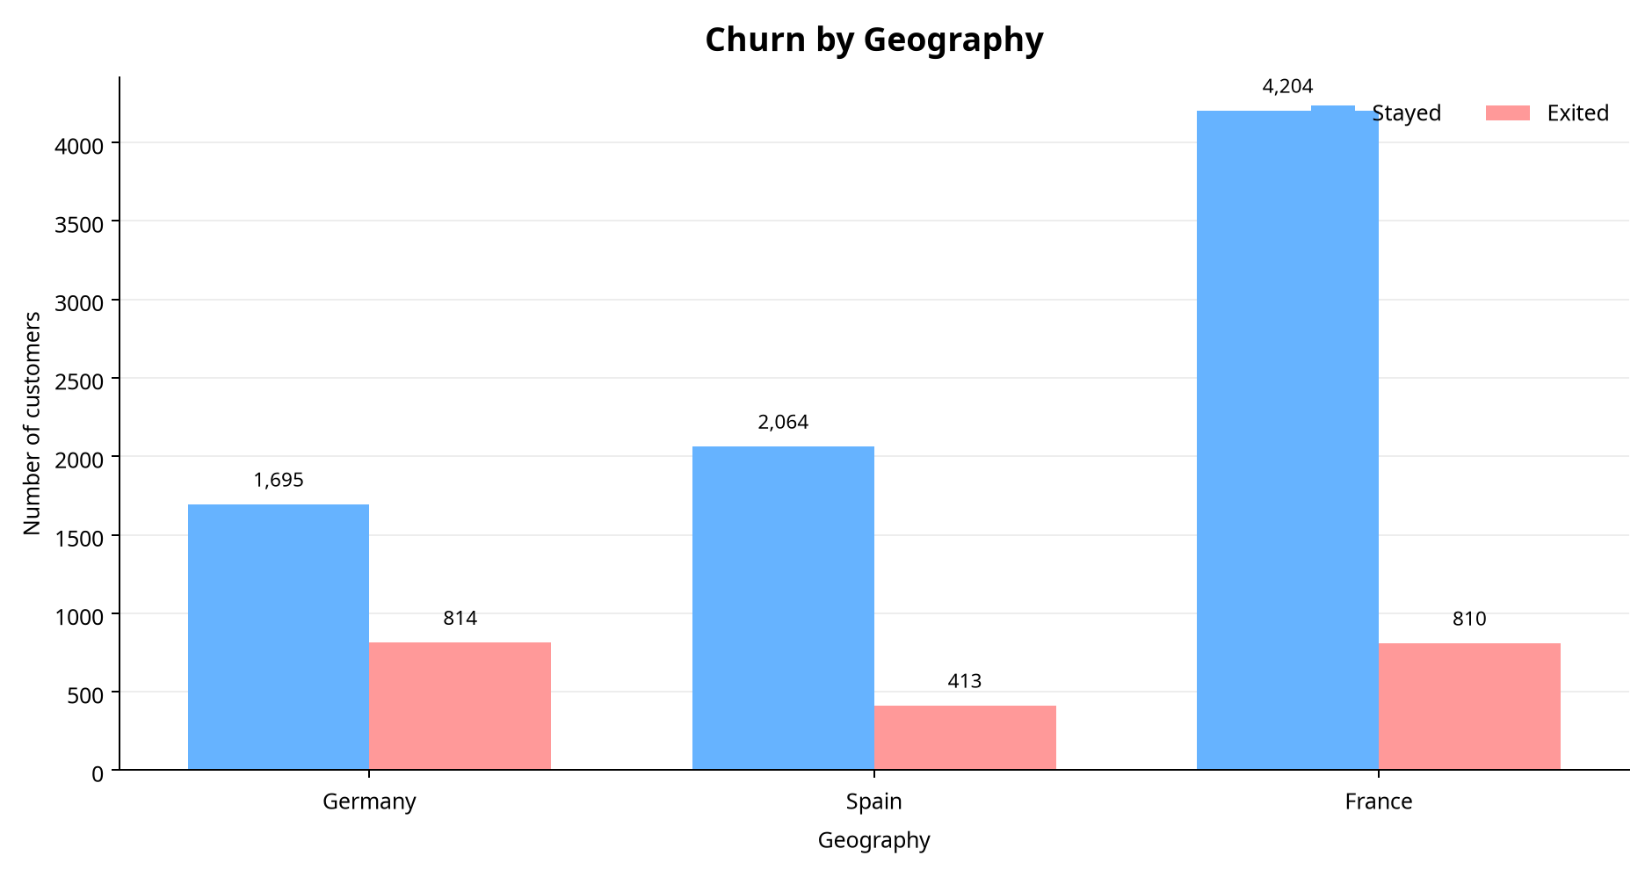
Figure 2: Churn by Geography
Geography | Total Customers | Stayed | Exited | Churn Rate (%)
Germany | 2,509 | 1,695 | 814 | 32.44%
Spain | 2,477 | 2,064 | 413 | 16.67%
France | 5,014 | 4,204 | 810 | 16.15%

3.3 Gender and Age Demographics
Female customers display a higher propensity to churn (25.07%, 1,139 exits) compared to male customers (16.46%, 898 exits). Furthermore, age analysis demonstrates a pronounced lifecycle risk pattern: churn is minimal among young adults (7.56% for ages 18–30) and seniors (9.93% for ages 70+), but escalates sharply starting in middle age, peaking at 30.79% for ages 41–50 and reaching 56.04% for the 51–60 age cohort.
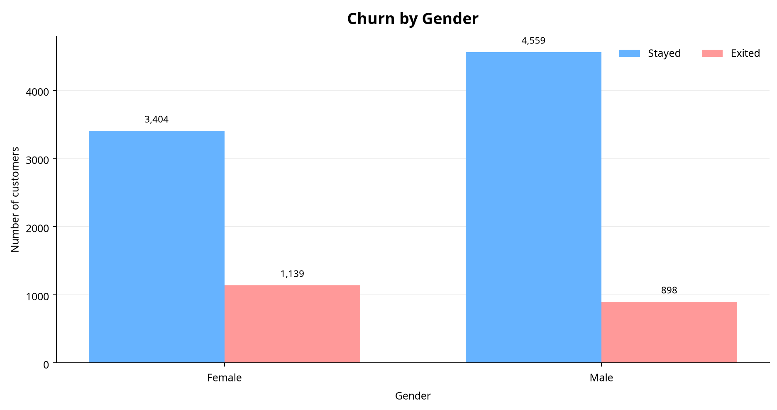
Figure 3: Churn by Gender
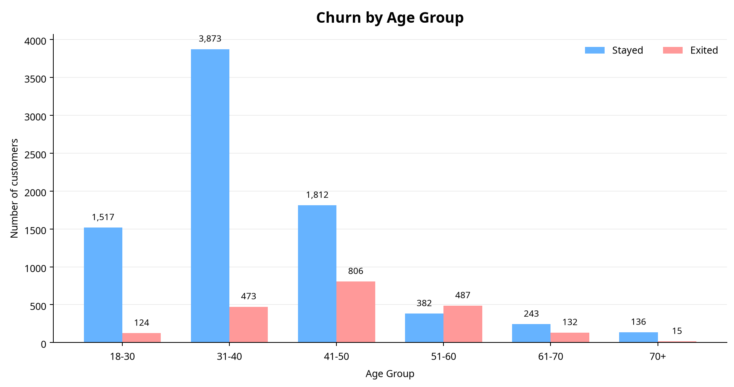
Figure 4: Churn by Age Group
Age Group | Total Customers | Stayed | Exited | Churn Rate (%)
18–30 | 1,641 | 1,517 | 124 | 7.56%
31–40 | 4,346 | 3,873 | 473 | 10.88%
41–50 | 2,618 | 1,812 | 806 | 30.79%
51–60 | 869 | 382 | 487 | 56.04%
61–70 | 375 | 243 | 132 | 35.20%
70+ | 151 | 136 | 15 | 9.93%

3.4 Member Activity Impact
Member engagement is a critical determinant of retention. Among the 5,151 active members, the churn rate is restricted to 14.27%. Conversely, among the 4,849 inactive members, churn surges to 26.85%. This underscores the efficacy of digital engagement and proactive outreach in mitigating attrition risk.
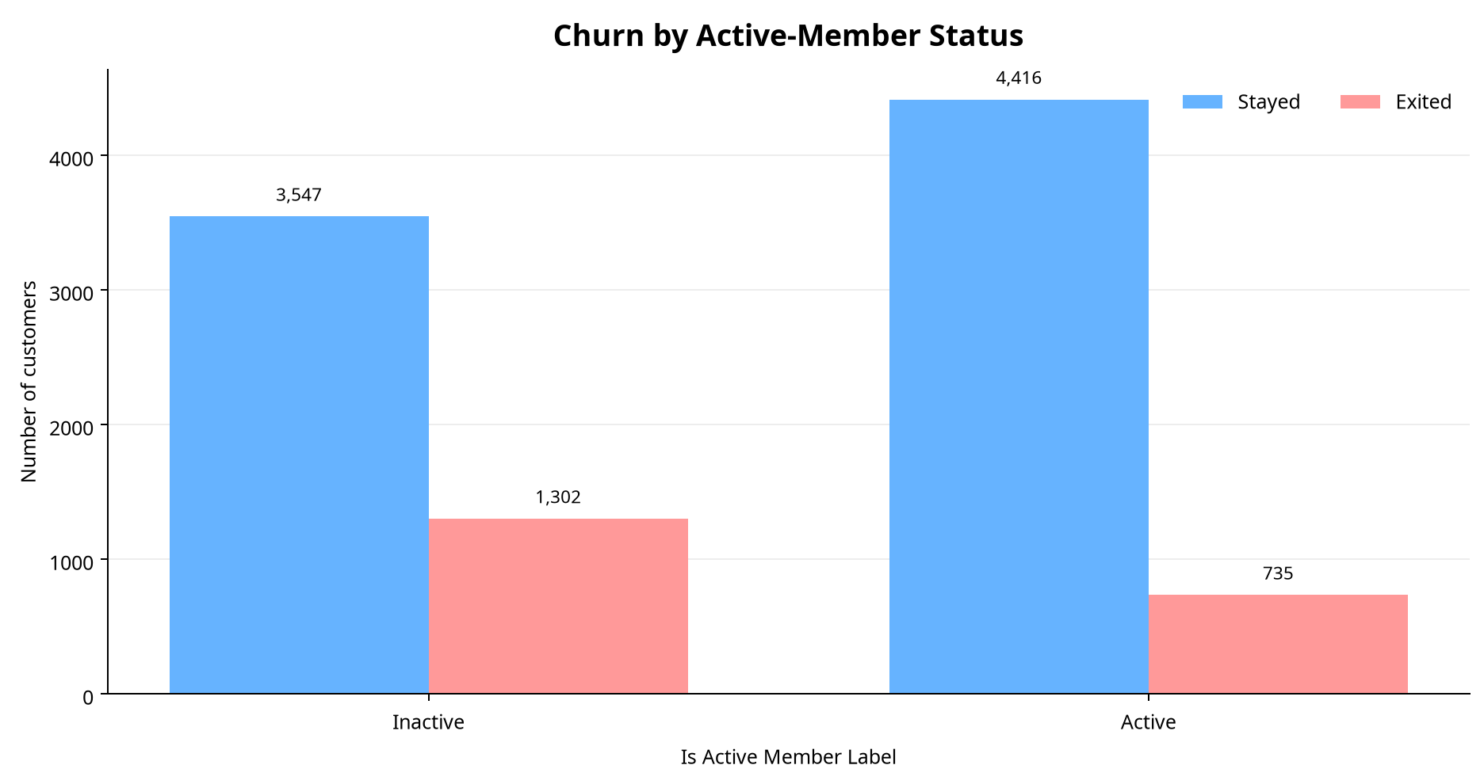
Figure 5: Churn by Active-Member Status

4. Strategic Recommendations & Action Plan
Based on the quantitative findings and visual insights, management should prioritize the following four strategic initiatives:
1. Launch Germany-Specific Retention Taskforce: Address the 32.44% attrition rate in Germany by reviewing localized product pricing, fee structures, and competitive offerings against regional retail banks.
2. Dedicated Relationship Management for Ages 41–60: Given the severe drop-off observed in middle-aged cohorts (peaking at 56.04% for ages 51–60), assign dedicated financial advisors to provide personalized wealth management and asset-planning consultations.
3. Automated Inactive-Member Re-engagement Campaigns: Implement targeted digital marketing and incentive campaigns for the 4,849 inactive members to bridge engagement gaps and reduce their 26.85% churn baseline.
4. Female Segment Experience Review: Conduct qualitative user research to identify unmet financial or service needs among female account holders, ensuring equitable product satisfaction.
Priority | Target Segment | Risk Signal | Recommended Action | Success Metric
High | Germany | 32.44% Churn Rate | Audit local pricing & competitive positioning | 90-Day Retention Rate
High | Ages 51–60 | 56.04% Churn Rate | Deploy dedicated advisory & loyalty perks | Segment Attrition Rate
Medium-High | Inactive Members | 26.85% Churn Rate | Execute automated re-engagement workflows | Active Member Ratio
Medium | Female Customers | 25.07% Churn Rate | Conduct qualitative surveys & UX audits | Customer Satisfaction Score

5. Project Limitations & Future Scope
While this report provides actionable descriptive insights, certain limitations should be noted. The dataset represents a cross-sectional sample without longitudinal tracking, precluding causal inference between demographic attributes and churn events. Furthermore, technical identifiers such as CustomerId were programmatically generated to support Tableau integration and do not reflect internal bank CRM primary keys.
Future iterations of this portfolio project will incorporate time-series behavioral tracking, customer service interaction logs, and transactional frequency metrics to transition from descriptive risk scoring to predictive survival analysis.

References
[1] Bank Customer Churn Dataset (10,000 Records, Standardized Analytics Release). Prepared for Retail Banking Portfolio Analysis, 2026.
[2] Tableau Desktop & Interactive Dashboard Technical Documentation, Version 2026.1.
[3] Python Software Foundation. Python 3.11 Standard Library and Pandas/Matplotlib Data Analysis Framework.

