2017-18

**Useful Information for New PhD Students**

**This unofficial manual refers primarily to ARI specific information**



Astrophysics Research Institute

Liverpool John Moores University

IC2, Liverpool Science Park

146 Brownlow Hill

Liverpool

L3 5RF



+44 (0)151 2312941 AstrophysicsLJMU 

<http://www.astro.ljmu.ac.uk/> @LJMU_Astro

# Welcome

Whether you’re a returning student or completely new to the department, welcome to the Astrophysics Research Institute! We hope this handbook will give you an overview of things that are useful to know during your time as a PhD student here. If you have questions about anything not covered here the PhD students in the years above should be your first source of information!

The Astrophysics Research Institute (ARI) is part of the Faculty of Engineering and Technology at Liverpool John Moores University and the current head of institute is Professor Chris Collins. As well as being home to astrophysics research, the department also runs the Liverpool Telescope (located on La Palma), and teaches degree programmes including a joint astrophysics undergraduate degree with the University of Liverpool.

The ARI is located within the Liverpool Science Park, and shares the IC2 building with other scientific organisations including the University of Liverpool’s Institute of Infection & Global Health. The building is open 24/7; because of this and its shared nature you need a fob to enter both the main building and each floor at any time of the day. The ARI has rooms and offices on all but the ground floor of the IC2 building, including the entirety of the 2nd floor, which is where the reception and PhD office are located. Some ARI offices and rooms are located on the 1st floor, and the Liverpool Telescope office can be found on the 3rd floor.

The building’s kitchen facilities are available for use by everyone; help yourself to tea, coffee, sugar, and milk. Please wash up any mugs, plates, or cutlery you use, or place them in the dishwasher.

Liverpool Science Park will take any deliveries addressed to you at the ARI, and letters will be placed in your post box in the PhD office. There are cupboards containing stationery freely available for use in room 2.14 (across the hall from the main PhD office).

**This document is unofficial (compiled by previous students for their convenience) and it refers primarily to ARI specific information. You should refer to the university’s student handbook (**[**https://www.ljmu.ac.uk/about-us/public-information/student-regulations/student-handbook**](https://www.ljmu.ac.uk/about-us/public-information/student-regulations/student-handbook)**), the graduate school Code of Practice (**[**http://bit.ly/2aIyGmI**](http://bit.ly/2aIyGmI)**) and the Faculty student handbook (**[**http://bit.ly/1UvmsKs**](http://bit.ly/1UvmsKs)**) for more information.**

# Useful Contact Information

Below is some contact information you may commonly need in the department, faculty, and university. A comprehensive list of email addresses for members of the department can be found at <http://www.astro.ljmu.ac.uk/people>.

## Useful contacts

**S.** **Kobayashi@ljmu.ac.uk** - Shiho Kobayashi, *ARI Postgraduate Admissions Tutor*

**A.E.Montaubin@ljmu.ac.uk** - Alexia Montaubin, *Faculty Research Administrator for ARI*

**C.M.FaircloughLowry@ljmu.ac.uk** - Chris Fairclough-Lowry, *Research Support Officer*

**R.M.Boulter@ljmu.ac.uk** - Rach Boulter, *3is training*

**reception@liverpoolsciencepark.co.uk** - Liverpool Science Park, *for matters regarding the office or building.*

The department’s Health and Safety Officer is Dan Harman, and the current First Aiders are Dan Harman, Stuart Bates, and the LSP Reception Staff.

The PhD office telephones can be used to call outside numbers by first pressing 9, and you can get through to the LJMU Switchboard by pressing 0. The office telephones can be called on 0151 231 2923.

## Enrolment confirmation letter

You may need to obtain an enrolment confirmation letter if, for example, you need to defer student loan payments or confirm your student status to a bank. To obtain this letter you can email **AvrilRobartsStudentAdmin@livjm.ac.uk** from your student email; they should be able to send you a .pdf confirmation letter.

## ARI mailing lists

*Membership of the following mailing lists - apart from ast-outreach - is automatic. Instructions for joining the outreach list can be found in the Outreach section of this handbook.*

**ast-ari@ljmu.ac.uk** - - - - - - - - - - Entire department (excluding visitors and MPhys)

**ast-academicstaff@ljmu.ac.uk** - - - - - - - - - - - - - - - - - - - - - - - - All teaching staff

**ast-outreach@ljmu.ac.uk** - - - - - - - - - - - - - - - - - - - - - - - - - Outreach information

**ast-phd@ljmu.ac.uk** - - - - - - - - - - - - - - - - - - - - - - - - - - - - - - - - - - PhD students

**ast-mphys@ljmu.ac.uk** - - - - - - - - - - - - - - - - - - - - - - - MPhys (Master’s) students

# Regular Events

A number of events take place in the ARI most weeks (details may vary).

* **Most Research Groups have at least one weekly meeting to discuss papers or other ongoing research.**
* Tuesday 3pm onwards - **Tea time**

Department staff and students gather in the staff room (first floor) for informal tea/coffee and discussions.

* Wednesday 3.30pm - 4.30pm **-** **Seminar**

During term time an external speaker gives a seminar on their field and research, usually in the Redmonds Building (just down the road). The schedule can be found at <http://www.astro.ljmu.ac.uk/seminars>.

PhD students purchase donuts and/or other snacks for the seminar; there will be a schedule in the PhD office you can put your name on (currently organised by Lawrence). Maximum spend £25, and you can claim this back from Maureen, so keep your receipt and take it to her to get your money back.

There will often be lunch or dinner trips with the speaker; emails will be sent around about this during the week.

* Social events:

Tuesday 11am – Football:

A group of staff and students play football regularly. Speak to Seb Turner to be added to the mailing list.

Friday evening - a trip to the pub!



* Monthly - **PhD Colloquium**

Each month there is an opportunity for you to informally share the work you’ve been up to with the other PhD students and collect opinions or advice on your work. Date and time varies.

* Bi-annual - **PhD talks**

As well as the informal monthly discussions there is a more formal bi-annual (November and June) PhD talks session. All PhD students should present at this event, which may be attended by interested staff.

Both PhD sessions are organised by a 2nd year student

Most of these events take place in one of the IC2 meeting rooms; the calendar for bookings, where you can also book rooms, can be found at <http://www.astro.ljmu.ac.uk/mrbs/day.php>

# Your Research

STFC-LJMU funded PhD students, and most others, begin their PhD in October. Students with funding from other sources may start on different dates, though many will begin around the same time. During the first month there are a number of mandatory talks/events you will be contacted about, including department, faculty, and university inductions.

During the first year of your PhD you will attend monthly postgraduate discussion sessions. These sessions take the form of a member of staff in the department discussing their field of research or a particularly important paper that underpins their research. You should be contacted with further details on this around the start of your PhD.

STFC-LJMU funded students should be paid on the first Friday of each month after enrolment, unless you hear otherwise. Other funding payment dates may vary.

If you are having any issues during your PhD there are a number of people/venues where you can raise them. Shiho Kobayashi is the Postgraduate Admissions Tutor, and can help with issues related to admissions, registration, and forms. There is both a 1st year and 2nd year student representative who you can go to with issues. The 1st year rep should be the point of contact for general first year queries or concerns that need raising, and the 2nd year rep - who attends the Management Board Meetings - can raise PhD-wide issues to the department. Faculty level issues can be raised at the Faculty Research Degrees Committee meetings, where you will be represented by the faculty representative. The reps are as follows:

* **1st year rep** - TBC
* **Management board rep** - TBC
* **Faculty rep** - TBC

Mentors are permanent members of the departmental staff who you can talk to about any issue (directly or indirectly affecting your PhD or career afterwards) in addition to or instead of your supervisor(s). Discussions are private, though not confidential, so any issue raised may be passed along to other members of the department, faculty or university if the mentor deems it necessary or if they are required to do so. The available mentors are Andreea Font, Matt Darnley, Nate Bastian, Phil James, and Stacey Habergham.

The university also offers Student Advice and Wellbeing Services, which includes academic support (though they mainly deal with undergraduates, so may not be familiar with PhD related issues) as well as a counselling service (who can be contacted at **counselling@ljmu.ac.uk**), where you can discuss anything.

Your research project will be officially supported by two or three supervisors, one of whom will be your director of studies. Of these supervisors, one must have previously supervised at least 3 UK PhD students to completion. This is mostly important when it comes to completing your RD9R - you only need to worry about your primary supervisor when initially choosing your project.

### STFC/LJMU funded students

STFC/LJMU funded students will choose their research project during the first two weeks of their time at the ARI. You may already have a good idea what research project you want to do, but **you should investigate other projects; you might find out there’s something else that grabs your interest!**

During these two weeks you should organise meetings with potential supervisors to learn more about the research you could undertake, and attend the meetings organised by the research groups where you will learn what the various members are working on.

When you’ve decided which projects you want to work on and with which supervisor(s), you should email Chris Collins at the end of the 2nd week with a list of your top 4 project choices. In almost all cases you will get your top choice, but there may be some further discussions needed in the case that too many students want to work on the same topic.



## Forms

**RD9R** - To complete the registration of your research project you will need to submit LJMU’s RD9R form. This is primarily a summary of the research you intend to carry out during your PhD and confirmation of your supervisory team. The submission deadline is 3 months after the start of your PhD (so the end of the year for students starting in October - preferably before Christmas).

The empty form can be found at <https://www2.ljmu.ac.uk/RGSO/62172.htm>, and you will receive an annotated version with additional guidance at an induction session.

The second year PhD students are your best source of information on filling this form out, and you should ask them for copies of their forms if you want to see examples. The Postgraduate Admissions Tutor will check your form over before it’s officially submitted, and attends a meeting with LJMU confirming their contents, so they are the person to ask if the other PhD students don’t know the answer to something!

**RD45** - This is an annual monitoring form detailing your progress in the past year (or since you started) as well as your future plans. You’ll be emailed about this around May, and the deadline is usually around the end of June. - <https://www2.ljmu.ac.uk/RGSO/80412.htm>

**RD9T (& Transfer Report)** - By the end of the first year of your PhD you will need to submit a report to transfer from the MPhil degree to a full PhD. The report is similar to a mini-thesis and should contain background information on the area in which you are working (setting the scene for your project) as well as a description of the work you have carried out so far, and the work that you plan to carry out in future. It must be fully referenced. While you need to make sure you have a good plan for the future, don’t worry too much about the details; they are very rarely kept to and it can be amusing to look back on these later and realise how little you’ve achieved of your original plan.

You will also be given an oral examination on your work by a member of the department (chosen by your supervisor); your supervisor may or may not be present for this. This will check that you are making reasonable progress in your project, that everything is going ok and that you have a (semi-)realistic plan for the next 2 years.

**RD9Ext -** During your third year you may find, for any number of reasons, that you will require more time to complete your PhD. You can apply for an extension to your period of registration, which would give you 6 months more funding to help you complete your research and write-up. You will need to complete a RD9Ext form and submit a single page (500 word maximum officially) Scientific Justification for the extension. The Scientific Justification should include a short description of the aims of your PhD project and an update of its current status. Additionally, you should include a statement on how you intend to be involved in outreach activities. There should also be a timeline of how you plan to spend the remainder of your PhD, including the extra 6 months, and you should mention papers that you will write during this period and the date when you will submit your thesis. Details and availability of PhD extensions may vary for non-STFC students.

## Liverpool Telescope

All members of ARI (staff and PhD students) have access to the Liverpool Telescope. This is a 2.0 metre robotic telescope on La Palma and is equipped with optical and IR imagers, low and medium resolution optical spectrographs, and a polarimeter. Around 300 hours per semester are available for ARI members. It is allocated by a time allocation committee on the basis of proposals that must be submitted twice per year. If you are interested in using LT as part of your project, then the telescope astronomical staff Iain Steele, Chris Copperwheat, Robert Smith and Jon Marchant will be happy to provide advice on the application process, taking your observations and reducing the data. Full details of the telescope are on the website at <http://telescope.livjm.ac.uk/>.

## Travel

Prior to booking any travel you will need to complete a travel authorisation form, which must be signed by the head of department. To book travel, you will need to provide this form to a member of the admin staff with the details of what requires booking. To claim travel expenses, you can fill out the Student Bursary Claim Form (if you receive your bursary payments through LJMU) or the Student Expense Claim form (if you don’t).

# IT Facilities

You will find the answer to most questions you have about IT at the ARI at the SharePoint ‘ARI Computing Help’ page, accessible from the department’s main page (see image) or directly at <https://teams.ljmu.ac.uk/5/ARI/> (the password for the SharePoint is your LJMU one). For other issues contact **ast-support@ljmu.ac.uk**.

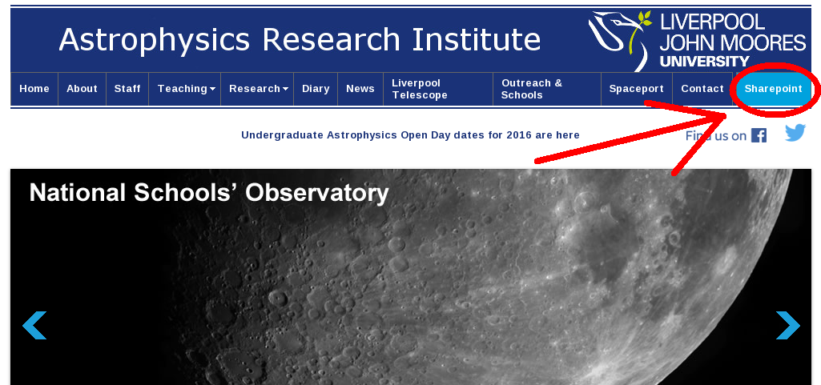

This section contains a summary of the information that should be most relevant to you.

## Logins

During your time at the ARI you will have two sets of login passwords. One is for the LJMU systems (including computers, email, and eduroam), and the other is for the ARI computers. Your LJMU password will require changing every 60 days.

To log in to the eduroam wireless, you will need to use [username]@ljmu.ac.uk as the login and your LJMU password.

Storage

There are two primary locations for storing your files:

* /home/[username] is a networked and backed up location. Space is limited so this is for storage of important files.
* /scratch is storage located on your desktop computer - **This** **is not backed up**. If you are saving data here it is highly recommended you back it up to an external hard drive or other backup location.

## Computing Clusters

If you have parallelised code or require large amounts of memory, you can connect to one of the department’s computing nodes to run your code/software. Full details are available on SharePoint.

To connect to one of the nodes from the command line inside the department use: ssh [node] where ‘node’ is cluster, comp16, or comp17 and the login is your ARI password. You can use top to check how busy that cluster is. HPC or other research group students may have additional computing resources (including clusters) available to them – your research group should share this information with you.

To connect to your computer or the nodes from outside the university, you must first connect to one of the two externally accessible machines - cluster or external. You can do this from a terminal with ssh [username]@[node].astro.ljmu.ac.uk and again login with your ARI password. From here you can ssh to your own starpc (e.g. ssh starpc43) or to one of the nodes.

To connect using a graphical interface you can use NoMachine. Full details on how to set-up NoMachine are available on SharePoint. Cluster and External each have 10 concurrent connections available; if you can’t connect to one for this reason try the other.

## Printing

The networked starpc computers are automatically connected to the networked printers:

* Laser2 - 1st floor, Room 105
* XRX1 - 2nd floor, Reception
* XRX2 - 2nd floor, Room 206
* XRX3 - 3rd floor, Liverpool Telescope office

The XRX printers can print in black & white or colour depending on whether you print via the -COL (coloured) option or not.

To print from a laptop or other computer not on the ARI network, you can use LJMU’s follow-you printing at <http://rprint.ljmu.ac.uk/>. After logging in you can select colour or black & white, upload your document, then take your student card to a printer, scan it, and follow the instructions.

## Email clients

To set up other email clients like Thunderbird, or to add email to your phone, use the following settings:

|  |  |
| --- | --- |
| Server settings: | Outgoing settings: |
| *Server name*: popimap.ljmu.ac.uk  *User name*: [Your ast… username]  *Port*: 993  *Security*: SSL/TLS, Normal password | *Server name*: smtp.ljmu.ac.uk  *User name*: [Your ast… username]  *Port*: 587  *Security*: STARTTLS, Normal password |

Passwords are your LJMU password.

## New computing equipment

New PhD students will have access to a basic desktop computer, but have some funds for new equipment. This can take the form of a new desktop, monitor(s), and/or laptop if needed. The exact amount available to spend will vary depending on your PhD funding, and you should clarify what you need with your supervisor and ARI computing staff before purchasing anything.

Desktop computers can be purchased from the list located in the SharePoint > Shared Documents > LJMU Desktop Buying Guide.pdf

To purchase new computing equipment (including desktops, laptops, monitors, or accessories such as external hard drives) first contact your supervisor, clearing it with them. You should then contact [ast-support@ljmu.ac.uk](mailto:ast-support@ljmu.ac.uk) with the details and your budget code (obtainable from Anna).

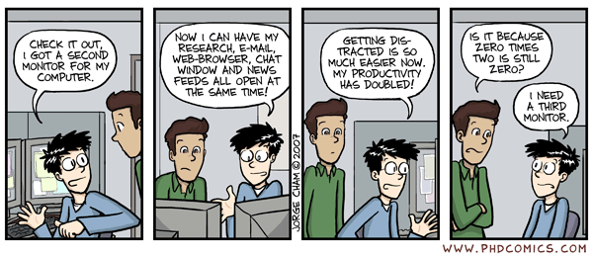

# Outreach

Outreach at the ARI is primarily coordinated by the National Schools’ Observatory team, who are always looking for willing volunteers interested in sharing their enthusiasm for astronomy with non-scientists!

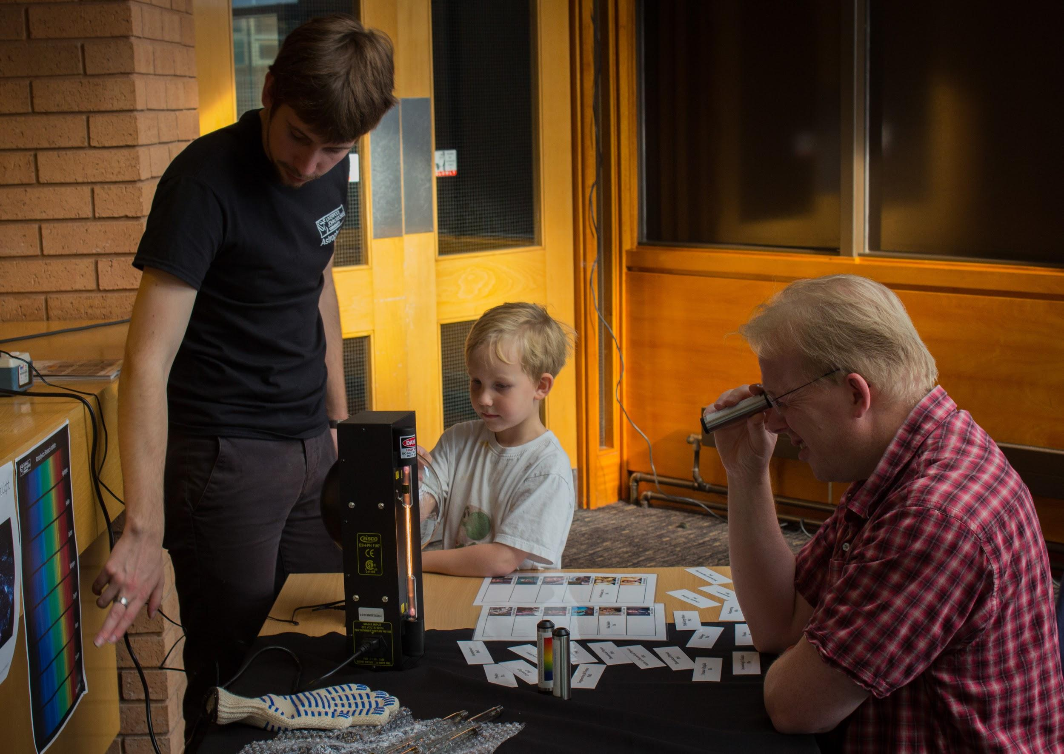

Outreach activities you can get involved in include school visits, museum events, other local events (e.g. Light Night), and the annual work experience week. There are also undergraduate open days you can help out with; get in contact with Dr. Ben Davies about these.

To get involved in outreach activities keep an eye out for departmental emails about upcoming opportunities, and subscribe to the outreach mailing list for full lists of the events you can get involved in. As well as being good fun to take part in, outreach also makes for good CV material!

To subscribe to the mailing list email **listserver@ljmu.ac.uk** with a blank subject and the text:

subscribe ast-outreach [your full email address]

The NSO team can be contacted at the following email addresses, or in room 2.22:

Andy Newsam - **A.Newsam@ljmu.ac.uk**

Stacey Habergham - **S.M.Habergham@ljmu.ac.uk**

Alison Keen - **A.Keen@ljmu.ac.uk**

Martin Coulby - **M.Coulby@ljmu.ac.uk**

# Teaching

The department delivers undergraduate astrophysics modules for the collaborative physics degree run between Liverpool John Moores University and the University of Liverpool as well as distance learning courses (including an MSc course). Some level of payment is associated with each course; details vary.

To teach in any of these courses you will need to have completed LJMU’s **3is training**. To sign up for 3is email Rach Boulter (R.M.Boulter@ljmu.ac.uk), who can let you know when the next sessions are running.

There are three primary ways in which you can get involved in teaching:

## Problems classes

The first year undergraduate Introduction to Astronomy (PHYS105) course runs weekly problems classes where undergraduates solve astronomy problems related to the course’s lecture content and have an opportunity to get feedback on their work from the lecturer (Prof. Andy Newsam) as well as three PhD student demonstrators.

Topics for this course include telescope design, photometry techniques, stellar evolution, galaxies, and other introductory areas.

The course runs for 6 weeks starting around February, and includes a weekly 2 hour problems class as well as homework. The student demonstrators attend each problems class to provide the students with help solving the problems and also mark their homeworks.

To get involved contact Matt Darnley ([M.J.Darnley@ljmu.ac.uk)](mailto:M.J.Darnley@ljmu.ac.uk)).



## Labs

Second year undergraduates attend a weekly Practical Astrophysics (PHYS216) course to learn how to use astronomical software and instrumentation. These take place across one and a half semesters (around 15 weeks in total) and usually require at least 3 PhD students as demonstrators.

The lab sessions take up a whole day each week and require knowledge of how to use Linux and GAIA.

There may also be availability for teaching in the first year physics labs.

To get involved contact Matt ([M.J.Darnley@ljmu.ac.uk](mailto:M.J.Darnley@ljmu.ac.uk)).

## Distance learning

For the distance learning courses (<http://www.astronomy.ac.uk/>) PhD students can help with general tutoring of participants (primarily answering questions related to the course and the work via email) and marking of work.

To get involved contact David ([D.Hyder@ljmu.ac.uk](mailto:D.Hyder@ljmu.ac.uk)).

# EU/International Students

EU and international students may require enrolment confirmation letters for signing up for things like bank accounts. See the contact information section for information on how to obtain one of these.

International (non-EU) students will need to periodically fill out an International PGR Students Attendance/Progression Monitoring Form. These will be emailed to you when necessary.

Twice a year (usually November and March) there will also be a meeting in person with international students to confirm details including your address.

EU/International students with any issues regarding the above or related matters should contact David Hyder ([D.Hyder@ljmu.ac.uk](mailto:D.Hyder@ljmu.ac.uk)).

# Additional Opportunities

Beyond your PhD research at the ARI there are a number of opportunities for placements, studentships, and internships. The list below is not exhaustive, but contains some of the options you may want to discuss with your supervisor if you’re interested:

* ESO Studentship Programme

*An opportunity to spend 1-2 years of your PhD at ESO in Germany or Chile*

<https://www.eso.org/sci/activities/FeSt-overview/ESOstudentship.html>

* Research Council Policy Internships Scheme

*An internship at a policy organisation for 3 months, working on science policy. Extends your PhD deadline by 3 months to compensate.*

<http://www.rcuk.ac.uk/skills/policy-internships-scheme/>

* ING Student Internships

*A one year internship at the Isaac Newton Group of Telescopes on La Palma*

<http://www.ing.iac.es/astronomy/science/studentship.html>

Additionally, there are a number of grants you can apply for to pay for travel, conferences, and/or equipment. Examples include the RAS Grant (<https://www.ras.org.uk/awards-and-grants/grants-for-studies>) and IOP Student Conference Fund (<http://www.iop.org/about/grants/research_student/page_38808.html>). You should speak to your supervisor for further information on grants and travel.

# [Extra documents]

Documents that could be attached to the end of this (mostly from sharepoint Shared Docs):

* Floor plan
* IC2 Emergency Evacuation Routes
* List of emergency numbers
* LSP Fire Policy